Tecnológico de Costa Rica

Artificial Intelligence

3rd Project - Neural Networks

Students:

Evan Blanco Rojas

Gabriel Rojas Alfaro

Juan Pablo Rodríguez Rojas

Teacher:

Abel Méndez Porras

06/16/2017

San Carlos’ Campus

**Result Evaluation Table**

For this project we used the K-Neighbors algorithm as the signs recognition method. We used 3 different signatures, 20 for each. The images were divided in cells to wrap each signature, with different amounts as can be seen in images 1, 2 and 3. The images were scaled so each signature had a size of 20x20 pixels.

Some of the results are resumed in this next table:

|  |  |  |  |  |  |
| --- | --- | --- | --- | --- | --- |
| **Name** | **Training time** | **Recognition time** | **Net size** | **Accuracy** | **Limitations found** |
| K-Neighbors  (5x4) | 0.0 | 0.0 | 20 | 100% | The algorithm wasn´t tested too much, for the tests realized we got the expected results. |
| K-Neighbors  (5x8) | 0.0 | 0.0 | 40 | 56.25% | For this example we tried to evaluate the algorithm with 2 sets of testing signatures; 1 used for training and one not included. As expected, the result was near a half of accuracy. A found limitation is that since we used a few signatures, there were also few pixels to compare, so both training and testing times were almost 0s. |
| K-Neighbors  (5x12) | 0.0 | 0.0 | 60 | 95.83% | All 3 signatures were recognized successfully, as the accuracy was almost 100%. We concluded that the size of the image affects the result, since using the raw scans, each signature was 400x400px, and the resulting accuracy was exactly 100%. |

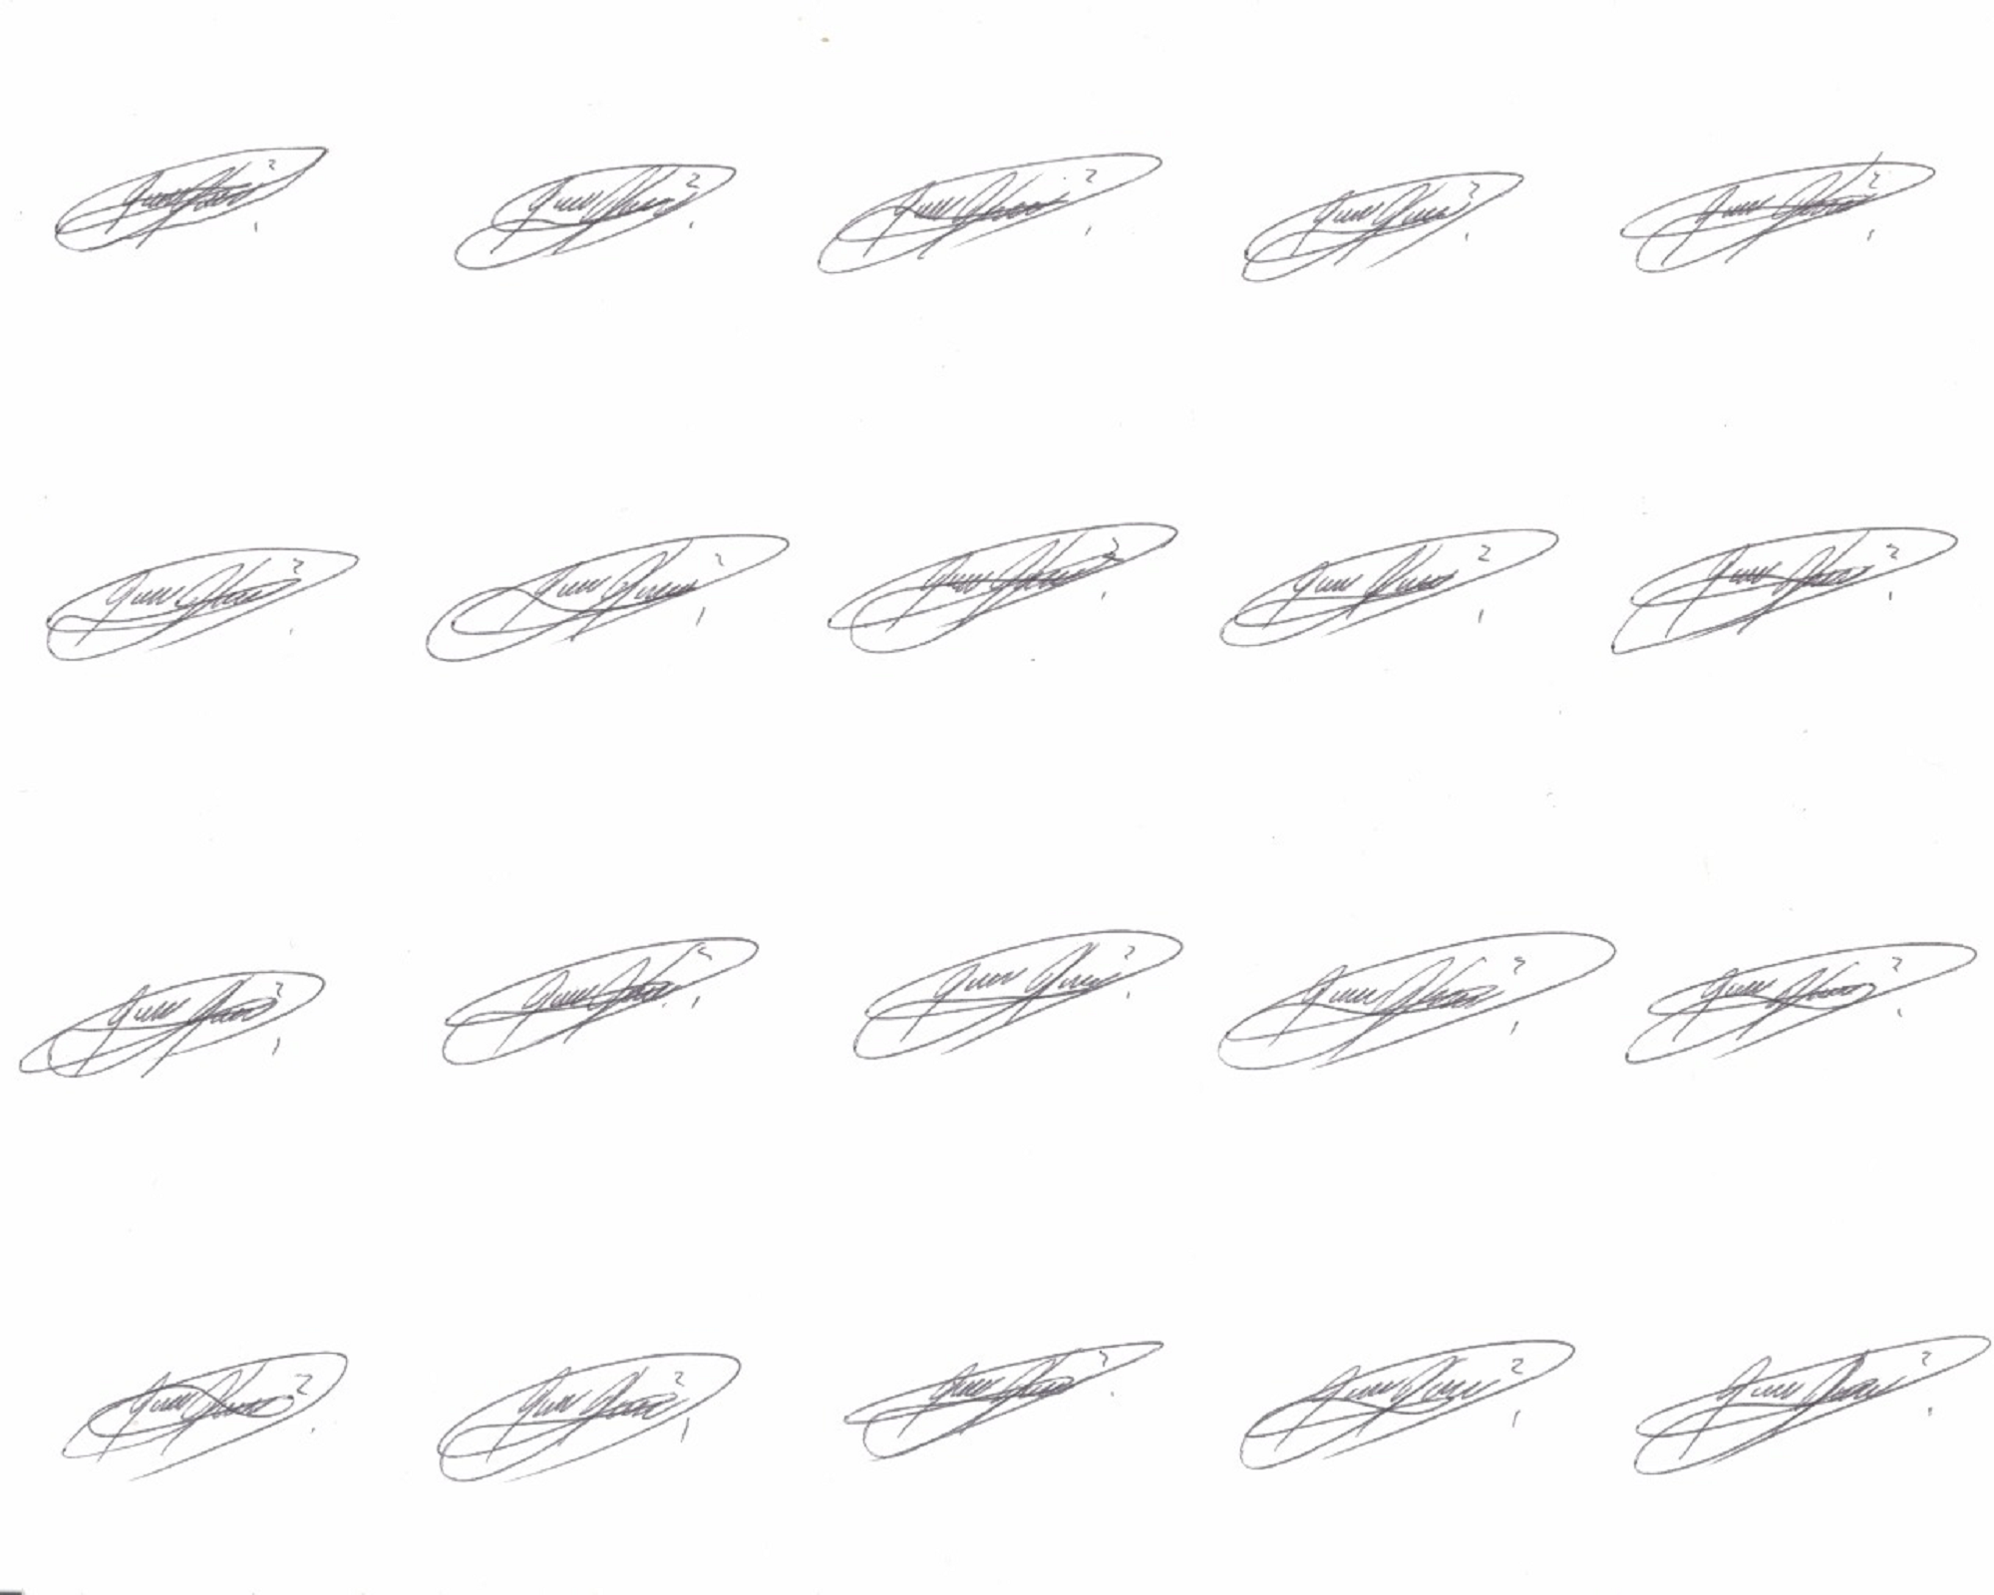

Image 1: 5x4

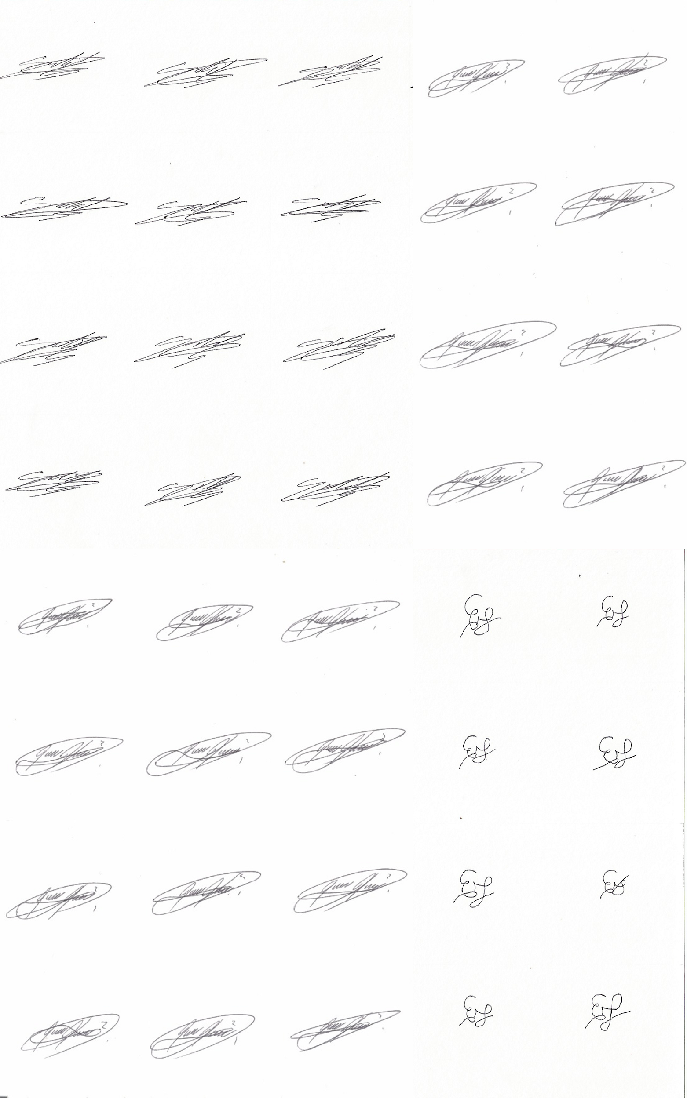

Image 2: 5x8

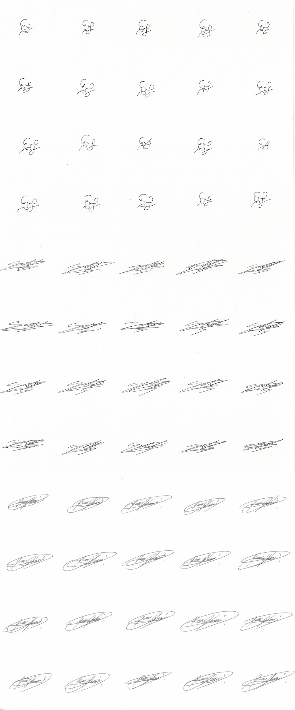

Image 3: 5x12

**Comments about what we learned and what could be improved on this system for real life use:**

**Evan Blanco:**

At the start we thought that implement a neural network will be so much more difficult as there are really complex to understand, when we get further in the investigation we could notice that the OpenCv library helps to manage this complex process in a very understandable way, of course we had to read and test so much with the library and the examples found in the OpenCv documentation for guide and help us understand how those code works. After all we could understand very well how this work and we implemented the K-neighbors algorithms for the signs example proposed.

Talking about real life use for this system I think it could definitely be so much useful but a little bit of exhausted in the data training step because it will need to learn about a lot of signs and this could be a difficult process to reach, by the other hand this could help a lot to the sign checks in some test or exams at the schools or universities.

The result of this neural networks were very good as waited, it really works and just needed a short python code using this OpenCV library. The algorithm tested was K-neighbors as mentioned before, we couldn't find a stable example for the radial basis or multi levels algorithms.

**Gabriel Rojas**

As we learned in classroom, neural networks are a great resource in terms of artificial intelligence. Almost every topic related to learning is reduced to pattern recognition, and that is what neural networks are for, as a simulation of the most powerful organ of the human body, the brain. Trying to put such a complex system in code would be almost unthinkable, but is possible. A great approach to it is already created in this library; OpenCV. Having such a powerful resource at hand is a great progress in technology, and we could have a taste of it. Here, we tried to implement and understand some techniques like the K-nearest neighbours, one of the simplest classification algorithms.

Following this example of signatures, it would be really useful in terms of legal documentations and fraud avoidance, making some adjustments in precision and sensibility according to the situation.

**Juan Pablo Rodríguez**

First of all, it is fair enough to recognize what amazing is the Open CV library, it is very simple in most of the cases with just some lines of code the library can make very exciting works.  
For this project we learned the main steps to training a neuron, for our case we implemented a KNN algorithm. We didn’t have to get involve with the algorithm programming because the Open CV library has a very optimized one, we decide to use that because it never wouldn't be the same performance to use it or program the algorithm by ourselves.

I think this is a very ambitious project, it could be used for multiple applications but for me the most important could be for “Detection of counterfeit signatures”, of course for that purpose it’s necessary to develop a more depurate code, but in this case is kind of difficult because as I said before the algorithm was just called like a function, we don’t have access to the code, but probably if we had that would fit the algorithm to the specific necessity, something like tailor made. Nowadays is very common to found counterfeit signatures in different frauds where people lost all their belongings, for people how pass for bank agents asking for personal information and to sign different documents so that why the problem interested me a lot because could fix a real problem.

So that's why I assume the challenge of continuing working with the Open CV library because I realize by doing this project that very ambitious projects as this one could be developed. I have had a lot of fun doing this project!!