DareBoost

Dareboost is a tool for testing, analysis and monitoring of website’s quality and speed of access. Dareboost can be used through their online website or using an extension for chrome or firefox.

**FEATURES:**

* **Synthetic Monitoring:** Dareboost can monitor your pages within only a few seconds. This can be scheduled for automatic monitory may it be daily or hourly.
* **User Journey Monitoring:**
* **Website Analysis:** Dareboost can check and give out detailed info about your website from the performance of your website to the accessibility of it.
* **Website Speed Test:** This can simulate how many people can access your website simultaneously. This gives out detailed info for both the user and the technicalsides.

**WEBSITE STANDARDS:**

I have ran some test using dareboost. For every 1 hour I analyzed the website.

***WEBSITE SAMPLE:***

[***http://aboitizfoundation.org/***](http://aboitizfoundation.org/)



***WEBSITE TEST WITH DAREBOOST:***

***HOUR 1***

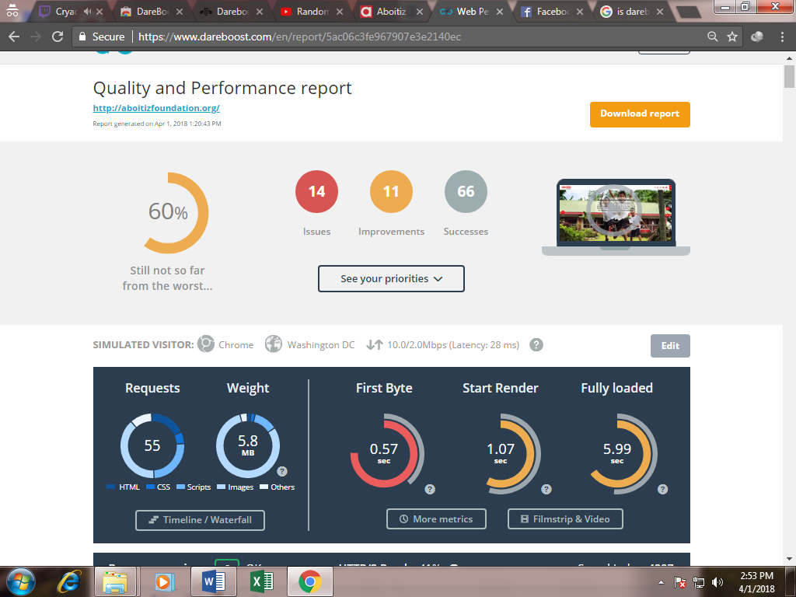

***HOUR 2:***

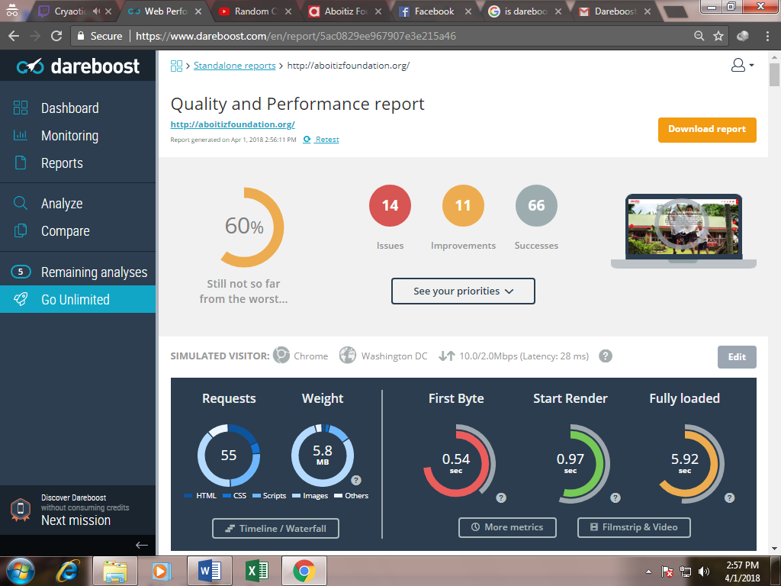

***STANDARDS:***

Dareboost Rates the website from security to accessibility with a score of 90 to 100 to be deemed as passing.

This standards includes but not limited to:

* Data amount – includes resources, file formats, redirects, cookies, requests, CSS, and compression
* Browser rendering – includes dependency of third party content, parsing of javaScript, Character sets, HTML response, execution of Scripts, client-server redirection, injection of scripts, use of import Stylesheets, Dom elements
* Quality – includes the use of gzip/deflate, Css selectors and properties, comments, Separation of html and stylesheets, overridden css, colors, extension of resources, IDs in codes, duplicates of CSS and the use of CSS selectors
* Security – Secured Connection, Content Security, cookies, links, integration of web
* SEO – the meta description, alt attributes, the use of Open Graph, number of links. Generally how you used your html tags and the elements in them
* JQuery – includes on how many Jquery you used and how fast it is. The use of DOM
* Cache Policy –includes requests from third partires, inline scripts and Headers (e.g Expires, Vary)
* Compliance – includes BOM (Byte order Mark), the use of obsolete tags, java Applets, the use of standard links, no use of Flash and Silverlight plugin, EOT format, Depracated attributes

***COMPARISON***

**SECURITY TYPES:**

* **HTTPS CONNECTION –** this pertains on if the browser is using an https connection to guarantee confidentiality
* **Content Security-** This pertains on how the contents are protected from attacks (e.g XSS attacks)
* **Auto-Detect of Resource Types –** This pertains to disable the auto detect to protect from malicious exploits
* **Clickjacking Attacks –** This pertains to keep malicious people away from integrating into the website
* **XSS attacks –** This pertains when the website blocks the entire page when ant XSS attack is suspected

**COMPARISON BETWEEN *Aboitizfoundation.org* VS *redcross.org.ph***

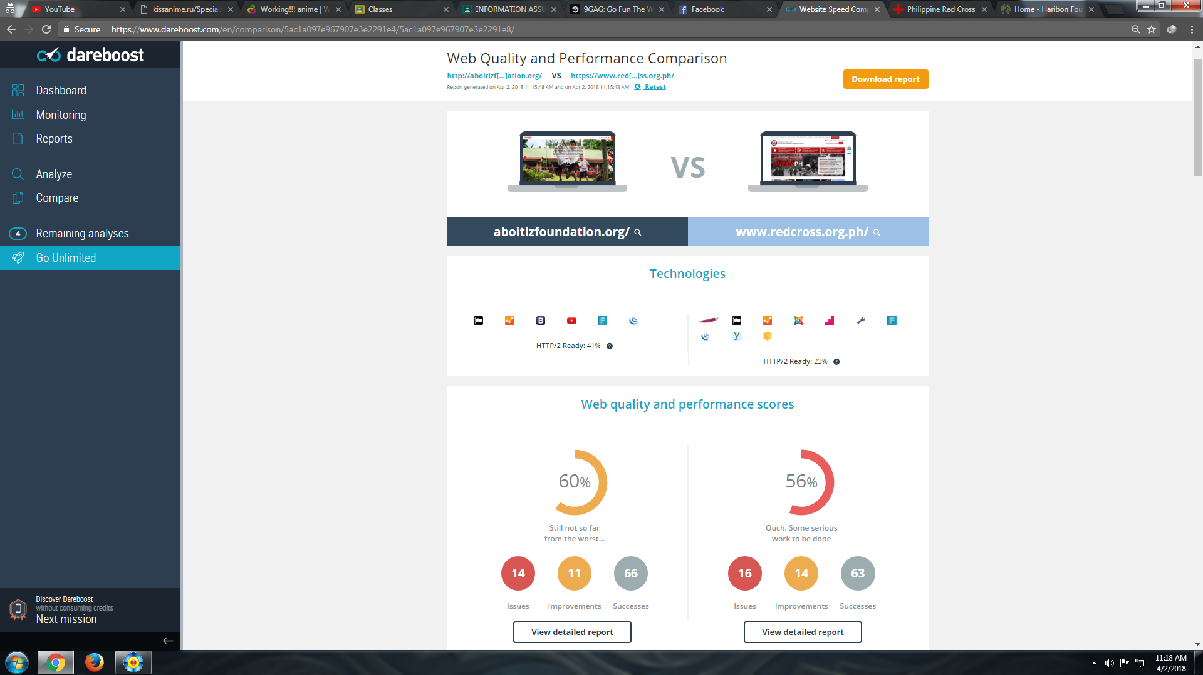

**SECURITY REPORT**

|  |  |  |
| --- | --- | --- |
| ***Aboitizfoundation.org*** | **Security** | ***redcross.org.ph*** |
| **0/100** | **HTTPS CONNECTION** | **0/100** |
| **0/100** | **Content Security** | **0/100** |
| **96/100** | **Auto Detect of Resource Types** | **0/100** |
| **100/100** | **Clickjacking attacks** | **0/100** |
| **100/100** | **XSS attack** | **0/100** |

**COMPARISON BETWEEN *Aboitizfoundation.org* VS *haribon.org.ph***

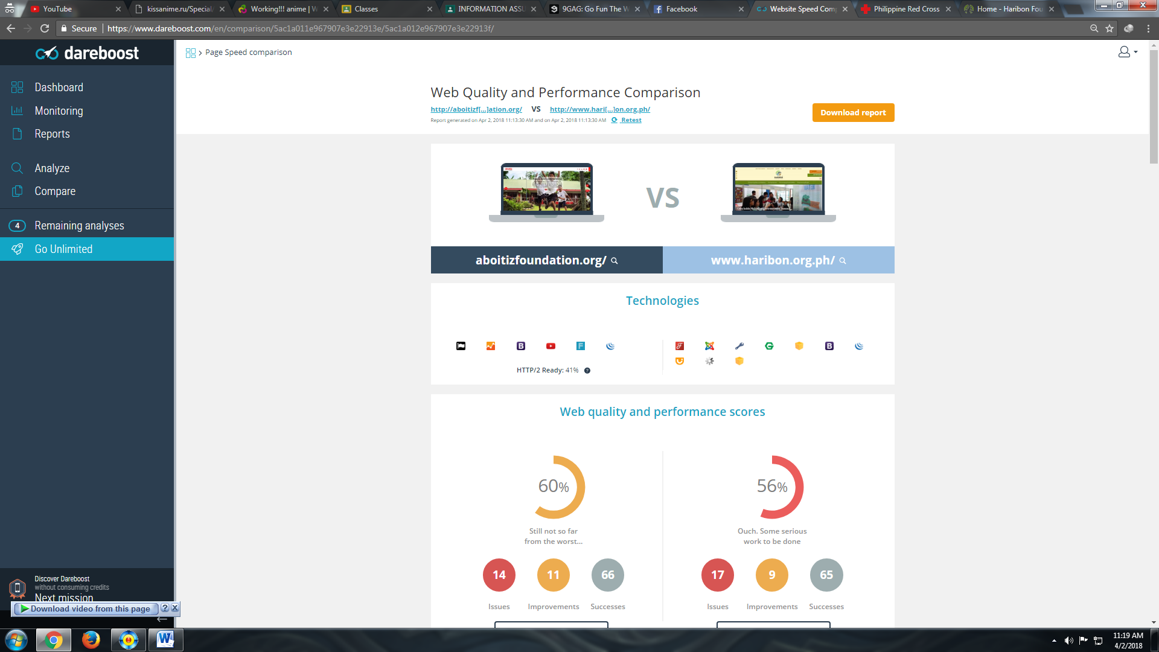

**SECURITY REPORT**

|  |  |  |
| --- | --- | --- |
| ***Aboitizfoundation.org*** | **Security** | ***haribon.org.ph*** |
| **0/100** | **HTTPS CONNECTION** | **0/100** |
| **0/100** | **Content Security** | **0/100** |
| **96/100** | **Auto Detect of Resource Types** | **0/100** |
| **100/100** | **Clickjacking attacks** | **0/100** |
| **100/100** | **XSS attack** | **0/100** |

**CONCLUSION:**

Out of all the website aboitizfoundation.org is the most secure out of all of them. Although not entirely secure especially that that neither of the three website uses https connection, aboitizfoundation.org still proved to be a a little bit secured than the rest. With that in mind and also looking at the statistics the other two website deemed unsecured especially with connections and they are also exposed to attacks.