Why Do We Have Cities?
Historically – 8000 BCE -3000 BCE
- Places of trade often built along trade routes.
- Place of military defense, on small or large scales.
- Center of political activity with access to power.
- Center of religious activity with access to priests, objects of worship.
Economically
- There are many “economies” or efficiencies that result from cities
  - Cost to produce or consume goods and services is lower
- There are knowledge spillovers in cities skills/entrepreneurial activity increases
- There are many public goods aspects to cities
  - Public goods: non-rival and non-excludable (i.e. streetlights, roads)
    - Non-Rival: One person’s use doesn’t prevent someone else’s use.
    - Non-Excludable: Just because you are not a tax-paying resident in the city, you can not prevent them from using it.
- Cities may provide many opportunities for entertainment, learning and engaging in a community increase people’s utility

Species – organisms with similar characteristics that can reproduce themselves and their offspring can reproduce.

Urban – that which is characteristic of a city, includes built infrastructure.
Habitat – natural home or environment of plant, animal, or other organisms.

Previously, walls may have defined a city, but today the boundaries are often blurred.

Megacity – a metropolitan area with 10+ million people
- Most megacities are in the global south.
- According to the UN, megacities have increased from 8 in1975 to 33 in 2025.

A megacity that housed the entire population of the world at a similar concentration to a dense city like Paris would occupy around 350,000 square kilometers or three US states.
- But if these citizens lived side-by-side in ranch houses, they would require a further 4 planets would of land to satisfy their resource demands.

Shrinking Cities – cities of which people are moving out, making its population less dense.
- Modern cities (i.e. Buffalo, Scranton, Poughkeepsie) and shrinking and global cities (i.e. New York, San Francisco)
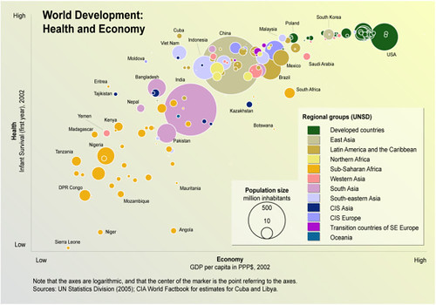

There appears to be a correlation between economics and health countries on the top left corner that have higher incomes also have high life expectancies.

A planetary boundary is a safe operating space for humans

