Metadata Assignment

27 January 2017

In this scenario, you’re working with a sample of images from the University Library’s Special Collections. Using these images and the information that’s supplied, walkthrough the metadata creation process.

In the previous module on the Lifecycle of a Digital Object, you learned how to develop a digital project or exhibit by first asking:

* What is your research question?  What's the story you're trying to tell?
* What is the purpose of the exhibit or project?

After defining your project goals and working through the initial planning stages, your next steps are to:

1. What are you describing (e.g., images, documents, mixed materials, etc.)?
2. What kind of information do you want to record? Who is your audience, now and in the future? Who is going to be using these resources and how? What kind of experience are you trying to create (e.g., a timeline, a map, etc.)?
3. What data points are necessary to support that user experience? What data points are necessary to make your resources meaningful? Create metadata your wish list; find your golden minimum based on your project goals.
4. Map desired data points to appropriate Dublin Core elements.
5. For which metadata elements do you want make use of data value standards (e.g., controlled vocabulary terms, specific encoding or formats standards, or do you want to develop your own)?
6. Using your metadata template, create descriptive metadata records for each of the images given.

For more guidance on the metadata creation process, refer to the Metadata Creation LibGuide: <http://guides.library.ucsc.edu/c.php?g=618773>

Sample Images

1. Information about the photograph: This photo was taken in 1968 by Peggy Long.

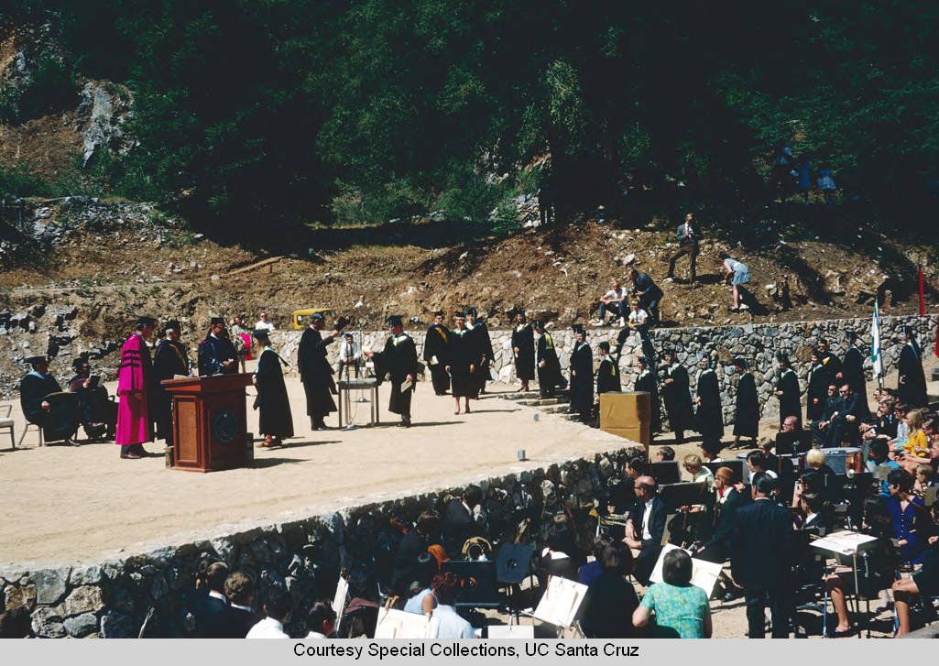

1. Information about the photograph: This photo is from the campus’ Photography Services. There is a note on the inventory that reads, “Student strike.”

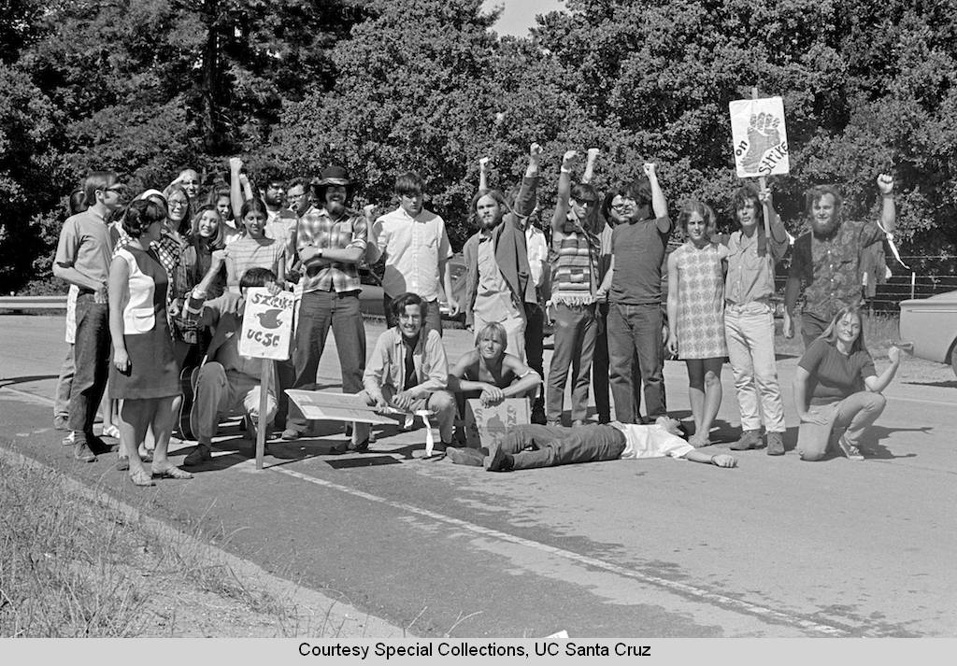

1. Information about the photograph: This photo is part of the University Library’s slide collection. It is undated.

