Joseph R. Palicke

ECE 44800

Project 1

Problem 1:

\*Note, since the bandwidth of the message in problem 1 isn’t large, the sidebands are hard to see on the PSD. Therefore, I did a separate MATLAB version where you can more clearly see the sidebands of S(f). That also contains calculations for the power, etc. This file is attached as PalickeProblem1.pdf

Problem 1 Scope Plots:

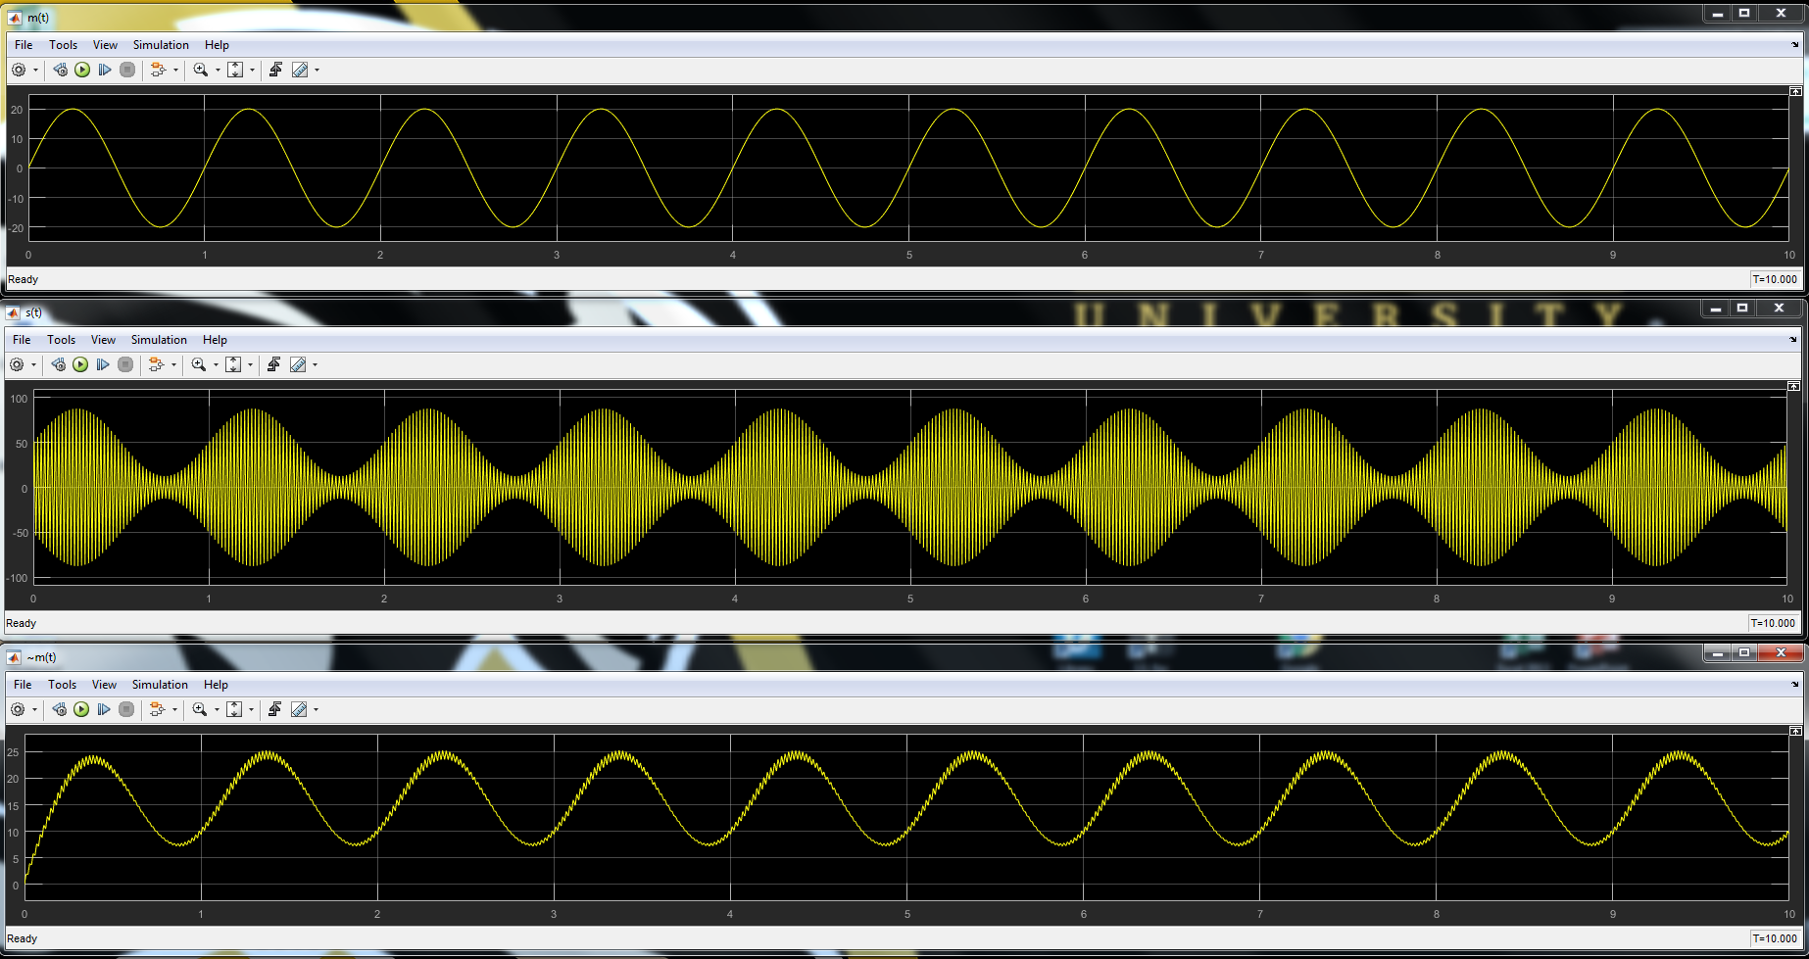

Problem 1 PSDs

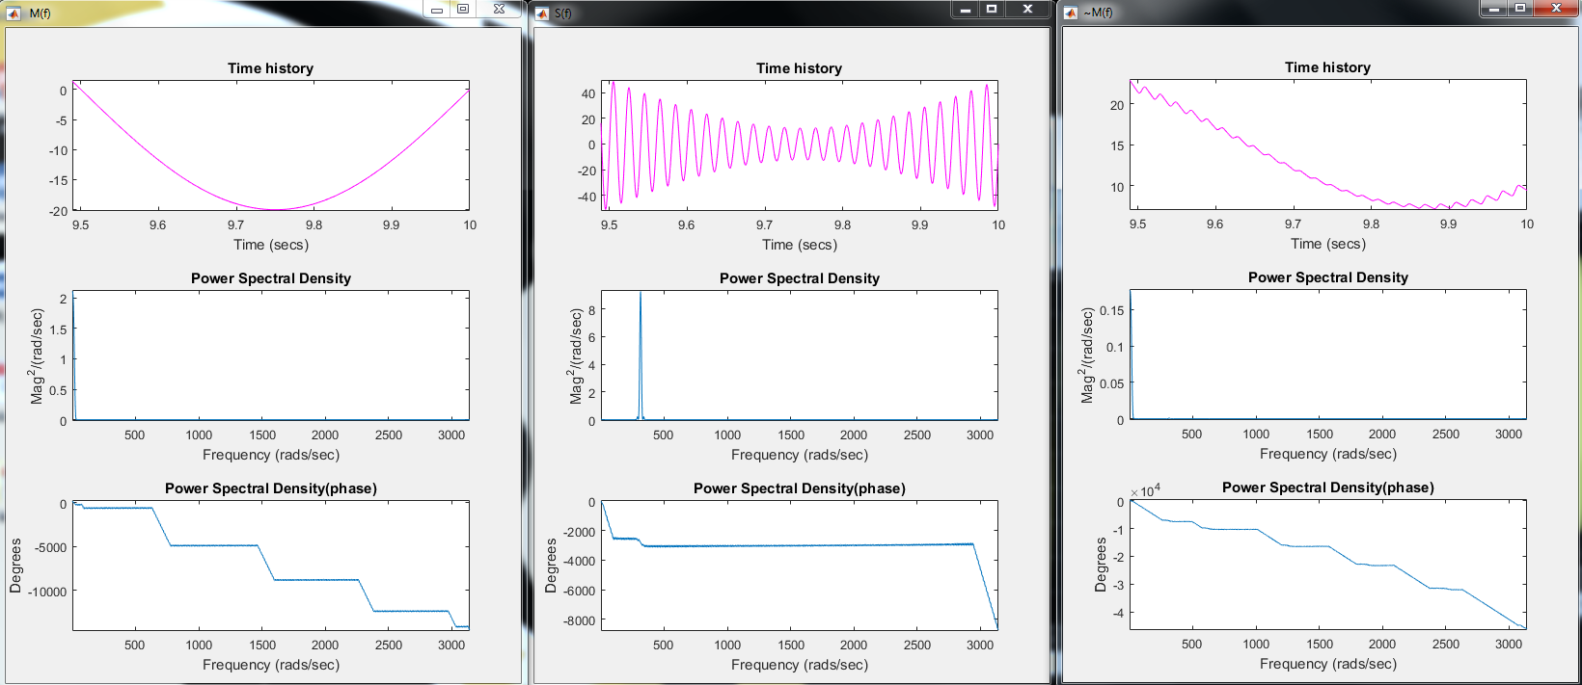

Problem 1 Block Diagram

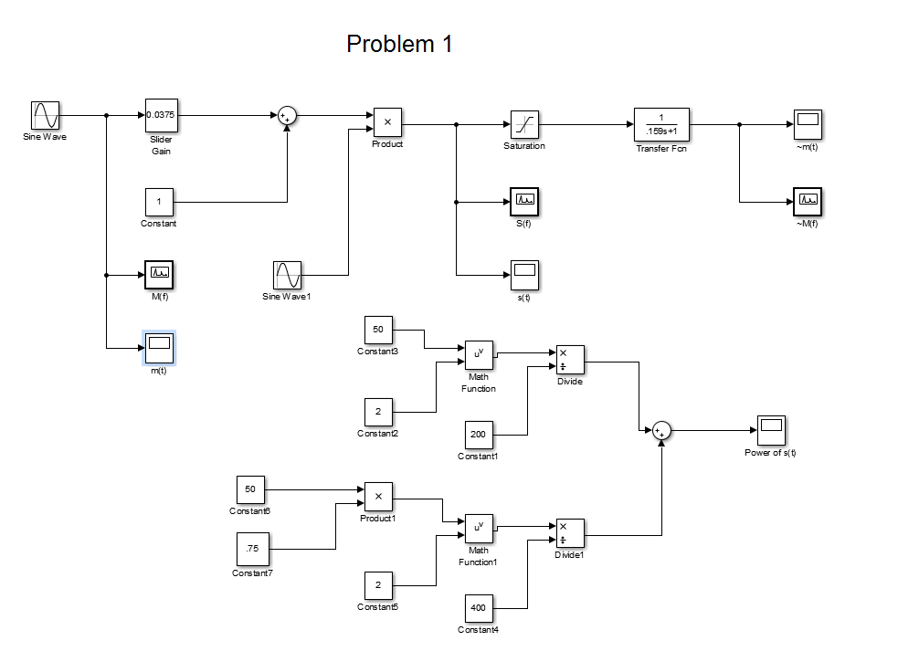

Problem 2:

1. Graph of Am = 6v, showing phase reversal and therefore, overmodulation. Any Am over 5V exhibits this behavior.

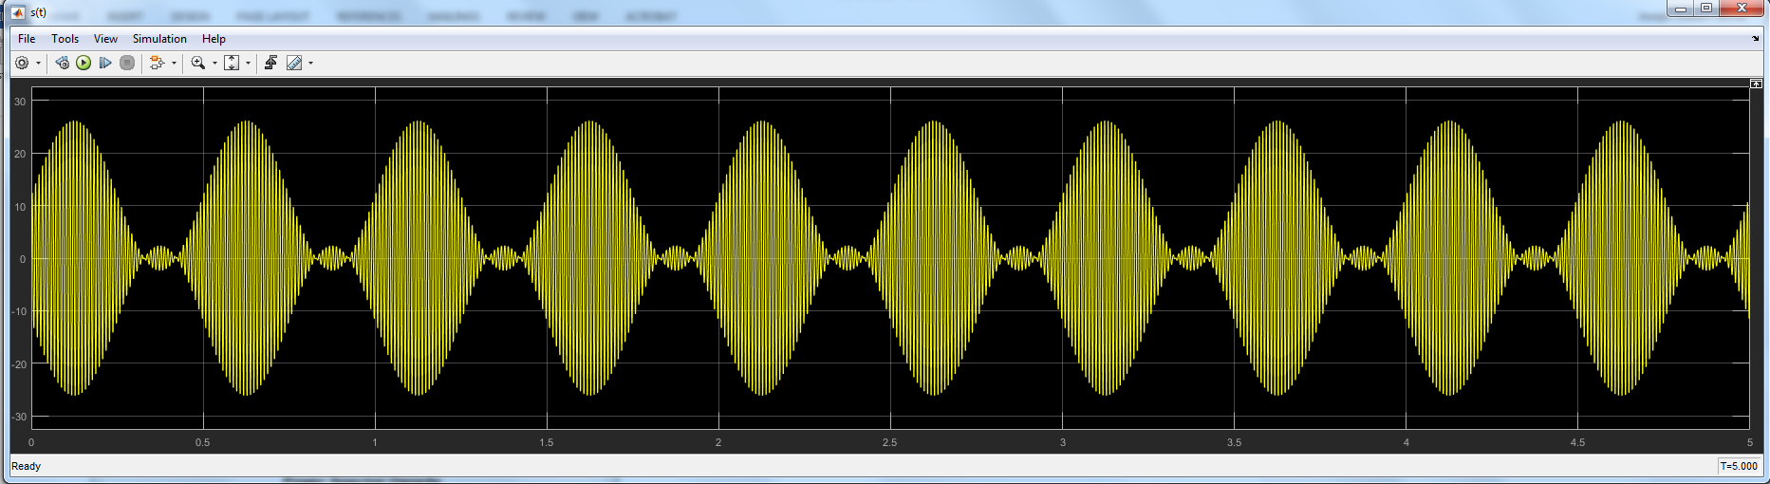

1. V2(t), S(t) and PSD figures

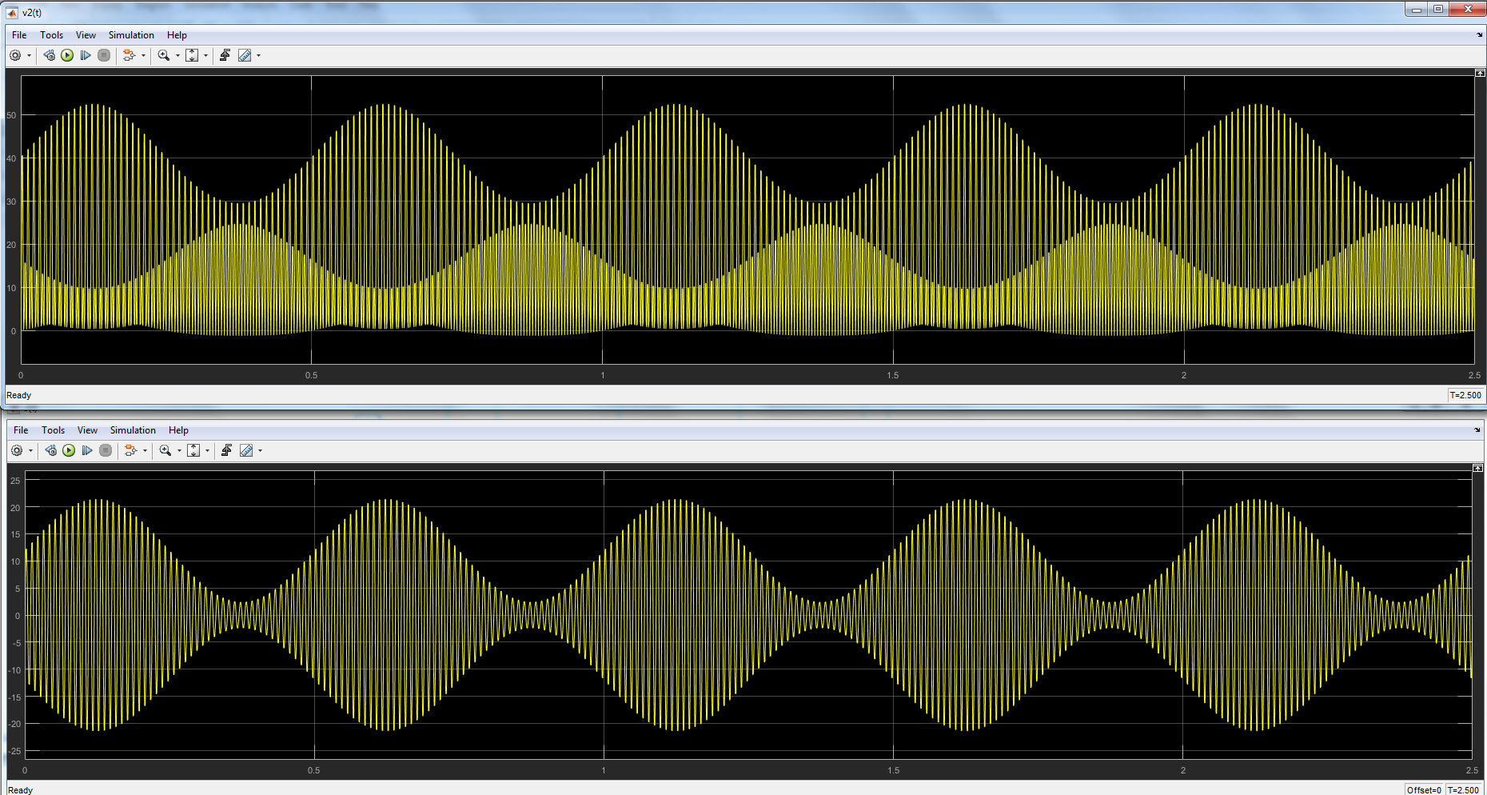

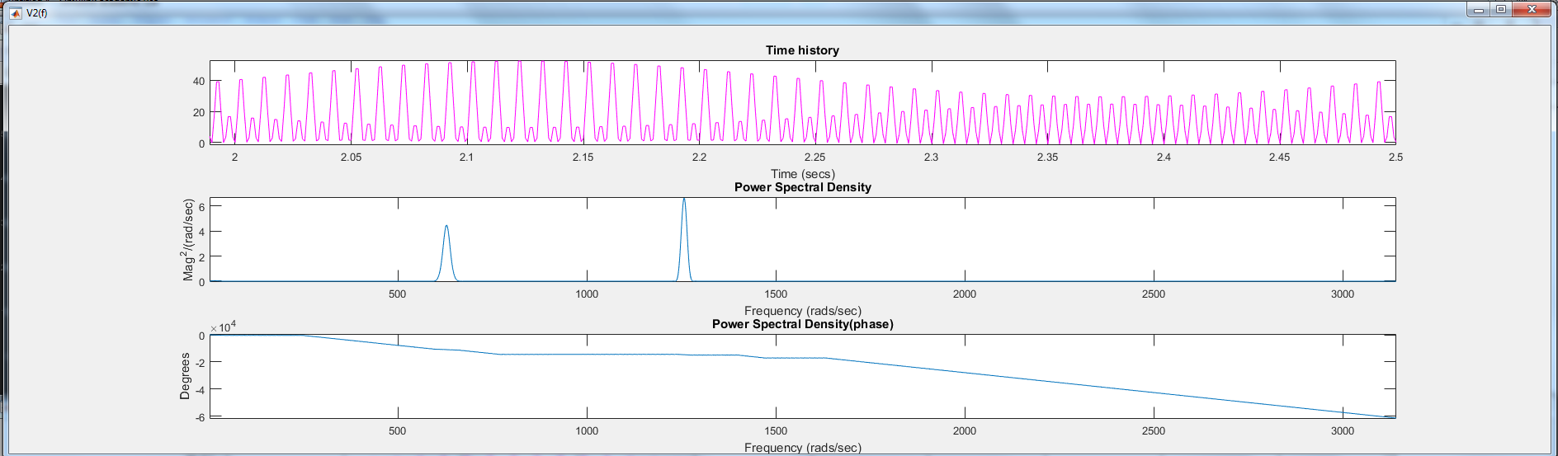

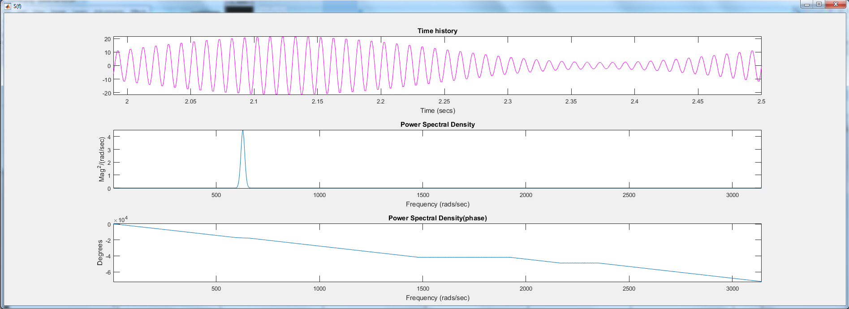

1. The center frequency of the filter should be 200 Hz, while the filter bandwidth must be greater than 2\*fm, or greater than 4 Hz. This will get rid of the 2nd harmonic in the v2(t) PSD.

The model used for Problem 2 is below

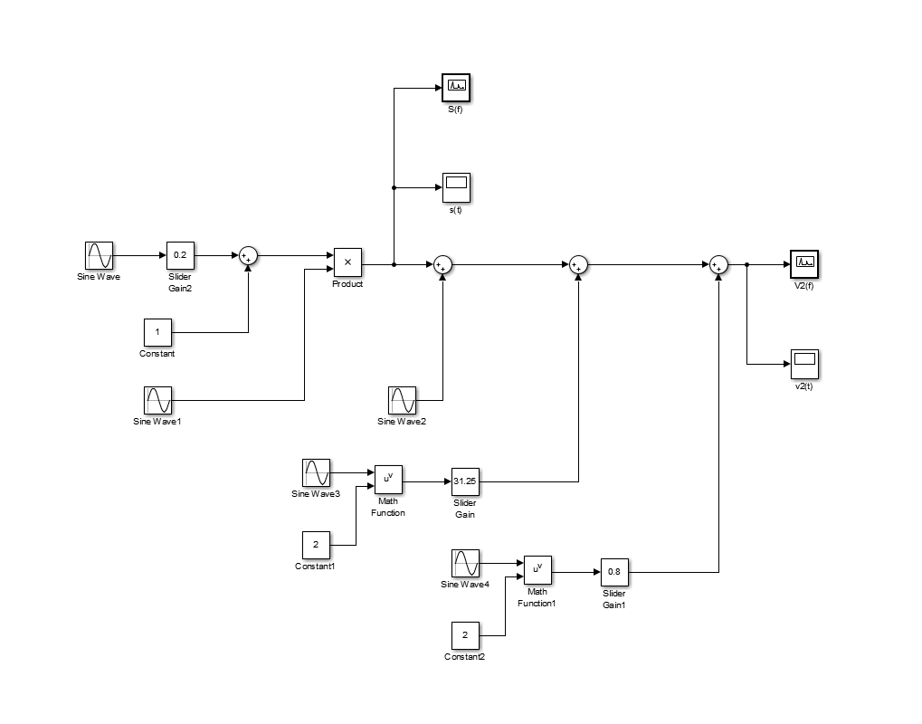

Problem 3:

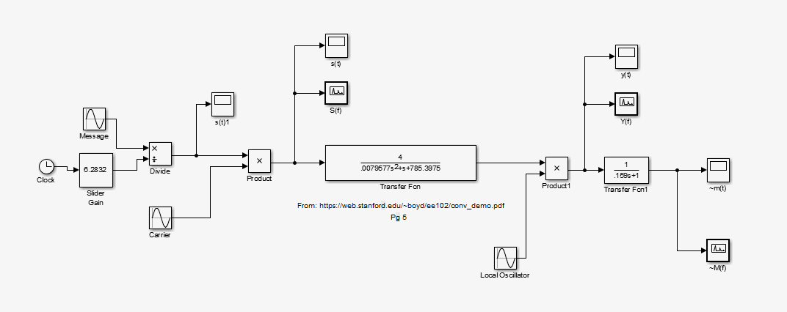

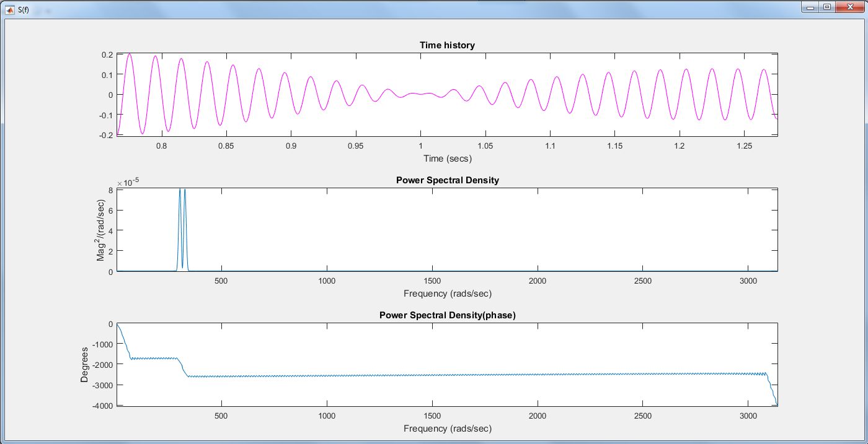

PSD Y(f) and ~M(f)

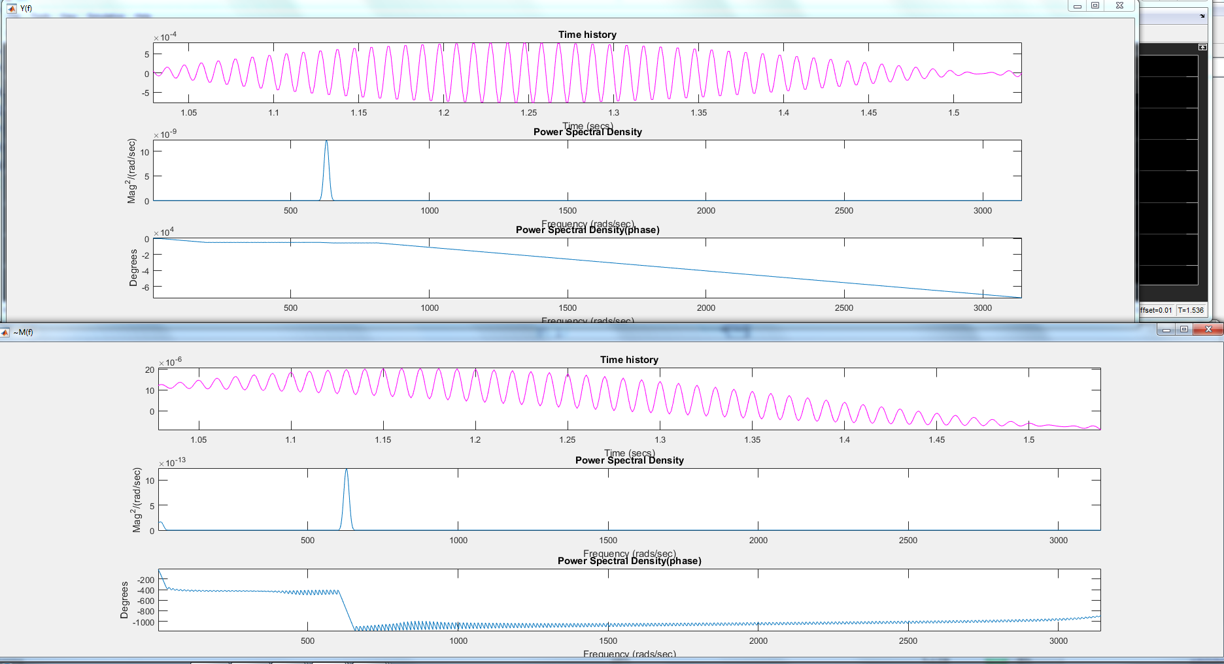

Scopes

