**LAB9**

**Jimmy Palma**

**610756**

1. **Starting with the values 1, 2, 4, 4, 5, 6, 9, 11, 12, 12, 17, do the following:**  
    **a. Create a heap H in which these values are the keys.**

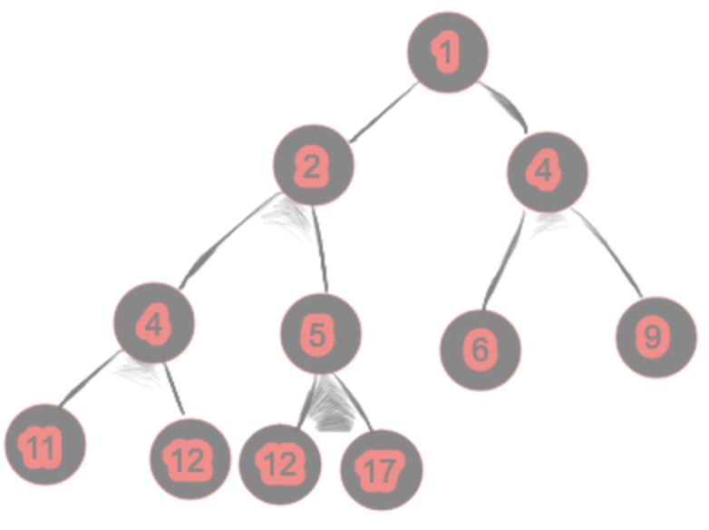

**b. Perform the insertItem algorithm to insert the value 7 into H. Show all steps.**

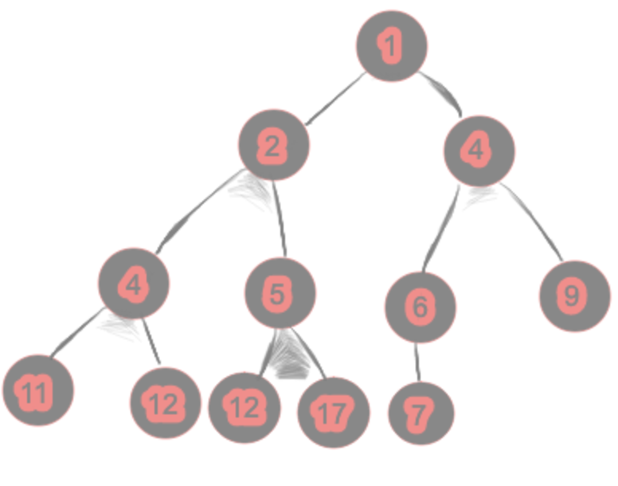

**c. Perform the removeMin algorithm on H and show all steps.**

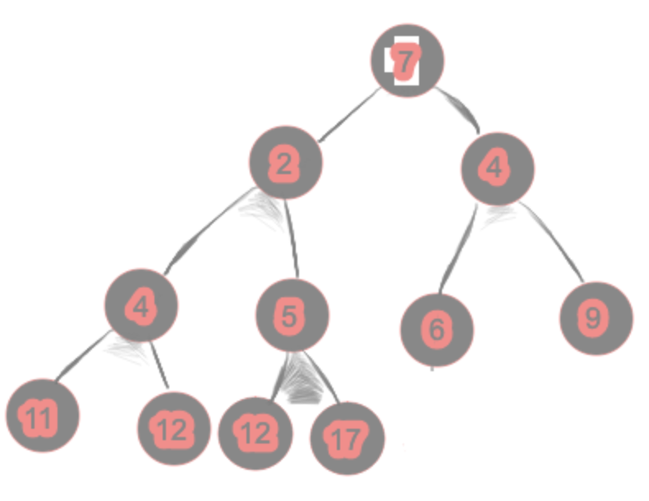

Downheap

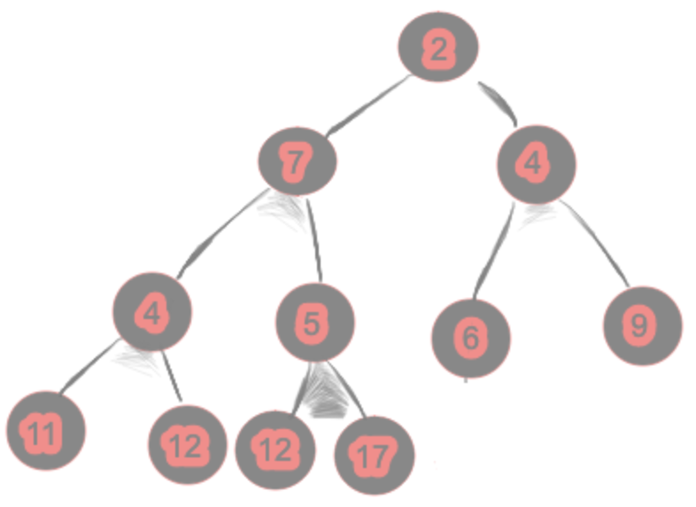

Downheap

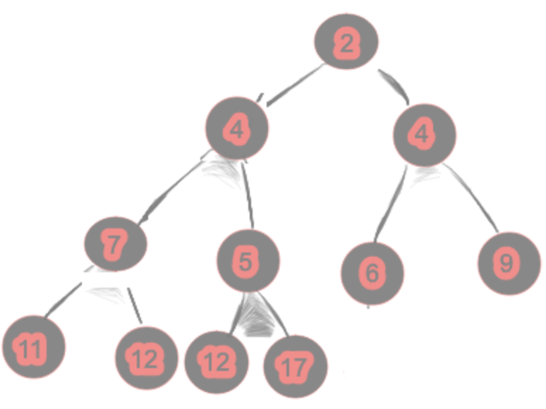

1. **Carry out the steps of the recursive algorithm BottomUpHeap for the input sequence 11, 5, 2, 3, 17, 24, 1**

BUH(11, 5, 2, 3, 17, 24, 1)

K=11 A={5, 2, 3} B={17, 24, 1}

1) BUH(5, 2, 3)

K=5 A={2} B={3}

BUH(2) = 2

BUH(3) = 3

[5, 2, 3]

Downheap

[5, 2, 3]

2) BUH(17, 24, 1)

K=17 A={24} B= {1}

BUH(24) = 24

BUH(1) = 1

[17, 24, 1]

Downheap

[24, 17, 1]

[11, 5, 11, 2, 3, 17, 1]

Downheap

[24, 5, 11, 2, 3, 17, 1]

[24, 5, 17, 2, 3, 11, 1]

1. **Draw an example of a MaxHeap whose keys are all the odd numbers lie in [1, 21] (with no repeats), such that the insertion of an item with key 14 would cause up-heap to proceed all the way up to a child of the root (replacing that child’s key with 14).**
2. 