1.-

The ***equals*** method calls used are different.  
The equals p1.equals(p2) tries to compare an instance of **PersonWithJob** to an instance of a **Person** using an equal method defined under **PersonWithJob** method. This argument fails to satisfy the condition "a **Person** is an instance of **PersonWithJob**". In the implemented code **PersonWithJob** is an instance of a **Person**, but **Person** is not an instance of of a **PersonWithJob**. The inheritance relationship is one way relations. Every **PersonWithJob** is a **Person,** but not every **Person** is a **PersonWithJob.**

3.-

A)

This not make sense to implements inheritance because between the classes Circle and Cylindre does not exist the '*IS-A'* criterion.

B)

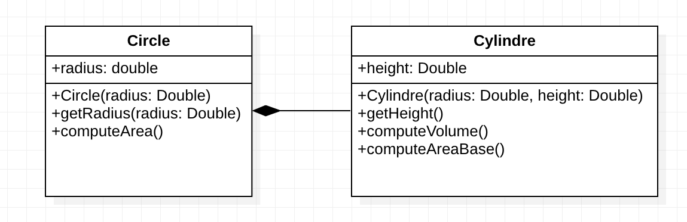

4.-

