**ADMIN FUNCTIONALITIES**

**Add Advertisements**

Admin can push Advertisements on home page to all users or targeted users.

The Advertisement fields are:

Image URL: image to show in the advertisement.

Description: Test to describe the advertisement.

Link url: Link to the advertisement page

Minimum age: users should have this age to see the advertisement.

Country: users from this area can see the advertisement.

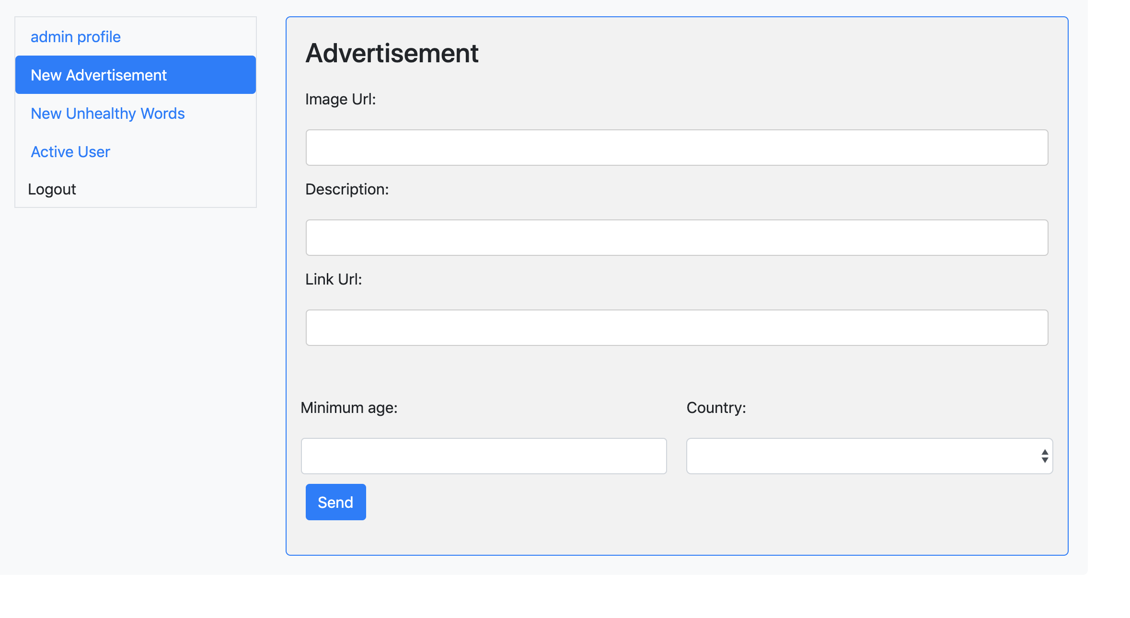

**Unhealthy Words**

Admin can add words that are considered unhealthy.

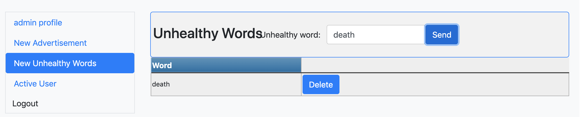

If the user has submitted 20 posts with unhealthy words, the system automatically disables the account the next time the user logs in.

**Active user**

If the user account is disabled, user can send an activation request to the admin

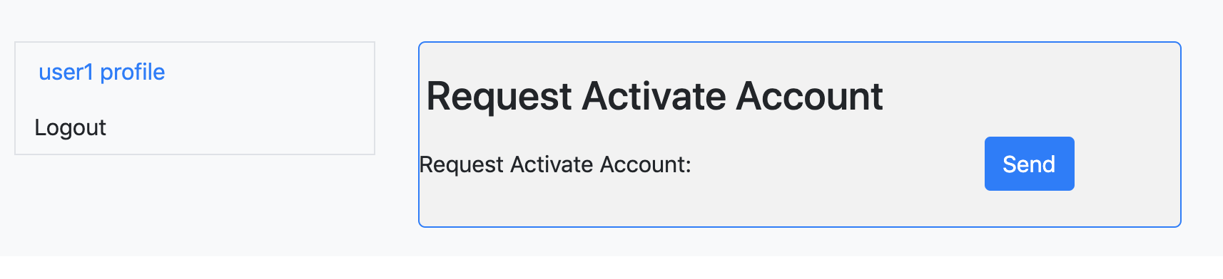

The admin can see all the activation request and decide if the account should be activate or not

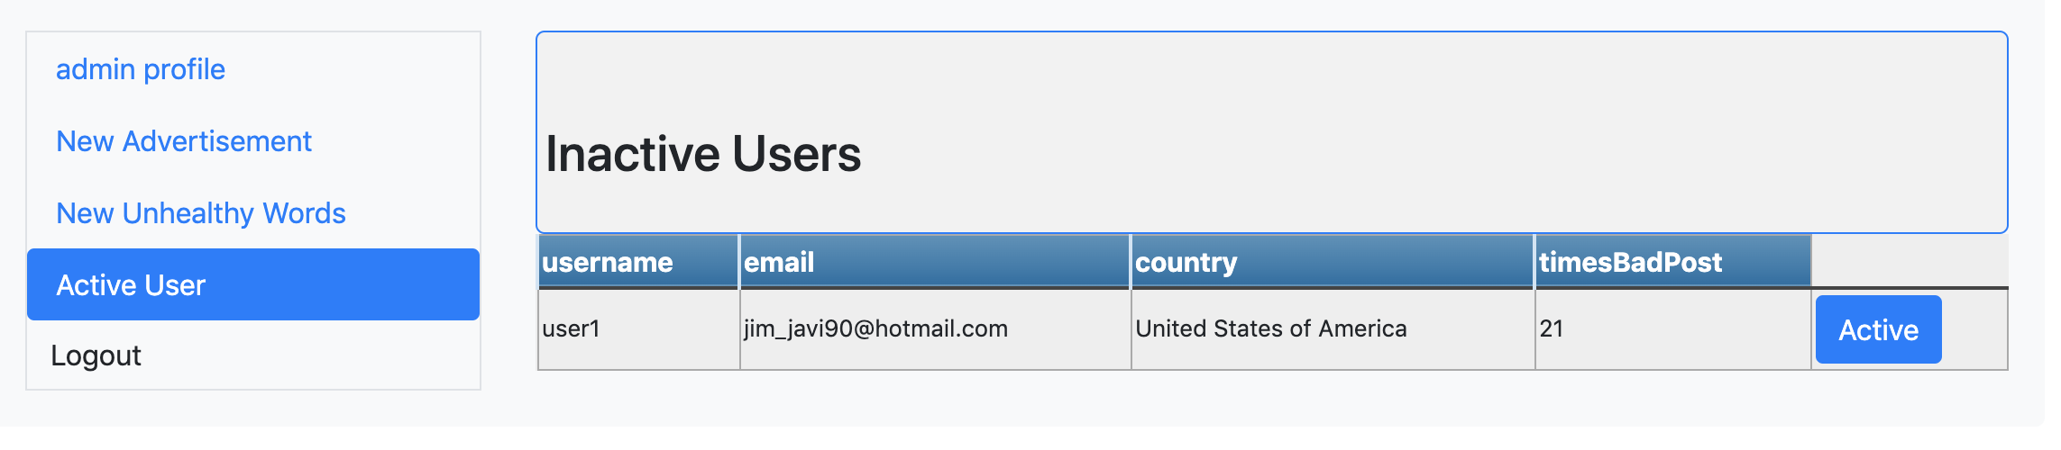

**USER FUNCTIONALITIES**

**Posts**

Users can see the latest posts from followers’ posts.

User can like/unlike, comment/uncomment on others’ posts.

Users can send posts with photos and texts.

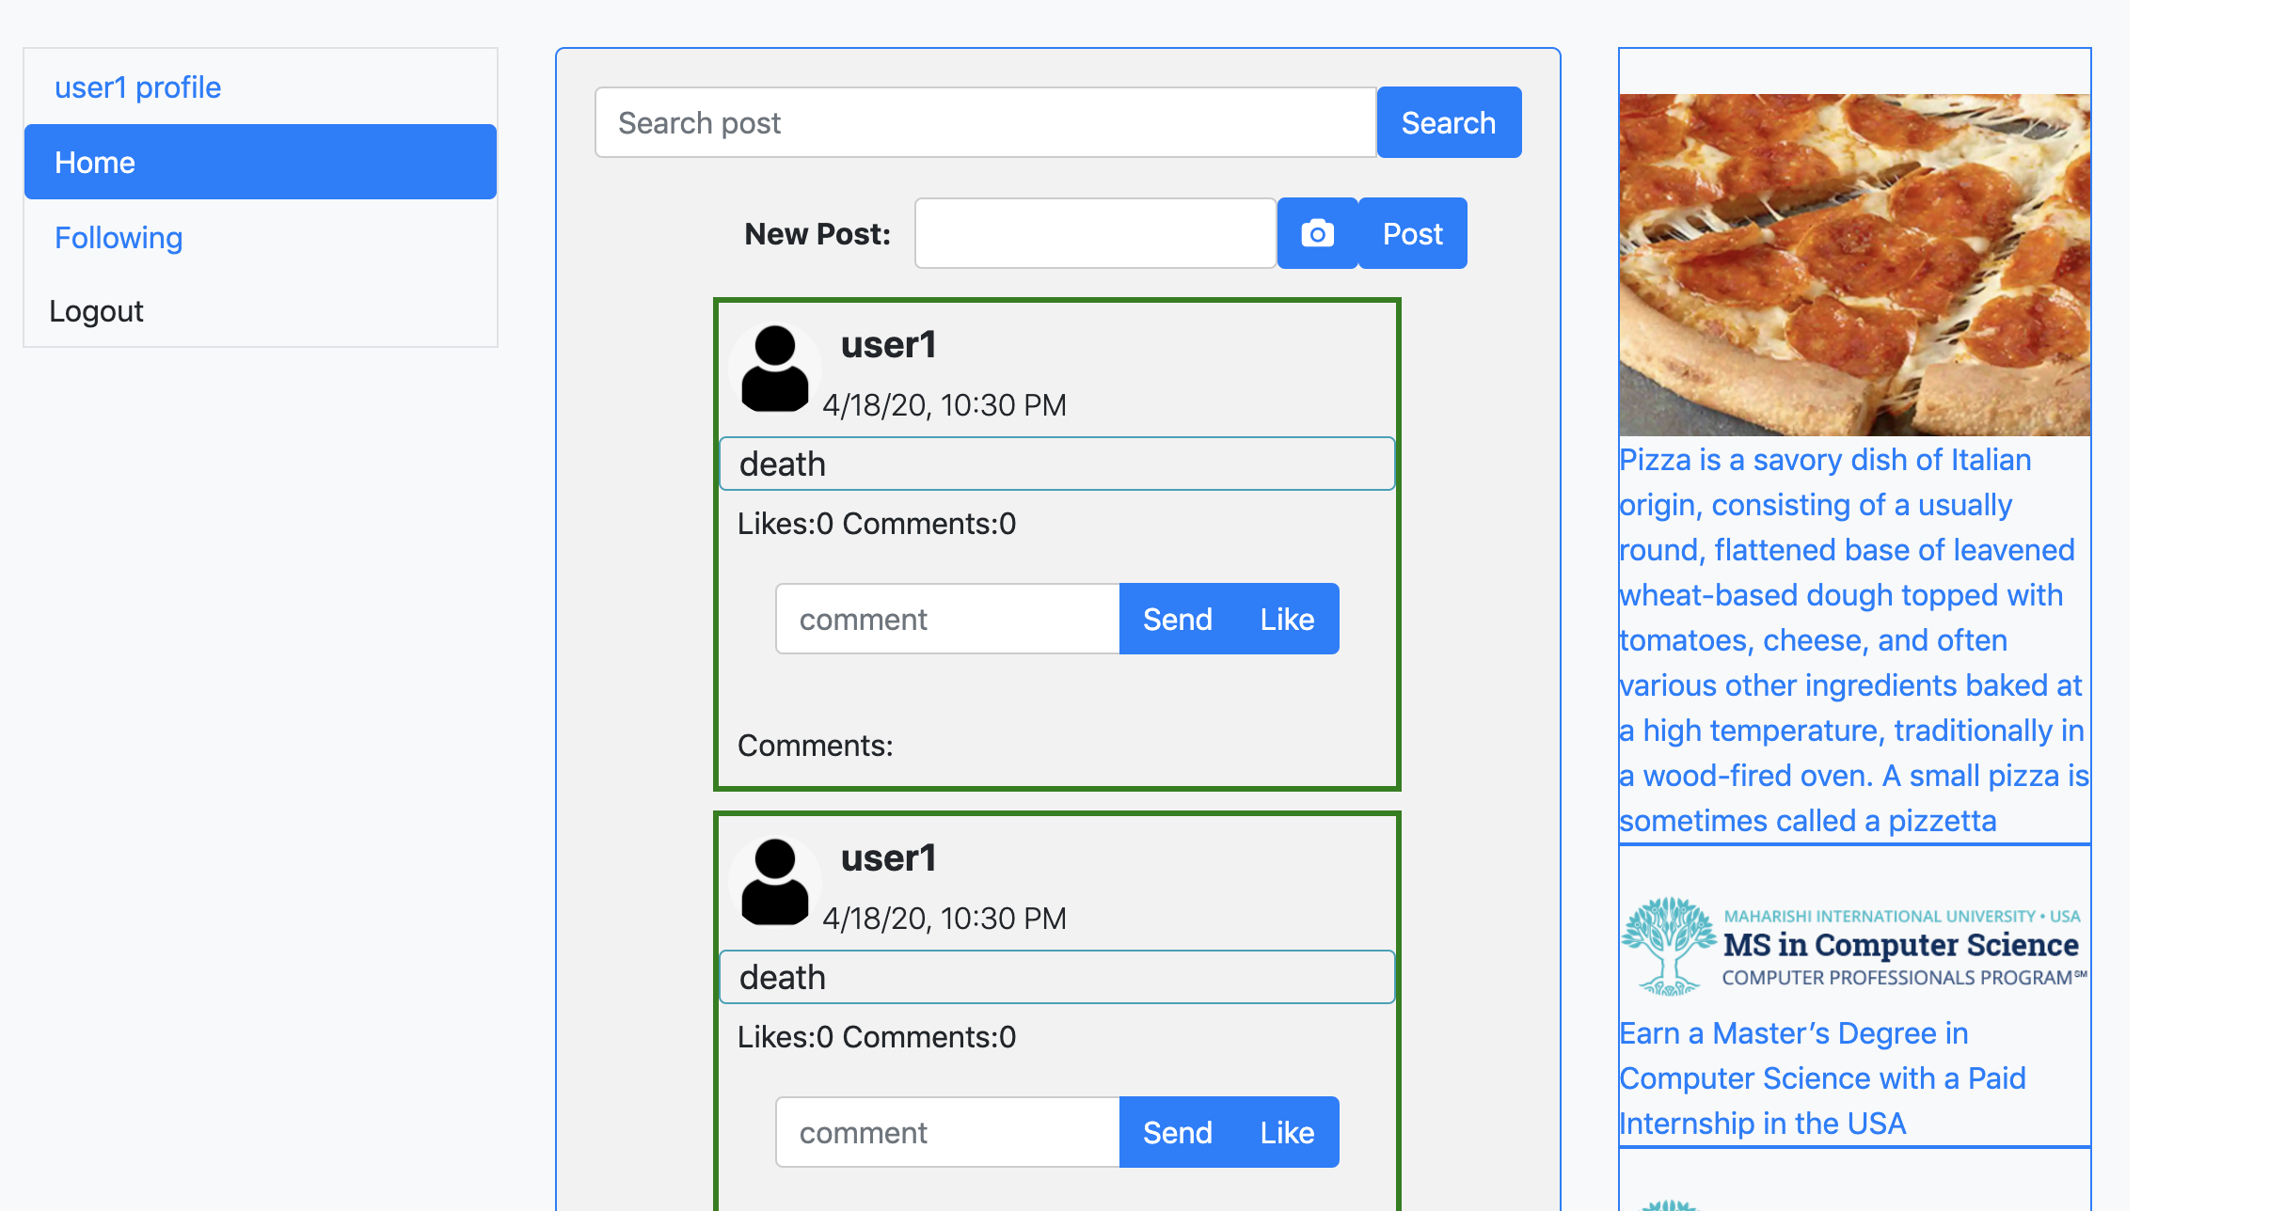

**Following**

Users can follow/subscribe other users.

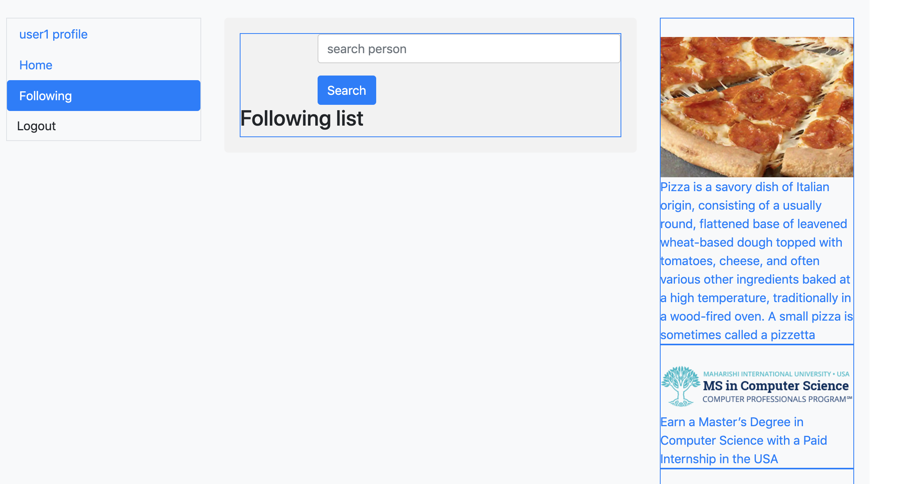

**GITHUB REPOSITORIES**

**Front-end:** <https://github.com/B-Galbadrakh/mwa-front-end>

**Back-end:** <https://github.com/B-Galbadrakh/mwa-back-end>

**LIST EACH MEMBER'S TASKS**

**Jimmy Palma**

* New Advertisement (admin)
* Advertisement (user)
* New unhealthy words (admin)
* Disabled user account (user)
* Request activation (user)
* Activate user (admin)

**Galbadrakh Battur**

* Login / Logout of regular and admin user. jwt token implemented and token is being sent in every request. In back-end middleware is checking whether token is applied or not
* Fundamentals of the web application initial screens and functionalities
* Post list /news feed/ like page, show posts that are the owner and followers made.
* Post list section shows last 10 posts and if user scrolls down it will show the further posts /infinite scroll is implemented/
* User details section user can update their image of a profile.
* On post user and followers can write a comment and like and unlike
* User can post image with description.
* Comment and like counts are visible to users
* On news feed section use can search for a post of followers and his or her post
* Followers menu: user can search for a user and follow.
* As soon as user presses follow button it will turn to unfollow button for unfollow functionality
* Register new user
* Deployment of the application

User details section as follows image uploaded:

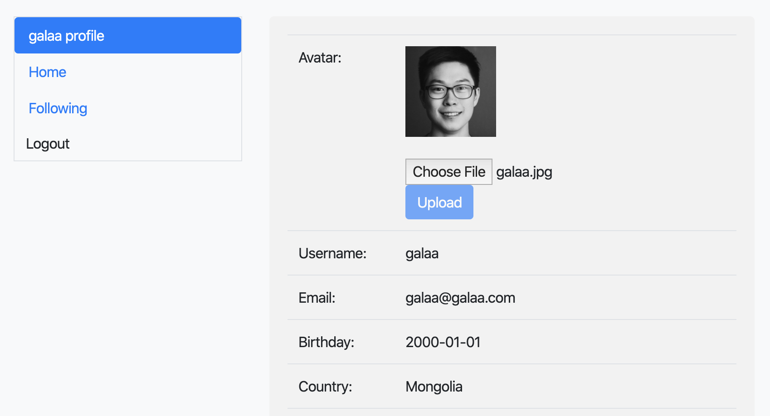

Post section seeing own and followers post

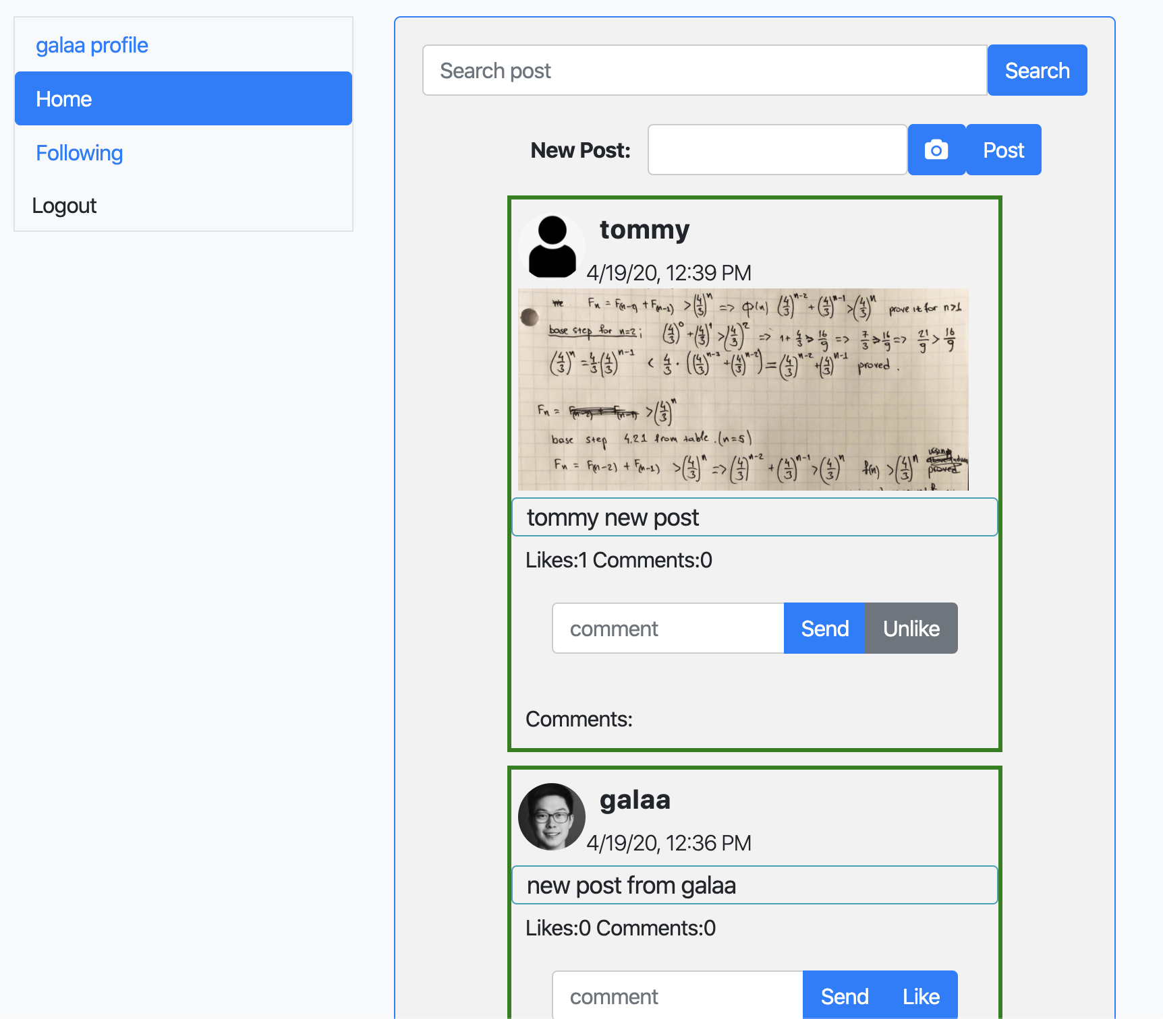

Following section, current followers and search result shown below:

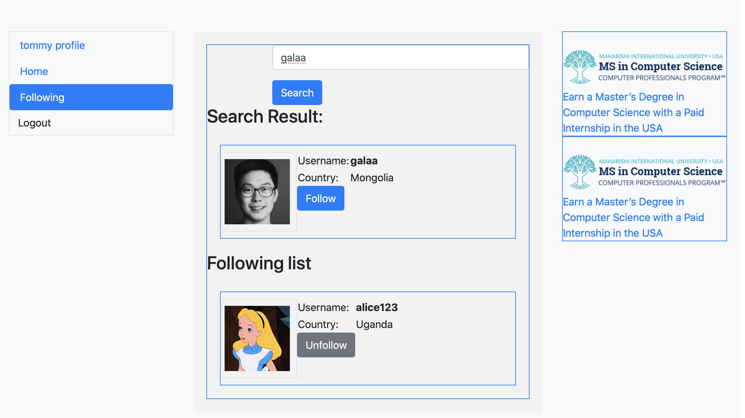

From this tommy user can follow “galaa” directly from search result

Comment section is shown below

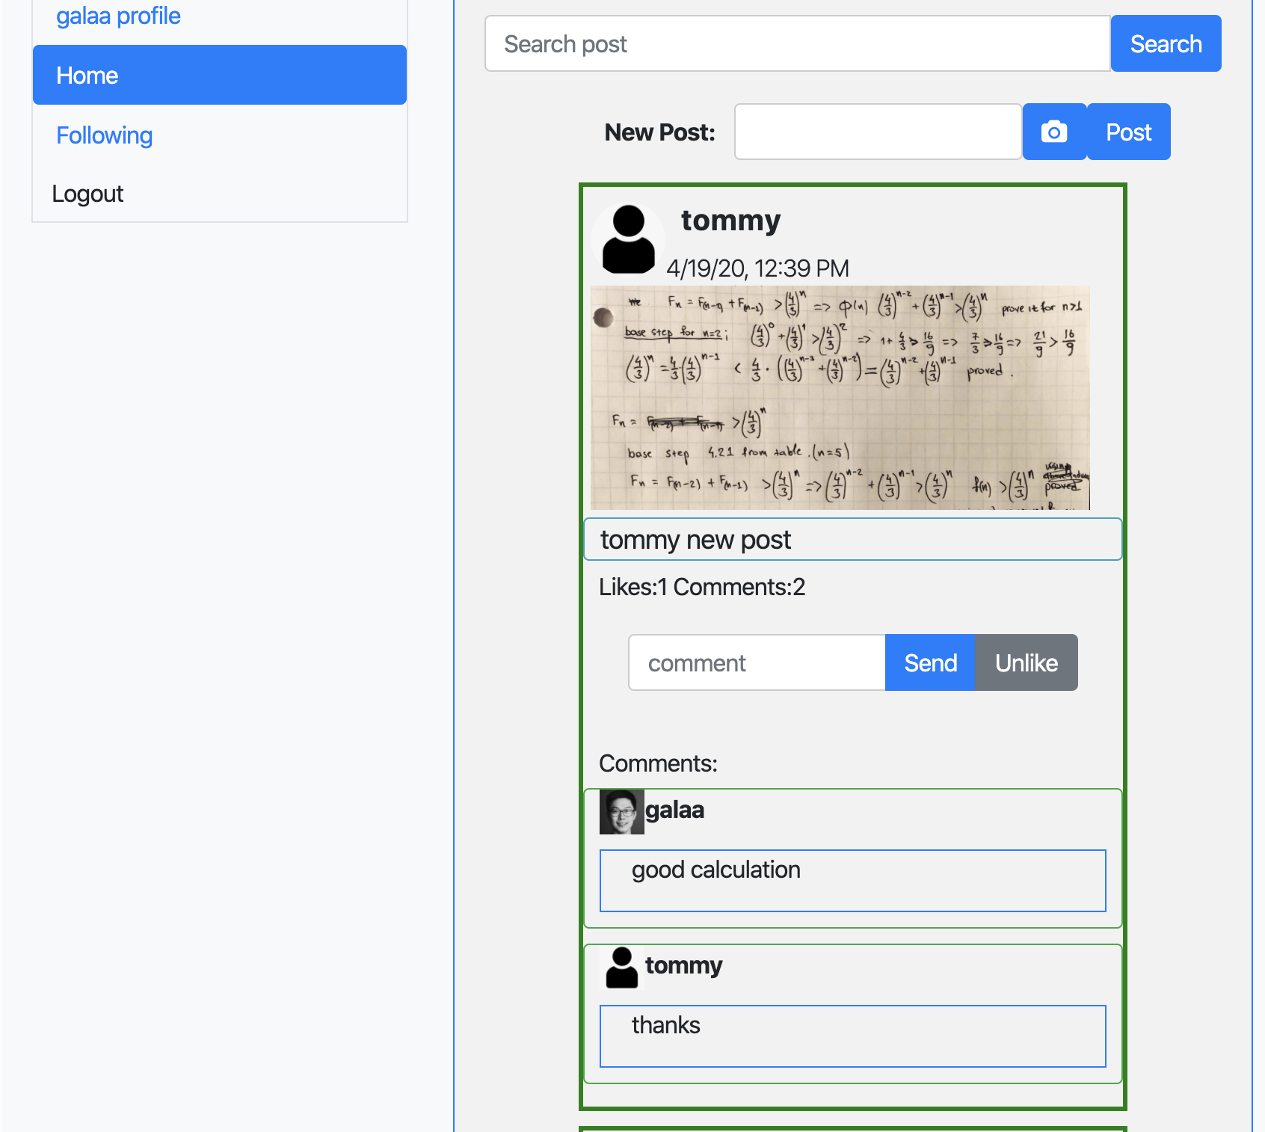

**Conclusion:**

Web application works as expected, it has been deployed in heroku service. The outcome of this lesson and projec was huge. All the understanding of angular and REST NodeJS Express MongoDB’s are covered and makes the web application to work. Also understood how to implement third party libraries from npmjs.com. Also understanding of deployment played huge role in in this project. From the lectures and videos that provided was really useful to make this project and really helped us the acquire knowledge about modern web application development and deployment.

**LIVE URL TO VIEW PROJECT ONLINE**

<https://wishlistapp-mwa.herokuapp.com/>

**USERS**

* Username: admin

Password: admin

* Username: user1

Password: user