**For each of the following software qualities, describe 2 to 5 examples that you know that will increase this particular quality.**

▪ **Performance**

Implementing design patters in development software

Improve algorithms to increase work speed

▪ **Scalability**

Work with new technologies like Microservices (divide the project in small components) and publish them in services like AWS or Kubernates

Stateless Systems

▪ **Availability**

Load balancing, services like Docker and Kubernates implement LB by default

In microservices, work with technologies like hystrix, this implements circuit breaker pattern

▪ **Maintainability**

Work with Test Drive development

Work with technology like Jenkings

▪ **Reliability**

Microservices work with actuator.

Failover

Context Diagram

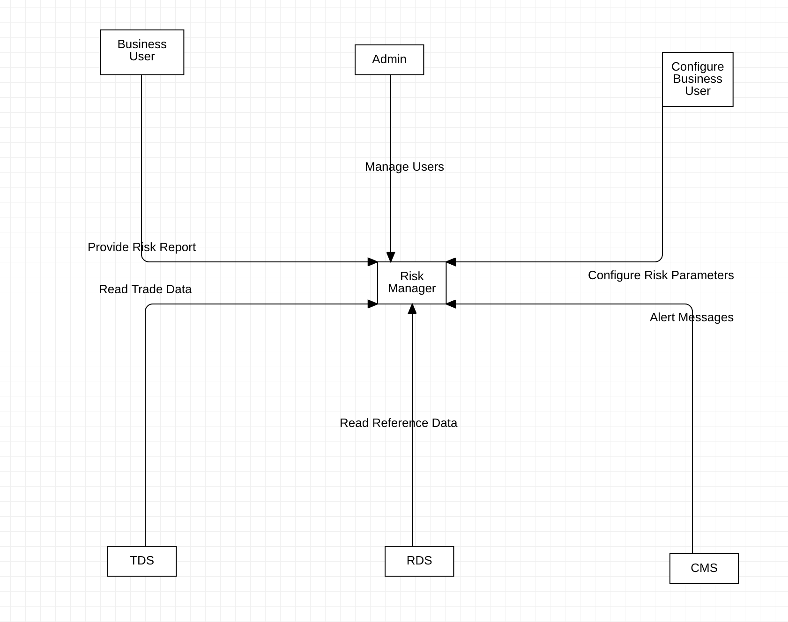

Container Diagram

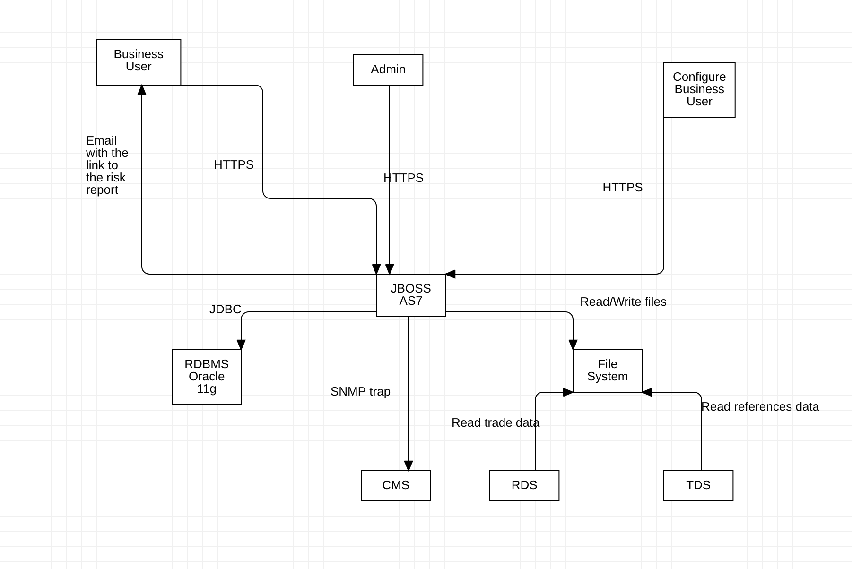

Component Diagram

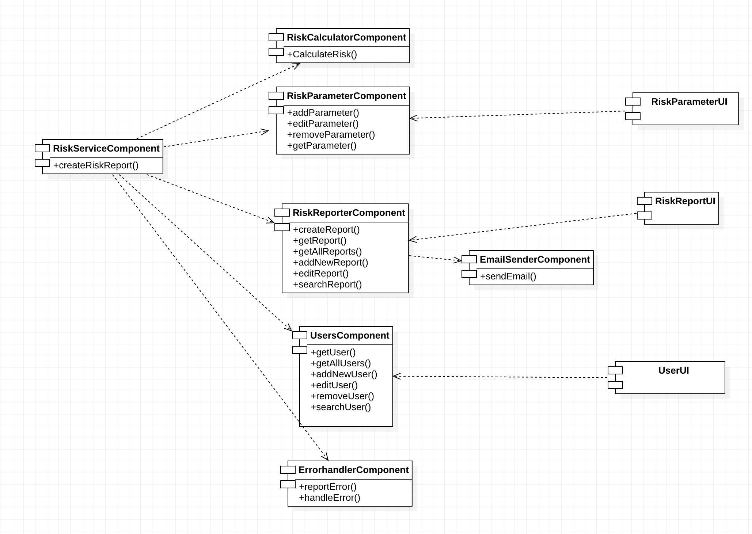

Sequence Diagram

