Exercise 1

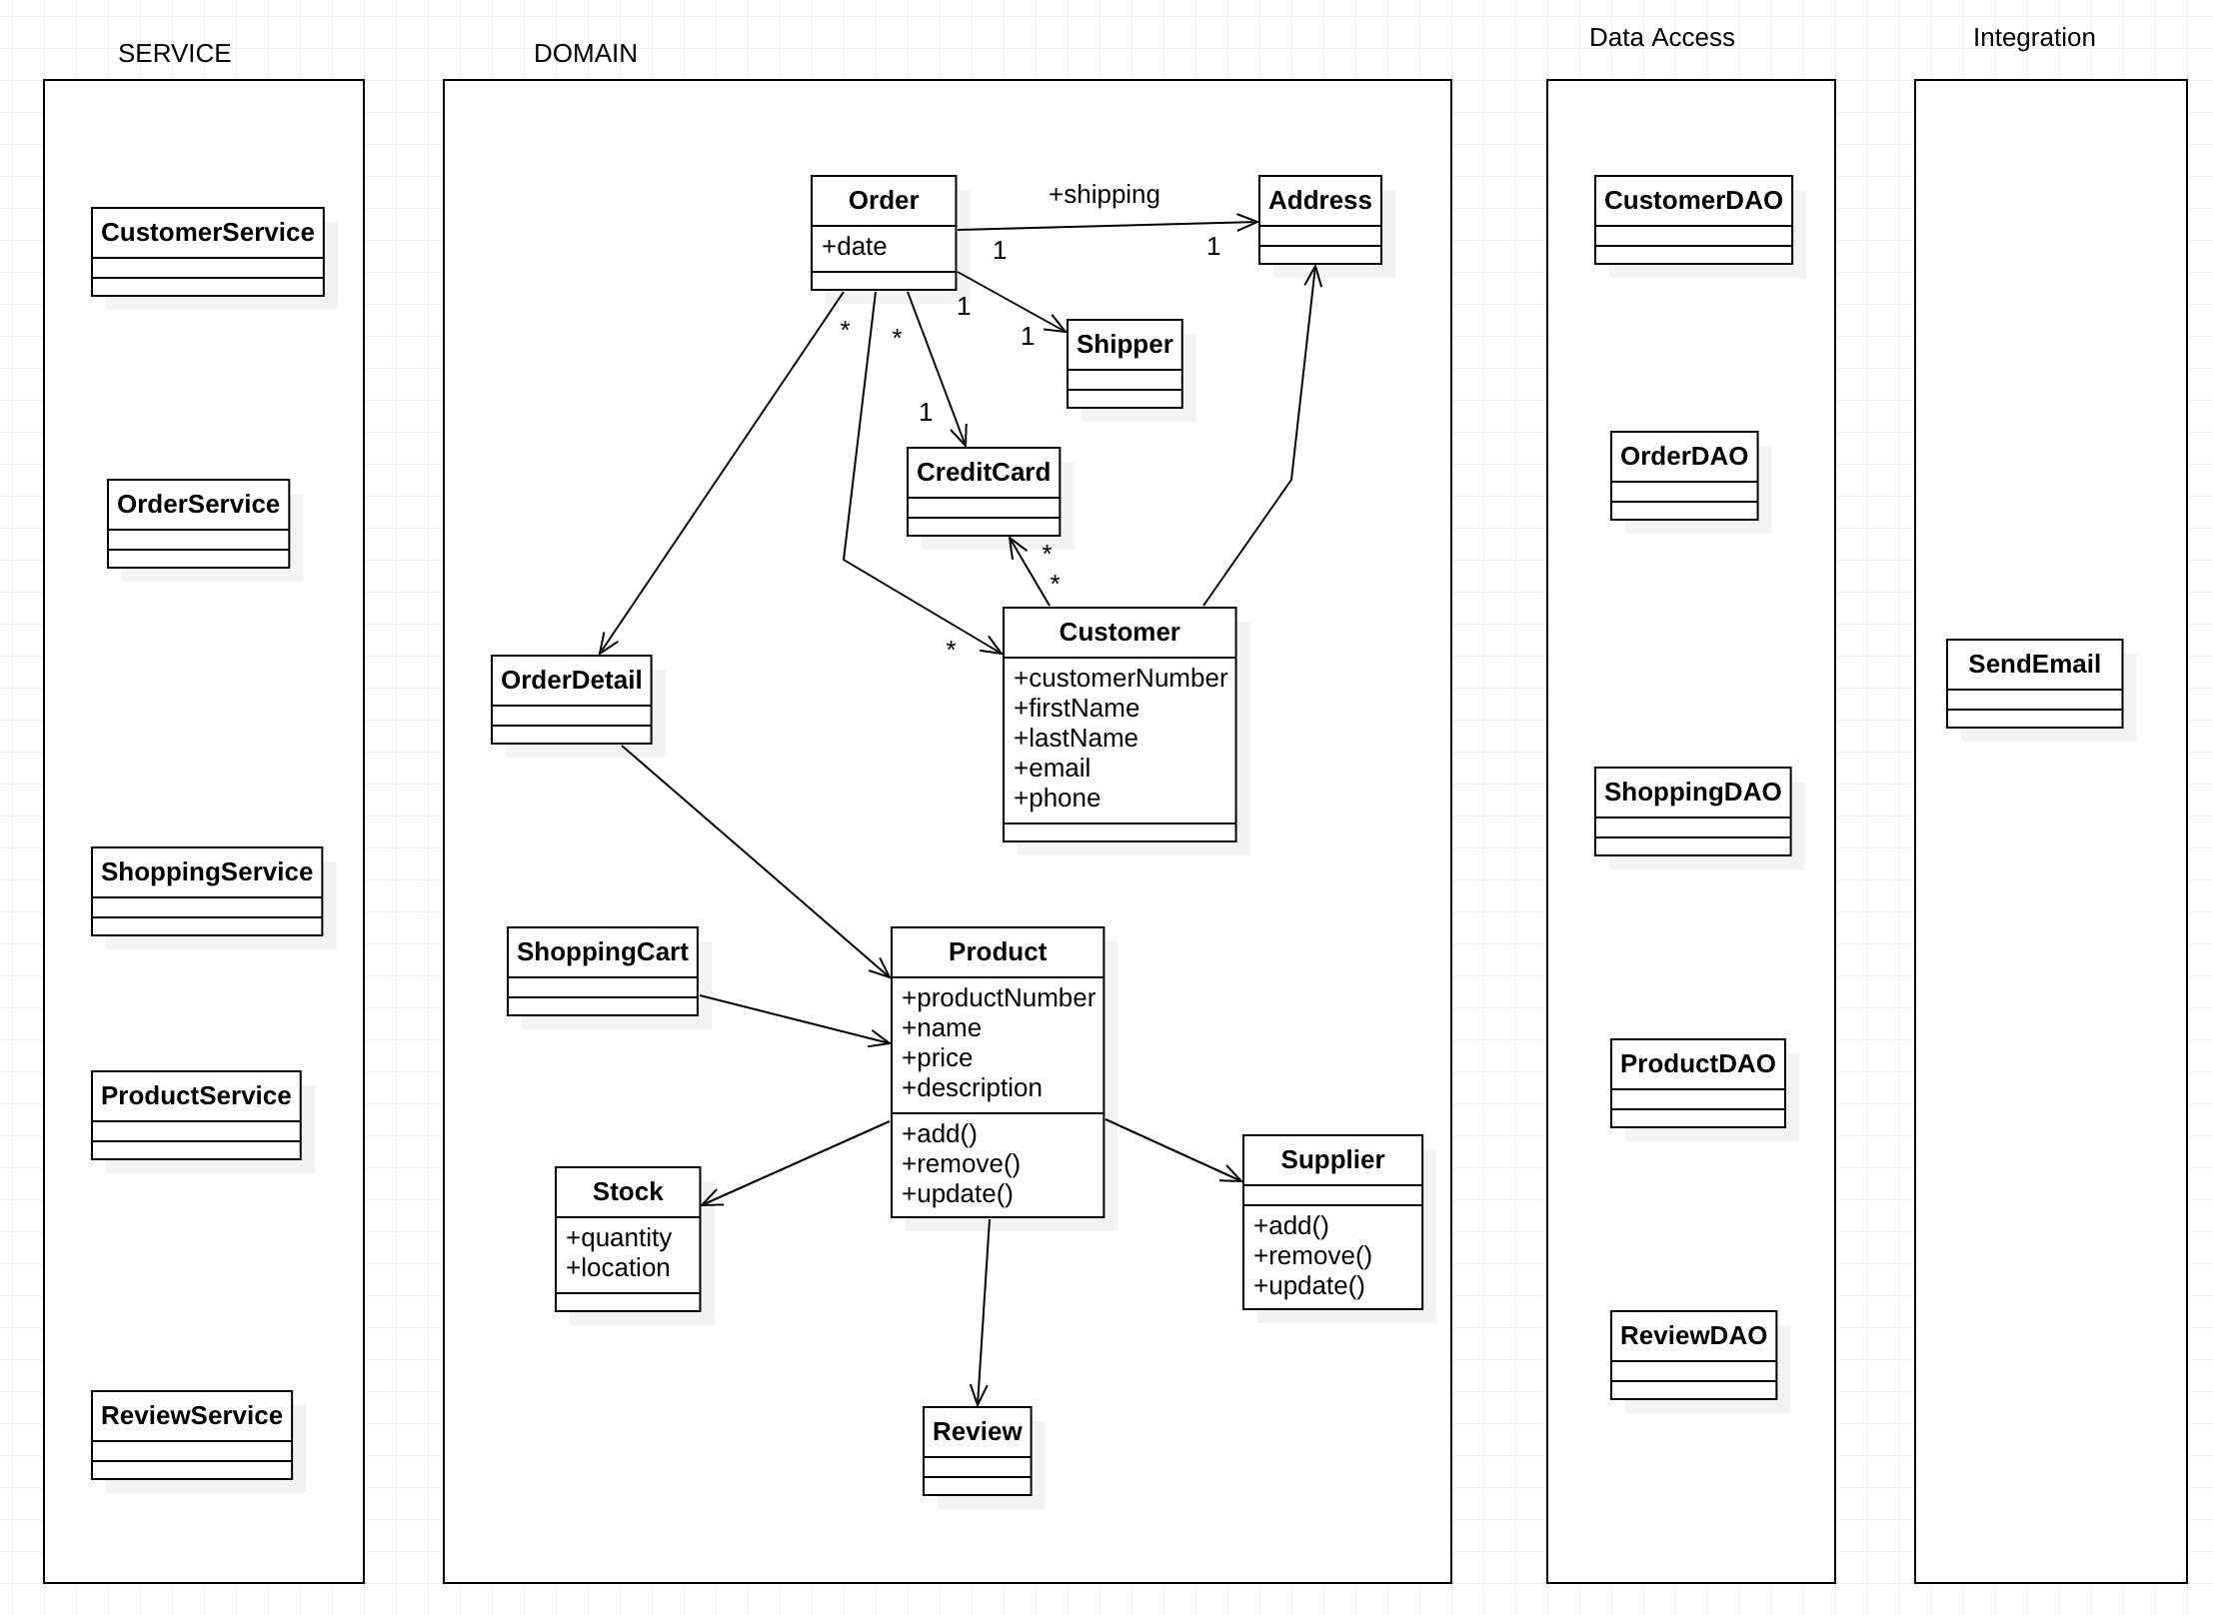

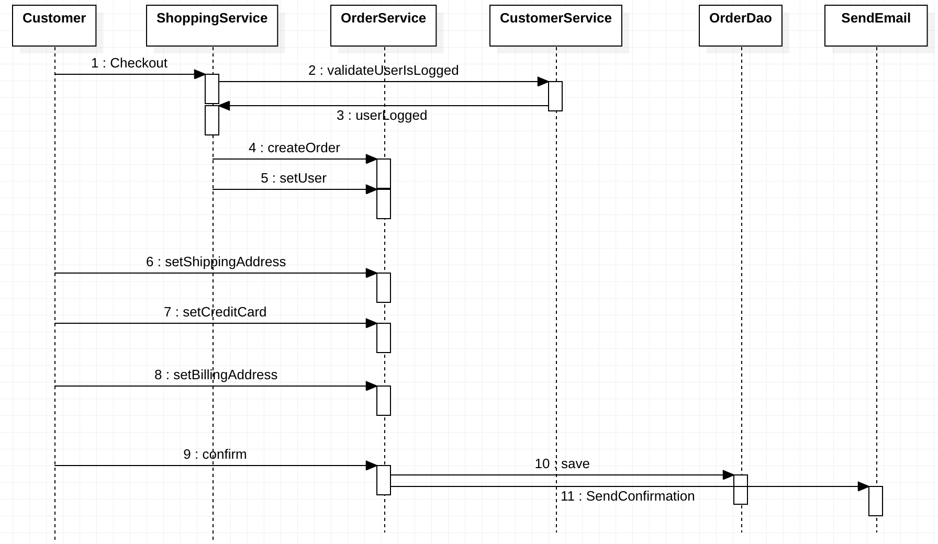

Exercise 2

|  |  |  |  |
| --- | --- | --- | --- |
|  |  | Advantages | Disavantages |
| Front-End | Mobile (Android, iOS) | Faster, Scalable | volatile |
| Browser |
| Back-End | Server | easy to share in modules | less scalable |
| Database | long time persistence | Low performance |

Exercise 3

|  |  |  |  |
| --- | --- | --- | --- |
| **Integration possibility** | **Advantage** | **Disadvantage** | **When to apply** |
| RMI |  | Only works in JAVA | Just for development and test |
| JMS | Asynchronous | Need middleware | Applications between same company |
| SOAP | Secure | Only works with XML | When need security and standard |
| REST | Many languages, XML, JSON | Less security | Everywhere |
| Serialized objects over HTTP | Simple | Only works in JAVA | Applications managed by the same project |
| Database Integration | Simple | Low performance | Never |
| File Based Integration |  | Low performance | Only to send documents |
|  |  |  |  |
|  |  |  |  |