Javascript Module Exercises

**1. Determine what this Javascript code will print out (without running it):**

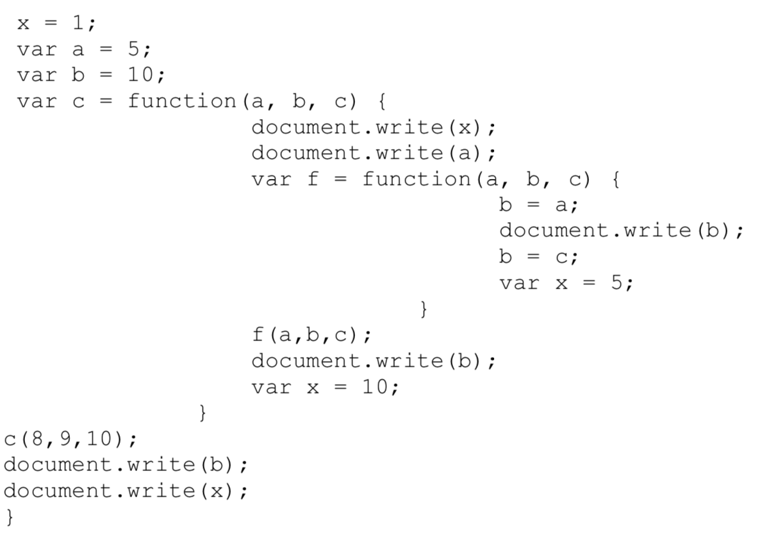

1 8 8 9 10 1

**2. Define *Global Scope* and *Local Scope* in Javascript.**

Any variable declared outside of a function belongs to the global scope, and is therefore accessible from anywhere in your code. Each function has its own scope, and any variable declared within that function is only accessible from that function and any nested functions.

**3. Consider the following structure of Javascript code:**

**// Scope A**

**function XFunc () {**

**// Scope B**

**function YFunc () {**

**// Scope C**

**};**

**};**

**A)**  **Do statements in Scope A have access to variables defined in Scope B and C?**

false

**B)**  **Do statements in Scope B have access to variables defined in Scope A?**

true

**C)**  **Do statements in Scope B have access to variables defined in Scope C?**

false

**D)**  **Do statements in Scope C have access to variables defined in Scope A?**

true

**E)**  **Do statements in Scope C have access to variables defined in Scope B?**

true

**4. What will be printed by the following (answer without running it)?**

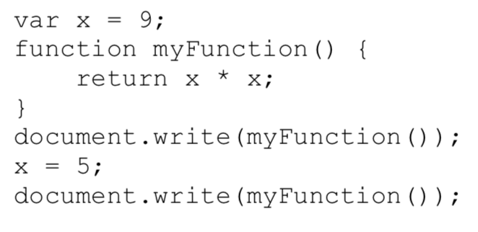

81 25

**5. What will the *alert* print out? (Answer without running the code. Remember ‘hoisting’.)?**

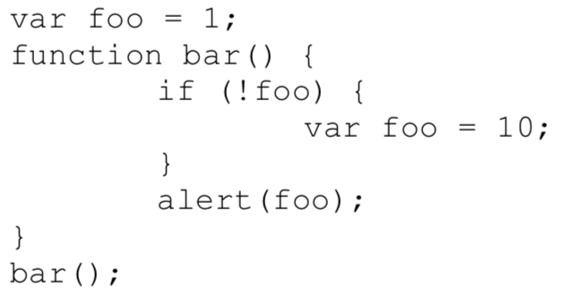

1

**6. Consider the following definition of an *add*( ) function to increment a *counter* variable:**

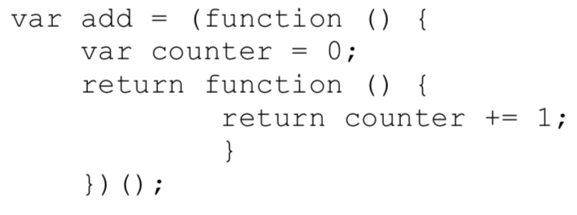

**Modify the above module to define a *count* object with two methods: *add*( ) and *reset*( ). The *count*.*add*( ) method adds one to the *counter* (as above). The *count*.*reset*( ) method sets the *counter* to 0.**

**var add = (function(){**

**Var counter = 0;**

**Return {**

**Increase: Function() {**

**counter += 1;**

**},**

**Reset: function() {**

**Counter = 0;**

**}**

**}**

**})();**

**7. In the definition of *add*( ) shown in question 6, identify the "free" variable. In the context of a function closure, what is a "free" variable?**

Free variables are simply the variables that are neither locally declared nor passed as parameter. In this case counter is a free variable.

**8. The *add*( ) function defined in question 6 always adds 1 to the *counter* each time it is called. Write a definition of a function *make*_*adder*(*inc*), whose return value is an *add* function with increment value *inc* (instead of 1). Here is an example of using this function:**

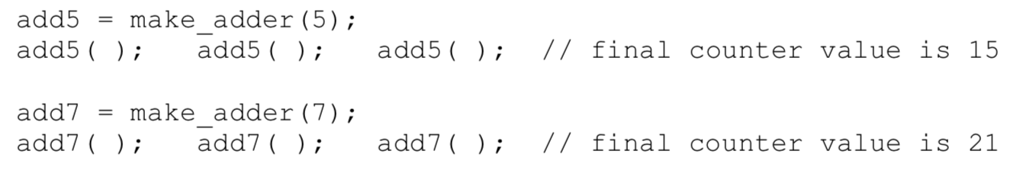

**var *make*_*adder* = (function(inc){**

**Var counter = 0;**

**Return {**

**Increase: Function() {**

**counter += inc;**

**}}**

**})();**

**9. Suppose you are given a file of Javascript code containing a list of many function and variable declarations. All of these function and variable names will be added to the Global Javascript namespace. What simple modification to the Javascript file can remove all the names from the Global namespace?**

Modularize it to remove it from global namespace, we use notation like this: ( the Javascript code here )();

**10. Using the *Revealing Module Pattern*, write a Javascript definition of a Module that creates an *Employee* Object with the following fields and methods:**

**Private Field: name**

**Private Field: age**

**Private Field: salary**

**Public Method: setAge(newAge)**  
 **Public Method: setSalary(newSalary)**  
 **Public Method: setName(newName)**  
 **Private Method: getAge( )**  
 **Private Method: getSalary( )**  
 **Private Method: getName( )**  
 **Public Method: increaseSalary(percentage)**  
 **Public Method: incrementAge( ) // uses private getAge( )**

Var employee = (function(){

Return {

SetAge: setAge,

SetSalary: setSalary,

SetName: setName,

IncreaseSalary: increaseSalary,

IncrementAge: incrementAge

}

Var name;

Var age;

Var salary;

Function setAge(){}

Function setSalary(){}

Function setName(){}

Function getAge(){}

Function getSalary(){}

Function getName(){}

Function increaseSalary(){getSalary()}

Function incrementAge(){getAge()}

})();

**11. Rewrite your answer to Question 10 using the *Anonymous Object Literal Return Pattern*.**

Var employee = (function(){

Return {

Let setAge = function(){},

let setSalary = function(){},

let setName = function(){},

let increaseSalary = function(){getSalary()},

Let incrementAge = function(){getAge()}

}

Var name;

Var age;

Var salary;Function getAge(){}

Function getSalary(){}

Function getName(){}

})();

**12. Rewrite your answer to Question 10 using the *Locally Scoped Object Literal Pattern*.**

Var employee = (function(){

Let object = {}

object. SetAge = function(){};

Object.setSalary = function(){};

Object.setName = function(){};

Object.increaseSalary = function(){getSalary()};

Object.incrementAge = function(){getAge()};

Return object;

Var name;

Var age;

Var salary;Function getAge(){}

Function getSalary(){}

Function getName(){}

})();

**13. Write a few Javascript instructions to extend the Module of Question 10 to have a public *address* field and public methods *setAddress*(*newAddress*) and *getAddress*( ).**

Var employee = (function(){

Let object = {}

object. SetAge = function(){};

Object.setSalary = function(){};

Object.setName = function(){};

Object.increaseSalary = function(){getSalary()};

Object.incrementAge = function(){getAge()};

Return object;

Var name;

Var age;

Var salary;Function getAge(){}

Function getSalary(){}

Function getName(){}

})();

var address;

employee. SetAddress = function(newAddress){

Addresss = newAddress;

}

Employee.getAddress = function(){

Return address;

}

**14. What is the output of the following code?**

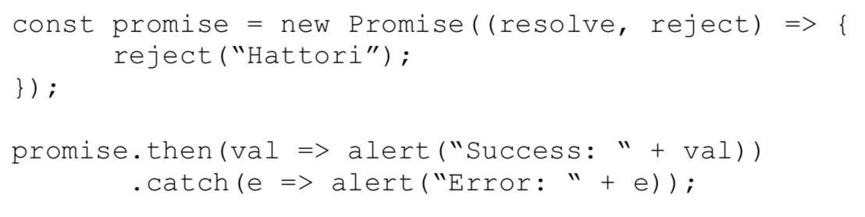

Error: Hattori

**15. What is the output of the following code?**

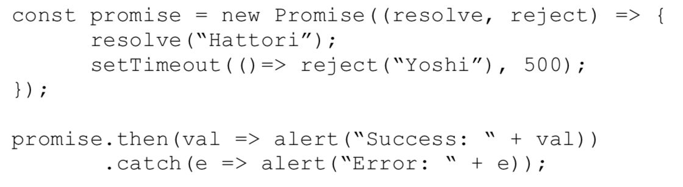

Success: Hattori