**jQuery Quiz I**

**1. In jQuery terminology, what is the difference between the “jQuery function” and the “jQuery object”?**

The jQuery function refers to the global jQuery function/object or the $ function depending

on the context. jQuery object is the object returned by the jQuery function that often represents a

group of elements

**2. Write jQuery code to find all h1 elements that are children of a div element and make their background color red. Sample HTML:**

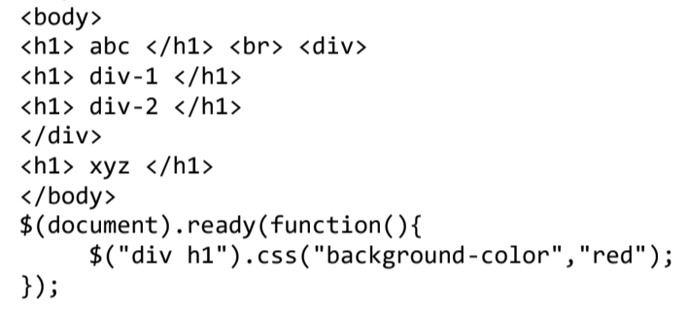

**3. Use a jQuery method to insert the text "YES!" at the end of the element.**

