**jQuery Quiz II**

**1. Which, if any, of the following 3 code fragments are equivalent? Explain why they are different, if they are. Explain why they can have different parameters and be equivalent, if they are equivalent.**

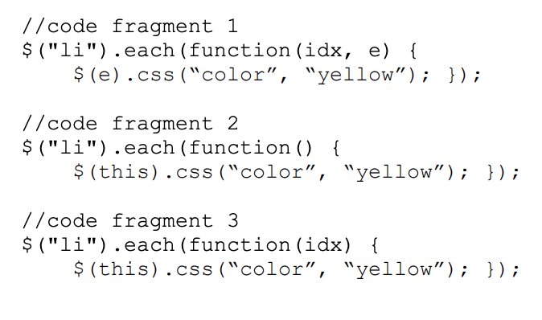

Three of them are equal, e and this refers to the same thing i.e each member elements in li.

And idx is the index, which serve no purpose in the three code fragments.

**2. Write a jQuery expression to find all divs on a page that include an unordered list in them, and make their text color be blue.**

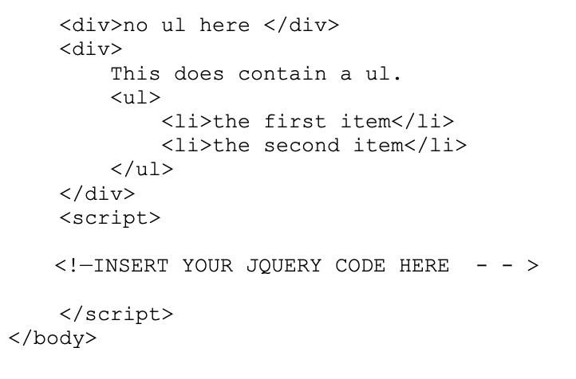

$("div").has("ul").css("color","blue");

**3. Write jQuery code to append the following div element (and all of its contents) dynamically to the body element.**

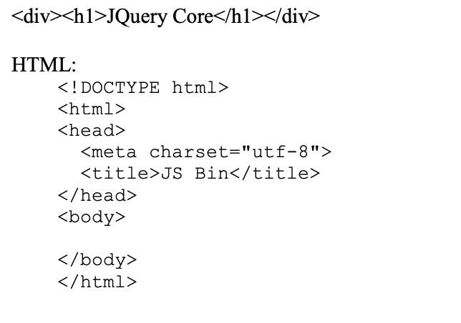

$("body").append("<div><h1>JQuery Core</h1></div>");