**jQuery Quiz III**

**1. Find the text in the first paragraph (stripping out the html), then set the html of the last paragraph to show it is just text (the red bold is gone).**

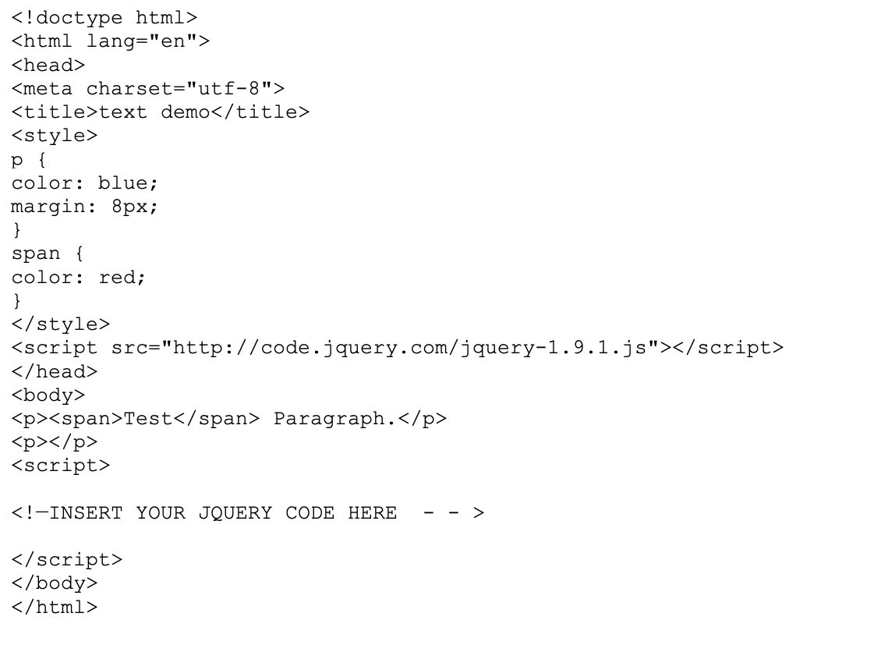

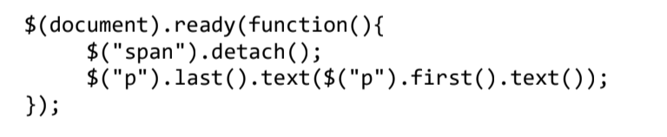

**2. Write jQuery code to create a red background for the level-2 list items.**

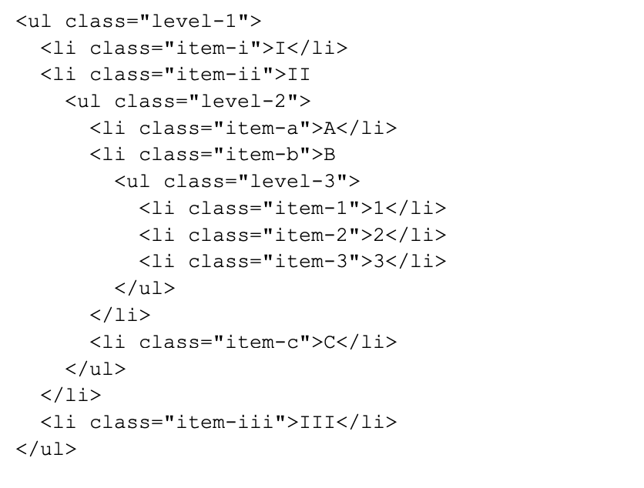

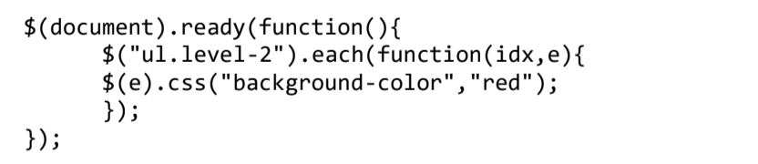

**3. Write jQuery code to select the element that comes immediately before item three and change its background color to blue.**

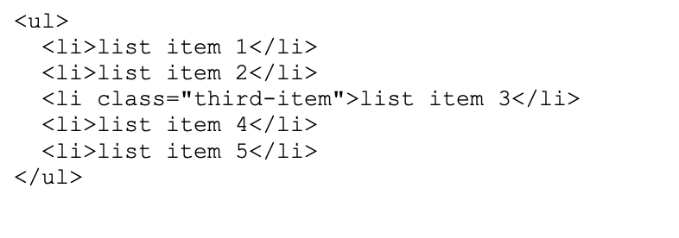

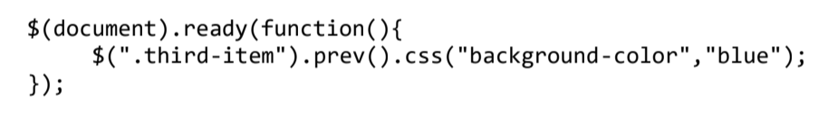

**4. Let us one additional requirement for the "Go Vegetarian" button of the Webville Eatery Menu described in Chapter 4 of Head First jQuery: "Turkey" in the ingredient list of any entree is replaced by "Mashed Potatoes" in the vegetarian version. You may assume there is a class "turkey" that identifies these items in the list. Describe the changes to the Javascript (jQuery) code to implement this new requirement**

We will detach turkey class and save it with some variable then replaceWith "Mashed

Potatoes" for the vegetarian version.

**5. Write Javascript (jQuery) code to change the color of the parent and grandparent list items of the span of text ("some text") in the following to green.**

