**Are you passionate about your work?**

Yes, because I love experimenting with code, for example, when I started learning android, my first project was an android app birthday to my cousin and I loved it and my cousin loved it too.

**Are you a go-getter? --** The **definition** of a **go getter** is a person who is ambitious and who isn't afraid to ask for and pursue what he wants. An example of a **go getter** is a person who has no hesitation about asking her boss for the raise she feels she deserves.

Yes if I think I deserve something

**Do you remain optimistic in the worst of times?**

In some cases yes, but sometimes you need the team support. Also, I think is better to be calm at first, and one way I calm down is to listen to my favorite music

**How well do you gel with other people at work?**

I enjoy working in a team environment and get along well with people. I think the best engineers are the one who can work in a team because you can help each other, and learn new things of team member experience

**Do you have a diverse set of skills?**

Do you mean tecknacly, personal

**Have you worked in a multicultural environment?**

Yes, in the job and in university projects

**What is your outlook on negative situations?**

Always ask for help to the people who have experience in that situation

**How do you handle conflict?**

If the conflict is with a team worker, at the beginning I try to talk to that person, but if the problem remains, we should talk with the supervisor

**Do you adapt well to new situations and people?**

Yes, I introduced myself to my colleagues right away and felt confident asking them questions in my first couple of weeks when I was unsure of something.

___________________

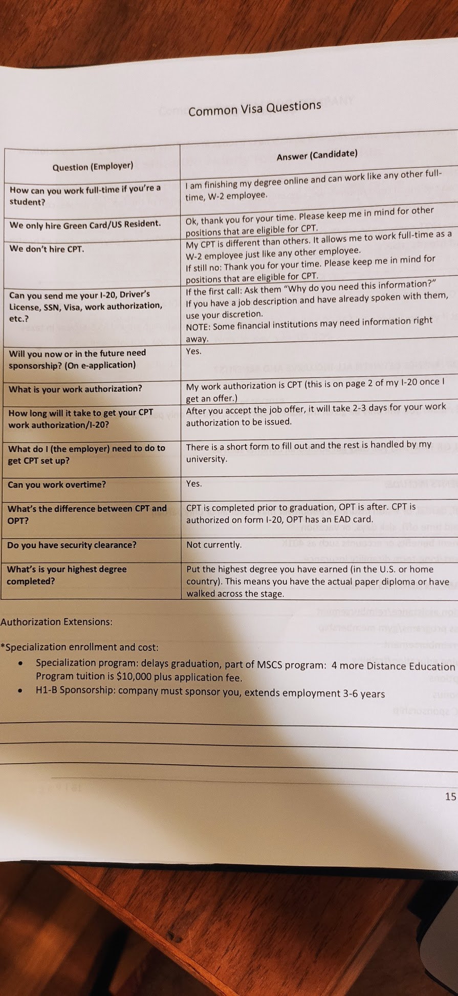

**What should I hire you?**

Why I will be happy in the job, learn new tech, meet new people, good problem solver