OVtool - Omitted Variable tool

*Note: This is a work in progress – last updated 04-16-2020*

# Introduction

The Omitted Variable Tool (OVtool) package was designed to assess the sensitivity of research findings to omitted variables when estimating causal effects using propensity score (PS) weighting. This package includes graphics and summary results that will enable a researcher to quantify the impact an omitted variable would have on their results. Burgette et al. (in preparation) describe the methodology behind the primary function in this package, ov_simgrid(). This document presents syntax for the implementation of the ov_simgrid() function and provides an example of how to interpret the packages’ graphical output.

This package is useful in a wide range of applications where researchers want to analyze how sensitive their research findings are to unobserved confounders that were not included in their propensity score and outcome models. It will estimate the potential impact of the unobserved counfounders on both the estimated treatment or exposure effects as well as on the statistical significance of an analysis.

# Example: Synthetic Data

This package is demonstrated using a synthetic data set that was derived from a large scale observational study on youth in substance use treatment. More specifically, it contains a subset of measures from the Global Appraisal of Individual Needs biopsychosocial assessment instrument (GAIN) (Dennis, Titus et al. 2003) from sites that adminstered two different types of substance use disorder treatments (treatment “A” and treatment “B”). The Center for Substance Abuse Treatment (CSAT) funded the sites that administered these two SUD treatments. This dataset consists of 4,000 adolescents. The main goal of this analysis is to understand the effect Treatment A and Treatment B, indicated by treat, have on mental health outcomes and to assess the potential for an omitted variable to bias the findings. To create our synthetic data set, we used an R package called “[synthpop](https://cran.r-project.org/web/packages/synthpop/vignettes/synthpop.pdf) : Bespoke Creation of Synthetic Data in R”.

In our synthetic dataset, there are 2,000 adolescents in each treatment group. Within this dataset there are variables on substance use disorder and mental health outcomes. For this tutorial we are particularly interested in the mental health outcome, eps7p_3, emotional problem scale (eps) recorded at three months. Higher values of eps indicate more emotional problems. Substance use researchers are particularly interested in whether or not treatment A reduces emotional problems more than treatment B. eps7p_3 ranges from zero to one, where higher values of EPS indicate more emotional problems. See (Dennis, 2003) for more details on this scale.

Past research has indicated there are many influential confounders when analyzing adolescents’ emotional problems, some included in this synthetic dataset (Diamond et al.). These variables were measured at baseline: emotional problem scale (eps7p_0), adjusted days abstinent (any in past 90) (ada_0), substance frequency scale (sfs8p_0), substance abuse treatment index (sati_0), in recovery (recov_0), traumatic stress scale (tss_0), mental health treatment in the past 90 days (mhtrt_0), and the depressive symptom scale (dss9_0).

We begin by loading the development version of the package from [GitHub](https://github.com/). If you haven’t installed the devtools package, make sure you uncomment and run the first line of the following code snippet prior to running the second line:

# install.packages("devtools")  
devtools::install_github("jpane24/OVtool")  
library(OVtool)  
set.seed(24)

We can load the synthetic dataset and print to screen the first six observations by running the following two commands:

data(sud)   
# head(sud)  
sud$treat = ifelse(sud$treat == "A", 1, 0)

The relevant variables in this analysis are:

* **Treatment indicator** treat: indicates treatment type where 1 is Treatment “A” and 0 is Treatment “B”
* **Outcome of interest** eps7p_3: emotional problem scale at 3-months
* eps7p_0: emotional problem scale at baseline
* sfs8p_0: substance frequency scale 8-item version at baseline
* sati_0: substance abuse treatment index at baseline
* ada_0: adjusted days abstinent at baseline
* recov_0: indicates whether the adolescent was in recovery at baseline, where 1 is in recovery and 0 is not in recovery
* tss_0: traumatic stress scale at baseline
* mhtrt_0: mental health treatment in the past 90 days at baseline
* dss9_0: depressive symptom scale at baseline

In the next section, we will show how our method works with the average treatment effect (ATE) using a continuous outcome. The OVtool also handles binary outcomes and weights that were estimated using the average treatment effect on the treated (ATT) estimand.

## Continous Outcome: Average Treatment Effect (ATE)

The OVtool can either take a vector of weights estimated using any method or a ps object produced by TWANG (Ridgeway et al., 2014). We begin walking through the OVtool by estimating weights using ps() from the TWANG package prior to running our outcome model using outcome_model(). The snippet of code belows walks through an example:

## Create Formula  
my_formula = as.formula(treat ~ eps7p_0 + sfs8p_0 + sati_0 + ada_0 + recov_0 +   
 tss_0 + mhtrt_0 + dss9_0)  
  
## Get weights  
sud = data.frame(sud)  
ps.twang <- ps(my_formula, data = sud, estimand = 'ATE', booster = "gbm",  
 stop.method = "ks.max", verbose=F, ks.exact = T)  
  
# Check Balance  
bal.table(ps.twang); # summary(ps.twang)

## $unw  
## tx.mn tx.sd ct.mn ct.sd std.eff.sz stat p ks ks.pval  
## eps7p_0 0.256 0.196 0.219 0.192 0.187 5.937 0.000 0.103 0.000  
## sfs8p_0 11.253 13.134 10.571 12.162 0.054 1.703 0.089 0.045 0.032  
## sati_0 8.233 22.128 2.145 10.658 0.345 11.088 0.000 0.121 0.000  
## ada_0 48.748 33.400 54.236 32.454 -0.166 -5.271 0.000 0.081 0.000  
## recov_0 0.246 0.431 0.240 0.427 0.015 0.479 0.632 0.006 1.000  
## tss_0 2.277 3.525 1.924 3.115 0.106 3.365 0.001 0.043 0.050  
## mhtrt_0 0.290 0.513 0.256 0.484 0.069 2.188 0.029 0.028 0.413  
## dss9_0 2.750 2.604 2.638 2.492 0.044 1.390 0.165 0.023 0.666  
##   
## $ks.max.ATE  
## tx.mn tx.sd ct.mn ct.sd std.eff.sz stat p ks ks.pval  
## eps7p_0 0.238 0.193 0.232 0.192 0.033 1.015 0.310 0.023 0.697  
## sfs8p_0 10.830 12.609 10.675 12.324 0.012 0.385 0.700 0.012 0.999  
## sati_0 5.302 17.852 4.087 15.449 0.069 1.955 0.051 0.024 0.641  
## ada_0 51.585 32.900 52.540 32.849 -0.029 -0.886 0.376 0.020 0.849  
## recov_0 0.247 0.431 0.240 0.427 0.017 0.506 0.613 0.007 1.000  
## tss_0 2.094 3.345 2.024 3.244 0.021 0.656 0.512 0.014 0.990  
## mhtrt_0 0.271 0.502 0.274 0.500 -0.006 -0.171 0.865 0.004 1.000  
## dss9_0 2.678 2.551 2.684 2.528 -0.002 -0.075 0.941 0.008 1.000

The output produced by the code snippet above shows that TWANG does a reasonable job of balancing. There are additional diagnostics we could check to ensure we have good balance but we move on without diving in further because the purpose of this tutorial is to showcase OVtool. The next step is to estimate the treatment effect and analyze the sensitivity of those results using OVtool. We first present how a researcher would produce results for their outcomes model (svyglm()). There are two options the researcher can take to input the relevant information to get their outcome results using outcome_model().

* Input a ps.object from TWANG and a stop.method (e.g. "ks.max") or
* Input a vector of weights, a data frame containing the data used, and the column name representing the treatment indicator, treatment.

The analyst must also provide a column name representing the outcome and a vector of covariates to be included in the final outcome model.

# Get weights (not needed if user inserts a ps object in OVTool)  
sud$w_twang = ps.twang$w$ks.max.ATE  
  
# Run Models -- first standardize outcome  
sud$eps7p_3_std = sud$eps7p_3/sd(sud$eps7p_3)   
  
# Use outcome_model() to run outcomes model  
results = outcome_model(ps_object = NULL,   
 stop.method = NULL,   
 data = sud,  
 weights = sud$w_twang,   
 treatment = "treat",  
 outcome = "eps7p_3_std",   
 model_covariates = c("eps7p_0", "sfs8p_0",  
 "sati_0", "ada_0",  
 "recov_0", "tss_0",  
 "mhtrt_0", "dss9_0"),  
 estimand = "ATE")  
  
summary(results$mod_results)

##   
## Call:  
## svyglm(formula = formula, design = design_u)  
##   
## Survey design:  
## survey::svydesign(ids = ~1, weights = ~w_orig, data = data)  
##   
## Coefficients:  
## Estimate Std. Error t value Pr(>|t|)   
## (Intercept) -0.7079871 0.0649876 -10.894 < 2e-16 ***  
## treat 0.0785796 0.0275254 2.855 0.00433 **   
## eps7p_0 1.6332282 0.1180704 13.833 < 2e-16 ***  
## sfs8p_0 0.0023047 0.0020310 1.135 0.25654   
## sati_0 0.0017325 0.0012363 1.401 0.16119   
## ada_0 -0.0000504 0.0007587 -0.066 0.94704   
## recov_0 -0.0693833 0.0314387 -2.207 0.02737 *   
## tss_0 0.0312059 0.0068902 4.529 6.10e-06 ***  
## mhtrt_0 0.2694083 0.0355520 7.578 4.34e-14 ***  
## dss9_0 0.0489996 0.0078452 6.246 4.66e-10 ***  
## ---  
## Signif. codes: 0 '***' 0.001 '**' 0.01 '*' 0.05 '.' 0.1 ' ' 1  
##   
## (Dispersion parameter for gaussian family taken to be 0.6890915)  
##   
## Number of Fisher Scoring iterations: 2

The outcome model results show an adjusted treatment effect estimate that accounts for some of the confounding between youth in the two treatment programs (A = 1 and B = 0). From the results, we can see that the effect size is 0.079 (p = 0.004), whereby youth receiving treatment A have slightly higher emotional problems at the 3-month follow-up than youth in treatment program B.

At this stage, researchers should begin to ask themselves if this effect is real and how sensitive it is. Our tool is used to help answer these sort of logical next step questions. The next snippet of code presents the main function in OVtool: ov_simgrid(). This function requires results from outcome_model() plus additional parameters including:

* weight_covariates: a vector of column names representing the covariates used to produce the analysts propensity score weights (these may or may not be the same as the list of covariates used for the outcome model)
* es_grid: a vector on an effect size scale representing the association between an unobserved confounder (omitted variable) and the treatment indicator
* rho_grid: a vector of correlations to simulate over. These correlations represent the correlation between the omitted variable and the outcome
* n_reps: the number of repetitions at each grid point. The package defaults to 101 (typically this is overkill and the analyst can reduce the number of repetitions to speed up run time).

The grid, as shown by the x-axis and y-axis in Figure 1 presents the effect size and rho, respectively. We define the effect size on the x-axis to show the strength of the relationship between the simulated unobserved covariate (U) and the treatment group indicator; it is defined as the standardized mean difference in U for the treatment A and treatment B groups. Typical rules of thumb for effect sizes (Cohen’s D) follow such that effect sizes greater than 0.2 would be considered small, 0.4 would be moderate and 0.6 would be large (cite Cohen’s 1995 paper). We define rho in this setting as the absolute correlation the unobserved covariate (U) has with the outcome of interest, with larger values indicating stronger relationships between U and the outcome. Please see Burgette et al. (in progress) for additional details on the methodology used by OVtool.

# Run OVtool (with weights/not a ps object)  
ovtool_results_twang = ov_simgrid(model_results=results,   
 weight_covariates=c("eps7p_0", "sfs8p_0",  
 "sati_0", "ada_0",  
 "recov_0", "tss_0",   
 "mhtrt_0", "dss9_0"),  
 es_grid = NULL,  
 rho_grid = seq(0, 0.40, by = 0.05),  
 n_reps=25)

## Warning in ov_simgrid(model_results = results, weight_covariates =  
## c("eps7p_0", : Ties in the outcome variable `y` may be problematic.

## [1] "6% Done!"  
## [1] "12% Done!"  
## [1] "18% Done!"  
## [1] "24% Done!"  
## [1] "29% Done!"  
## [1] "35% Done!"  
## [1] "41% Done!"  
## [1] "47% Done!"  
## [1] "53% Done!"  
## [1] "59% Done!"  
## [1] "65% Done!"  
## [1] "71% Done!"  
## [1] "76% Done!"  
## [1] "82% Done!"  
## [1] "88% Done!"  
## [1] "94% Done!"  
## [1] "100% Done!"

In our example, ov_simgrid produced a warning stating ties in the outcome variable may be problematic. This warning allows the user to continue with their analysis but it is important for the analyst to understand that when generating the omitted variable (U), the empirical cumulative distribution function (CDF) for the outcome within each treatment is used. Many ties could lead to issues. See Burgette et al. for details. Although not in this example, ov_simgrid may produce a warning asking the analyst to reduce the size of the rho grid. Typically, rho_grid will range from 0 to 0.45 but occasionally large values of rho_grid are intractable. A key assumption in this tool is the omitted variable is independent from all covariates included in the propensity score model; this assumption may result in correlations of the omitted variable that have a maximum bound below moderately sized correlations.

Furthermore, the user may expand the size of the effect size grid if the user feels it is applicable. To visualize our results, the plot.ov function will produce three graphics. The first graphic (Figure 1) plots the treatment effect contours without covariate labels. The second graphic (Figure 2) plots the p-value contours with the column names submitted to weight_covariates plotted by their raw rho and effect size. The third graphic (Figure 3) plots the treatment effect contours with the p-value contour overlayed and covariate labels.

plot.ov(ovtool_results_twang, print_graphic = "1")

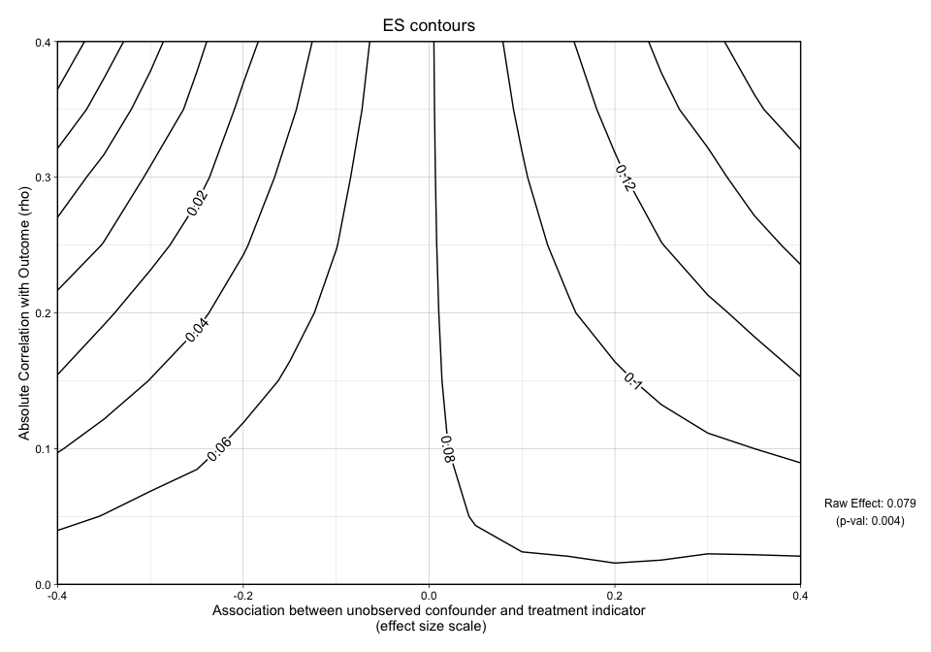

The y-axis in Figure 1 represents the unobserved confounder’s absolute correlation with the outcome and the x-axis is the association between the unobserved confounder and the treatment indicator on an effect size scale. The black lines represent effect size contours that run along the grid. The PS weighted treatment effect of Treatment A versus Treatment B equals 0.079 and is significant with a p-value equal to 0.004. However, looking at this graphic alone will not give us an idea of how sensitive the effect is.

plot.ov(ovtool_results_twang, print_graphic = "2")

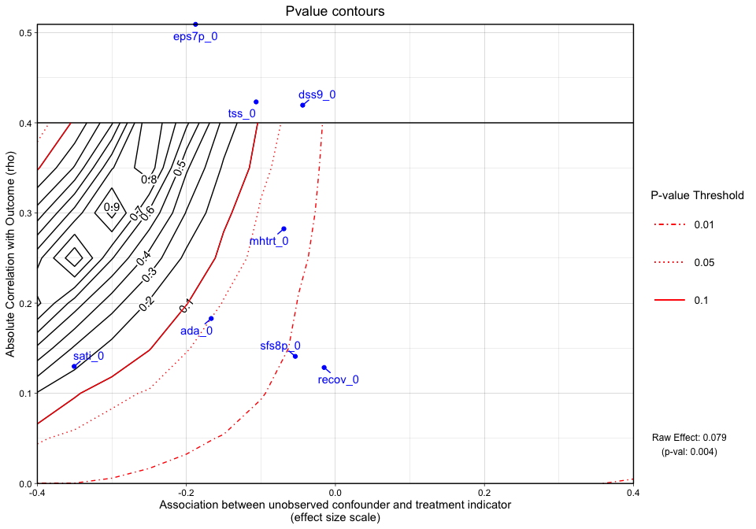

## [1] "NOTE: Covariates with absolute correlation with outcome greater than 0.4: eps7p_0 (Actual:  
0.509), tss_0 (Actual: 0.423), dss9_0 (Actual: 0.420)"

Figure 2 is a different variation of Figure 1 but only shows the p-value contours with an additional dimension, covariate labels. If a covariate has a raw correlation or effect size that is outside the range of the graphic limits, the tool will inform the user and will also plot a transparent red background in area of the graphic that is outside the range. In this case there were three covariates whose absolute correlations with the outcome were greater than 0.4. The blue dots and their labels on the plot represent the observed covariates correlations with the outcome (y-axis) and treatment indicator (x-axis). For instance, ada_0 and the outcome have approximately a 0.18 absolute correlation with the emotional problem scale at three months and an absolute association of approximately 0.17 effect size difference between the two treatment groups (magnitude of its relationship with the treatment indicator). In this case, not all of the observed covariate relationships with the outcome and the treatment indicator are “below” the 0.05 p-value threshold so the analyst potentially has results that are sensitive to an unobserved confounder. If the blue points all existed to the “right” of the 0.05 p-value contour, then unobserved confounders with similar associations would retain the significant effect and allow the user to conclude that the results are reasonably robust.

*Note: When the outcome model shows a significant effect, for all observed covariates, regardless of the sign of the association effect size difference between the two treatment groups, we force the sign of the magnitude to go with the direction of the significant effect. The blue points are meant to give the analyst an idea (using observed covariates as an indicator) of what would cause a change in the interpretation of their results.*

plot.ov(ovtool_results_twang, print_graphic = "3")

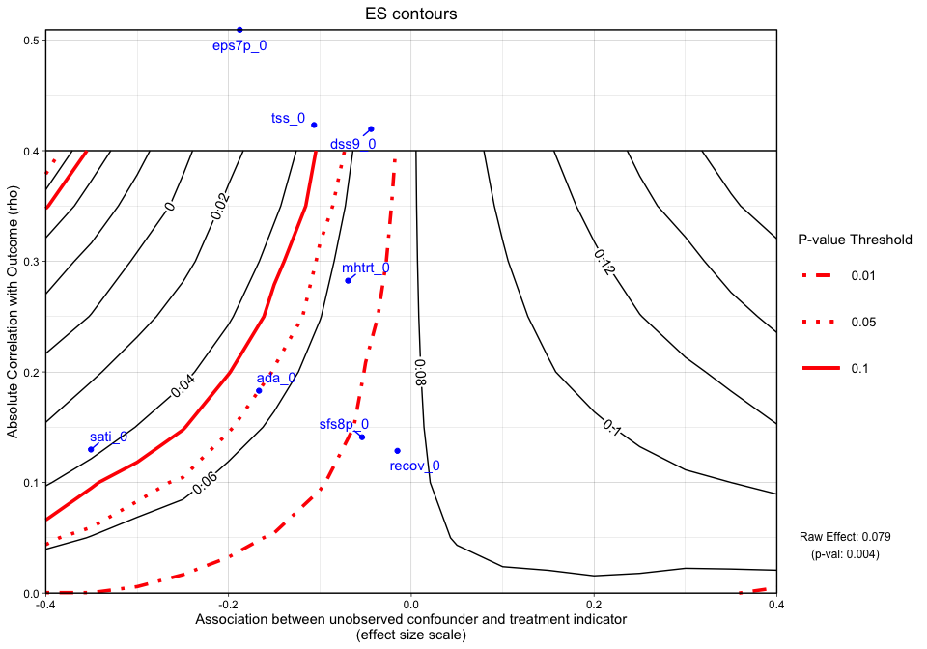

## [1] "NOTE: Covariates with absolute correlation with outcome greater than 0.4: eps7p_0 (Actual:  
0.509), tss_0 (Actual: 0.423), dss9_0 (Actual: 0.420)"

Figure 3, combines Figure 1 and Figure 2 into one graphic. Again, the y-axis in Figure 3 still represents rho, the absolute value of the correlation between the right-hand side variable and the outcome. The x-axis represents the association between the unobserved confounder and the treatment indicator on the effect size scale. Plotted at the bottom of the figure margin is the PS weighted treatment effect size (0.079) and associated p-value of 0.004. The solid black contours represent the effect size (treatment effect) contour lines and the red lines (sometimes dashed) represent the p-value threshold. The key on the right side of the graphic shows where various p-value cutoff lines are, including p = 0.05. The blue points on the plot represent the observed ovariate correlations with the outcome and effect size associations with the treatment indicator (e.g., standardized mean difference on the given covariates between the two groups). If there are observed absolute correlations with the outcome that are outside the range of the graphic, we indicate that by a red transparent background. Finally, we can interpret this graphic by running the summary command on the ov object:

summary.ov(OVtool_results = ovtool_results_twang, model_results = results)

## [1] "Recommendation for reporting the sensitivity analyses"  
## [1] "The sign of the estimated effect is expected to be robust to unobserved confounders that  
have the same strength of association with the treatment indicator and outcome that are seen in the  
observed confounders. In the most extreme observed case, the estimated effect size is reduced by 75  
percent."  
## [1] "Statistical significance at the 0.05 level is expected to be robust to unobserved  
confounders with strengths of associations with the treatment indicator and outcome that are seen  
in 5 of the 8 observed confounders. In the most extreme observed case, the p-value would be  
expected to increase from 0.004 to 0.496. Significance at the 0.05 level would not be expected to  
be preserved for unobserved confounders that have the same strength of association with the  
treatment indicator and outcome as eps7p_0, sati_0, tss_0."

The OVtool gives a recommendation on how to report findings regarding the direction of the treatment effect and statistical significance. An analyst could take the results produced by summary.ov() and plug them into a manuscript. In summary, the sign of the estimated effect is expected to be robust to unobserved confounders that have the same strength of association with the treatment indicator and outcome that are seen in the observed confounders. In the most extreme observed case, the estimated effect size is reduced by 75 percent. However, statistical significance at the 0.05 level is expected to be robust to unobserved confounders with strengths of associations with the treatment indicator and outcome that are seen in 5 of the 8 observed confounders. In the most extreme observed case, the p-value would be expected to increase from 0.004 to 0.496. Significance at the 0.05 level would not be expected to be preserved for unobserved confounders that have the same strength of association with the treatment indicator and outcome as eps7p_0, sati_0, tss_0.

# Conclusion

There is continuously a call for work on assessing the sensitivity of research findings. To our knowledge, this is a novel approach to assessing the sensitivity of research findings to omitted variables when estimating causal effects using PS weighting. Development of user friendly software tools are critical for advancing research. We hope that users will use our tool when they are trying to analyze how sensitive their results are to omitted variables when estimating causal effects using ps methods.

# Acknowledgements

The devlopment of this tutorial was funded by the National Institute of Health (R01DA045049; PIs: Griffin/McCaffrey). We thank (fill in). This tutorial uses a synthetic dataset of youth receiving two unidentified treatments from the GAIN; running on the true dataset will produce different results.

# References

*Will update to link with text*

CHIS (2005). California health interview survey (CHIS) 2003 Methodology Series. Los Angeles: UCLA Center for Health Policy Research.

Diamond, G., Godley, S. H., Liddle, H. A., Sampl, S., Webb, C., Tims, F. M., & Meyers, R. (2002). Five outpatient treatment models for adolescent marijuana use: a description of the Cannabis Youth Treatment Interventions. Addiction, 97, 70-83.

McCaffrey, D. F., Ridgeway, G., and Morral, A. R. (2004). Propensity score estimation with boosted regression for evaluating causal effects in observational studies. Psychological methods 9, 403.

Miles, J. N., Parast, L., Babey, S. H., Griffin, B. A., and Saunders, J., M. (2017) . A propensity-score-weighted popualtion-based study of the health benefits of dogs and cats for children. Anthrozoos 30, 429-440.

Ridgeway, G., McCaffrey, D., Morral, A., Burgette, L., and Griffin, B. A. (2014). Toolkit for weighting and analysis of nonequivalent groups: A tutorial for the twang package. Santa Monica, CA: RAND Corporation.

Saunders, J., Parast, L., Babey, S. H., and Miles, J. V. (2017). Exploring the differences between pet and non-pet owners: Implications for human-animal interaction research and policy. PloS one