Final Project Proposal

Year: 2020 Semester: Fall Team: 4 Project: Sowin’ Seeds

Creation Date: August 26, 2020 Last Modified: 8/27/2020

Team Members (#1 is Team Leader):

Member 1: Moiz Rasheed Email: mrasheed@purdue.edu

Member 2: Ethan Campbell Email: campb338@purdue.edu

Member 3: Josh Panos Email: panos@purdue.edu

Member 4: Jackie Malayter Email: malayter@purdue.edu

1.0 Project Description:

Global pollinator populations are declining. To help remedy this issue, we shall create a drone equipped with hardware that will detect apple blossoms, navigate slowly to the blooms, and touch the pollen-rich cores of the flowers. Moving flower to flower will allow this drone to act as a supplement for global pollinator populations. The drone will be equipped with a jetson nano that will perform the image detection and locate the drone relative to the flower. The STM32H7 is the primary controller for the drone, relying on the Pixhawk and nano for flight stability and spatial data respectively. It also will interface with a switch on the pollinator appendage. For our current prototype we are planning on having a battery life of 15 to 20 minutes for proof of concept and functional testing.

2.0 Roles and Responsibilities:

Josh Panos is a senior in electrical engineering. His interests are in embedded systems and VLSI. His role on the team is as the hardware engineer and will be overseeing the construction of a PCB as well as final product assembly. He has had prior experience as technical team leads working on power and communication electronics in autonomous robotics.

Moiz Rasheed is a senior in computer engineering. His interests are in embedded systems and machine learning. His role is team leader. He has had experience leading technical teams in the past. Notable roles have been software lead on Lunabotics and team lead of the CAM2 subteam Human Behavior. His technical expertise involves software and web development.

Ethan Campbell is a senior in computer engineering. His primary focus is Machine Learning. He has experience with C family languages and especially with python. He will participate as the software engineer for the team.

Jackie Malayter is a senior in electrical engineering. She enjoys studying signal processing techniques, primarily in mmWave comm applications but is extending her expertise to image processing. She has served as a systems engineering intern for her two internships and will take on this role on the project, assisting with image processing programming.

2.1 Homework Assignment Responsibilities

|  |  |  |  |
| --- | --- | --- | --- |
| *Design Component Homework* | | *Professional Component Homework* | |
| 3-Software Overview | EC | 9-Legal Analysis | MR |
| 5-Electrical Overview | JP | 10-Reliability and Safety Analysis | JP |
| 7-Mechanical Overview | MR | 11-Ethical/Environmental Analysis | JM |
| 8-Software Formalization | JM | 12-User Manual | EC |

Figure 1: Distribution of Homework Responsibilities

JP - Joshua Panos EC - Ethan Campbell MR - Moiz Rasheed JM - Jackie Malayter

3.0 Estimated Budget

An estimated budget for our project is shown below in figure 2.

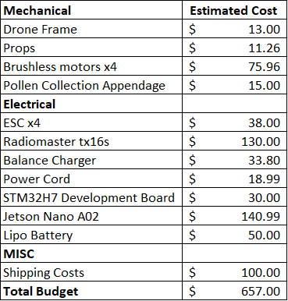

Figure 2: Estimated Budget

Purdue has allocated a budget of $425 per team and the remaining costs incurred on this project are going to be split among the team members. Currently we have not budgeted for a PCB since we are unsure if we are going to be able to create a PCB without the proper lab access. In lieu of this we have added the cost of our development boards to our budget.

4.0 Project Specific Success Criteria

1. An ability to detect the location of a flower in an image(s) frame. (s)
2. An ability to communicate flower positional data between the STM32 and the Jetson Nano. (h)
3. An ability to actuate and detect contact with a capacitive switch on the pollen collecting appendage. (h)
4. An ability to monitor battery life with the STM32 during drone flight. (h)
5. An ability to communicate with the flight controller over the mavlink protocol. (h)

5.0 Sources Cited:

No works were cited in this work.