Initial Project Proposal

Year: 2020 Semester: Fall 2020 Project Name: Sowing the Seeds

Creation Date: February 15, 2020 Last Modified: Feb 15, 2020

Team Members (#1 is Team Leader):

Member 1: Moiz Rasheed Email: mrasheed@purdue.edu

Member 2: Ethan Campbell Email: campb338@purdue.edu

Member 3: Joshua Panos Email: panos@purdue.edu

Member 4: Jackie Malayter Email: malayter@purdue.edu

1.0 Description of Problem:

Global pollinator populations are declining. In the United States, there has been a 59% loss of honey bee colonies between 1947 to 2005, while the demand for agricultural crops continues to increase rapidly [1]. Honey bees in particular are responsible for pollinating $15 billion in U.S. agricultural crops each year [5]. Pollination is an important issue since many flowering, fruit-bearing plants must be pollinated before they can grow marketable produce. This is significant for the agriculture industry, as they currently enjoy the crop pollination services many insects provide. The global food supply is at risk of experiencing shortages, as well, since flowering plants make up 35% of it and are mainly pollinated by insects. It has been shown that production declines when pollinators decline. The exact nature of the disappearance of our pollen spreading friends is unknown, but their absence has the potential to create a $235 - $577 billion dent in global crop production [3]. Therefore it is imperative to redouble conservation efforts and investigate alternative pollination methods so that production can continue to meet current and future needs.

2.0 Proposed Solution:

Our solution to the problem stated above is to create an automated drone system that is able to cross pollinate crops with minimal human input. Making a mass, species invariant pollination system is a large research topic and is out of scope for a couple of ECE seniors to do in a semester. Thus, rather than creating mass pollination we plan on targeting specific flowers to not only increase desired yield, but also to increase the efficiency of our pollination between crops. To accomplish this task we plan on fitting a drone with a camera that will be able to detect flowers and their pollen rich cores. A rough sketch of our design can be seen in the appendix.

A reasonable concern to have is the possibility of the pollen being blown away during approach due to the thrust of thedrone’s propellers. Luckily for us apples, our main crop of focus, have the sticky variety of pollen [10]. Sticky pollen is not easily blown away by the wind. In fact it is “designed” to be pollinated by insects and other animals [11]. Having said that, we are building a rather large drone, so the winds generated may be higher than what the flower is accustomed to. Taking this into consideration, our drone has a large wingspan, spacing the motors far apart/away from the appendage (q-tip like) used to interact with the flower in order to minimize the possible effect of the high turbulence generated by the motors.

3.0 ECE477 Course Requirements Satisfaction

3.1 Expected Microcontroller Responsibilities

Our microcontroller will interface with several peripherals. The microcontroller will handle data from one camera and relay that data to another device. Our microprocessor will also make flight decisions based on locational awareness and relay the commands to our flight controller.

Specifically, in terms of image processing, our microcontroller will interface with a single camera onboard the drone. It will take the data from the camera and relay it to a SBC, such as Jetson Nano, which will perform color blob detection and matched filtering techniques using OpenCV to identify if a flower is in sight of the camera. The microcontroller will receive the computed result from the SBC and will make flight decisions, giving control decisions to the FMU.

Based on our research into the drone hardware we are going to be using a 4S 5000mAh LiPo battery. This battery will have a fully charged voltage of 14.8V and therefore will be required to go through a buck-converter to step down 12V DC (6 – 20V) to 3.3V output. This will enable us to power the components on our PCB that require 3.3v logic. Wey. are confident this will meet the power requirements of our SBC and flight controller as well since similar setups have been achieved previously [12].

3.2 Expected Printed Circuit Responsibilities

The PCB shall be the primary point of contact between each of our systems including the camera, microcontroller, power system, SBC, and flight control hardware. We will be directly mounting our microcontroller to the pcb along with our power management ICs to monitor battery health and levels. We will also be mounting connections for our camera, SBC, flight control hardware so that they can not only be connected to each other but also controlled through our microcontroller. Since our flight control hardware has an on board radio we will be using that for our wireless control communication. Finally, due to the small form factor of our project we are planning on utilizing a 4 - 6 layer PCB so that we can minimize the total surface area of our PCB while allowing for large amounts of routed connections.

4.0 Market Analysis:

As stated previously, 35% of global crop production is dependent on pollinator species whose populations are declining. To combat this issue, farmers currently have to rent out the services of beekeepers for a couple weeks at the cool price of about $120,000 a year to supplant the services previously offered by wild pollinators. Even then, bees do not answer man's wishes and visit any flowers they please in a manner not necessarily efficient or desirable for the farmer. For example, in the apple growing industry, pollinating only king blooms is most desirable as they have the largest yield among all the blooms (by weight). Other not as targeted solutions, such as DropCopter, are in demand to quickly pollinate such blooms as they open earlier than others so that the trees devote most of their resources to high yield blooms. DropCopter’s increasing demand indicates that there is an available market for targeted pollination solutions to not keep pace with global food demand but exceed it.

Our product could also be utilized in greenhouses. Pollination is a challenge in enclosed structures, and hand pollination methods or bringing in pollinating insects is a necessity for some crops [4]. For greenhouse farmers who do not wish to use hand pollination, such as if they do not have the time to pollinate plants or do not wish to employ people to do so, the drone could be an investment that would allow the growth of crops that require pollination. For example, greenhouse farmers could grow seedless watermelon, muskmelons, and cantaloupe.

It should also be noted that urban greenhouses offer a hopeful source of food for a growing population. Researchers from Arizona State, Google, Tsinghua University, UC Berkeley, and University of Hawaii have proposed that if urban agriculture were fully implemented in cities, it could produce about 10 percent of the global quantity or legumes, roots, tubers, and vegetables [6]. The variety of food available for growth in urban gardens could increase with an automated pollinator where bees and other pollinators might not be easily attainable.

5.0 Competitive Analysis:

5.1 Preliminary Patent Analysis:

5.1.1 Vision-based pollination system [9]

The above link is to a patent for a vision based pollination system that was approved in April of 2018 and has gone into effect as of Feb 2, 2020. While this patent does not pertain to an aerial system it is targeted at the use of a mobile aperture in order to detect a flower in need of pollination along with the use of an expanding aperture to conduct such pollination methods.

However, since this patent is so recent and is officially going into use it is something to be aware of so that we can be sure that we are not infringing on any aspects of their design. In addition to this they are using a liquid pollen to be sprayed onto plants rather than pollination with the existing pollen.

One area of potential overlap in this patent is that they have identified their image processing algorithm as a part of their unit in order to identify plants and flowers in need of pollination. This system will also be used to control when and where pollen is dispersed unto the field in order to increase yield and effectiveness of the delivered pollen.

5.1.2 Systems and Methods for Pollinating Crops via Unmanned Vehicles [7]

This is a patent from Walmart describing a very general distributed system for crop pollination. It was filed on September 8th, 2016. Much of the details of the system’s implementation are left to the imagination as little specifics are given. However many different combinations of communication strategies between components of a system containing at least two drones, at least one docking station, an external computation/human interface device, and a database are presented. Possible sensors and control methodologies are discussed, but nothing extraordinary, excluding some of their ideas that would fall under the realm of sci-fi. Drones are equipped with pollen collectors/applicators made of/covered in a sticky material (or can just “lift” the pollen off the crop) and are instructed either by the offboard computation hub or by their own accord where to fly and what flowers to pollinate/re-pollinate. Docking stations are used to reconfigure and resupply the drones with optimal navigational equipment and power, as well as possible being able to pollinate themselves. The database and offboard computational hub are used to store and analyze pollen retrieval/application data to determine successful pollination attempts and serve as a user hub so that others may control the systems behavior.

In general, nothing of real substance is presented in this patent. It has the appearance of being just a bunch of surface level ideas produced from a brainstorming session of a couple of optimistic engineers. There is no proof from Walmart that such a device exists and the patent seems to be written in such a way as to be able to contest any future unmanned vehicle that pollinates flowers and communicates with a base station and other devices. It has not been approved yet and we highly doubt that such a general, non-specific patent will be approved as an original though, much less upheld in the court of law.

That is not to say that there was absolutely nothing of substance to be learned from this patent. It does list several different possible sticky substances to use for the pollen applicator/collector. Another idea of interest is the use of pressurized air streams to agitate the flower to collect pollen in order to avoid actually making physical contact.

5.1.3 Unmanned aerial vehicle for augmenting plant pollination [2]

This is a patent for an Unmanned Aerial Vehicle for Augmenting Plant Pollination. This patent aims to replace manual pollination and fixed machine pollination in lieu of declining bee populations. The inventor points out bees are unique in that their wings vibrate plants inducing them to release pollen. The inventor argues that manual solutions are expensive and insufficient because they do not vibrate plants; however, manual pollination is seen as a viable solution for some plant types. Fixed machines, on the other hand, can be damaging to the plant and are inconvenient to attach to plants and remove for charging.

The inventor proposes using an unmanned aerial vehicle (UAV) to include pollination. This UAV would induce a thrust that would contact a plant, vibrating it and causing it to release pollen. The thrust induced by the UAV is caused by varying the motor speed in order to produce a thrust with frequency. The benefits of this method is that the need to make physical contact with the plant is eliminated, reducing injury to the plan. The frequency of said vibrations would be 200 - 400 Hz. The thrust would be directed towards the plan.

The patent also describes using a navigation system that precludes the need to manually pilot the UAV, allowing cost-effective and large-scale implementation. Not specifically, the patent identifies this technology as potentially identifying a type of plant and then devising a flight plan. This patent suggests that the navigation system could be configured to automatically navigate the UAV along a flight plan.

5.2 Commercial Product Analysis:

5.2.1 [Dropcopter](https://www.dropcopter.com/)

This company would be seen as a direct competitor to our idea based upon the fact that they are performing aerial pollination for large crop fields to increase yields. However, their method of simply dropping pollen over fields is highly inefficient, whereas we want to utilize our drone to do flower to flower pollinating to have not only maximum efficiency but also maximum targeted pollination to increase overall crop yields.

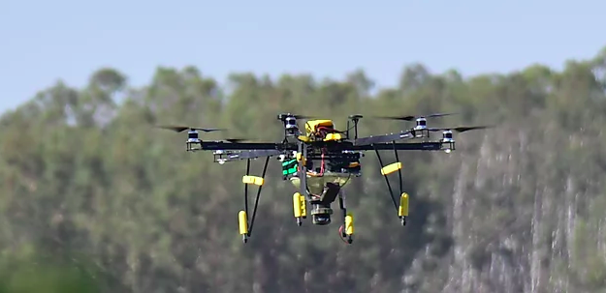

Similarities to idea:

* This project focuses on using a drone, or an unmanned aerial vehicle, to disperse pollen over fields of crops to increase crop yields
* This is also focused on a commercial application of the technology to be used in the food production

Differences to idea:

* This product requires the use of imported pollen from an external vendor which can then be loaded into the drones for deployment unto the fields. Whereas our project is focused on using the pollen available at the location. i.e pollination from plants and flowers at the fields.
* This product releases pollen in large batches and does not target individual flowers.

5.2.2 [Rent Mason Bees](https://www.rentmasonbees.com/)

While this product is not a direct competitor to our idea, it is worth noting that bees are rented by both home gardeners and farmers alike. In the same market segment, our drones could be rented by the same users to accomplish the same task.

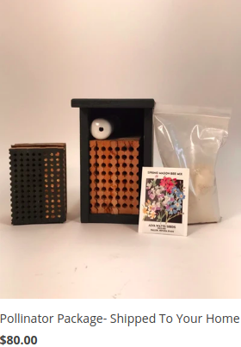

Similarities:

* This company offers pollination for hobbyists and farmers alike
* The company claims to increase pollination by

Differences:

* This company utilizes organic technologies instead of technological systems.
* This company ships their product and has a large distribution network. Our product would likely require close supervision initially.

5.2.3 [Edete Pollination Systems:](https://www.edetepta.com/)

Edete Precision Technologies for Agriculture has a two step process. First they collect pollen mechanically and store it for a year to ensure the pollen is desynchronized from farmers’ blooms. This is important for farmers that want to create hybrids. Then, they apply the pollen via semi-autonomous tractors that roam through fruit tree farms and electrostatically discharge the pollen onto flowers. The tractors use LIDAR sensors to measure the contours of the trees to place the pollen very close to the flowers.

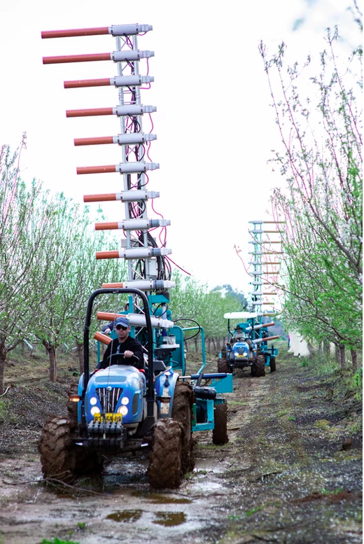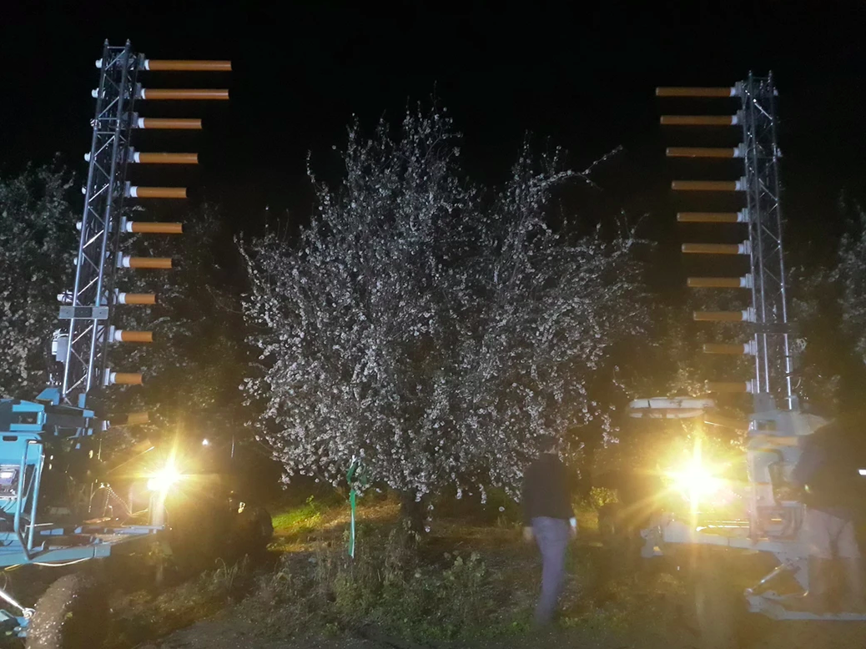

Similarities to our idea:

* Addresses the issue of artificial pollination
* Uses some autonomous principles to aid in pollination

Differences to our idea:

* Focused on assisting farmers with hybridization
* Requires a much larger scale of operations to be effective (mechanical harvesting, staffing, etc.)

5.3 Open Source Project Analysis:

5.3.1 [PX4 Autopilot - Open Source Drone Firmware](https://px4.io/)

The PX4 Autopilot is an open source flight controller firmware that is compatible with the Pixhawk open source flight controller hardware project. It is licensed under BSD, which means that it is available for commercial use and the vendors do not have to make their source available (unlike GPL).

Since the main objective of this project is not intended to develop a flight controller from scratch, as it is a complicated control problem, our team is interested in using these open source tools to actuate our drone’s motors. It has built in support for different telemetry sensors including GPS. It also provides a gambit of autonomous functionality such as setting up missions and flying to a series of waypoints. However, some modification will be required to the original source code in order to communicate with other onboard processors which are determining flight path and conducting image processing.

5.3.2 [Pixhawk](https://pixhawk.org/)

“Pixhawk is an independent open-hardware project that aims to provide the standard for readily-available, hiqh-quality and low-cost autopilot hardware designs for the academic, hobby and developer communities.”

Summary: This open source hardware controller is a good starting point for using a custom flight controller that can interact with many peripherals available on the market. The software is all open source so we could tailor the implementation to our needs.

Note: This would not replace a computer that does vision calculations (raspberry pi, jetson nano, etc.)

Licensing: CC BY-SA 3 - “The license allows you to use, sell, share, modify and build on the files in almost any way you like - provided that you give credit/attribution, and that you share any changes that you make under the same open source license ”

Advantages:

* The firmware is open source
* Schematics are available for most of the products
* Widely used
* Firmware is consistently maintained

Disadvantages:

* May require extra work/time on our end.

5.3.3 [Smart Flower Atlas](https://plant-tw.github.io/)

This open source project uses a subset of Machine Learning called Transfer Learning to identify classes of flowers []. Their implementation will be useful to study because they are able to rapidly identify classes of flowers with relatively few resources on the machine that implements the model.

Licensing:

* plant-model
  + Apache 2.0 - Can be used for commercial, modification, distribution, patent, private. Cannot use for trademark, liability, or warranties.
* plant-data
  + GNU Affero General Public License v3.0 - Can be used for commercial, modification, distribution, patent, private. Cannot use for trademark, liability, or warranties.
* ios-PlantCam
  + MIT License - Can be used for commercial, modification, distribution, patent, private. Cannot use for trademark, liability, or warranties.

These listed machine learning subprojects will be useful for understanding how to use neural networks to identify flowers.

6.0 Sources Cited:

1. S. Potts, J. Biesmeijer, C. Kremen, P. Neumann, O. Schweiger, W. Kunin, “Global pollinator declines: trends, impacts and drivers,” *Trends Ecol. Evol,* vol. 25, no. 6, pp. 345-351
2. P. R. Richard, “Unmanned aerial vehicle for augmenting plant pollination,” U.S. Patent 20200022312A1, Pending.
3. IPBES, Summary for Policymakers of the Global Assessment Report on Biodiversity and Ecosystem Services of the Intergovernmental Science-Policy Platform on Biodiversity and Ecosystem Services (IPBES Secretariat, 2019), p. XX.
4. G. Pullano, “Pollination of greenhouse vegetables a challenging endeavor ,” Vegetable Growers News , 18-Feb-2016. [Online]. Available: https://vegetablegrowersnews.com/news/pollination-of-greenhouse-vegetables-a-challenging-endeavor/. [Accessed: 27-Feb-2020].
5. <http://honeylove.org/bees/>
6. A. Crawford, “Big Data Suggests Big Potential for Urban Farming,” Wired, 20-Feb-2018. [Online]. Available: <https://www.wired.com/story/big-data-suggests-big-potential-for-urban-farming/>. [Accessed: 27-Feb-2020].
7. R. L. Cantrell “Systems and Methods for Pollinating Crops Via Unmanned Vehicles,” U.S. Patent Application 62384920 September 8 2016
8. G C M Santo “Classifying Flowers with Transfer Learning,” Towards Data Science , 22-Sep-2019. [Online]. Available: <https://towardsdatascience.com/classifying-flowers-with-transfer-learning-5e17925a1f59> [Accessed 22-Sep-2019]
9. D. Safreno “Vision-based pollination system” US Patent 20170042102A1 Febuary 16 2017
10. Jahed, Khalil Rahman, "Male and female interaction in apple: Pollen tube growth, fruit set, fruit quality, and return bloom" (2015). Open Access Theses. 495. <https://docs.lib.purdue.edu/open_access_theses/495>
11. Lloyd D.G., and Barrett S.C.H. “Discovery of the Secret of Nature in the Structure and Fertilization of Flowers” in Floral Biology: Studies on Floral Evolution in Animal-pollinated Plants. 1996. Web. ch. 1 pp. 28
12. Nvidia-Ai-Iot. “NVIDIA-AI-IOT/Redtail.” *GitHub*, <https://github.com/NVIDIA-AI-IOT/redtail/wiki/Skypad-TBS-Discovery-Setup>.

Appendix 1: Concept Sketch

