Functional Specification

Year: 2020 Semester: Fall Team: 4 Project: Sowin’ Seeds

Creation Date: August 1, 2020 Last Modified: September 03, 2020

Author: Team 4 Email: malayter@purdue.edu

Assignment Evaluation:

|  |  |  |  |  |
| --- | --- | --- | --- | --- |
| **Item** | **Score (0-5)** | **Weight** | **Points** | **Notes** |
| **Assignment-Specific Items** | | | | |
| **Functional Description** | 5 | x3 |  |  |
| **Theory of Operation** | 4 | x3 |  |  |
| **Expected Usage Case** | 5 | x3 |  |  |
| **Design Constraints** | 5 | x3 |  |  |
| **Writing-Specific Items** | | | | |
| **Spelling and Grammar** | 4.5 | x2 |  |  |
| **Formatting and Citations** | 5 | x1 |  |  |
| **Figures and Graphs** | 2 | x2 |  |  |
| **Technical Writing Style** | 5 | x3 |  |  |
| **Total Score** | 92 | | |  |

5: Excellent 4: Good 3: Acceptable 2: Poor 1: Very Poor 0: Not attempted

General Comments:

*Good job. Excellent work with the design constraints. Please check my comments.*

1.0 Functional Description

Our project consists of a pollination drone mounted with a single board computer, a microcontroller, and a flight controller. Before flight, hardware initialization is performed. It is required that the user ensures a line of sight (LOS) path to the foliage/trees for our prototype. The drone takes off to a height of 5 meters and ensures it is inside of its geofence, or navigates to its preloaded boundary. This is when flower identification begins, and, once a suitable target is determined, the drone navigates to the flower. Upon reaching a close range, the drone slows down so as to not accidentally injure the flower. The appendage on the drone makes contact with the flower, and then the drone retreats to find another target. Local pollination is performed for a small amount of time, and then the drone tags the current GPS location. The drone then leaves the current GPS location to a new location a meter or more away and continues the pollination process. This is due to the fact that apple blossoms are self-sterile [3]; the drone must find a different plant to cross pollinate the crop. The drone will have a homing button for manually ending pollination, but will also monitor the battery to make a safe landing automatically if the battery gets too low.

2.0 Theory of Operation

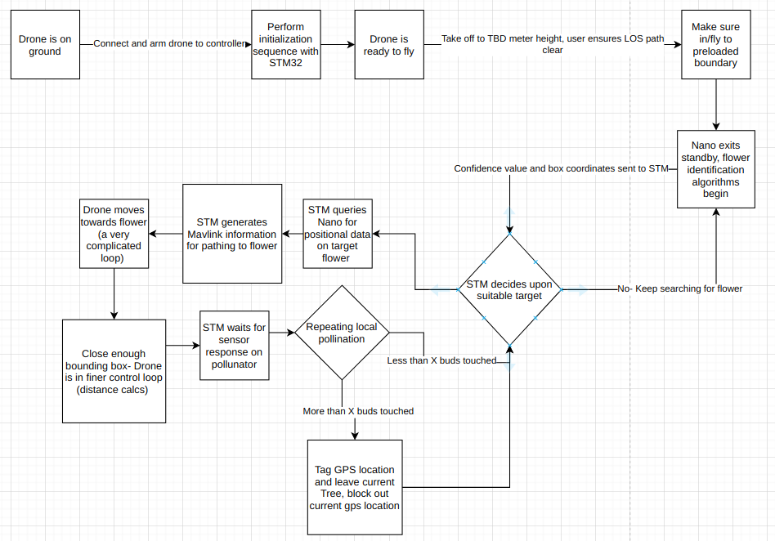

Figure 1: functional block diagram

The purpose of the pollination drone is to collect some pollen from one flower/ tree and deposit it on another flower/tree. It is important for the drone to not stay in the same location but continually move around the field since apple trees are not self pollinating [3]. The microcontroller will issue flight instructions to and poll telemetry data from the PixHawk flight controller using the MAVLink protocol [1]. The microcontroller will keep track of the number of flowers visited in a segment of the field to ensure it is pollinating between trees.

The Jetson Nano is attached to a USB camera. It analyzes the incoming video feed frame by frame to determine bounding box coordinates of apple blossoms in its field of view. We will be using a deep convolutional neural network object detector on the nano to obtain the coordinates. The microcontroller will interface with the Jetson using the Serial Peripheral Interface (SPI). Bounding box and confidence data are sent to the microcontroller. The system uses this data to direct the drone towards the bounding box of the flower. The control algorithm will take into account centering the bounding box in frame, making it bigger in frame, and aiming the appendage towards the center of the box.

The pollinator appendage will be attached to a servo motor and have a capacitive touch sensor at the end to detect contact. The pollinator appendage will use animal hairs (horse hairs are easily attainable from paint brushes) attached to the end for adequate pollen collection and deposition [4]. The servo will be controlled using a PWM signal, where certain duty cycles correspond to certain angles.

The microcontroller communicates with the battery monitor IC with the I2C (or UART depending on model) interface. The microcontroller will continually monitor the amount of flight time remaining with current battery levels. When the battery reaches near depletion, the system will direct the drone to land to avoid a crash.

Figure 1 describes how the different systems interact with each other. On start up, the STM32H7 will direct the drone towards the orchards if it is not already there. Next it will turn on the image detection software and begin to direct the drone towards optimal flowers. The STM will direct the drone towards a flower until it detects contact. It will then direct the drone towards a flower in the same locality as the one touched. Once a certain number have been touched in one locality (tracked using GPS coordinates from Pixhawk), it will direct the drone to a new area. Not shown on the diagram is that once the battery percentage becomes near 20% (monitored continuously), the STM will direct the drone to land.

3.0 Expected Usage Case

Our project is intended to be a highly mobile drone that will require minimal human input to operate. This drone is expected to operate autonomously once it has been given the GPS coordinates of its geographic position to operate in. After this region has been identified the drone will continually perform a loop to mate with flowers and collect their pollen before moving onto another tree. This product is designed to be used by apple farmers and as a result our product is designed to require little technical literacy on the algorithms contained within for proper use. All the farmer would need to do to ensure proper operation is know the dimensions of their farm accounting for LOS obstructions and monitor weather conditions before use. Due to the nature of its outdoor use case we are advising the drone not be used during rain storms or pre tornado wind conditions. While we are designing the drone to be able to fly stably in the wind, sudden high strength gusts allow for the risk of the drone being blown into a tree therefore damaging the blossoms.

4.0 Design Constraints

4.1 Computational Constraints

The computational constraints for the pollination drone can be separated into two categories: processes done with the STM32H745, and processes done on the Nvidia Jetson Nano. The STM32H745 will be responsible for flight decisions and the Nano will be responsible for the computer vision. There are two modes of operation for the Nano: high power and low power. The high power mode will be enabled whenever the Nano is required to do computer vision tasks. Low power mode will be used when the drone is navigating between long range destinations. The Jetson Nano will be processing video either from a USB camera or a MIPI CSI camera [7]. Using a neural network, the Nano will detect flowers from the video stream and pass the data via SPI to the STM32. In high power mode the Nano will be using its full computational load to process the video stream through the neural network. The STM32H745 will query the nano for positional data of potential flowers, along with heuristics. The STM32H745 will then decide which potential flower to pollinate based on the heuristics and flight plan information. This will not be computationally intensive for the STM32H745. Additionally, the STM32H745 will decide when to switch flowers and Nano power modes, return home, and land.

The STM32H745 will also have to interface with the Pixhawk 4 Mini via the MAVLink protocol. via UART. From the Pixhawk, the STM23H745 will retrieve navigational data.

While close to the flower, the drone will have to make rapid calculations. If the Nano is processing the video stream through the neural network too slowly, the Nano will switch to geometrical processing on the video stream. This method will be much faster, and allow the STM32H745 to query the Nano at a faster rate.

The STM32H745 is equipped with 2 Megabytes of flash memory. This means our program must be small enough to fit within 2 Megabytes. This is not an especially challenging constraint.

The STM32H745 has 1 Mbyte of RAM. This means our stack and heap must fit within 1 Mbyte. So, our flower buffer data cannot be very large.

The Jetson nano has 4 GB of RAM. This will mostly be consumed by the video stream, but it should still be sufficient for our needs.

4.2 Electronics Constraints

The system has five main parts. The microcontroller, the nano, the flight controller (and all other associated flight hardware), the battery monitor IC and the pollination appendage. The microcontroller will communicate with the nano over SPI. The microcontroller will implement the MAVLink protocol over the UART interface to the PixHawk flight controller. The microcontroller will have to use UART or I2C to communicate with the battery monitor IC depending on which model is selected. The pollination appendage will be controlled with a servo, which will be actuated by a PWM signal, where different duty cycles correspond to different angles. The capacitive touch sensor at the end of the appendage will require a single I/O pin.

The supporting hardware for the flight system includes four ESC’s (one for each brushless motor), a radio receiver, a power distribution board, and a GPS module. Since these items are mostly plug and play out of the box and directly interface with the PixHawk flight controller and not the microcontroller (the main focus of our efforts), the details of their communication are not our concern.

4.3 Thermal/Power Constraints

After reviewing the thermal constraints of the Jetson Nano, STM32, and pixhawk 4 mini we must ensure that each board's critical components remain below 95 degrees C, 110 degrees C and 85 degrees C respectively. However, due to the nature of our drone flying in the air we do not foresee large build ups of heat to be a major issue. Based upon calculations done for our drone’s power consumption we are currently projecting our drone to have an active flight time of 10 minute before having to return for recharging to ensure proper battery health. To determine this amount of flight time some assumptions were made about the drone’s activity during flight. First off, it was assumed that the drone would spend sixty percent of its time in flight in a hovering mode. This means that the drone will be using only as much power as required to keep the drone at its current height. Next it was assumed that forty percent of the time would be spent lifting the drone which we specified to be a thrust to weight ratio (T/W) of 1.5x. This T/W was chosen so that we can ensure greater stability in our flight without taking sharp motions.

However, this breakdown of sixty-forty hovering to lifting respectively resulted in a power consumption of 383.6W for the motors. After running a rudimentary power analysis on the Nano, we expect it to consume 8W on average. These two major power consumers resulted in a total power consumption of 391.6W. To determine the approximate flight time for our drone we divided this wattage by the total watts in our battery at full capacity. Since we are going to be running this project for proof of concept purposes, we are planning on having a 10 minute flight time to demonstrate our image detection algorithm and pollination process. In addition to this, we are planning to simply swap out batteries from our balance charger with a target charging speed of 20 minutes in order to limit down time for battery swaps between runs of the drone.

4.4 Mechanical Constraints

*Weight Constraints:*

Motor thrust is 1380g \* 4 = 5,520g, so our total weight must be ideal ½ of this for best control [5].

Below is the total weight of our components:

|  |  |  |
| --- | --- | --- |
| Item On Board | Weight (g) | Product/vendor website: |
| Drone Frame | 599g | [HobbyKing](https://hobbyking.com/en_us/hobbyking-super-h-600-quadcopter-kit.html?queryID=7febae66a5120566e1b5993f69a06456&objectID=18118&indexName=hbk_live_magento_en_us_products) |
| Jetson Nano a02 | 249g | [Nvidia](https://developer.nvidia.com/embedded/jetson-nano-developer-kit) |
| Brushless Motor (4) | 288g total | [SunnySkyUSA](https://sunnyskyusa.com/products/sunnysky-x2216-brushless-motors) |
| Speed controllers (4) | 36g total | [HobbyKing](https://hobbyking.com/en_us/blheli-s-30a.html?queryID=e2ad57aa4779f92ecbfbdc8201107f5e&objectID=59322&indexName=hbk_live_magento_en_us_products) |
| Propellers (4) | 15g total | [APC](https://www.apcprop.com/product/11x4-7sf-b4/) |
| Battery | 574g | [HobbyKing](https://hobbyking.com/en_us/turnigy-heavy-duty-5000mah-4s-60c-lipo-pack-w-xt-90.html?queryID=7d7ea692d3266b865667f8e1c3656d24&objectID=69111&indexName=hbk_live_magento_en_us_products) |
| Pixhawk4 mini | 37g | [HolyBro](https://shop.holybro.com/pixhawk4-mini_p1120.html) |
| STM32H7 dev board | 120g | [Mouser](https://www.mouser.com/ProductDetail/STMicroelectronics/NUCLEO-H743ZI2?qs=lYGu3FyN48cfUB5JhJTnlw%3D%3D&gclid=CjwKCAjwqML6BRAHEiwAdquMnezYtSUfwFOVVK-qWvOiWTB8AbiNCVwjWLFnWNncyxM gkeqXIzvVoBoCXUkQAvD_BwE) |
| **Total on board mass:** | 1,918 g |  |

Total on board mass is computed with development kits on board. Our current device weight is very close to our maximal weight, so throughout our project we must be very cognizant to avoid adding additional weight to the payload. Additionally, beyond prototyping, the removal of hardware from developer kits to PCB’s could reduce weight. Therefore, we are within our allowable weight range, but we recognize that this is a critical requirement.

*Size and Hardware Placement constraints:*

The drone platform for mounting hardware is 11.5” by 3”. There are two platforms on the drone. All of our hardware and battery must fit on two 11.5” and 3” platforms.

The front rotors of the drone extend 8.5” from the front of the drone platform. The appendage must be, at least, 9” to avoid collision with the plant; however, this is an ideal circumstance and additional 6” or more would be best to avoid damaging the plant with the rotors and wind generated from the rotors. This metric should be tested with the prototype and appendage length shall be adjusted accordingly.

*Packaging:*

We are going to advise our user to fly the drone in good weather without rain or excessive wind. Avoiding drone operation in rain is justifiable in that pollinators do not pollinate in rain, and, if pollen grains come into contact with water, it can be damaging to the pollen [6]. Nonetheless, our packaging is going to have to be both lightweight (as to not exceed mass constraints) and have ventilation for the hardware. We will have to carefully design the packaging to make sure, for example, dew does not drip onto the hardware. Thus, our packing is going to have to be water resistant from the side facing the plant, perhaps with a vent on the posterior end of the drone to prevent overheating of hardware. Because our drone will not be enduring excessive mechanical shocks (it touches the flower lightly), the durability of our packaging is constrained to surviving at most the shock of landing.

4.5 Economic Constraints

Based on our competitor analysis we have not found a project that performs the specific service that we are planning on providing. However, there are several companies and methods for conducting artificial pollination of plants where insects, such as bees, are unable to complete the job. One such solution is Dropcopter, which charges farmers three hundred dollars per acre in addition to the cost of pollen to pollinate their fields [8]. However, dropcopter relies on a process called dust pollination which according to MIT results in an estimated pollination to be seventy-five percent less effective than traditional insect pollination, with an additional side effect of fruits being approximately forty percent smaller when compared to traditional insect pollination [9].

According to this same article from MIT the method of hand pollination is expected to be the same level of efficiency as traditional pollination or even better given intentional biodiversity considerations. However, the going rate for hand pollination is between $2,313 - $2,888 per acre depending on labor fees [9]. Our drone aims to conduct hand pollination autonomously throughout an orchard. Based upon the prices listed above we would like to charge four hundred to six hundred dollars per acre for our services.

4.6 Other Constraints

Because this drone is fairly large, it could potentially damage people or property. The drone must have safety features to minimize the risk of harming individuals. The drone also must not damage the trees/flowers it is trying to pollinate.

One safety constraint that is critical to development of the drone is human supervision. Whenever the drone is on, an observer will always have their finger on the remote kill switch.

Additionally, the drone will have a safety protocol loop running with high priority that monitors for any unusual sensor data. If any anomalies are detected, the drone will initiate a shutdown sequence.

For safety purposes, the drone will have a manual override mode. The manual override mode will allow the flight operator to take over control of the drone with a RC receiver controller.

5.0 Sources Cited:

1. “MAVSDK, The Standards Compliant SDK for MAVLink,” Dronecode. <https://www.dronecode.org/sdk/> (accessed Sep. 03, 2020).
2. Jahed, Khalil Rahman, "Male and female interaction in apple: Pollen tube growth, fruit set, fruit quality, and return bloom" (2015). Open Access Theses. 495. <https://docs.lib.purdue.edu/open_access_theses/495>
3. J. B. Free, B. D. Smith, K. G. Stott, and I. H. Williams, “The pollination of self-fertile apple trees,” Journal of Horticultural Science, vol. 49, no. 3, pp. 301–304, Jan. 1974, doi: 10.1080/00221589.1974.11514583.
4. S. A. Chechetka, Y. Yu, M. Tange, and E. Miyako, “Materially Engineered Artificial Pollinators,” Chem, vol. 2, no. 2, pp. 224–239, Feb. 2017, doi: 10.1016/j.chempr.2017.01.008.
5. J. Reid, “Multirotor Motor Guide,” Rotor Drone Pro. [https://www.rotordronepro.com/guide-multirotor-motors/#outer-popup](https://www.rotordronepro.com/guide-multirotor-motors/" \l "outer-popup) (accessed Sep. 03, 2020).
6. K. Garvey, “Five reasons why all this rain is bad for almond pollination season,” Bug Squad. [https://ucanr.edu/blogs/blogcore/postdetail.cfm?postnum=23286#:~:text=Honey%20bees%20usually%20neither%20forage,tubes%20are%20supposed%20to%20emerge](https://ucanr.edu/blogs/blogcore/postdetail.cfm?postnum=23286" \l ":~:text=Honey bees usually neither forage,tubes are supposed to emerge) (accessed Sep. 03, 2020).
7. MIPI. 2020. MIPI Camera Serial Interface 2 (MIPI CSI-2). [online] Available at: <https://www.mipi.org/specifications/csi-2> [Accessed 3 September 2020].
8. “Syracuse drone company offers orchards alternative to bees - syracuse.com.” https://www.syracuse.com/business/2019/10/syracuse-drone-company-offers-orchards-alternative-to-bees.html (accessed Sep. 03, 2020).
9. [1]M. H. Allsopp, W. J. de Lange, and R. Veldtman, “Valuing Insect Pollination Services with Cost of Replacement,” PLoS ONE, vol. 3, no. 9, p. e3128, Sep. 2008, doi: 10.1371/journal.pone.0003128.