Mechanical Overview

Year: 2020 Semester: Fall Team: 4 Project: Sowin Seeds

Creation Date: 09/23/2020 Last Modified: 09/23/2020

Author: Moiz Rasheed Email: [mrasheed@purdue.edu](mailto:mrasheed@purdue.edu)

Assignment Evaluation:

|  |  |  |  |  |
| --- | --- | --- | --- | --- |
| **Item** | **Score (0-5)** | **Weight** | **Points** | **Notes** |
| **Assignment-Specific Items** | | | | |
| **Commercial Packaging Analysis 1** | 4.5 | x2 |  |  |
| **Commercial Packaging Analysis 2** | 4.5 | x2 |  |  |
| **CAD Model Illustrations** | 5 | x4 |  |  |
| **Project Packaging Specifications** | 5 | x2 |  |  |
| **PCB Footprint Layout** | 4.5 | x2 |  |  |
| **Writing-Specific Items** | | | | |
| **Spelling and Grammar** | 5 | x2 |  |  |
| **Formatting and Citations** | 5 | x1 |  |  |
| **Figures and Graphs** | 5 | x2 |  |  |
| **Technical Writing Style** | 5 | x3 |  |  |
| **Total Score** | 97 | | |  |

5: Excellent 4: Good 3: Acceptable 2: Poor 1: Very Poor 0: Not attempted

Comments:

*Excellent work with the CAD design. Please check my comments.*

1. Commercial Product Packaging
   1. Product #1: Dropcopter

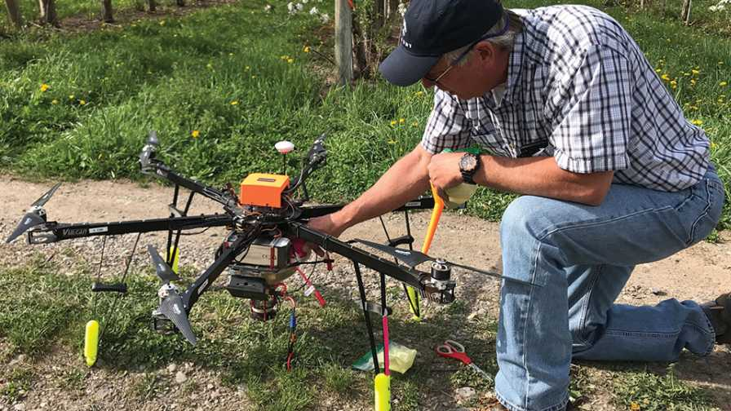

Figure 1: Dropcopter drone

Dropcopter is a company that provides the service of pollinating orchards. Their drone is a 3 ft wide hexacopter with a small pollen dispersal system underneath. The drone has large stand-offs such that it stands about a foot and a half tall. This is to accommodate for the pollen dispersal system that sits underneath the frame and rotors. [1]

The increased number of rotors allows them to produce more thrust but this is a tradeoff with their increased size and power consumption from the motors. However, this may require less torque from each motor, causing them to operate in their area of peak efficiency, consuming less power per motor. The copter’s size is also due to the large pollen spreading carriage hanging underneath.

Our project will be a quadcopter on a 600mm frame. Hexacopters are useful for heavy lifting and stability. Our project requires more maneuverability. Our frame is 600mm diagonally. Not as large as dropcopter’s but larger than the ideal. This is mainly due to revision 1/prototyping reasons. Our quadcopter is also significantly shorter. The small standoffs on our copter’s arms (DJI flame wheel 450) are more than enough since we do not have a large payload hanging underneath. For their purposes, dropcopter’s design is adequate, however our product is an improvement in pollination methodology. Instead of having to buy or collect pollen from elsewhere and then distribute it, we are taking inspiration from natural pollinators that just redistribute the existing pollen from the flowers in the area.

* 1. Product #2: Miyako Tiny Drone Pollinator Research Project

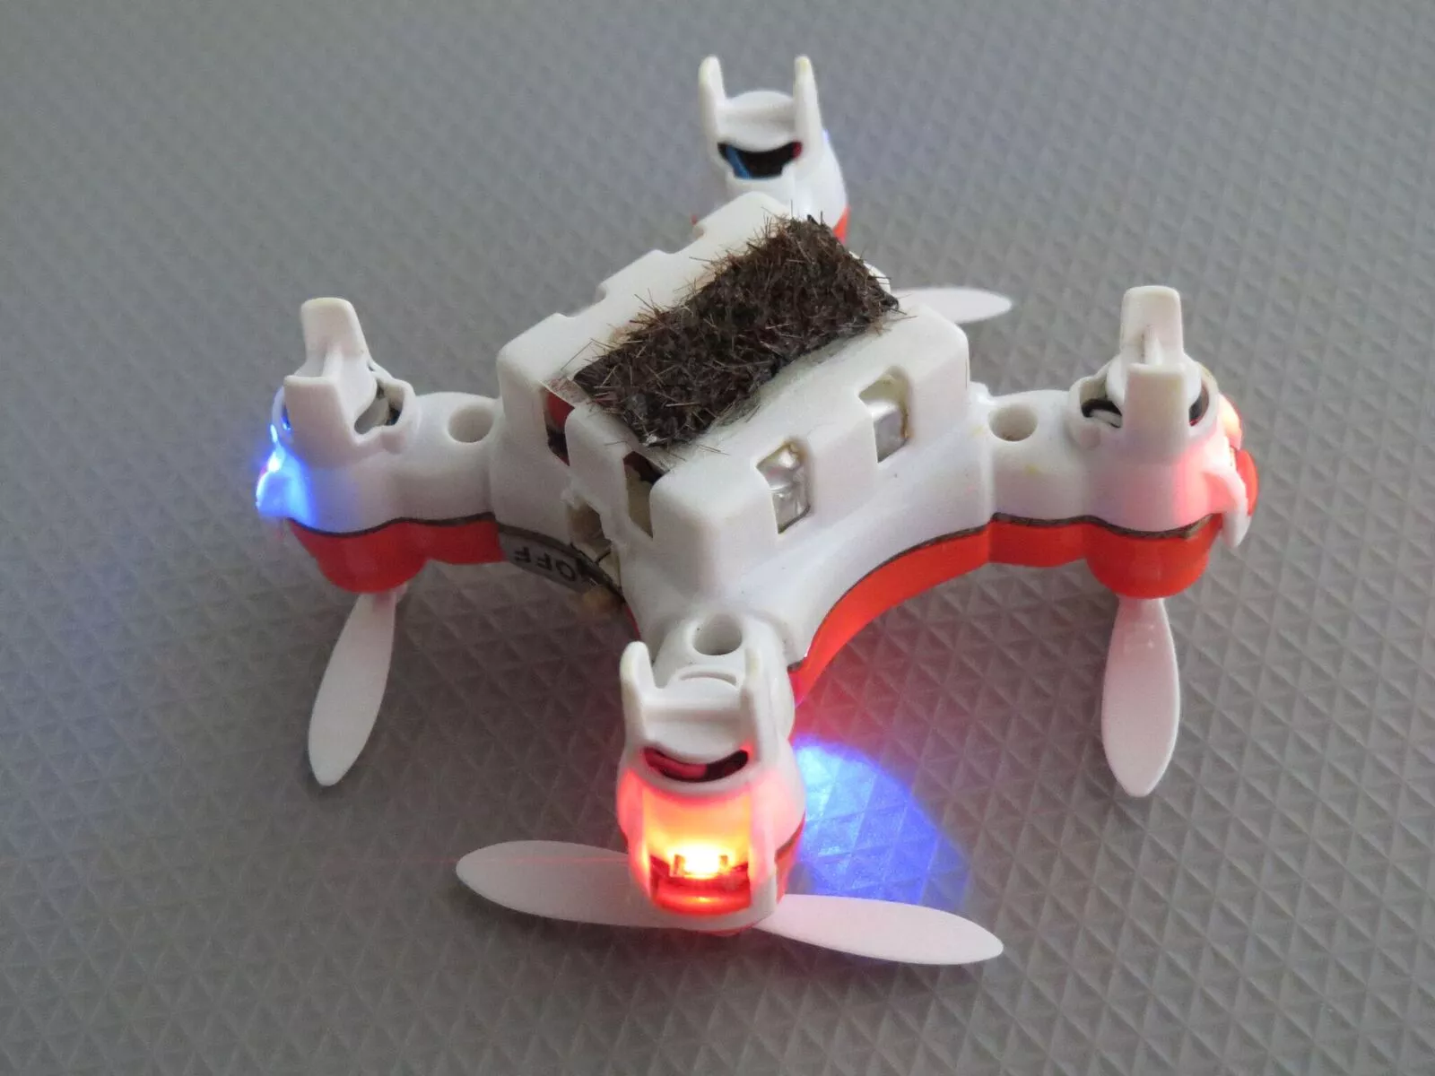

Figure 2: Miyatso’s Amazon Drone

Miyatso’s research team used a tiny 4x4cm plastic drone purchased on Amazon to carry out their experiment. They attached a strip of horse hairs coated in Miyatso’s special gel he developed which improves the pollen retainment and deposition properties of the hairs. The drone uses DC motors and is piloted manually. [2][3]

The drone’s small size is ideal as the propellers cause little wash, disturbing the flowers less. However, this pro is counteracted by its small size as well. The frame cannot support an appendage, so the pollen collecting/depositing mechanism is attached to the body of the drone. Therefore, the drone must effectively body slam the flower. This, combined with the manual control of the drone, caused the propellers to damage the petals of the lily. A lily is the only flower suited to this size of drone and placement of pollen collection mechanism because of its large size and splayed out gonads.

The body of our drone is made of carbon fiber and high density polyethylene. The large size of our drone and electronic cargo necessitates these materials to maintain the structural integrity of the drone. However, ideally we would eventually like our drone to reach these small sizes in future revisions. This research project has informed us though, that even with a small drone, a probe will be necessary to avoid damaging the petals and reach into flowers with a more conservative display of their gonads.

3.0 Sources Cited

[1]“Bee Free! How Growers Can Pollinate with Drones - Growing Produce.” https://www.growingproduce.com/fruits/bee-free-how-growers-can-pollinate-with-drones/ (accessed Sep. 24, 2020).

[2]“Watch This $100 Drone Try to Do a Bumblebee’s Job | MIT Technology Review.” https://www.technologyreview.com/2017/02/09/243611/watch-this-100-drone-try-to-do-a-bumblebees-job/ (accessed Sep. 24, 2020).

[3]“Amazon.com: Pocket RC Quadcopter Mini Drone Nano for Kids and Adults Portable Helicopter RTF Micro Plane with Headless Mode, 3D Flip, Speed Adjustment, LED Lights, 2.4Ghz 6 Axis Gyroscope, Children’s Day Gift: Toys & Games.” https://www.amazon.com/Quadcopter-Portable-Helicopter-Adjustment-Gyroscope/dp/B07ZK4C5TN/ref=sr_1_13?dchild=1&keywords=tiny+drone&qid=1600982018&sr=8-13 (accessed Sep. 24, 2020).

Appendix 1: CAD Model Illustrations

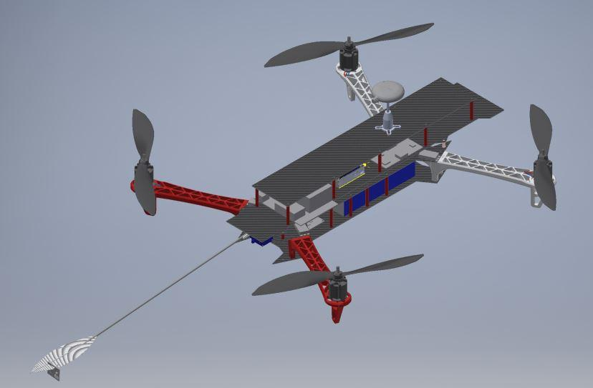

Figure 3: Drone model

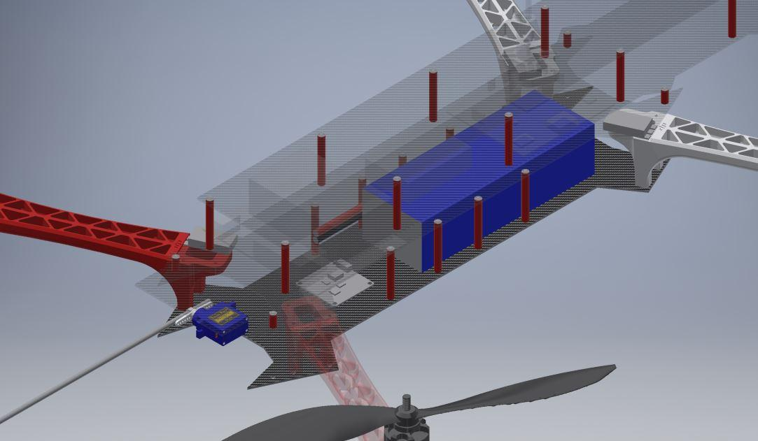

Figure 4: Drone battery and PDB positioning

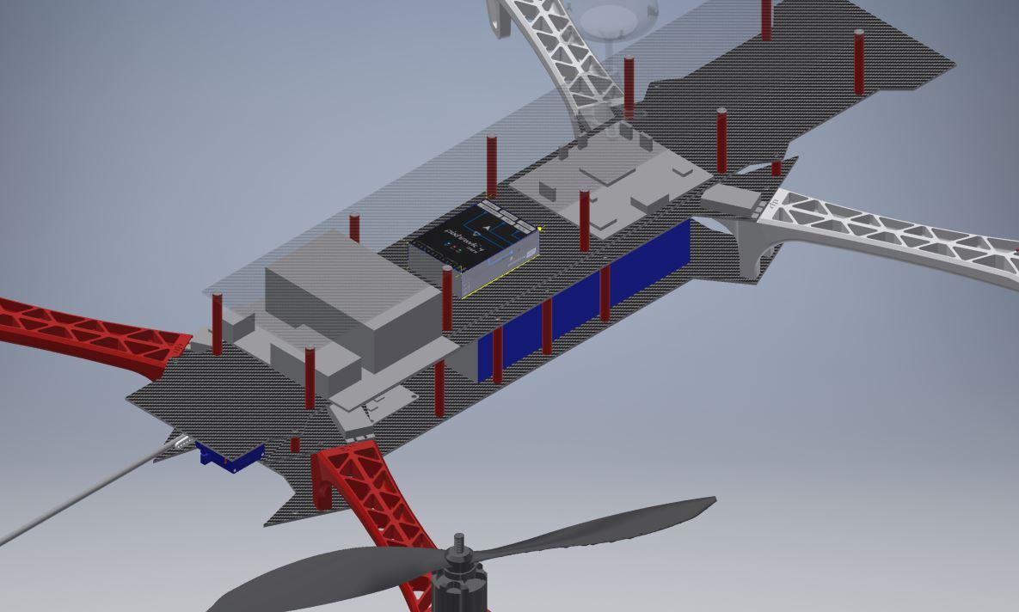

Figure 5: pixhawk, nano, and pcb mounting

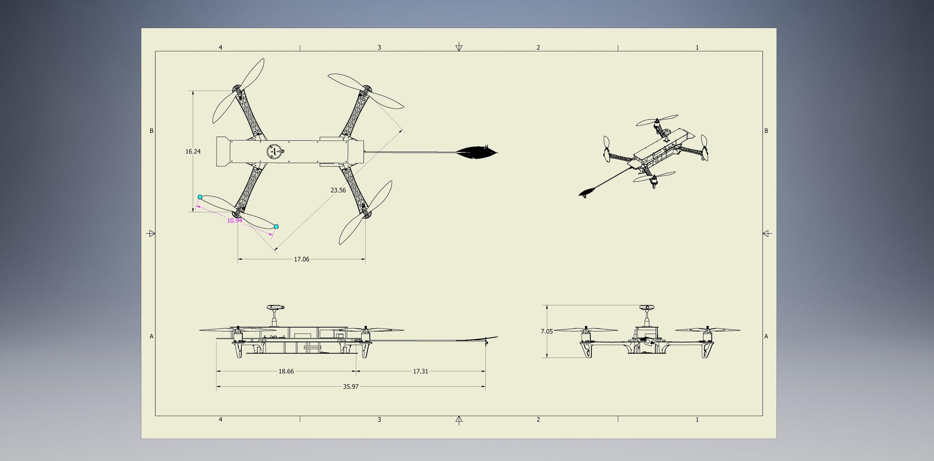

Figure 6: Drone dimensions. Units in inchesAppendix 2: Project Packaging Specifications

|  |  |  |  |
| --- | --- | --- | --- |
| **Material** | **Tools Required** | **Weight (g)** | **Cost ($)** |
| 600mm Drone frame set | alan screwdriver bit set | 600 | 13.00 |
| Dowel rod | saw, glue | 10 | 5.00 |
| feather/paint brush hairs | glue/tape | negligible | free |

Table 1: Materials

Appendix 3: PCB Footprint Layout

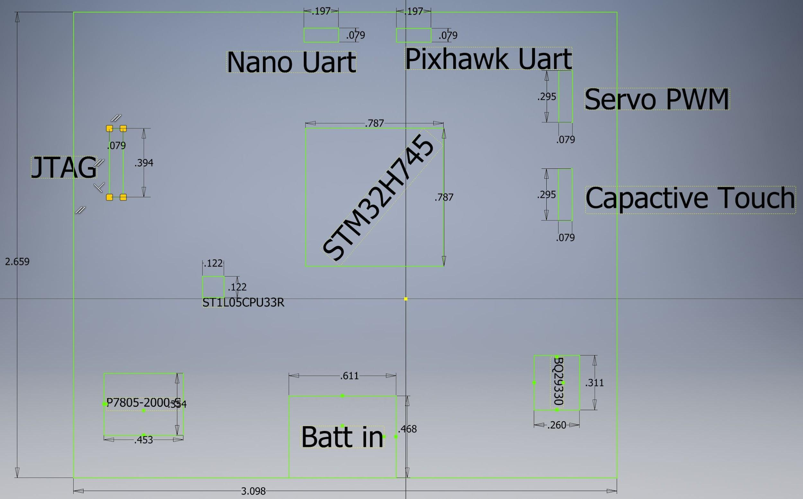

Figure 7: PCB layout. **dimensions in inches**

|  |  |  |
| --- | --- | --- |
| IC | Purpose | Package Type |
| STM32H745 | microcontroller | LQFP |
| BP29330 | battery monitor | TSSOP-30 |
| P7805-2000-S | battery to 5V regulator | through hole |
| ST1L05CPU33R | 5 to 3.3V regulator | DFN-6 (looking for alternatives) |
| Nano Uart, Pixhawk Uart, Servo PWM, Capacitive Touch, and JTAG | interfaces | breakout pins |

Table 2: PCB components

Area = 8.2 in^2