CSE 141L Milestone 2

John Adams A16499049

# Academic Integrity

Your work will not be graded unless the signatures of all members of the group are present beneath the honor code.

To uphold academic integrity, students shall:

* Complete and submit academic work that is their own and that is an honest and fair representation of their knowledge and abilities at the time of submission.
* Know and follow the standards of CSE 141L and UCSD.

Please sign (type) your name(s) below the following statement:

I pledge to be fair to my classmates and instructors by completing all of my academic work with integrity. This means that I will respect the standards set by the instructor and institution, be responsible for the consequences of my choices, honestly represent my knowledge and abilities, and be a community member that others can trust to do the right thing even when no one is watching. I will always put learning before grades, and integrity before performance. I pledge to excel with integrity.

John P Adams

# 0. Team

John Adams.

# Introduction

Name: TMR (too many registers)

Philosophy: Use specialized registers so you can do more “stuff” without having to specify where it comes from.

Goals: make a cpu that was:

* easy to code for (lots of registers, designed with for loops in mind, 8-bit literals, many math operations)
* entirely from scratch, because why would you learn how to use an api when you can spend twice as long writing and debugging your version.

My cpu is a Load-Store (register-register) architecture. Although by using one of the address registers, it would be possible to implement a stack in software with only 2 instructions for push (stor b {reg}, incr b) and pop (load b {reg}, decr b).

# Architectural Overview

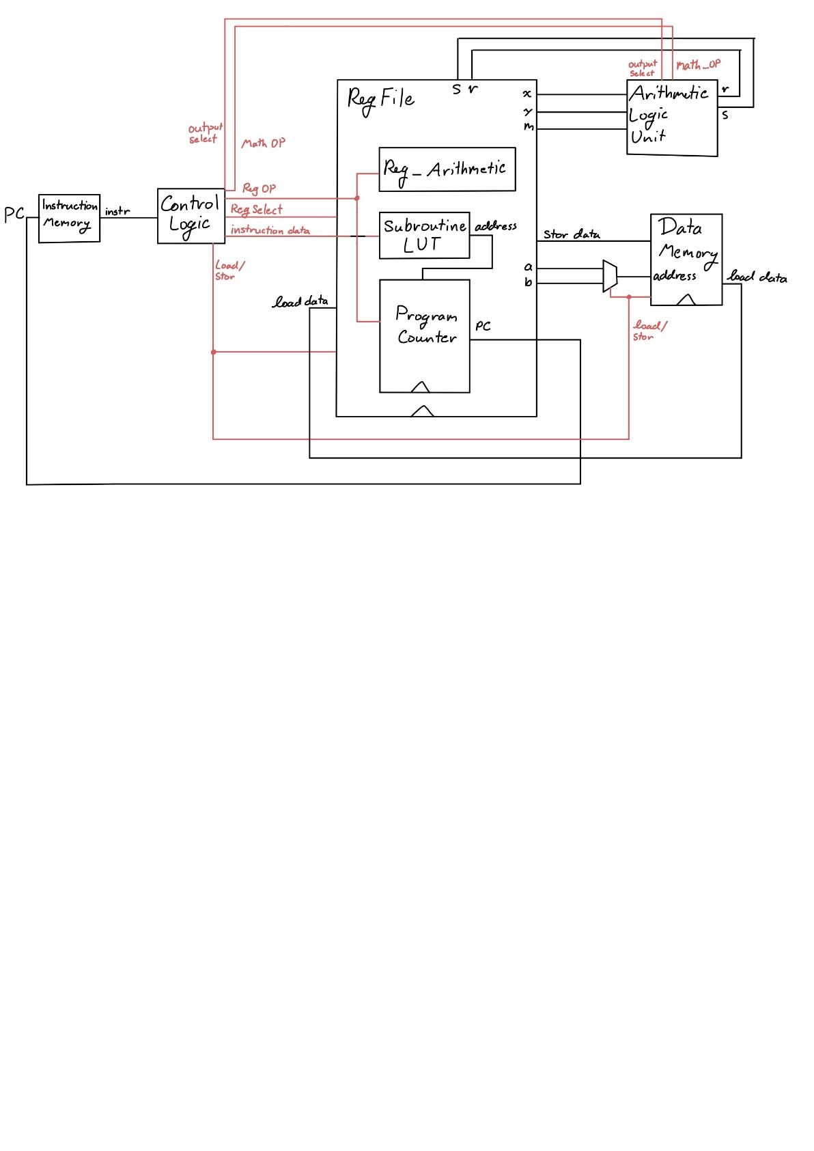

# Machine Specification

## Instruction formats

|  |  |  |
| --- | --- | --- |
| **TYPE** | **FORMAT** | **CORRESPONDING INSTRUCTIONS** |
| I | 5-bit OP code, 4-bit val | vall, valh, jtsr |
| R | 5-bit OP code, 4-bit reg | movc, movd,  movm, movn, movx, movy,  mova, movb, movi, movj,  movk, movv, movz,  bizr, bnzr, incr, decr, flip |
| F | 5-bit OP code, 4-bit operand | mthr, mths, func |
| I’ | 5-bit OP code, 1-bit reg, 3-bit val | jizr, jnzr, lslc, lsrc, seth |
| R’ | 5-bit OP code, 1-bit reg, 3-bit reg | load, stor |

## Operations

|  |  |  |  |  |
| --- | --- | --- | --- | --- |
| **NAME** | **TYPE** | **BIT BREAKDOWN** | **EXAMPLE** | **NOTES** |
| vall  value register low nibble | I | 5-bit OP code (00000)  4-bit value (XXXX) | # let v hold b00110000  vall 4’b1010  # v now holds b00111010 |  |
| valh  value register high nibble | I | 5-bit OP code (00001)  4-bit value (XXXX) | # let v hold b00110000  valh 4’b1010  # v now holds b10100000 |  |
| jtsr  jump to subroutine | I | 5-bit OP code (11000)  4-bit value (XXXX) | # let LUT[3]= 10’b0100010111  # let pc hold 10’b0000000001  jtsr 4’b0011  # pc now at 10’b0100010111 |  |
| mov$  move to register | R | 1-bit OP code (0)  4-bit register (XXXX)  4-bit register (XXXX) | # let v hold b10001000  # let x hold b00000000  movx v  # x now holds b10001000 | mov is considered a single instruction, but is encoded at mov$ where $ is the name of the destination register (excluding r/s) |
| bizr  branch if zero | R | 5-bit OP code (10110)  4-bit register (XXXX) | # let r hold b00000000  # let pc hold 10’b1000100100  # let z hold b11000000  bizr r  # pc now at 10’b1011000000 | bizr/bnzr can only update the lower 8-bits of the program counter. |
| bnzr  branch if not zero | R | 5-bit OP code (10111)  4-bit register (XXXX) | # let r hold b00000000  # let pc hold 10’b1000100100  # let z hold b11000000  bnzr r  # pc now at 10’b1000100101  # branch was not taken |  |
| incr  increment register | R | 5-bit OP code (10010)  4-bit register (XXXX) | # let a hold b01010000  incr a  # a now holds b01010001 |  |
| decr  decrement register | R | 5-bit OP code (10011)  4-bit register (XXXX) | # let b hold b10000000  decr b  # b now holds b01111111 |  |
| flip | R | 5-bit OP code (11110)  4-bit register (XXXX) | # let n hold b00000000  # let c hold b00001011  flip c  # n now holds b00000100 | if reg[4] == 1: destination is n  otherwise: destination is m  xor the reg[2:0]th bit in the destination |
| amp  logical and | F | 5-bit OP code (1101X)  4-bit operation (0000) | # let x hold b11111100  # let y hold b00111111  mth r amp  # r now holds b00111100 | For all operations, source registers are x and y, and the result is stored in either r or s register |
| lor  logical or | F | 5-bit OP code (1101X)  4-bit operation (0001) | # let x hold b11111100  # let y hold b00111111  mth r lor  # r now holds b11111111 |  |
| flp  logical not | F | 5-bit OP code (1101X)  4-bit operation (0010) | # let x hold b11111100  mth r flp  # r now holds b00000011 |  |
| eor  logical exclusive or | F | 5-bit OP code (1101X)  4-bit operation (0011) | # let x hold b11111100  # let y hold b00111111  mth r eor  # r now holds b11000011 |  |
| rsc  right shift carry | F | 5-bit OP code (1101X)  4-bit operation (0100) | # let x hold b10111100  # let y hold b00111111  mth r rsc  # r now holds b11011110 | res = {y[0],x[7:1]} |
| lsc  left shift carry | F | 5-bit OP code (1101X)  4-bit operation (0101) | # let y hold b00111111  mth r lsc  # r now holds b00011111 | res = {x[6:0,]y[7]} |
| rol  rotate left | F | 5-bit OP code (1101X)  4-bit operation (0110) | # let x hold b11101000  # let y hold b00000011  mth r rol  # r now holds b01000111 | rotate x by value in y[2:0] |
| add  algebraic add | F | 5-bit OP code (1101X)  4-bit operation (0111) | # let x hold b00001111  # let y hold b00000001  mth r add  # r now holds b00010000 |  |
| sub  algebraic subtract | F | 5-bit OP code (1101X)  4-bit operation (1000) | # let x hold b00010110  # let y hold b00000111  mth r sub  # r now holds b00001111 |  |
| eql8  check for byte equality | F | 5-bit OP code (1101X)  4-bit operation (1001) | # let x hold b10101000  # let y hold b10101111  mth r eql8  # r now holds b00000000 |  |
| eql5  check for upper 5-bit equality | F | 5-bit OP code (1101X)  4-bit operation (1010) | # let x hold b10101000  # let m hold b10101111  mth r eql5  # r now holds b00000001 | tests for x[7:4] = m[7:4]  **note** this is the only math instruction that uses an register other than only x, y |
| revx  reverse byte x | F | 5-bit OP code (1101X)  4-bit operation (1011) | # let x hold b11110000  mth r revx  # r now holds b00001111 |  |
| revy  reverse byte y | F | 5-bit OP code (1101X)  4-bit operation (1100) | # let y hold b10100011  mth r revy  # r now holds b11000101 |  |
| parx  compute x parity | F | 5-bit OP code (1101X)  4-bit operation (1101) | # let x hold b00000111  mth r parx  # r now holds b00000001 |  |
| pary  compute y parity | F | 5-bit OP code (1101X)  4-bit operation (1110) | # let y hold b10101010  mth r pary  # r now holds b00000000 |  |
| ljp$  long jump | F | 7-bit op code (1111100)  2-bit operation (XX) | # let z hold 11111111  func ljp3  # pc now at 10’b1111111111 | ljp is part of the function group, and can be called by specifying func ljp$ where $ is the decimal representation of the upper 2 bits of the next program counter value. |
| strl | F | 9-bit op code  (111111100) |  |  |
| strh | F | 9-bit op code  (111111101) |  |  |
| rfsr  return from subroutine | F | 9-bit op code  (111111110) |  |  |
| done  set done flag | F | 9-bit op code  (111111111) |  |  |
| seth  set high | I’ | 5-bit OP code (11001)  1-bit register (X)  3-bit value (XXX) | # let m = b00001111  seth m 110  # m now holds b01001111 | m[val] = 1; |
| lslc  logical shift left with carry | I’ | 5-bit OP code (11100)  1-bit register (X)  3-bit value (XXX) | # let m = b00111100  # let n = b10000000  lslc m 1  # m now holds b01111001 | shifts (m/n) left by val, shifts in val highest bits from the other register (n/m) |
| lsrc  logical shift right with carry | I’ | 5-bit OP code (11101)  1-bit register (X)  3-bit value (XXX) | # let m = b00000101  # let n = b00001000  lsrc n 3  # n now holds b10100001 | shifts (m/n) right by val, shifts in val lowest bits from the other register (n/m) |
| jizr  jump if zero |  |  |  |  |
| jnzr  jump if not zero |  |  |  |  |
| load  load register |  |  |  |  |
| stor  store register |  |  |  |  |

## Internal Operands

There are 16 registers (since I needed 11, I added the other 5 to use up the rest of the 4-bits needed to pick between more than 8)

Several registers are special-purpose.

address: a, b - specify the memory address for load and store instructions

math: x, y - primary inputs for ALU

result: r, s - read-only result registers from ALU

bitwise: m, n - registers for bit-wise operations, and additional ALU input parameters (for special operations)

value: v - location for literal value instructions

branch: z - branch target

link: l - holds previous pc location after a jump to subroutine instruction

generic: c, d, i, j, k - generic registers for counters and other things.

## Control Flow (branches)

Note: cycles are a measure of jumping to a **user-specified address** (i.e. directly from a literal value).

There are two conditional branches (branch if zero and branch if not zero) which can update the lower 8-bits of the program counter to the value in the branch (z) register based on the value of any register (range:256, precision:1, cycles: 4).

There are 4 ways to update the program counter in code

* jmp instructions add or subtract (3’b * 2) from the program counter (range: 16, precision: 2, cycles: 1)
* jtsr (jump to subroutine) set the pc register to any of 16 predefined addresses (range:1024, precision:1, cycles:1)
  + also stores the previous pc address + 1 in the link (l) register
  + using multiple jtsr instructions in sequence does not store multiple values in the link register.
* rfsr (return from subroutine) restore the value of the pc register to the value in the link (l) register (range:1024, precision:1, cycles:1)
  + when manually setting the link register (l) this function can be used as a branch-always. However only the low 8-bits are accessible.
* long-jump functions modify the upper 2-bits of pc and load the branch (z) register into lower 8-bits (range:1024, precision:1, cycles:4)

## Addressing Modes

Memory is handled indirectly. Memory addresses must be stored in either of the two 8-bit address registers (a, b).

Load instructions can read either address register and store into only one of the 3-bit accessible registers (c, d, m, n, x, y) excluding the read-only result registers (r, s).

Store instructions can also read either address register and then store from only one of the 3-bit accessible registers (r, s, c, d, m, n, x, y).

# Programmer's Model [Lite]

**4.1** There are a large number of registers, each of which supports increment/decrement and can be the cmp source for branch instructions. This allows for simultaneous counters to exist at the same time, without sacrificing too much space for other important values. This is especially true of the memory address registers, allowing for a 2-instruction increment-load or decrement-load style sequential memory access.

The math x/y registers and result r/s registers are best suited to a particular workflow, that being load x, load y, compute > r, mov x <- r, compute > s, etc. A good example of this is a double-precision (16-bit) xor, which can be accomplished in 7 instructions. The relatively small distance provided by the conditional-relative-jump instructions makes it easier to do conditional branching forward, with one larger absolute jump back to the beginning of the program for looping processes.

The inclusion of a link register allows for simple 1-instruction branch to subroutines, and a 1-instruction return from that subroutine back to the main thread of execution. This encourages modularity of code, such that up to 16 different smaller programs can be executed from the main program. Additionally only their starting positions have to be noted, as the return-from-subroutine instruction utilizes the link register to continue execution.

**4.2** The arm instruction set is proprietary protected by copyright and patent such that a license is required to modify and reproduce the same instruction set. I got around this by not looking too much at the arm instruction set. I came up with my own set of instructions needed for the programs, added some more unique instructions, and made my ISA take advantage of special use registers, which are not part of the arm ISA.

**4.3** No, the ALU is not used in non-arithmetic instructions. There are two additional simplified arithmetic logic units inside the register file that handle calculating relative jumps and register increment/decrement operations. This reduces the amount of re-routing required to update registers (and since my ALU uses fixed input and output registers it is easier to implement it as a single-purpose ALU)

# Individual Component Specification

## **Top Level**

Module file name: top_level.sv

### **Functionality Description**

Consists of wires and the instantiations of the processor components. It also includes one mux for selecting between address registers (a/b).

### **Schematic**

## **Program Counter**

Module file name: program_counter.sv

Module testbench file name: tb_program_counter.sv

### **Functionality Description**

The program counter is a separate module located inside the register file. The register file decodes instructions from the controller and passes in a series of flags to the program counter that determine how it updates the counter.

Note: it is inside the register file module, but is entirely self-contained, I am just too lazy to add another 8 outputs to the register file to put the program counter on the top level.

### **(Optional) Testbench Description**

Test bench sets all the flags individually with different address inputs to test for branch conditions and standard incrementation of the counter.

### **Schematic**

### **(Optional) Timing Diagram**

## **Instruction Memory**

Module file name: instr_memory.sv

### **Functionality Description**

Stores the instructions used in the programs. It supports a size up to 1024 bytes, accessible using a 10-bit program counter.

It is a read only memory, and does not support writing during execution.

### **Schematic**

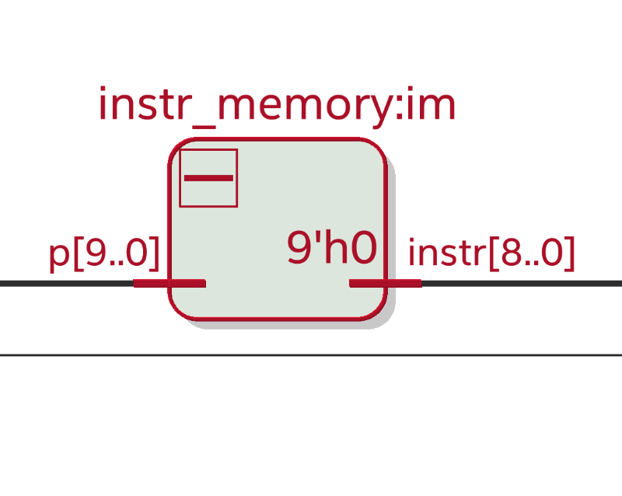

## **Control Decoder**

Module file name: control_logic.sv

### **Functionality Description**

This module decodes a 9-bit instruction into a

* Math operation selection and ALU flags
* Register File operation selection and flags (branch conditions)
* Memory Load/Store and address selection bit
* Done flag

### **Schematic**

## **Register File**

Module file name: register_file_r.sv

### **Functionality Description**

Holds all the registers, and has several sub-modules: program counter, subroutine look up table, register arithmetic.

The register file decodes register instructions from the control logic module (move, increment/decrement, branch/jump, subroutine, load/store, bitwise updates, and in-place shifting) and sets various flags according to the instruction to be executed. There are 3 distinct sections, one for setting flags, one for preparing data for the instruction, and one for executing the instruction (updating registers) on the following clock pulse.

### **Schematic**

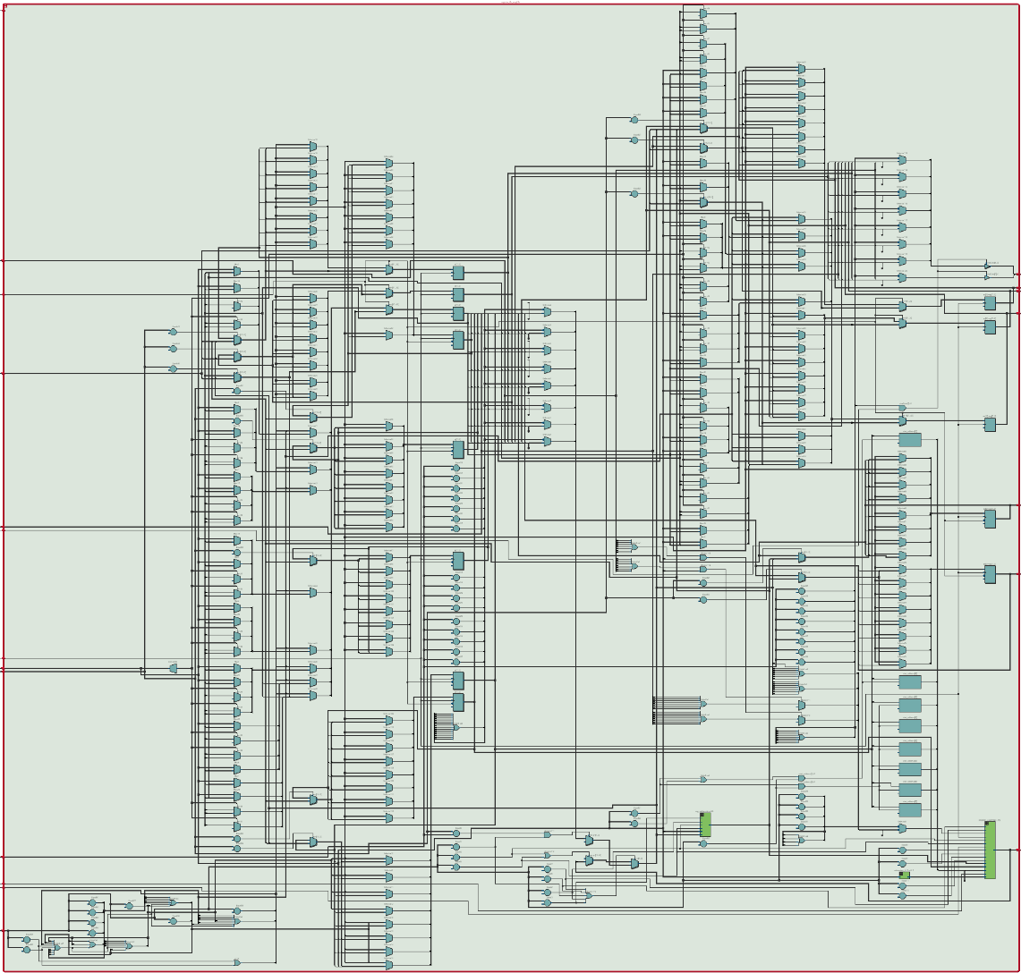

## **ALU (Arithmetic Logic Unit)**

Module file name: arithmetic_logic.sv

Module testbench file name: tb_arithmetic_logic.sv

### **Functionality Description**

Does one of 16 different math and logic operations on the two input registers x, y (except for 1 instruction that uses x and m). The result of the operation is stored in either the r or s output register dependent on the selection bit.

### **(Optional) Testbench Description**

The testbench performs each of the operations with 2 different pairs of inputs of x and y (except for test for upper-5-bit equality, which uses x and m).

### **ALU Operations**

logical and, logical or, logical not (x), logical exclusive or, logical right shift with carry-in (y>>x), logical left shift with carry-in (x<<y), rotate left (x), rotate right (x), add, subtract (x-y), test for equality (x==y), test for upper-5-bit equality (x[7:4] = m[7:4]), reverse x, reverse y, parity of x, parity of y.

### **Schematic**

### **(Optional) Timing Diagram**

## **Data Memory**

Module file name: data_memory.sv

### **Functionality Description**

Takes an address in, load/store flag, and data_in/data_out and either writes data into the specified address or loads data out of the address.

### **Schematic**

## **Look Up Tables**

Module file name: subroutine_LUT.sv

### **Functionality Description**

A 4-bit lookup table which outputs 10-bit addresses to the program counter during jump to subroutine instructions.

### **Schematic**

## **Other Modules (if necessary)**

Module file name: reg_arithmetic.sv

### **Functionality Description**

Takes in a 10-bit value and does one of 3 arithmetic operations: increment, decrement, add 4’bXXX0 (specified by the instruction). This enables any register to be incremented, as well as handles local jumps of the program counter. Contains Full-Adder modules (which are self explanatory).

### **Schematic**

# Program Implementation

Note: these look perfectly fine in a text editor, word is causing some ridiculous spacing. (just make sure tab-width=4)

## Program 1 Assembly Code

litl 1101 // program 1 start (1)

lith 0001

mova l // store 29 in a

litl 1011

lith 0011

movb l // store 59 in b

load a d // .load_routine

decr a // d= {00000, b11, b10, b9}

load a c // c= {b8, b7, b6, b5, b4, b3, b2, b1}

decr a

movm c // .parity_8

movn d // {n,m} holding data

lslc n 4 // n= {0, b11, b10, b9, b8, b7, b6, b5}

movm m // m= 8'b00000000;

lslc n 1 // n= {b11, b10, b9, b8, b7, b6, b5, 0}

movx m // x= m

mthr parx // r= ^x

jizr r 010 // if odd parity else jump by 0100 4 (pc = 22)

lith 0000

litl 1000

flip l // n^00000001

movd n // d= n= {b11, b10, b9, b8, b7, b6, b5, p8}

movm c // .parity_4 m= {b8, b7, b6, b5, b4, b3, b2, b1}

movn n // n= 00000000

lslc m 4 // m= {b4, b3, b2, b1, 0, 0, 0, 0}

lith 0001

litl 0000 // l= 00010000

movx l // x= 00010000

movy m // y= {b4, b3, b2, b1, 0000}

mthr amp // r= {000, b1, 0000}

lith 1110 // l= 11100000

movx l // x= 11100000

mths amp // s= {b4, b3, b2, 00000}

movc s // c= {b4, b3, b2, 00000}

lith 0000

litl 0001 // l= 00000001

movx r // x= {000, b1, 0000}

movy l // y= 00000111

mthr rol // r= {0000, b1, 000}

movx r // x= r

movy c // y= {b4, b3, b2, 00000}

mthr lor // r= {b4, b3, b2, 0, b1, 000}

movm r // m= r

movy d // y= {b11, b10, b9, b8, b7, b6, b5, p8}

litl 0000

lith 1111 // l= {11110000}

movx l // x= l

mthr amp // r= {b11, b10, b9, b8, 0000}

movx r // x= r

mthr parx // r= ^{b11, b10, b9, b8}

movy c // y= {b4, b3, b2, 00000}

mths pary // s= ^{b4, b3, b2}

movx r

movy s

mthr eor // r= ^{b11, b10, b9, b8, b4, b3, b2}

jizr r 010 // if odd parity else jump by 0100 4 (pc= 60)

lith 0000

litl 0100

flip l // m^0001000

movc m // c= m= {b4, b3, b2, p4, b1, 000}

movx c // .parity_2 x= c

lith = 1100

litl = 1100

movy l // y= 11001100

mthr amp // r= x&y = {b4, b3, 00, b1, 000}

movx d // x= {b11, b10, b9, b8, b7, b6, b5, p8}

mths amp // s= {b11, b10, 00, b7, b6, 00}

movx r

movy s

mthr parx // r= ^{b4, b3, b1}

mths pary // s= ^{b11, b10, b7, b6}

movx r

movy s

mthr eor // r= ^{b11, b10, b7, b6, b4, b3, b1}

jizr r 010 // if odd parity else jump by 0100 4 (pc = 79)

lith 0000

litl 0011

flip l // m^00000100

movc m // c= m= {b4, b3, b2, p4, b1, p2, 00}

movx c // .parity_1

lith 1010

litl 1010

movy l // y= 10101010

mthr amp // r= {b4, 0, b2, 0, b1, 000}

movx d // x= {b11, b10, b9, b8, b7, b6, b5, p8}

mths amp // s= {b11, 0, b9, 0, b7, 0, b5, 0}

movx r

movy s

mthr parx

mths pary

movx r

movy s

mthr eor // r= ^{b11, b9, b7, b5, b4, b2, b1}

jizr r 010 // if odd parity else jump by 0100 4 (pc= 98)

lith 0000

litl 0001

flip l // m^00000010

movc m // c= m= {b4, b3, b2, p4, b1, p2, p1, 0}

movx c // .parity_0

movy d

mthr parx

mths pary

movx r

movy s

mthr eor // r= {b11, b10, b9, b8, b7, b6, b5, p8, b4, b3, b2, p4, b1, p2, p1}

jizr r 010 // if odd parity else jump by 0100 4 (pc = 110)

lith 0000

litl 0000

flip l // m^00000001

movc m // c= m= {b4, b3, b2, p4, b1, p2, p1, p0}

stor b n // .stor_routine

decr b

stor b m

decr b

litl 0111 // .prog1_complete

ltlh 0000

movz l

bnzr a // branch if a != 0

movl l // l= 00000000

func strl // start_address = 0000000000

litl 0001 // l= 00000001

func strh // start_address = 0100000000

func done // done = 1;

## Program 2 Assembly Code

// program 2 start (256)

litl 1101

lith 0001

mova l // store 29 in a

litl 1011

lith 0011

movb l // store 59 in b

load b d // .load_routine

decr b // d= {b11, b10, b9, b8, b7, b6, b5, p8}

load b c // c= {b4, b3, b2, p4, b1, p2, p1, p0}

decr b

movm m // .parity_0

movn n // m= n = 0

movx c // x= c

movy d // y= d

mthr parx // r= ^{b4, b3, b2, p4, b1, p2, p1, p0}

mths pary // s= ^{b11, b10, b9, b8, b7, b6, b5, p8} (parity 8)

movx r

movy s

mthr eor // r= p0 = ^{b11, b10, b9, b8, b7, b6, b5, p8, b4, b3, b2, p4, b1, p2, p1, p0}

movm s // m= p8

lslc m 3 // m= {0000, p8, 000}

movn r // n= p0

litl 0000 // .parity_4

lith 1111

movy l // y= 11110000

movx c // x= {b4, b3, b2, p4, b1, p2, p1, p0}

mthr amp // r= {b4, b3, b2, p4, 0000}

movx d // x= {b11, b10, b9, b8, b7, b6, b5, p8}

mths amp // s= {b11, b10, b9, b8, 0000}

movx r // calculate parity with masked bits

movy s

mthr parx

mths pary

movx r

movy s

mthr eor // r= p4 = ^{b11, b10, b9, b8, b4, b3, b2, p4}

jizr r 0001 // if odd parity, else jump to 293

seth 0010 // m = {0000, p8, p4, 0, 0}

litl 1100 // .parity_2

lith 1100

movy l // y= 11001100

movx c // x= {b4, b3, b2, p4, b1, p2, p1, p0}

mthr amp // r= {b4, b3, 00, b1, p2, 00}

movx d // x= {b11, b10, b9, b8, b7, b6, b5, p8}

mths amp // s= {b11, b10, 00, b7, b6, 00}

movx r // calculate parity with masked bits

movy s

mthr parx

mths pary

movx r

movy s

mthr eor // r= p2 = ^{b11, b10, b7, b6, b4, b3, b1, p2}

jizr r 0001 // if odd parity, else jump to 309

seth 0001 // m= {0000, p8, p4, p2, 0}

litl 1010 // .parity_1

lith 1010

movy l // y= 10101010

movx c // x= {b4, b3, b2, p4, b1, p2, p1, p0}

mthr amp // r= {b4, 0, b2, 0, b1, 0, p1, 0}

movx d // x= {b11, b10, b9, b8, b7, b6, b5, p8}

mths amp // s= {b11, 0, b9, 0, b7, 0, b5, 0}

movx r // calculate parity with masked bits

movy s

mthr parx

mths pary

movx r

movy s

mthr eor // r= p1= ^{b11, b10, b7, b6, b4, b3, b1, p2}

jizr r 001 // if odd parity, else jump to 325

seth 0000 // m= {0000, p8, p4, p2, p1}

movi m // .error_correction i= m

movj n // j= {0000000, b0}

movm c

movn d // {n,m}= {b11, b10, b9, b8, b7, b6, b5, p8, b4, b3, b2, p4, b1, p2, p1, p0}

movy y

movx n

mthr lor // r= {0000000, b0}

mths amp // s= 00000000

jizr r 011- // if b0= 1, else pc= 339

flip i // flip bit in {n,m} in position i[3:0]= {p8, p4, p2, p1}

lith 0100 // (one error)

litl 0000 // l= 01000000

jizr s 101 // jump to 347

movk k // no op padding

movx i

mthr lor // r = {0000, p8, p4, p2, p1}

jizr r 011 // if b0= 0 && (p8|p4|p2|p1), else jump to 347

lith 1000 // (two errors)

litl 0000 // l= 10000000

jizr s 001 // jump to 346

movl l // (no errors) l= 00000000

movk l

movk l // k= {F1, F0, 000000}

movc m // store data in {d,c}

movd n

lith 1110 // .decode data

litl 1000

movy l // y= {11101000}

movx m // x= {b4, b3, b2, p4, b1, p2, p1, p0}

mthr amp // r= {b4, b3, b2, 0, b1, 000}

movm r // m= r

movn n // n= 00000000

lsrc m 011 // m= {000, b4, b3, b2, 0, b1}

lsrc n 001 // n= {b1, 0000000}

lsrc m 010 // m= {00000, b4, b3, b2}

lslc m 101 // m= {b4, b3, b2, b1, 0000}

movx d // x= {}

lith 0000

litl 0111

movy l // y= 00000111

mthr rol // r= {p8, b11, b10, b9, b8, b7, b6, b5}

movx r // x= r

lith 0111

litl 1111

movy l // y= 01111111

mthr amp // r= {0, b11, b10, b9, b8, b7, b6, b5}

movn r // n= r

lsrc m 100 // m= {b8, b7, b6, b5, b4, b3, b2, b1}

movc m // c stores lower decoded data

movm m // m= 00000000

lsrc n 100 // n= {00000, b11, b10, b9}

movx n // x= n

movy k // y= {F1, F0, 000000}

mthr lor // r= {F1, F0, 000, b11, b10, b9}

movd r // d stores upper decoded data

stor a d // .store_routine

decr a

stor a c

decr a

lith 0000 // check completion

litl 0101

movz l

bnzr a // if a!=0, then continue from 261 (0100000101)

movl l // l= 00000000

func strl // start_address = 0000000000

litl 0010 // l= 00000010

func strh // start_address = 1000000000 (512)

func done // done = 1;

## Program 3 Assembly Code

// program 3 (512) 1000000000

litl 0000 // .initialization

lith 0010

movc c // c= 00000000 (occurences in byte)

movd d // d= 00000000 (occurences across bytes)

movb l // b= 00100000 (32)

movi l // i= 00100000 (32)

mova a // a= 00000000 (0)

load a m // m= 01234567

incr a

decr i

movj j // j= 00000000 (occured in byte) .setup_next_byte

load b x // x= vwxyz000

load a n // n= 89abcdef .load_next_byte

incr a

decr i

mthr eql5 // r= (x[7:4] == m[7:4]) .check_pos0

jizr r 010 // if equal, else jump +4

incr c

incr j

incr j

lslc m 001 // m= {1234567, 8} .check_pos1

lslc n 001 // n= {9abcdef, 1}

mthr eql5 // r= (x[7:4] == m[7:4])

jizr r 010 // if equal, else jump +4

incr c

incr j

incr j

lslc m 001 // m= {234567, 89}

lslc n 001 // n= {abcdef, 12}

mthr eql5 // r= (x[7:4] == m[7:4])

jizr r 010 // if equal, else jump +4

incr c

incr j

incr j

lslc m 001 // m= {34567, 89a} .check_pos3

lslc n 001 // n= {bcdef, 123}

mthr eql5 // r= (x[7:4] == m[7:4])

jizr r 010 // if equal, else jump +4

incr c

incr j

incr j

lslc m 001 // m= {4567, 89ab} .check_pos4

lslc n 001 // n= {cdef, 1234}

mthr eql5 // r= (x[7:4] == m[7:4])

jizr r 001 // if equal, else jump +2

incr d

lslc m 001 // m= {567, 89abc} .check_pos5

lslc n 001 // n= {def, 12345}

mthr eql5 // r= (x[7:4] == m[7:4])

jizr r 001 // if equal, else jump +2

incr d

lslc m 001 // m= {67, 89abcd} .check_pos6

lslc n 001 // n= {ef, 123456}

mthr eql5 // r= (x[7:4] == m[7:4])

jizr r 001 // if equal, else jump +2

incr d

lslc m 001 // m= {7, 89abcde} .check_pos7

lslc n 001 // n= {f, 1234567}

mthr eql5 // r= (x[7:4] == m[7:4])

jizr r 001 // if equal, else jump +2

incr d

lslc m 001 // m= {89abcdef}

movx j // x= j (0 if no in-byte occurrences, >0 if atleast one)

movy y // y= 0

mthr lor // r= x= k

jizr r 001

incr k

litl 1010 // .check_completion

lith 0000

movz l // z=00001010 (10)

bnzr i // if i = 0, else jump back to 1000001010 (522)

movj j // j= 00000000 .last_byte0 -------------------------

movn n // n= 00000000

load b x // x= vwxyz000

mthr eql5 // r= (x[7:4] == m[7:4])

jizr r 010 // if equal, else jump +4

incr c

incr j

incr j

lslc m 001 // m= {1234567, 0} .last_byte1

mthr eql5 // r= (x[7:4] == m[7:4])

jizr r 010 // if equal, else jump +4

incr c

incr j

incr j

lslc m 001 // m= {234567, 00} .last_byte2

mthr eql5 // r= (x[7:4] == m[7:4])

jizr r 010 // if equal, else jump +4

incr c

incr j

incr j

lslc m 001 // m= {34567, 000} .last_byte3

mthr eql5 // r= (x[7:4] == m[7:4])

jizr r 010 // if equal, else jump +4

incr c

incr j

incr j

movx j // x= j (0 if no in-byte occurrences, >0 if atleast one)

movy y // y= 0

mthr lor // r= x= k

jizr r 001

incr k

lith 0010 // .store_complete

litl 0001

movb l // b= 00100001 (33)

stor b c // mem[33] = occurrences in byte

movm k

incr b

stor b m // mem[34] = bytes with occurrences

incr b

movx c

movy d

mthr add // r= (c + d) = (occurences in byte) + (occurences across bytes)

stor b r // mem[35] = total occurrences

func done

# Changelog

* Milestone 2
  + Architectural overview
    - Updated diagram.
  + Machine Specification
    - Instruction Format
      * Replaced movp instruction with jtsr to reflect architectural changes.
    - Operations
      * Added missing instructions (everything that wasn’t a math/logic instruction).
    - Internal Operands
      * Changed literal register (l) to value register (v).
      * Removed PC as a register (not allowed).
      * Added link register (l).
    - Control Flow
      * Removed the branch always (movp) instruction.
      * Added information on the new jtsr and rfsr instructions.
  + Programmer’s Model
    - 4.1 Added suggestion to use subroutines in code to reduce code reuse.
    - 4.3 Added response.
  + Individual Component Specification
    - Added components.
  + Changelog
    - Added changelog.
* Milestone 1
  + Initial version