Sleep Duration, Difficulty, and Health Correlates Among U.S. Adults (NHANES 2009–2011)
October 15, 2025
Table of Contents

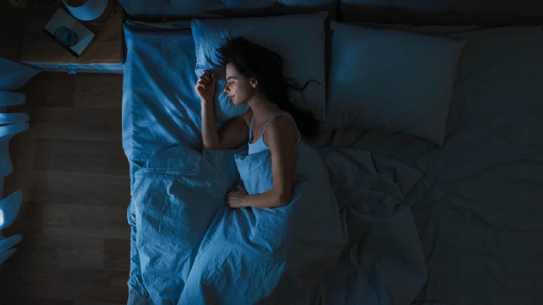

Introduction
Sleep is a crucial factor influencing physical, emotional, and cognitive health. Adequate sleep supports immunological response, metabolic balance, and mental resilience, while long-term sleep loss is associated with obesity, heart disease, anxiety, and depression (Cappuccio et al., 2010; Itani et al., 2017). Stressors, digital exposure, and changing work habits have all been recently linked to the widespread sleep disruptions that affect the length and quality of sleep in modern societies.
This project uses data from the NHANESraw (2009–2011) survey dataset, which is conducted by the Centers for Disease Control and Prevention (CDC) to monitor health and nutrition trends in the United States (Centers for Disease Control and Prevention [CDC], 2013). The dataset contains 20,293 responses (including all of the missing values). The purpose of this analysis is to investigate and illustrate the relationship between sleep patterns and demographic characteristics, lifestyle choices, and overall health, not to establish cause and effect. The assumption, however, is that BMI (Body-Mass-Index), mental health, age, gender, and amount of physical activity all have a significant effect on sleep.

Background
The Centers for Disease Control and Prevention (CDC) operates the National Center for Health Statistics (NCHS) program to administer the National Health and Nutrition Examination Survey (NHANES). The U.S. population’s health and nutritional status are assessed through a combination of laboratory testing, structured interviews, and physical examinations (Centers for Disease Control and Prevention [CDC], 2013). The NHANES incorporates both self-reported and objective medical data, in contrast to the majority of health surveys which only utilize questionnaires. This gives a comprehensive picture of how biological and lifestyle factors interact to affect the overall health of an individual.

Data and Cleaning Strategy
The NHANESraw dataset contained numerous missing values and data inconsistencies. For the purpose of preserving as many observations as possible, data cleaning was approached on a question-by-question basis. Rows with missing values were eliminated only for the variables pertinent to each analysis, as opposed to eliminating all incomplete records at once. For numerical variables, extreme outliers were removed to enhance the quality of the data. For instance, observations reporting less than 2 hours or more than 15 hours of sleep were not included in the SleepHrsNight variable because these values were deemed unrealistic.
To make comparisons easier, some variables were also re-coded or normalized. For example, in order to enable faceted visualizations by age range, the Age variable was binned into an AgeGroup column with categories of 16–24, 25–34, 35–44, 45–54, 55–64, 65–74, and 75+. Furthermore, inconsistent labels for categorical variables were standardized. The Race1 variable, which had distinct entries for “Mexican” and “Hispanic,” was one such example. For the purposes of maintaining consistency, all “Mexican” entries were recorded as “Hispanic,” since “Mexican” is a subgroup of “Hispanic.”
Overall, these focused cleaning and normalization processes enhanced dataset comparability and reliability across analyses, ensuring that the outcomes represented real relationships rather than artifacts.

Guiding Research Questions
This project aims to explore how demographic, behavioral, and health-related factors correlate with sleep duration and sleep difficulty among U.S. adults. The analysis began with ten exemplary questions, which were subsequently refined to seven primary research questions. Specifically, this study addresses the following:
- How does reported sleep duration relate to reported difficulty sleeping across age groups?
- How specifically does Reported General Health associate with Reported Sleep Trouble?
- How does the proportion of reported trouble sleeping vary by age group for males versus females?
- Among adults aged 21 years or older, what patterns in sleep duration are observed across different lifestyle groups (smokers, drinkers, both, or neither)?
- What is the relationship between reported physical activity and average sleep duration among adults in the United States?
- What association, if any, exists between daily screen time and nightly sleep duration?
- What is the observable relationship, if any, between reported average sleep duration and average blood pressure (systolic and diastolic) in adult participants?
Additional exploratory questions and visualizations that were considered, but not included in the final analysis are presented in the Appendix.

Results and Visualizations
QUESTION 1
Out of the six guided questions, three of them were ones that matched the initial assumptions for this project. The other four were somewhat of a surprise. The first question, for instance, explored the relationship between age groups and difficulty sleeping. The initial assumption was that age had a significant effect on sleep and that participants that reported having trouble sleeping slept for a fewer number of hours on average. The visualization and statistical test confirmed this assumption.
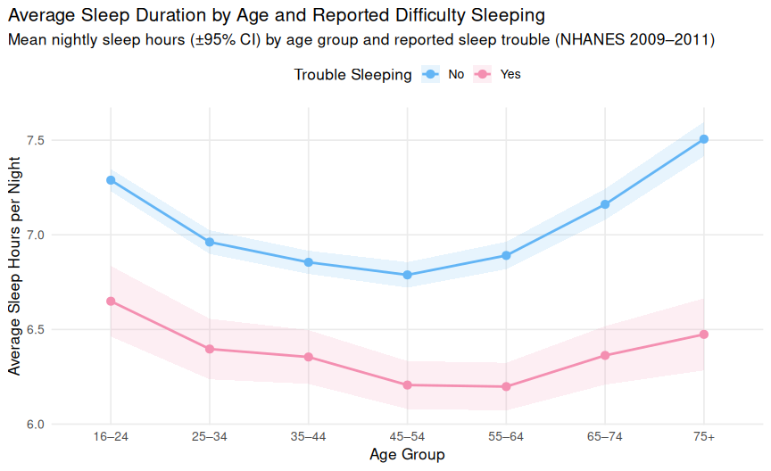
Figure 1. Average Sleep Duration by Age and Reported Difficulty Sleeping
Mean nightly sleep duration (±95% confidence intervals) by age group and self-reported trouble sleeping. Respondents who reported having trouble sleeping consistently averaged fewer hours of nightly rest across all age groups, with both groups showing a slight rebound in older adulthood (NHANES 2009–2011).
As might be expected, participants who did not report having sleep problems, typically slept longer per night than people who reported having difficulty. Among those without reported sleep difficulty, older adults (aged 65 years or older) disclose a larger average sleep duration per night than the younger participants. However, while the younger participants typically slept longer on average per night than older adults, the relationship is reversed among those who have reported having sleep issues.
This discrepancy may be the result of lifestyle and general health factors. While older adults with sleep problems may experience comorbid health conditions that further disrupt sleep, younger participants with reported sleep trouble are typically less impacted by chronic physical conditions caused by age, that can further disrupt rest. On the other hand, compared to younger or middle-aged adults, older participants (65 years old or higher) without reported sleep disturbances may benefit from having more off time due to retirement, for example. Participants in their middle years (45-64 years old) received the least amount of sleep per night, which may be the result of potential time constraints and other related health conditions.
QUESTION 2
Similarly, the second question also demonstrated to be what was expected initially. Assuming mental and physical health affects sleep, it was deduced that there should exist a positive correlation between a participant’s reported general health and reported sleep trouble. The visualization and analysis is shown below.
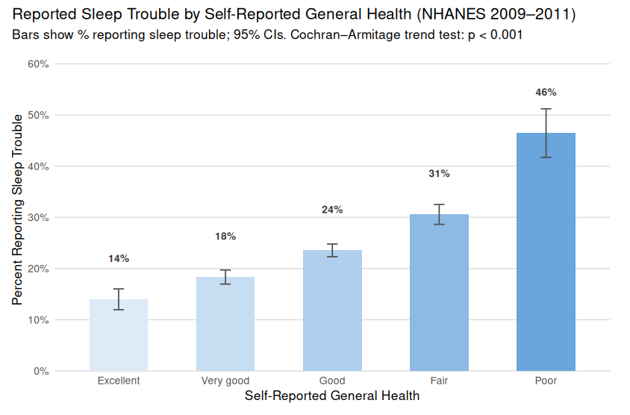
Figure 2. Reported Sleep Trouble by Self-Reported General Health (NHANES 2009–2011)
Percent that reported Sleep Trouble for each category of Self-Reported General Health. Error bars are 95% confidence intervals (NHANES 2009–2011).
It can be observed that among people who have reported having a lower general health have also reported having a higher percentage of reported sleep trouble. To verify statistical significance, the following statistical test was performed.
Statistical Test: Chi-Squared Test for Trend (Cochran–Armitage trend test)
Hypothesis:
H₀: There is no linear trend in reported sleep trouble percentage across reported general health categories.
H₁: There is a positive linear trend (reported sleep trouble percentage increases as reported general health worsens).
Testing at significance level = 0.05.
Conclusion:
The p-value was found to be less than 2.2e-16 which is much less than the significance level = 0.05. Therefore, there is very strong evidence to conclude that the percentage of participants reported having trouble sleeping increases as their reported general health worsens.
QUESTION 3
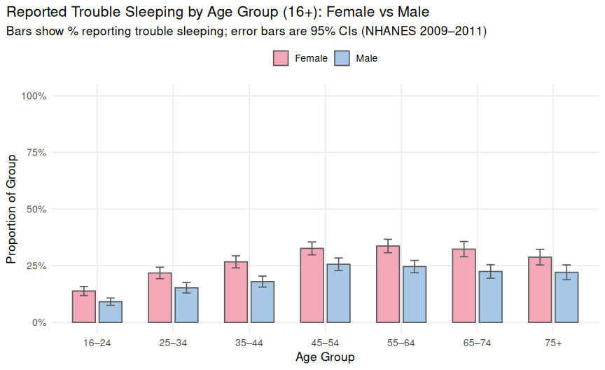
Figure 3. Reported Trouble Sleeping by Age Group (16+) and Gender
Proportion of reported trouble sleeping across different age groups for Males and Females. Error bars are 95% confidence intervals (NHANES 2009–2011).
Based on Figure 3, females across all age groups exhibited a higher proportion of reported trouble sleeping compared to males. To determine whether these differences are statistically significant, a series of two-proportion z-tests were conducted for each age group separately at a significance level of 0.05. The null hypothesis states that females and males have equal proportions of reported sleep trouble, while the alternative hypothesis posits that females have a higher proportion of reported sleep trouble than males. The results of these tests are summarized in the table below:
Age Group | P-Value
16-24 | 0.000157
25-34 | 0.000104
35-44 | 0.00000141
45-54 | 0.000288
55-64 | 0.00000582
65-74 | 0.0000101
75+ | 0.00297
The findings demonstrated that both proportional z-tests had p-values that were significantly below the significance threshold level of 0.05. Consequently, across all age groups, there is statistically significant evidence to suggest that women reported a higher percentage of sleep difficulties than men.
It is crucial to take into account that the dependent variable does not reflect objectively measured sleep duration or quality, but rather self-reported sleep issues. Therefore, even though the analysis shows that women are more likely to report having trouble sleeping, this does not necessarily mean that they actually have more sleep problems compared to their male counterparts. These results might be the result of disparities in perceptions, health awareness, or symptom disclosure willingness.
A Nuffield Health article titled “5 Reasons Men Avoid Going to the Doctor,” published in 2024, supports this interpretation by claiming that approximately 65% of men put off seeking medical attention when they are ill, pointing to a larger trend of male under reporting. Therefore, rather than being due to physiological differences, the observed gender disparity in reported sleep trouble may be partially caused by social or behavioral factors.
In terms of age, the pattern was more predictable: middle-aged participants reported the highest rates of sleep problems, which is in line with the previous assumptions that this particular age group sleeps less on average than younger and older adults due to time constraints or health conditions.
QUESTION 4
Results from Question 4 deviated from the original hypothesis. Initially, it was presumed that participants who smoked or drank would also have reported less regular or healthier sleep patterns compared to those that did neither. The density plot and related statistical test, however, indicate otherwise.
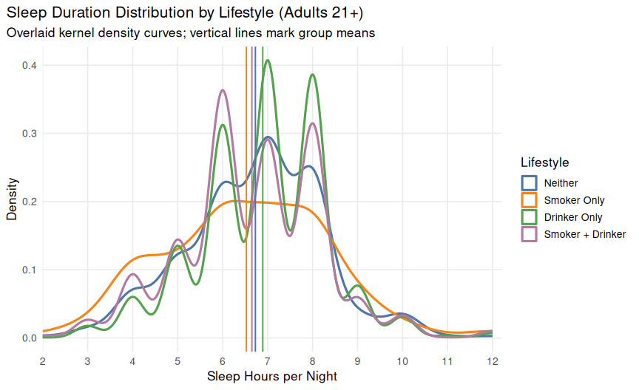
Figure 4. Sleep Duration Distribution by Lifestyle (Adults 21+)
Kernel density plot displaying the distribution of nightly sleep duration among adult participants aged 21 years or older, grouped by lifestyle category (smoker only, drinker only, both, or neither). The normalized probability density function is represented by each curve, with vertical lines denoting the average amount of sleep for each group. In contrast to non-smokers and non-drinkers, smokers and drinkers exhibit wider and more irregular distributions, suggesting greater variability in sleep patterns, even though mean values are similar across lifestyles (NHANES 2009–2011).
Compared to drinkers or people who do neither, the distribution for smokers is noticeably smaller, suggesting that the majority of smokers sleep roughly seven hours every night with less variation among the group. On the other hand, there is more variation among those who reported drinking, with noticeable peaks occurring at six, seven, and eight hours of sleep on average per night. Compared to smokers, even those who claimed did not smoke or drink had more varied sleep duration.
These results were unexpected since it had been assumed that poorer sleep habits were associated with unhealthier lifestyles. This result emphasizes a crucial point: irregularities or bad habits in one area of life do not always indicate unhealthy behavior in another. Although this is still purely conjectural, it is plausible that smokers in this instance follow more regimented routines, which may be connected to the habitual character of their behavior.
QUESTION 5
The results for the next questions were a bit surprising. For Question 5 in particular, it was expected that physical activity positively affects sleep quantity and quality. However, the box plot below seems to indicate that there is actually no correlation between them.
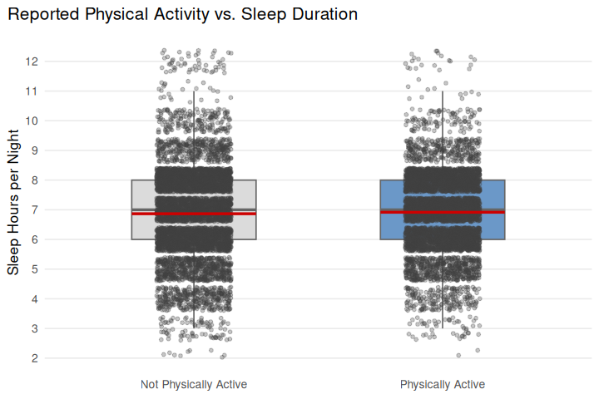
Figure 5. Reported Physical Activity vs. Sleep Duration
Boxplot comparing average hours of sleep reported among adults who claimed to be physically active versus those who did not. The mean sleep durations (red lines) are nearly identical between groups, suggesting that reported physical activity level does not substantially influence total sleep time (NHANES 2009–2011).
These results are notable because many studies indicate that more exercise results in better sleep quality. However, there are some key considerations to take part. Average sleep duration is a measure of healthy sleep habits, but it is not the primary measure of a person’s health. After all, sleep quality also needs to be considered, which can differ drastically from sleep quantity. Second, sleep is the dependent variable in this case. It is possible that sleep has more of an effect on physical activity, than physical activity has on sleep. Sleep is the cause of a variety of different factors, physical prowess being one of them. Therefore, a key takeaway may be that a lack of significant association in one direction does not preclude a meaningful causal relationship in the other in retrospect to average hours of sleep per night.
QUESTION 6
The results to Question 6 was possibly the most surprising out of all the results. The assumption was that screen usage would impact sleep. This is because many electronic devices emit blue light, which diminishes the amount of melatonin in the body. Melatonin, for reference, helps regulate the sleeping cycle and aids the body in falling asleep (Cappuccio et al.). However, the visualization below tells a different story.
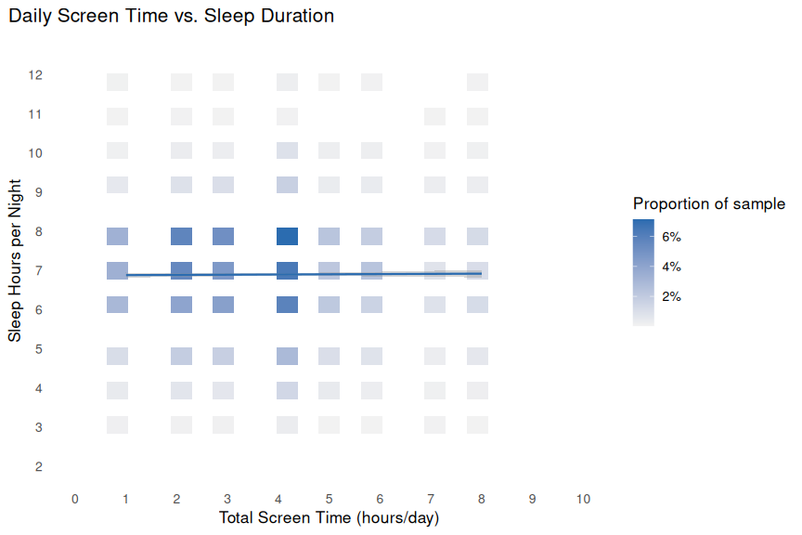
Figure 6. Daily Screen Time (Computer + TV) vs. Sleep Duration
Heat map illustrating the relationship between total daily screen time (hours spent watching TV and using a computer) and average nightly sleep duration among participants aged 16 and older. The percentage of respondents who fall into that screen time–sleep range is shown by each tile. The majority of people cluster around 7 hours of sleep per night, according to the fitted regression line (slope ≈ 0.005, R² ≈ 0.004), which indicates no discernible relationship between total screen exposure and sleep duration (NHANES 2009–2011)
As depicted by the visualization, the regression line is relatively flat, indicating that as reported screen time increases, average sleep duration does not change substantially. Although this finding may come as a surprise, it is consistent with the knowledge that sleep quantity and quality are two distinct metrics. While total sleep hours may appear unchanged, increased screen exposure, especially before bedtime, can still impair sleep quality (e.g., restfulness or sleep latency). It’s also crucial to consider that the dataset used in this analysis was taken from the 2009–2011 NHANES cycle, which only tracked screen time on computers and televisions, which does not include smartphone use. Since this time frame precedes the widespread adoption of most modern smartphones, the relationship between screen exposure and sleep duration may appear weaker than it would in more recent data.
Question 7
It was also expected that blood pressure would have a noticeable effect on sleep. There are two values that measure someone’s blood pressure: systolic and diastolic blood pressure. According to an article by VeryWellHealth on systolic vs diastolic blood pressure, systolic blood pressure is more important to doctors because it measures the heart when it’s at its highest pressure point (during the heartbeat). However, for this report, both systolic and diastolic pressures are analyzed. The results are shown below.
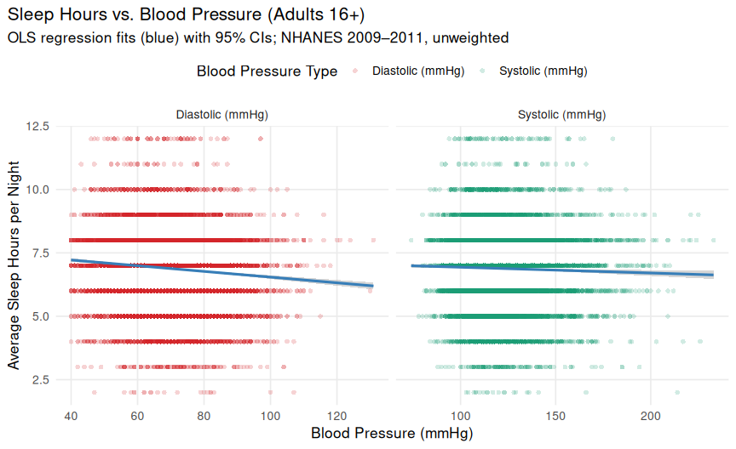
Figure 7. Sleep Hours vs. Blood Pressure (Adults 16+)
Scatterplots displaying the relationship between nightly sleep duration (hours) and average blood pressure (systolic & diastolic) among adults aged 16 and older. An ordinary least squares (OLS) regression line with blue bands representing 95% confidence intervals is included in each panel. While there are weak negative correlations between sleep duration and both diastolic and systolic blood pressure (p < 0.01), the data are not clearly linear and are widely scattered. The regression lines only explain less than 1% of the variance and summarize a very slight downward trend, suggesting that blood pressure is not a reliable indicator of sleep duration.
Statistical Test: Pearson’s correlation and simple linear regression were performed for each blood pressure type.
- Diastolic (mmHg): r = −0.092, p < 0.001, n = 11,773, slope = −0.011 hours/mmHg (≈ −0.66 min/mmHg), R² = 0.008
- Systolic (mmHg): r = −0.029, p = 0.002, n = 11,773, slope = −0.0023 hours/mmHg (≈ −0.14 min/mmHg), R² = 0.001
Although both tests reached statistical significance due to the large sample size, their effect sizes were negligible in practical terms. This suggests that blood pressure explains less than 1% of the variance in reported sleep duration.
The expectation was that both measurements of blood pressure would have a negative effect on how long participants slept per night (so, the higher the blood pressure, the fewer the hours of sleep). However, as can be seen in the scatterplots above, there is a negligible negative correlation between both measurements and sleep. The p-value is relatively low, which typically indicates there exists a significant correlation between the two variables. However, the relatively low R² value may be influenced by the dataset, which contains thousands of observations after missing data is excluded. Considering these factors, blood pressure appears to have no profound effect on sleep duration. This finding was somewhat unexpected, however it should be noted that individuals largely have control over their sleep schedules. Many people are aware of the benefits associated with obtaining approximately eight hours of sleep per night, and actively strive to meet this goal. Blood pressure, by contrast, is unlikely to directly influence the decision of when to go to bed. Instead, it may be more compelling to examine how sleep may affect blood pressure, since blood pressure is not a factor most people can directly control, unlike the decision of when to go to bed.

Limitations and Sources of Error
When interpreting the findings of this analysis, it is important to take into account a number of limitations and possible sources of error.
First, some variables in the NHANESraw dataset used in this study are dated, as it was gathered between 2009 and 2011. Given the significant changes in smartphone use and digital habits since then, this is especially pertinent for metrics such as daily screen time. As a result, some relationships, including those between screen time and sleep duration, may not fully reflect patterns observed in 2025. Second, as stated earlier, self-reported data from questionnaires and interviews make up a portion of the dataset. Recall bias, social desirability bias, and rounding errors may affect these kinds of data. For example, participants may tend to estimate total hours of sleep instead of reporting precise durations.
Furthermore, although precautions were taken to guarantee data consistency, such as eliminating missing entries based on question-specific criteria and filtering implausible values, these actions might have resulted in selection bias or decreased the representativeness of particular subgroups. Additionally, re-coding and grouping variables (e.g., binning age into categories or combining “Mexican” into “Hispanic”) made the data easier to analyze, but they might have masked more subtle differences within groups. To add on to this, the NHANES’ intricate survey weights were not applied; instead, the dataset was analyzed as a straightforward random sample. Therefore, the results are not strictly generalizable to the entire U.S. population; rather, they describe associations within the sample itself.
Next, cross-sectional data, which offers a moment in time, forms the basis of the study. Although correlations can be found, such as between blood pressure and sleep duration, causal relationships cannot be deduced. Results may also be impacted by unmeasured confounding factors such as stress, occupation, or long-term medical conditions. Finally, human judgment in establishing thresholds, exclusions, and groupings invariably introduces some subjectivity, even in the face of efforts to maintain objectivity during data cleaning and interpretation.
All things considered, even though these restrictions limit the accuracy and generalizability of some findings, the findings nevertheless provide insightful information about the sleep patterns and their relationships to various demographic and health characteristics among American adults.

Conclusion
Despite growing public awareness, many aspects of how sleep interacts with behavior and self-perceived health remain unclear. For instance, people may have comparable sleep schedules but greatly differ in their degrees of wellbeing and rest. The importance of looking at both hours slept and self-reported difficulty sleeping is highlighted by the distinction between sleep quantity and quality. This distinction is especially important to remember because confusing sleep quality and quantity can lead to dangerous assumptions. For example, one of the results indicates that screen time and hours of sleep do not correlate. If taken at face value, people may assume that sleep and screen time do not correlate. However, this assumption is false and dangerous because there are a multitude of studies that show how blue light negatively affects melatonin production. Sleep quantity is easier to measure, but that doesn’t mean it should be the only value used to explain sleep. After all, sleep is a mysterious phenomenon that to this day still stumps the scientific community. Sleep quality is arguably just as, if not more, important than sleep quantity. It cannot be ignored simply because some researchers want to cut corners.
In addition, it’s important to keep in mind that causal relationships don’t always go both ways. For instance, it’s heavily implied in an article written for the Cleveland Clinic that sleep has a significant effect on blood pressure. However, the results of this project indicate that blood pressure has a limited effect on the number of hours a person sleeps. The main takeaway of this project is to never take common sense for granted. It’s always better to test theories, no matter how obvious they may seem at first, because the results may be different than expected. A good test may include certain statistical methods, but an even great test is to simply visualize the theory by plotting a dataset. As the famous saying goes, “a picture is worth a thousand words”.

Reproducibility and Code Availability
All the source code is available on GitHub with the main Rmd file to reproduce all the results from this report as well as separate R files to be able to reproduce results for each individual question explored.
This analysis was conducted in R utilizing the following packages: tidyverse, gridExtra, scales, and broom.
The included NHANESraw.csv dataset must be in the working directory before execution in order for the results to be reproduced. All of the figures, tables, and statistical outputs in this report can be completely recreated with these dependencies and resources in place.

Appendix
Although they were created during the analysis’s exploratory stage, the following analysis questions and accompanying visualizations were eventually omitted from the final report. These figures are included here to show the variety of exploratory methods used on the NHANES dataset and to document the larger analytical process. Although they offered helpful intermediate insights, they either failed to identify strong patterns, were redundant with other visuals, or were not sufficiently informative for the research questions.
What is the relationship between average sleep duration and the number of poor mental health days, and how does this relationship differ across age groups?
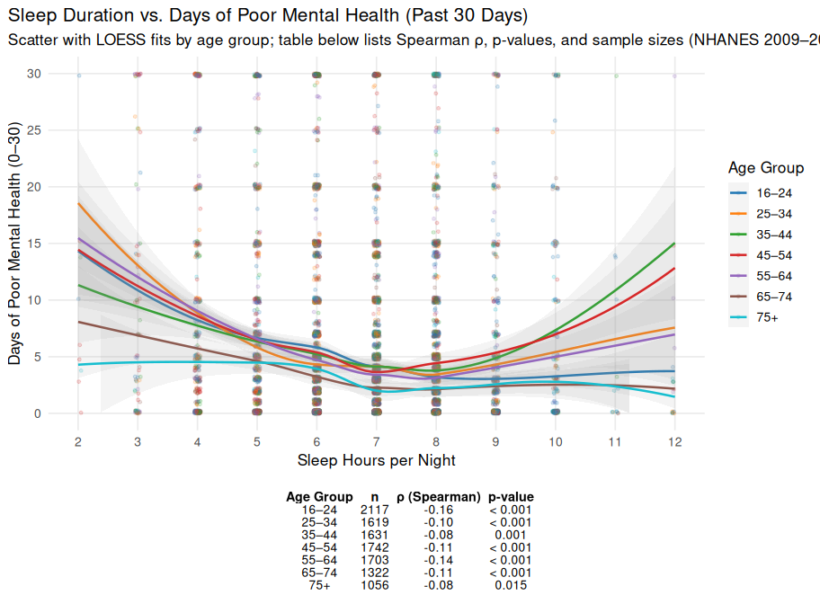
Figure 8. Sleep Duration vs. Days of Poor Mental Health (Past 30 Days) per Age Group
Scatterplot with LOESS smoothing lines showing the association between average nightly sleep duration and the number of self-reported days of poor mental health within a 30 day period, separated by age group. Across all groups, much shorter or longer sleep durations than the average were generally associated with more days reported with poor mental health. On average, the lowest number of poor mental health days in the 30 day period occurred when participants revived nearly 7 hours of sleep per night. The accompanying table lists Spearman correlation coefficients (ρ), p-values, and sample sizes for each age group (NHANES 2009–2011).
How does the proportion of reported trouble sleeping vary by age group for different races?
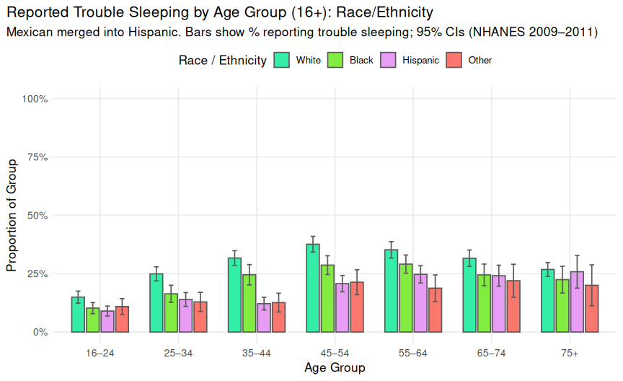
Figure 9. Reported Trouble Sleeping by Age Group (16+) and Race/Ethnicity
Bar chart showing the proportion of adults reporting trouble sleeping by race/ethnicity across seven age groups. Mexican participants were merged into the Hispanic category. Each bar represents the estimated percentage within a group, with 95 % Wald confidence intervals shown as error bars. Prevalence of reported sleep trouble tends to increase from young adulthood through middle age and remains elevated into older adulthood, with White respondents generally reporting the highest rates across most age categories (NHANES 2009–2011).
How does sleep duration vary with BMI categories across different genders?
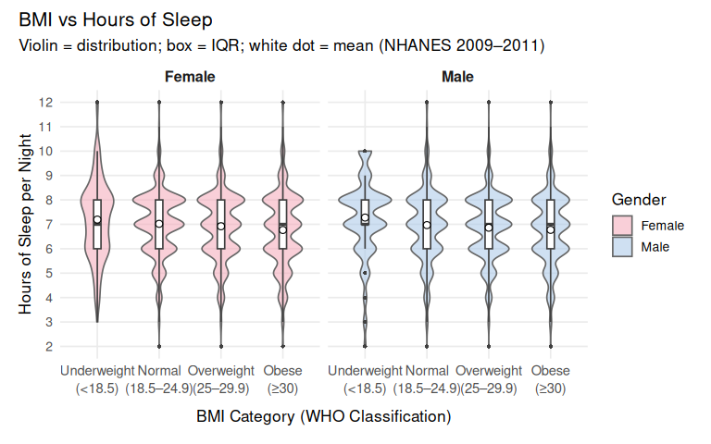
Figure 10. Sleep Duration vs Body Mass Index (BMI) by Gender
Average nightly sleep hours across BMI categories, separated by gender. Each violin represents the distribution of self-reported sleep duration within a BMI group, with the box showing the interquartile range and the white dot marking the mean. Data from NHANES (2009–2011).

References
- Buysse, D. J. (2014). Sleep health: Can we define it? Does it matter? Sleep, 37(1), 9–17. https://doi.org/10.5665/sleep.3298
- Cappuccio, F. P., D’Elia, L., Strazzullo, P., & Miller, M. A. (2010). Sleep duration and all-cause mortality: A systematic review and meta-analysis of prospective studies. Sleep, 33(5), 585–592. https://doi.org/10.1093/sleep/33.5.585
- Clinic, C. (2023, February 13). How a Lack of Sleep Contributes to High Blood Pressure. Cleveland Clinic; Cleveland Clinic. https://health.clevelandclinic.org/can-lack-of-sleep-cause-high-blood-pressure
- Centers for Disease Control and Prevention (CDC). (2013). National Health and Nutrition Examination Survey: Analytic guidelines, 2011–2012. U.S. Department of Health and Human Services.https://www.cdc.gov/nchs/nhanes
- Fogoros, R. (2010, October 14). Systolic and Diastolic Blood Pressure. Verywell Health; Verywellhealth. https://www.verywellhealth.com/systolic-and-diastolic-blood-pressure-1746075
- Itani, O., Jike, M., Watanabe, N., & Kaneita, Y. (2017). Short sleep duration and health outcomes: A systematic review, meta-analysis, and meta-regression. Sleep Medicine, 32, 246–256. https://doi.org/10.1016/j.sleep.2016.08.006
- MedPsych Health. (n.d.). Woman sleeping peacefully in bed [Photograph]. MedPsych Health.https://www.medpsychhealth.com/ wp-content/uploads/shutterstock_1427337869-1440x810.jpg
- Naseem, A. (2024, May 22). 5 reasons men avoid going to the doctor | Nuffield Health. Www.nuffieldhealth.com. https://www.nuffieldhealth.com/article/5-reasons-men-avoid-going-to-the-doctor

