# CS 447 Assignment 01

Hyunjae Park (20463482)

hj8park@uwaterloo.ca

1. 10pts
2. x = []
3. x = [3]
4. x = [1, 3, 5, 7]
5. x = [-10, -9, 0, 99, 100]

I = 1

cnt = 1

PC = second iteration after cnt = cnt + 1

1. 10pts
2. 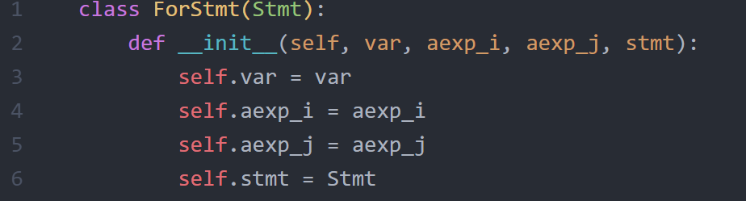

|  |  |
| --- | --- |
| < x<=j, q>↓false | < x<=j, q>↓true <S; for x=i to j do S, q>↓q’ |
| <for x=i to j do S, q>↓q | <for x=i to j do S, q>↓q’ |

1. 20pts
2. 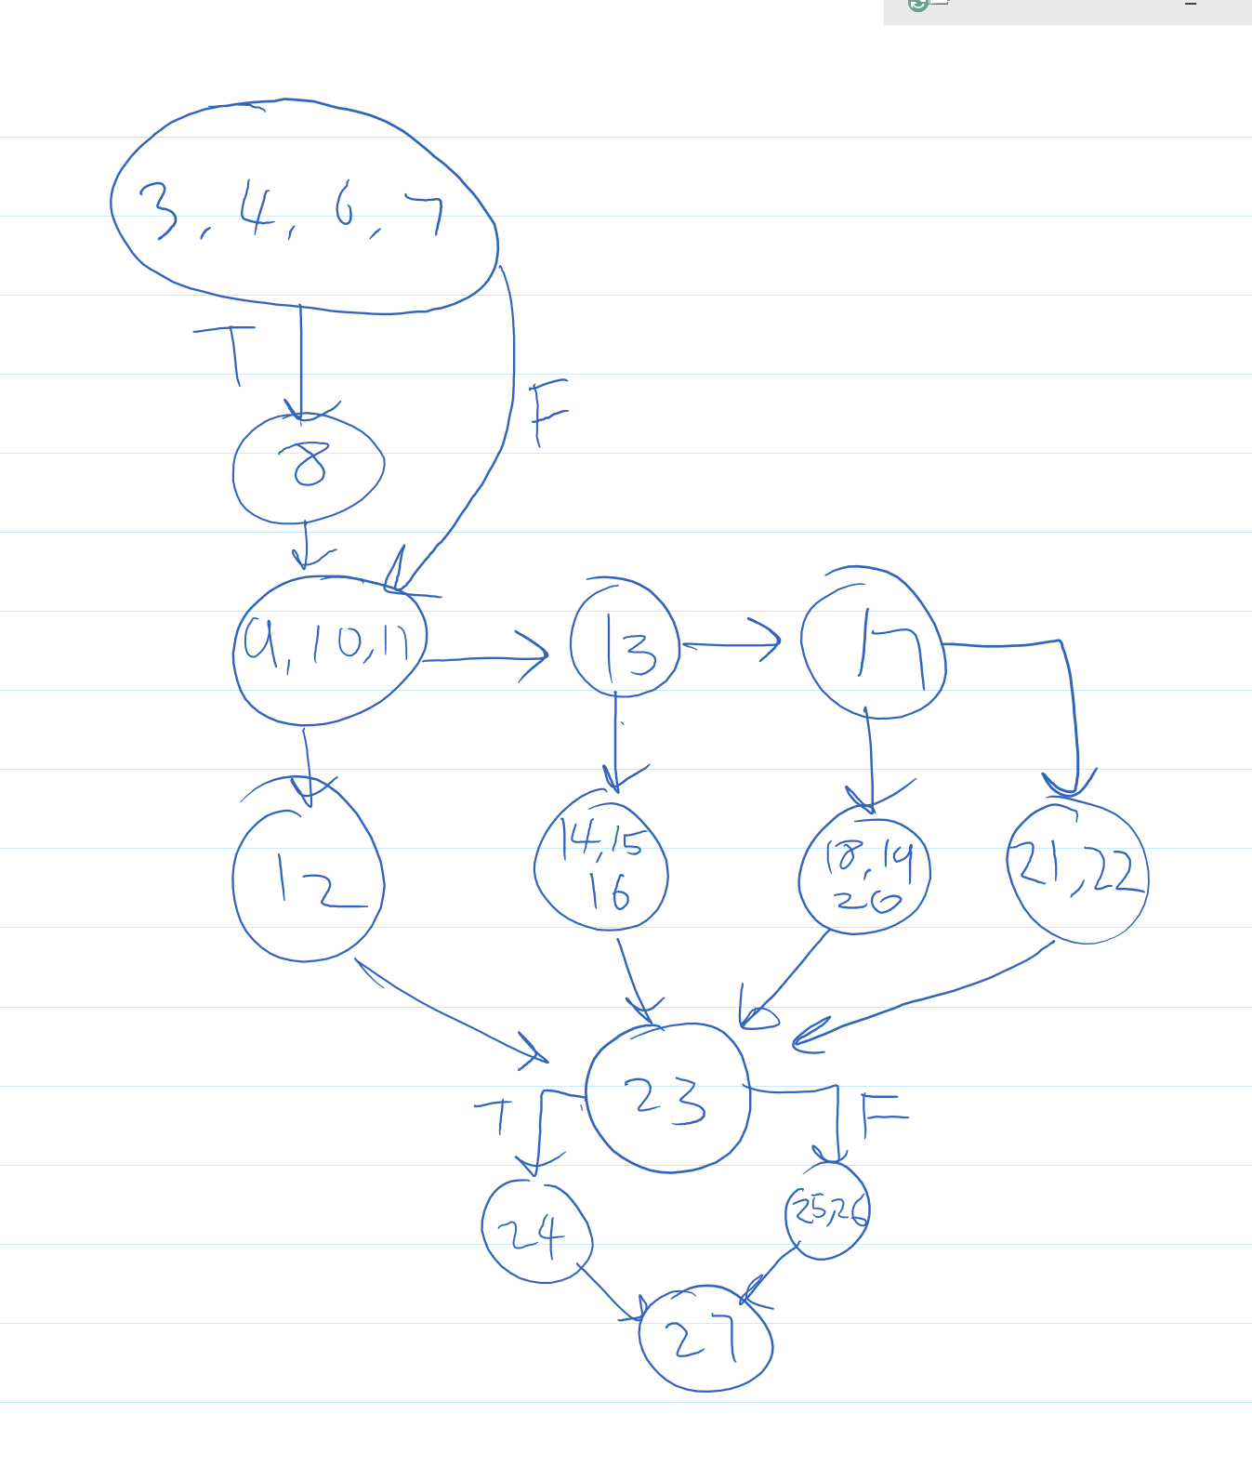

TR_NC = [3, 8, 9, 112, 13, 14, 17, 18, 21, 23, 24, 25, 27]

TR_EC = [(3,8), (3,9), (8,9), (9,12), (9,13), (12,23), (13,14), (13,17),(14,23), (17,18),(17,21),(18,23), (17,21),(23,24),(23,25), (24,27),(25,27)]

TR_EPC= [(3,8,9), (3,9,12), (3,9,13), (8,9,12), (8,9,13), (9,12,23), (9,13,17), (9,13,14), (12, 23, 24), (12,23,25), (13,14,23), (13,17,18), (13,17,21), (14,23,24), (14,23,25), (17,18,23), (17,21,23), (18,23,24), (18,23,25), (21,23,24), (21,23,25), (23,24,27), (23,25,27)]

* infeasible: [(12,23,24), (14,23,25), (18,23,25), (21,23,25)]

TR_PPC= [(3,8,9,12,23,24,27), (3,8,9,12,23,25,27), (3,8,9,13,14,23,24,27), (3,8,9,13,14,23,25,27), (3,8,9,13,17,18,23,24,27), (3,8,9,13,17,18,23,25,27), (3,8,9,13,17,21,23,25,27), (3,8,9,13,17,21,23,25,27)]

1. 30pts