# Page Prototype

## Step 1: Design an Event

### Competitor site 1: Facebook (when a friend posts a picture)

* Picture preview of what was posted
* Friend/Page you follow that posted it
* Their profile picture
* A preview of a part of the comment section
* Any tags of other people or locations
* Time of date when they posted it
* See the people that liked/reacted to the photo
* Comments with when they posted it, their name, their profile picture
* Options to like or reply to those comments
* Reactions/likes on those comments
* The option to share the photo
* The hidden drop menu on the top left that can let you do other things like unfollow that person
* Their statement of their photo
* Your own blank text box on the bottom, ready for you to comment, post a picture, or sticker for your friend’s post

### Competitor site 2: LinkedIn (same thing with facebook)

* Who posted it
* Their profile picture
* How many followers they have (for this, it’s the uw linkedin page)
* When they posted the post
* Their statement, but not the whole thing if it’s too long
* Likes, comments, share button
* How many likes, and comments they got
* Preview of the picture
* Top left, drop list of options to do with that post (copy link, hide, unfollow, etc)

### My site: <site name here>

* Profile picture
* Name of person
* When they posted that photo
* How many mutual friends you have with them
* Their statement about the photo
* Photo preview should be the biggest thing in this
* Likes, comments, share button
* But also a rating option, out of 5 stars, a way to find the quality of a post from friends or businesses

## Step 2: Prototype an Event Area

Here is a prototype of how the Event area will look

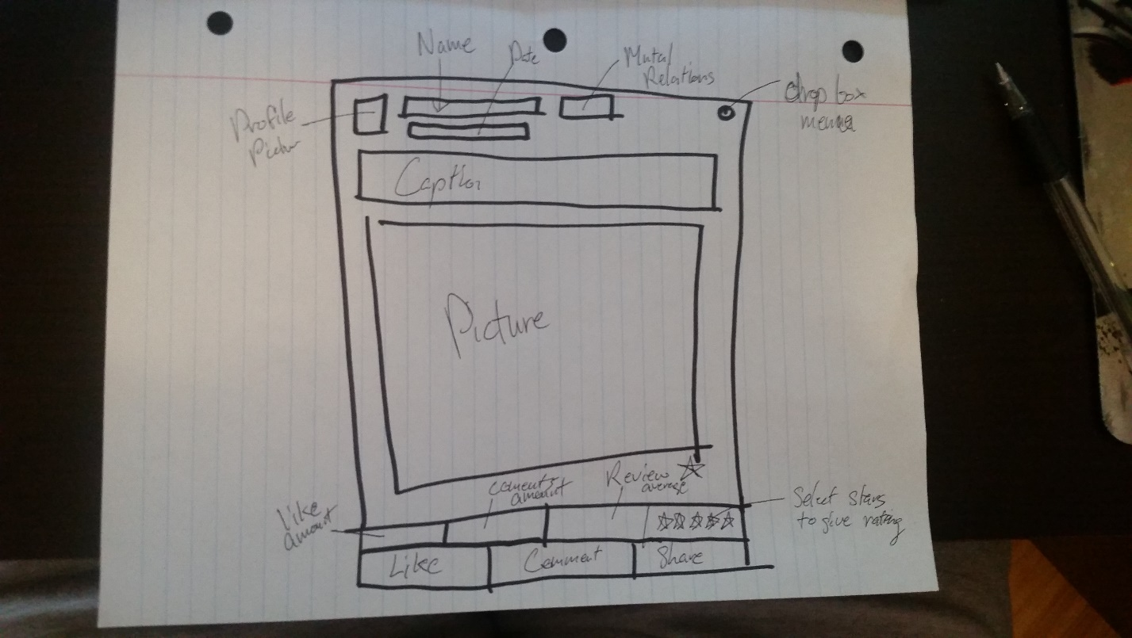

## Step 3: Prototype the Event Page

Here is a prototype that shows how the Event area fits in a wider page