# User testing

## Step 1: The Usability Test

User Feedback: Explain here in detail

1. Felt like it was a little too compact at the end
2. Search bar can be a little bigger
3. Have the more important things bigger

### Proposed Changes as a result of feedback

1. Make the pages a bit more spacious
2. Search bar bigger
3. Will highlight the important details

## Step 2: Revision

Explanation of changes made

1. We want to make users not confused when looking at our website. We want to make the flow easier for them
2. We shouldn’t have people confused on the simple stuff like search bars and icons
3. Details of boxes should be easier and make sense to users why it’s placed there.

Sketch with changes

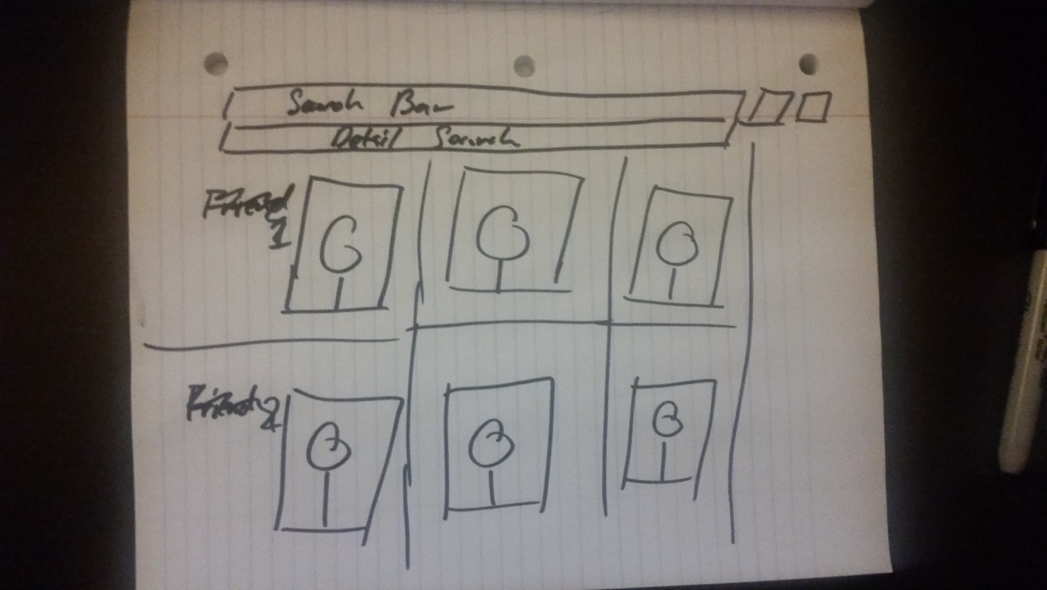

## Step 3: Second Usability Test

User Feedback: Explain here in detail

1. Feels like the pictures are too much
2. Space can be more wisely used here. Maybe put more stuff on both sides?
3. You can put little details underneath the pictures just for better layout design.

Proposed Changes as a result of feedback

1. Put stuff on the sides
2. Putting little basic info underneath the photos
3. Make the pictures smaller to compensate for basic info text box

## Step 4: Revision

Explanation of changes made

1. I want to make users feel like they’re getting more info for less work, that’s why we put that basic info for each picture
2. Have more constant shortcuts on the sides for anything the user needs.
3. Putting pictures only made it feel the page is empty. By reducing the size of the photos, we can put more interaction with the user 