Programming environment : Python 2.7

Operation of Server:

Checks whether a port no. Is entered by user or not.

Checks whether port no. Is greater than 5000 and begins the communication else rejects the execute command.

Functions are defined for each of following tasks: get file, put file. get image, put image, list all files, rename a file, exit, incorrect command.

Infinite loop rmakes available all these functions to the user.

Operation of Client:

Checks whether ip address and port no. Is entered by user or not.

Functions are defined for each of following tasks: get file, put file. get image, put image, list all files, rename a file, exit, incorrect command. Each function can be executed by entering it in required format.

Infinite loop rmakes available all these functions to the user.

Server:

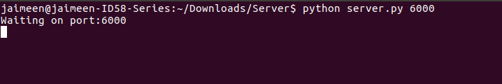

Client:

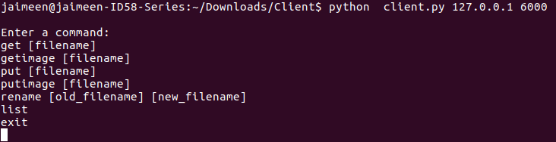

Client and Server:

