THE PARTNER-TRACK WARDROBE
A Visual Field Guide to Dressing for Quiet Status
Tailored for: warm-climate (US South / Southwest / West) client base · menswear · mid-premium “smart value” · status without flash

How to use this guide. Every diagram and fabric swatch here was drawn specifically to teach the vocabulary — these are illustrations, not photos. Under each term you'll find a blue “See real photos online” link; click it to pull up live examples on your screen. Read this top-to-bottom once; after that it's a reference. The buying plan at the end tells you what to get first.

The One Idea Everything Hangs On
In the rooms you're trying to enter, status is signaled by discernment and restraint — not by spending visibly. The academic name for this is inconspicuous consumption (Elizabeth Currid-Halkett, The Sum of Small Things, 2017): the modern elite abandoned logos because logos are now cheap to fake and therefore worthless as a marker. Today wealth is read through fit, fabric, craftsmanship, grooming, and demonstrated knowledge — cues only insiders decode.
Fit > fabric > restraint. No visible logos. Muted solids. Natural fibers. A matte finish. One good watch. And the evident ease of a man who isn't trying to impress anyone.
Loud branding now signals the opposite of wealth — it reads as hungry, not secure. Keep that lens on every choice below.

1. Suits — Your High-Impact Tool, Not a Daily Uniform
Reality check: in modern consulting the everyday suit is largely gone. The rule is still “dress one notch better than your client,” but the baseline dropped — partners live in sport coats and odd trousers, and pull out a real suit for the pitch, the board readout, the final presentation, or the banking/insurance/pharma/government client. So you need few suits, but excellent ones. Start with two solids: navy and charcoal (or mid-grey).

Suit colors — what reads serious
 |  |  | 
Navy  #1 — dynamic credibility | Charcoal  sober authority | Mid-grey  versatile, cool in heat | Black  AVOID by day (funeral/waiter)

🔗 See real photos online

Suit patterns — from quietest to loudest
A “solid” is one flat color. The patterns below add subtle interest. The first three read as solid from across a room (safe and high-status); the last three get progressively bolder. For your goal, stay in the top row.
 |  |  | 
Birdseye  tiny dots — reads solid | Nailhead  slightly bigger dots | Sharkskin  fine diagonal weave | Pinstripe  thin crisp lines — banker
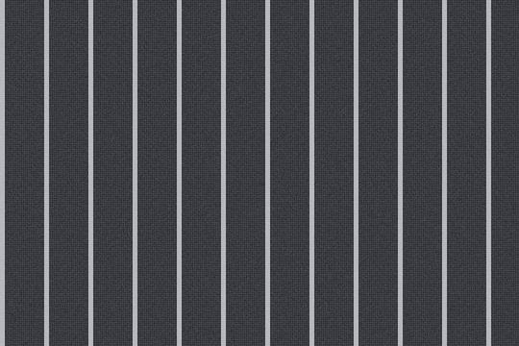 |  | 
Chalk stripe  softer, wider — bolder | Glen check  the “Prince of Wales” check | Windowpane  wide grid — too loud for suits

Quiet-wealth sweet spot: solids and the “semi-solids” (birdseye, nailhead, sharkskin) — same formality as a solid, with quiet depth. A faint glen-check grey is a tasteful third suit. Skip chalk stripe and windowpane — they say “look at me.”
🔗 See real photos online

Fabric & weight — the most important choice for the heat
The variable that keeps you cool isn't just weight — it's the weave. An open, airy weave vents heat far better than a dense one. Your targets:
- High-twist worsted / “fresco” — the top warm-weather cloth. Tightly twisted yarn in an open weave; breathes like linen but resists wrinkles all day, so you look composed while everyone else is crumpled.
- Tropical worsted (~230 gsm / 8–10 oz) — softer and dressier than fresco; great if fresco feels a touch coarse to you.
- Hopsack — a loose basketweave (shown below). Breathable, springs back from wrinkles, but reads casual — it's a blazer/sport-coat cloth, not a formal-suit cloth.
- Skip linen for client work (wrinkles aggressively — keep it for weekend jackets); avoid synthetics entirely (sheen + sweat); insist on breathable Bemberg/cupro lining, and prefer half- or quarter-lined jackets.

Hopsack: the open basketweave you can see up close — breezy, casual, blazer territory.
🔗 See real photos online

Construction — the #1 quality tell
Inside the chest of a good jacket floats a layer of “canvas” that lets it mold to your body and drape cleanly. A cheap jacket glues a stiff “fusible” layer instead — it feels like cardboard and can bubble after dry-cleaning. The rule:
Avoid fused at all costs. Half-canvas is the value pick. Full canvas only if the budget stretches.
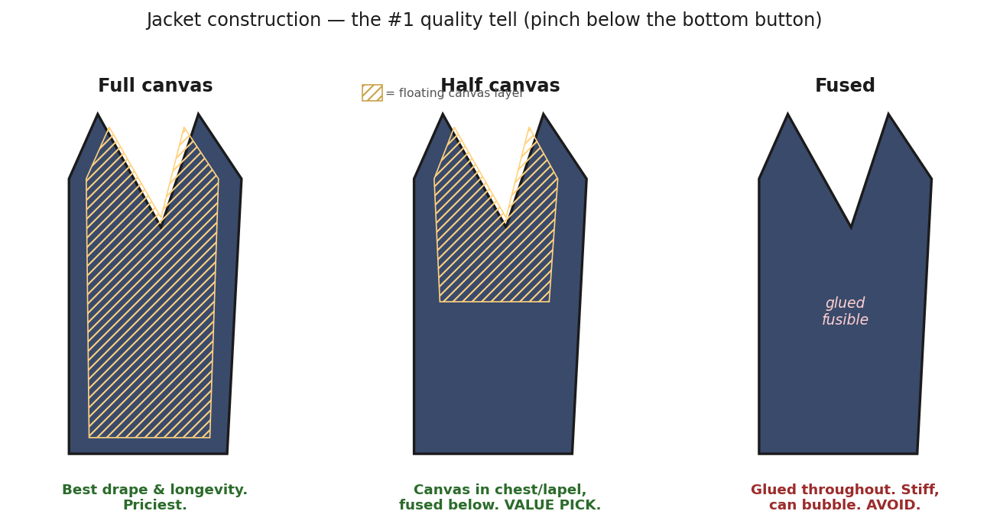
How to check in the store: pinch the front of the jacket just below the bottom button. If you feel a separate floating layer between the outer cloth and the lining, it's canvassed (good). If it feels glued into one stiff sheet, it's fused (skip it).
🔗 See real photos online

Fit — “modern classic,” never shrunken-slim, never baggy
- Shoulder: the seam ends right at your shoulder bone — no overhang, no pulling. This is the hardest thing to alter, so it must be right off the rack.
- Length: the jacket covers your seat; too-short reads “trying too hard.”
- Sleeve: show about ¼–½ inch of shirt cuff below the jacket sleeve.
- Trousers: slight taper, hem just kissing the shoe (see “break” in the next section).
🔗 See real photos online

Mid-premium brands worth your money
- Spier & Mackay — best price-to-quality; has a purpose-built warm-weather “tropical” line.
- Suitsupply — the benchmark; their made-to-measure (~$660–715) even gets you full canvas in tropical cloth.
- Proper Cloth — best remote made-to-measure for fit precision + breathable fabrics.
- J.Crew Ludlow — solid on sale; Brooks Brothers 1818 is fine if you confirm it isn't fused.

2. The Consultant's Real Uniform — Business Casual
This is what you'll actually wear most days, and where most of your status signal now lives. The cornerstone is the navy hopsack blazer: a “sport coat” (a jacket worn with non-matching trousers) in that breathable basketweave. One blazer dresses up with a shirt and tie, or down with a fine knit — endlessly. Go for a soft, lightly-structured jacket; a fully “deconstructed” one (no internal structure at all) flatters only a minority of builds.
🔗 See real photos online

Trousers & the “break”
“Break” is how the trouser hem meets your shoe — the small fold (or lack of one) at the bottom. It's one of the quickest tells of whether trousers were hemmed by someone who knows what they're doing. Aim for no break or a quarter break; avoid the dated “full break” pooling.
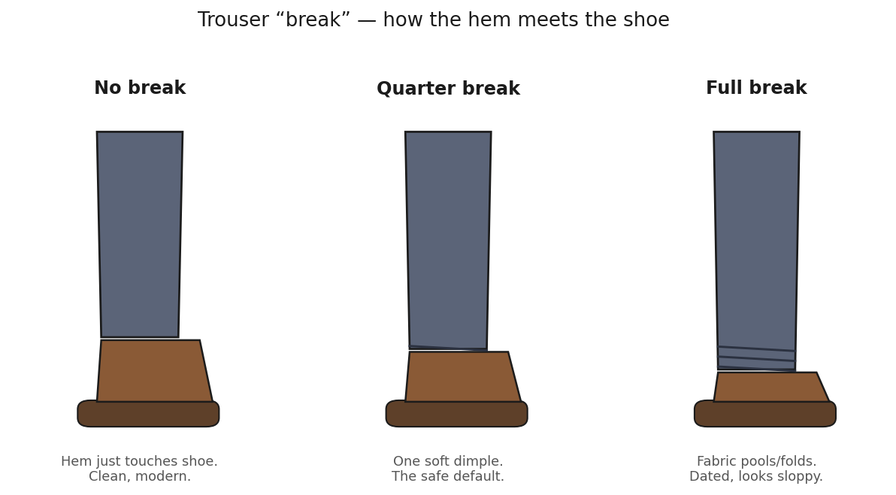
Fabrics: high-twist/tropical wool for the dressy end, quality cotton chinos for everyday (pressed, never wrinkled). Palette: grey, stone, olive, navy. Flat front is the safe default.
🔗 See real photos online

Dress-shirt collars
The collar shape sets how formal a shirt looks and whether it works without a tie. The gap between the collar points widens as you go from point → spread.
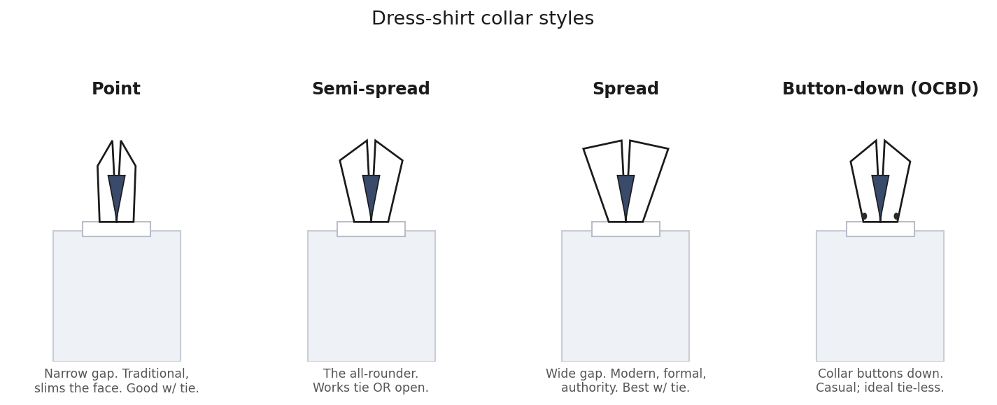
- Semi-spread: the best all-rounder — works with a tie or open at the neck.
- Spread / point: more formal/authoritative with a tie; needs enough body to not collapse when open.
- Button-down (OCBD): the collar literally buttons down to the shirt; casual, and the ideal collar for the no-tie look because it stays put instead of flopping open.
🔗 See real photos online

Cuffs
Two kinds. For a no-tie consulting office you want the everyday barrel cuff. French (double) cuffs need cufflinks and read black-tie-formal — too dressy for daily wear.
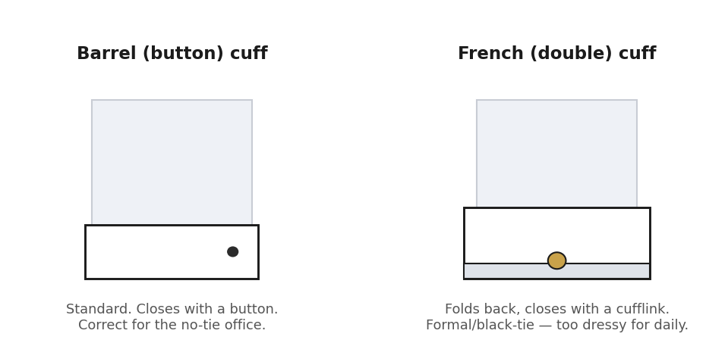
🔗 See real photos online
Shirt colors: white (most formal) and light blue (everyday) are your core. Subtle stripes or micro-checks for casual days only. Fabrics: poplin (crispest/dressiest) → twill → oxford-cloth (most casual, the home of the button-down). Knitwear: fine-gauge merino polos and crewnecks read upscale; avoid heavy logo'd “golf-dad” piqué polos in corporate-bright colors.

3. Shoes, Belts & Leather — Where the Cognoscenti Look First
The quality signal in a shoe is resoleable welted construction. A “Goodyear-welted” shoe is stitched (not glued) so it can be resoled and last decades; cheap shoes are glued and die when the sole wears. Insiders genuinely read this.

The single most useful distinction: Oxford vs. Derby
This is the term people most often get wrong. It's about the lacing, not the toe:
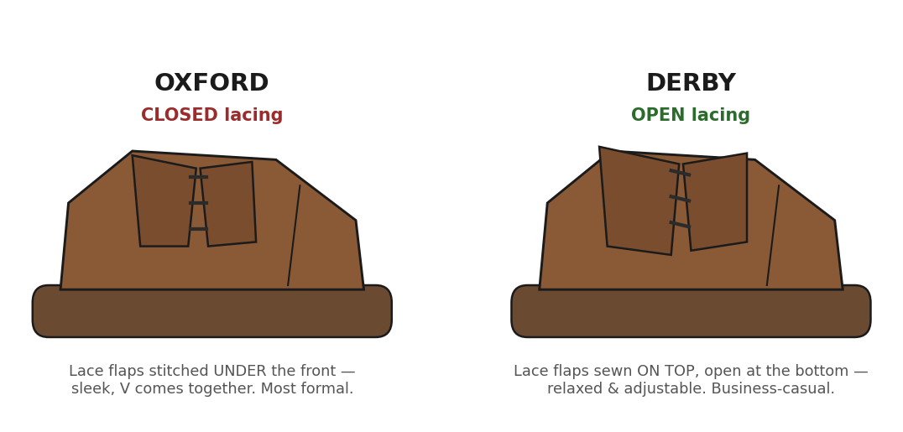
🔗 See real photos online

Styles, most formal → most casual
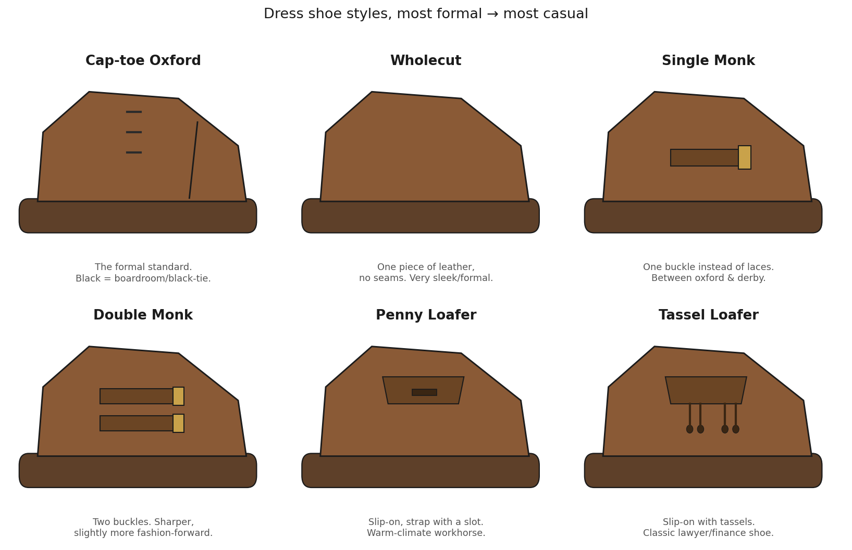
In your warm climate, penny loafers and suede loafers/derbies are the smart-casual workhorses; own one pair of black cap-toe oxfords for the formal end.
🔗 See real photos online

Toe shape — a quiet cheap-shoe giveaway
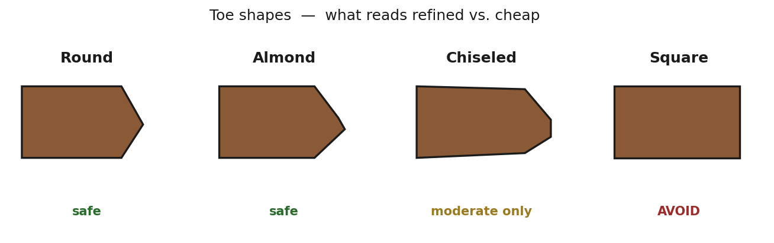
🔗 See real photos online

Leather color — formality runs light → dark
“No brown in town” has been dead since the 1950s; brown is your everyday default. Reserve black for the most formal settings. Oxblood/burgundy is a knowing, high-status choice with navy and grey.
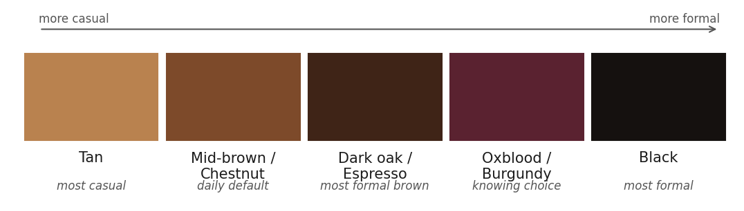
🔗 See real photos online

Belts & socks
- Belts: match the belt's leather color AND finish to your shoes (shiny belt with shiny shoes; matte/suede with matte). Keep the buckle plain and small — a logo buckle is the clearest “trying too hard” tell. Skip the belt entirely with a tux or side-adjuster trousers.
- Socks: wear over-the-calf length so no shin shows when you cross your legs; match socks to your trousers, not your shoes. White athletic socks with dress shoes is the #1 mistake. For loafers in heat, use no-show socks with a silicone grip — never go truly sockless (it ruins the lining).
🔗 See real photos online
Brands at smart value: Allen Edmonds “Park Avenue” on sale (~$250–350), Carmina (~$475, the quality sweet spot), Loake 1880 / Meermin (entry Goodyear-welt). Keep them on cedar shoe trees, brush them, and resole rather than replace — well-kept shoes are themselves a quiet-wealth signal.

4. Watches & Accessories — Handled Right
The watch is the single biggest male status signal — and the easiest place to out yourself as new money. The principle: the right watch is legible only to people who know. A watch worn to be seen across a room reads as insecurity. Quiet status lives in the dress and tool registers, not the flashy gold or hyped pieces.
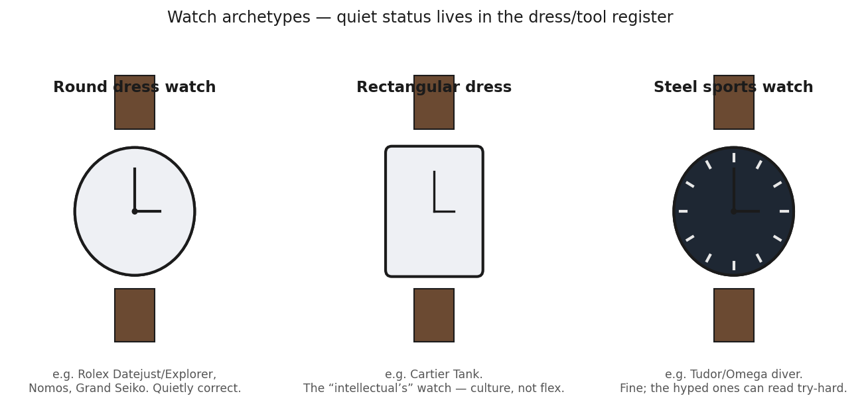
- Quietly correct: steel Rolex Datejust/Explorer, Cartier Tank (the “intellectual's” watch), Grand Seiko, Nomos. At mid-premium: Tudor (Rolex-owned, ~$4k), Omega, Nomos.
- Reads try-hard: gold/two-tone, diamond bezels, oversized “trophy” watches. An Apple Watch is fine but neutral — it signals busyness, not taste; if you wear one with tailoring, use a leather band.
🔗 See real photos online

Ties & the knot
Ties have receded to client days, pitches, and formal meetings; a deliberate open collar is now a legitimate senior move. When you do wear one, the knot matters more than people think — smaller is more refined.
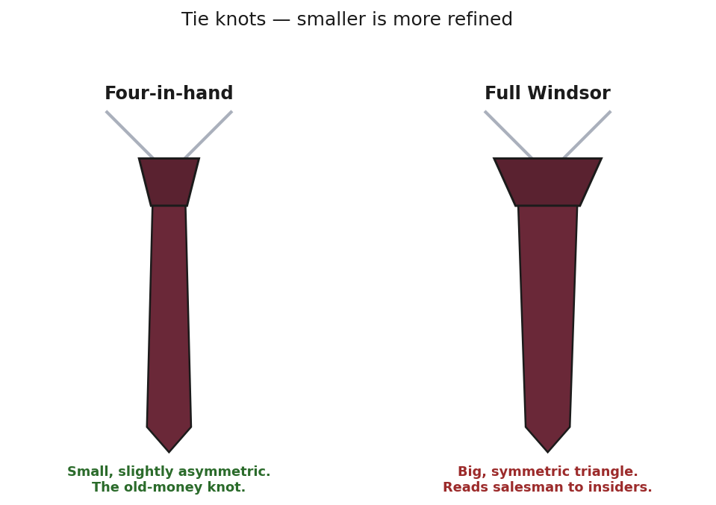
- Ties: textured “grenadine” silk (matte, not shiny) in solid navy or burgundy is almost foolproof. Tie it with a four-in-hand knot. Avoid shiny satin and novelty/logo ties.
🔗 See real photos online

Everything else — keep it quiet
- Pocket square: white linen, folded flat. Never match it exactly to your tie (looks pre-packaged).
- Eyewear: understated, logo-free frames (Oliver Peoples, Cutler & Gross, Garrett Leight).
- Bags: a single unbranded quality leather piece beats logo luggage every time. Monogram/print bags (LV, Goyard, Gucci) are a top new-money tell.
- Jewelry: wedding band + watch and essentially nothing else. Slim plain wallet. Persol sunglasses over flashy designer shades.
🔗 See real photos online

5. Dinner Parties, Client Dinners & Social Events
Memorize one combination and you're covered for almost any social or client-entertainment setting: navy blazer + grey trousers + brown loafers, with a white or light-blue shirt.
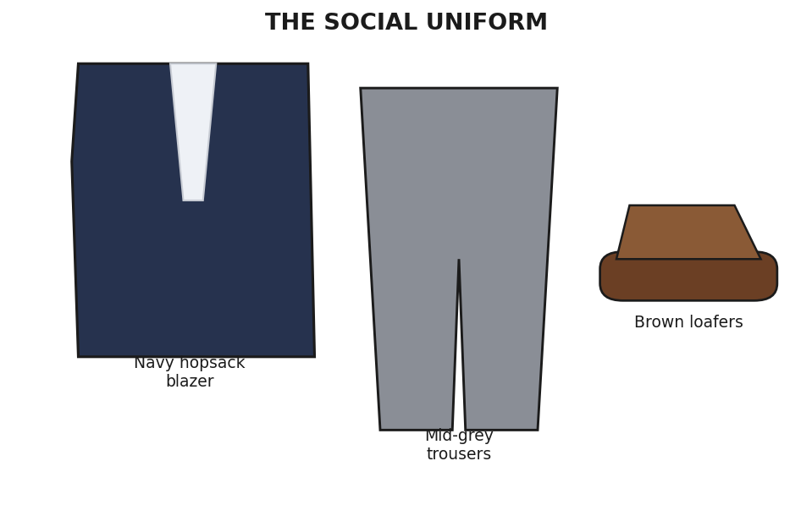
The social uniform — works from a partner's dinner to a client restaurant to a bar.
- Smart casual decoded: pair one dressier item with one casual item, and when unsure, dress one notch up (a jacket can always come off).
- Partner's dinner (at home): the social uniform above, or dark clean denim + a casual button-down + loafers. No full suit — it reads stiff in someone's home.
- Client dinner (restaurant): sport coat with an open collar (or a fine roll-neck when cooler). Tie optional, often omitted.
- Country club / golf: quality polos, well-fitting chinos, tailored above-knee shorts in real heat. Keep performance polyester to the course, not the clubhouse.
- Good denim in upscale-casual: dark, clean, well-fitted, no rips or fading. Dress the jacket down (light textured sport coat), never the jeans up. Never a t-shirt under the coat.
🔗 See real photos online

6. The Mistakes That Mark You as an Outsider
- ✗ Visible logos / monograms — the cardinal sin; now reads new-money.
- ✗ Shiny fabric — the classic cheap-synthetic tell (quality wool is matte).
- ✗ Bad shoulder fit, “X” pull-lines at the button, wrong sleeve or trouser length.
- ✗ A flashy gold/diamond “trophy” watch — or an Apple sport-loop with a suit.
- ✗ Matched tie-and-pocket-square sets; a big shiny Windsor knot.
- ✗ White or athletic socks with dress shoes; socks that show ankle when seated.
- ✗ Square-toe or plasticky “corrected-grain” shoes; logo belt buckles.
- ✗ Heavy logo'd golf polos in corporate-bright colors.
- ✗ Over-tight, “sprayed-on” tailoring — strained buttons read trying-too-hard.
- ✗ Distressed or faded jeans in an upscale setting.

7. Your Prioritized Buying Plan
Buy in this order — each tier delivers the most status-per-dollar before the next.

Tier 1 — the anchors (do these first)
Item | What to get / notes
Navy suit | Half-canvas, tropical/high-twist wool. Spier & Mackay or Suitsupply (MTM gets full canvas); Proper Cloth for remote fit.
Black cap-toe oxfords | Goodyear-welted. Allen Edmonds Park Avenue on sale (~$250–350) or Carmina (~$475).
Navy hopsack blazer | The cornerstone. Spier & Mackay (~$250 on sale) or Suitsupply Havana.
A good watch | Highest-leverage single signal. Tudor, Omega, Grand Seiko, Nomos — or a Cartier Tank / steel Datejust if you stretch.

Tier 2 — round out the uniform
Item | What to get / notes
Charcoal/grey suit | Same fabric & construction logic as the navy.
Dress shirts ×3 | White + light-blue poplin (semi-spread), one button-down oxford. Proper Cloth MTM (~$125) or Spier & Mackay.
Brown shoes | A chestnut/dark-oak derby or penny loafer + one suede loafer for the heat.
Trousers | Grey + stone tropical wool or quality chinos (Sid Mashburn, Todd Snyder — size up at Sid Mashburn).
Fine merino knits ×2–3 | John Smedley, Sunspel, Luca Faloni; Uniqlo extra-fine merino is a budget sleeper.
Belts & socks | One belt matching each shoe finish; over-the-calf socks.

Tier 3 — the finishing signals
Item | What to get / notes
Ties & pocket squares | Navy + burgundy grenadine ties; white linen squares.
Eyewear & sunglasses | Logo-free frames; Persol sunglasses.
Bag & shoe care | One unbranded leather bag; cedar shoe trees + a horsehair brush.

Two Honest Caveats
- 1. The “old-money insider code” is eroding under social media, so chasing a recognizable “quiet luxury aesthetic” can itself look trend-driven. The durable move is the timeless fundamentals — fit, fabric, restraint — not the hashtag.
- 2. Norms are office-, partner-, and engagement-specific. Read your actual partners and clients; “dress for the client” always wins over any rule in this guide.

Where this comes from
Synthesized from menswear and horology authorities and the academic literature on status signaling, including: Permanent Style, Put This On, Die Workwear, Gentleman's Gazette, He Spoke Style, Hodinkee, A Collected Man, StyleForum, Dappered, and Elizabeth Currid-Halkett's “The Sum of Small Things” (Princeton, 2017). Diagrams and swatches were drawn for this guide to illustrate the terminology; use the blue links throughout for live photo examples.

