Title for validation plan for product product_A in production Cell AB

This is an autogenerated validation plan completed by Report Application.

This report is for product_A in production cell AB.

Image added

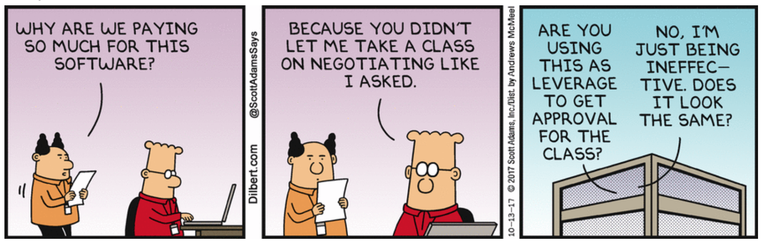

Table added

|  |  |  |
| --- | --- | --- |
|  |  |  |
|  |  |  |
|  |  |  |
|  |  |  |
|  |  |  |