VALIDATION PLAN

# VALIDATION OF 123 spin in TOOL TOOL#ID IN MOULDING CELL AC

This is a VP that stipulates the pre-agreed requirements to validate 123 spin in TOOL 205 IN MOULDING CELL AC. Such that TOOL 205 IN MOULDING CELL IN MOULDING CELL AC can consistency produce 123 spin that meets the requirements of specification *BS123*.

Generic text…

Generic text..

Generic text..

Generic text..

Shown below elements of the process that are within scope of this validation;

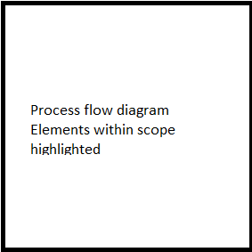

As this is a new product / duplicate tool / customization validation will consist of;

[New Product] / [Duplicate tool] / [Customization]

Generic text for [New Product] / [Duplicate tool] / [Customization] sample size based on batch size & lowest AQL.

To demonstrate TOOL 205 IN MOULDING CELL *AB* can consistency produce 123 spin *,* 1250pcs [sample size] shall be inspected per run against the following characteristics from product specification *BS123*;

|  |  |  |  |  |
| --- | --- | --- | --- | --- |
| **Defect #** | **Defect description** | **AQL** | **Sample size** | **Inspection qty** |
| 1 | Flash | 0.040% | 1250pcs | A1 R2 |
| 2 | Damage | 0.65% | 1250pcs | A14 R15 |
| 3 | Scratches | 1.0% | 1250pcs | A21 R22 |
|  |  |  |  |  |