VALIDATION PLAN

VALIDATION OF PRODUCT_A TOOL #1234 IN MOULDING CELL AB

This is a Validation Plan that stipulates the pre-agreed requirements to validate PRODUCT_A TOOL #1234 IN MOULDING CELL AB. Such that TOOL #1234 IN MOULDING CELL AB can consistency produce PRODUCT_A that meets the requirements of specification BS123.
Generic text…
Generic text..
Generic text..
Generic text..
Shown below elements of the process that are within scope of this validation;
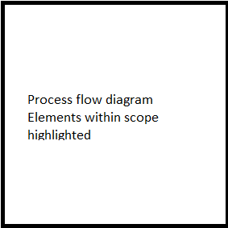
As this is a new product / duplicate tool / customization validation will consist of;
[New Product] / [Duplicate tool] / [Customization]
Generic text for [New Product] / [Duplicate tool] / [Customization] sample size based on batch size & lowest AQL.

To demonstrate TOOL #1234 IN MOULDING CELL AB can consistency produce PRODUCT_A, 1250pcs [sample size] shall be inspected per run against the following characteristics from product specification BS123;
Defect # | Defect description | AQL | Sample size | Inspection qty
1 | Flash | 0.040% | 1250pcs | A1 R2
2 | Damage | 0.65% | 1250pcs | A14 R15
3 | Scratches | 1.0% | 1250pcs | A21 R22

