VALIDATION PLAN

# VALIDATION OF Product B in TOOL TOOL#ID IN MOULDING CELL Production Cell #AB

This is a Validation Plan that stipulates the pre-agreed requirements to validate Product B in TOOL TOOL#ID IN MOULDING CELL Production Cell #AB. Such that TOOL TOOL#ID IN MOULDING CELL IN MOULDING CELL Production Cell #AB can consistency produce Product B that meets the requirements of specification *BS123*.

Generic text…

Generic text..

Generic text..

Generic text..

Shown below elements of the process that are within scope of this validation;

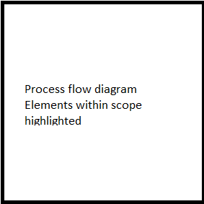

As this is a new product / duplicate tool / customization validation will consist of;

[New Product] / [Duplicate tool] / [Customization]

Generic text for [New Product] / [Duplicate tool] / [Customization] sample size based on batch size & lowest AQL.

To demonstrate TOOL TOOL#ID IN MOULDING CELL *AB* can consistency produce Product B *,* 1250pcs [sample size] shall be inspected per run against the following characteristics from product specification *BS123*;

|  |  |  |  |  |
| --- | --- | --- | --- | --- |
| **Defect #** | **Defect description** | **AQL** | **Sample size** | **Inspection qty** |
| 1 | Flash | 0.040% | 1250pcs | A1 R2 |
| 2 | Damage | 0.65% | 1250pcs | A14 R15 |
| 3 | Scratches | 1.0% | 1250pcs | A21 R22 |
|  |  |  |  |  |