**# # # How to process everything with a single Intent**

* Apparently it is possible to have an intent that catches everything with a SearchQuery slot:  
  * <https://towardsdatascience.com/why-its-hard-to-develop-a-conversational-alexa-skill-b8689f57a7f>, <https://developer.amazon.com/es/blogs/alexa/post/a3142024-75cf-46bb-924a-0ab3524a5c07/5-techniques-to-replace-amazon-literal-and-improve-skill-accuracy>
  + Example:  
    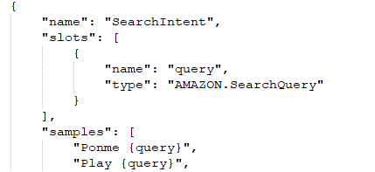  
    * But I cannot define a sample “{query}”, it is required a phrase before.
* Literal slot type definition (<https://developer.amazon.com/es-ES/docs/alexa/custom-skills/literal-slot-type-reference.html>).  
  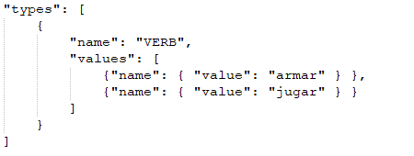
* When Alexa didn’t recognize the statement, it entered to the “AnswerIntent”.  
  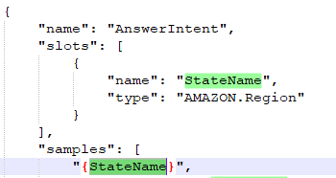  
    
  * Looks like that’s the default behavior in this case.  
  