**# # # First contact to Alexa Skill Development**

The first skill I executed is a copy of an interaction model using an existing AWS Lambda function.  
* <https://androidphoria.com/tutoriales/como-escuchar-musica-youtube-alexa-gratis>

**Terminology (part 1):**

* **Skills** are like apps for Alexa (with voice interfaces).
* An **interaction model** defines the words and phrases that users can say to Alexa to make the skill do what they want.  
  **\* Requirements:**
  + An Internet-accessible endpoint for hosting your cloud-based service.
  + A development environment (you can author a Lambda function in Node.js, Java, Python, C#, Go, Ruby, or PowerShell).

**\* Types:**

* + Pre-built ("Alexa, turn on the light.").  
    * You simply define your skill to accept these predefined requests.
  + Custom ("Alexa, plan a trip from Seattle to Denver.").

**How to create an skill (part 1):**

* **Flow to create a skill:**  
  
  + Design
  + Build
  + Test
  + Publish
  + Monitor
* Host a **Custom Skill as an AWS Lambda Function** or asan HTTP service.  
  * <https://developer.amazon.com/.../host-a-custom-skill-as-an-aws-lambda-function.html>  
  * <https://developer.amazon.com/.../host-a-custom-skill-as-a-web-service.html>
  + For HTTPS services it is required that they are accessible through internet.
* **Building** my skill:  
  * <https://developer.amazon.com/es-ES/docs/alexa/build/build-your-skill-overview.html>
  + **\* Requirements:**
    - Alexa development console.  
      * <https://developer.amazon.com/.../about-the-developer-console.html>
    - Alexa Skills Kit SDKs.  
      * <https://developer.amazon.com/.../alexa-skills-kit-sdks.html>
    - A code editor of your choice.
  + It is possible to build an Alexa-hosted Skill.  
    * <https://developer.amazon.com/es-ES/docs/alexa/hosted-skills/build-a-skill-end-to-end-using-an-alexa-hosted-skill.html>

**AWS Account creation:**

* **I created an AWS account,** if I use a limited amount of resources the AWS Lambda functions execution service will be free.  
  * <https://aws.amazon.com/es/free/>
  + I need to wait for the payment method verification.
  + Basic support level (free) selected.

**For future reference:**

* It could be interesting to check **Alexa conversations**.  
  * <https://developer.amazon.com/en-US/docs/alexa/conversations/about-alexa-conversations.html>

**How to create an skill (part 2):**

* **Conclusions** about how to create an Alexa Skill.
  + Create Skill at *Alexa Developer Console*.  
    * <https://developer.amazon.com/alexa/console/ask>  
    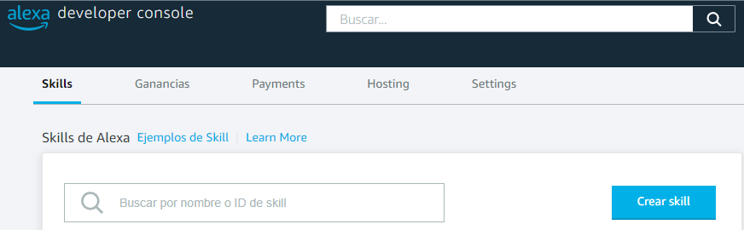
  + Create interaction model (pre-built or custom).  
    * <https://github.com/alexa-samples/skill-sample-nodejs-quiz-game/blob/master/models/en-US.json>
  + Create Lambda function (e.g. [skill-sample-nodejs-quiz-game/.../index.js](https://github.com/alexa-samples/skill-sample-nodejs-quiz-game/.../index.js)).  
    * <https://us-east-2.console.aws.amazon.com/lambda/home?region=us-east-2#/begin>  
    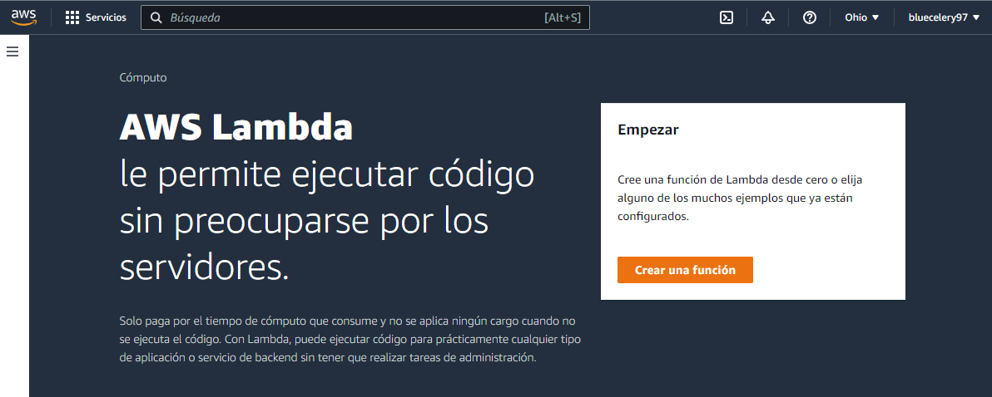
  + Specify Lambda function endpoint in the Alexa Developer Console.  
    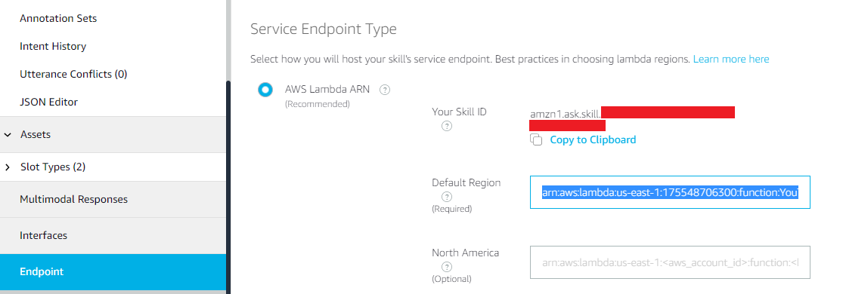  
    **\* E.g.** “*arn:aws:****lambda****:us-east-1:175548706300:****function****:YouTube*”

**For future reference:**

* For routines I created an account at IFTTT dot com (<https://ifttt.com/>).  
  *\* I can create 2 applets with the free account.*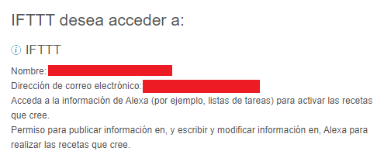

**Terminology (part 2):**

* Understanding the difference between **intent, utterance and slot**.  
  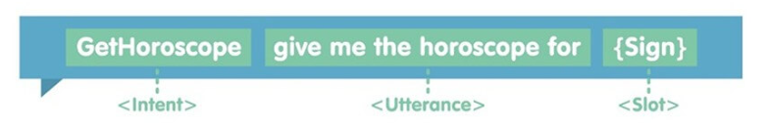  
  * <https://www.screenmedia.co.uk/lab/alexa-skill-development-understanding-intents-utterances-and-slots/>
  + An **intent** doesn’t relate to the specific words that a user says, but the high-level goal they are aiming for.
  + The **utterances** are the specific phrases that people will use when making a request to Alexa.
  + A **slot** is a variable that relates to an intent.
* I cannot add *Intent Launch Phrases* nor *Skill Launch Phrases* until I publish the skill, but I can specify routines in my Alexa device to open the Skill.  
  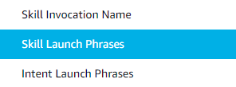  
  

**Understanding Skill example:**

Inspecting a **Skill example** (<https://github.com/alexa-samples/skill-sample-nodejs-quiz-game>).

* **Interaction model JSON FILE:**
  + interactionModel.languageModel
    - invocationName  
      
    - intents  
      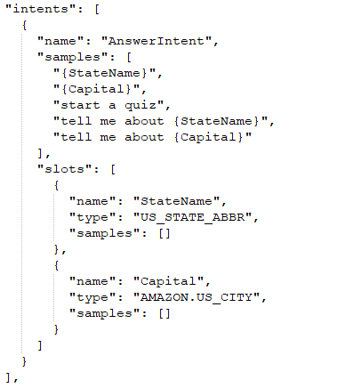  
      * Slot pre-built types: <https://developer.amazon.com/es-ES/docs/alexa/custom-skills/slot-type-reference.html>
    - types (slot types)  
      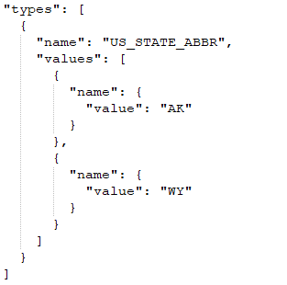 (e.g. #1)  
      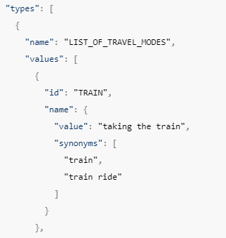 (e.g. #2)  
      * The values that this particular type admits to trigger the Intent: <https://developer.amazon.com/en-US/docs/alexa/custom-skills/create-and-edit-custom-slot-types.html#json-for-slot-types-interaction-model-schema>
* **NodeJS Lambda function:**
  + It is composed of these sections…
    - Lambda setup.  
        
      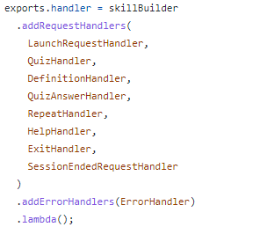  
      * All the handlers are passed, and it is exported the **handler instance**.
    - Helper functions.
    - Constants (data arrays and literals).
    - Handlers.
      * canHandle() function.  
        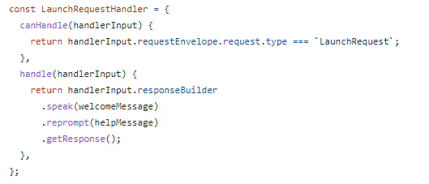  
        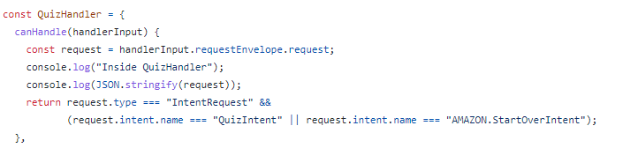  
        * I assume this is called during Lambda setup to map the handlers to their respective request types and intent names.
      * handle() function.  
        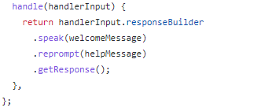  
        * I assume this is called when the Handler intent is received.
    - Alexa SDK import.  
      
* **About Alexa SDK Core:**
  + ***HandlerInput*** instance.  
    * <https://alexa-skills-kit-python-sdk.readthedocs.io/en/latest/api/core.html?highlight=handlerInput>
    - I can share variables through Intents with the *HandlerInput.AttributesManager*.  
      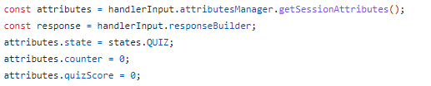  
        
      * It is required to save them after any modification:  
      
    - It is possible to check if the Alexa device has a display:  
      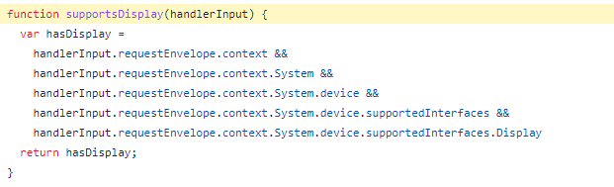
    - To generate an answer:  
        
        
      * The *reprompt* is for the scenario where the user does not respond in 8 seconds.
    - To get the slots value:  
      

**Questions:**

* How to **wait more time for an answer** from user after the reprompt to prevent the skill from closing? **R.** Using the *Speech Synthesis Markup Language* ([**SSML** reference](https://developer.amazon.com/en-US/docs/alexa/custom-skills/speech-synthesis-markup-language-ssml-reference.html#audio)) to reproduce a silence audio stored in Amazon S3 (AWS).  
  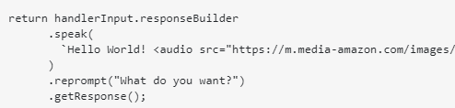  
  * <https://stackoverflow.com/questions/47019319/is-it-possible-for-alexa-to-wait-in-a-skill-without-directly-awaiting-user-input>, <https://stackoverflow.com/questions/69134378/alexa-skills-how-to-prompt-user-for-response-after-audio-player-finish-playing>