**# # # Executing Quiz Sample**

* <https://github.com/alexa-samples/skill-sample-nodejs-quiz-game>

* I inserted the interaction model directly in the Alexa Developer Console > Custom > Interaction Model > JSON Editor  
  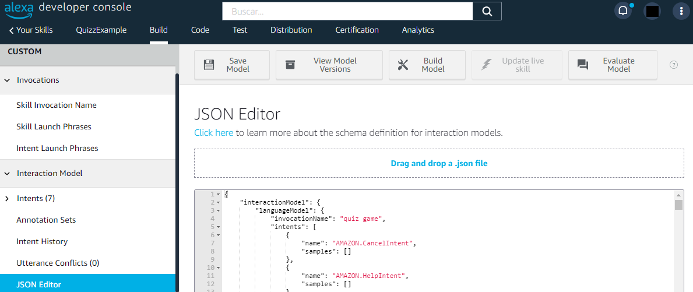  
  * <https://github.com/alexa-samples/skill-sample-nodejs-quiz-game/blob/master/models/en-US.json>
* Added the basic info for the AWS Lambda function.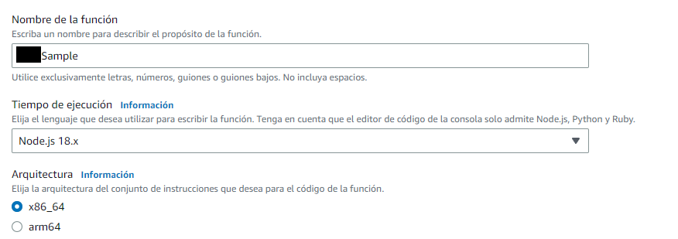
* Added Alexa as trigger for the function (Skill ID from Alexa Developer Console > Custom > Endpoint).  
  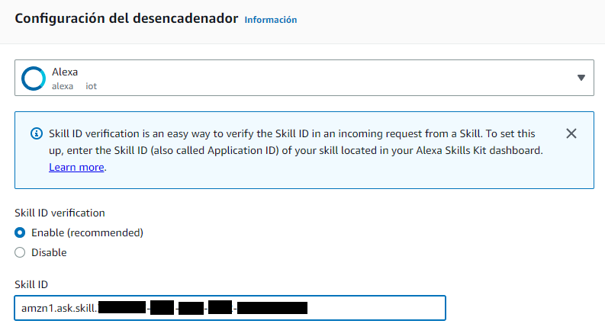  
  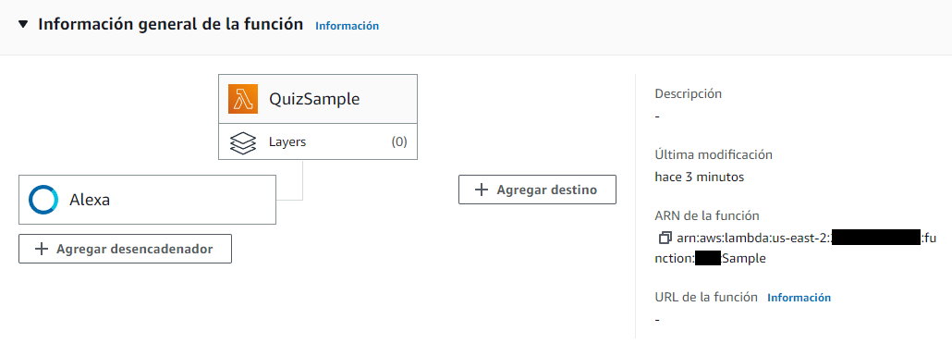  
  *\* Now it shows in the general function info.*
* Copied ARN into Skill ID from [Alexa Developer Console > Custom > Endpoint].  
  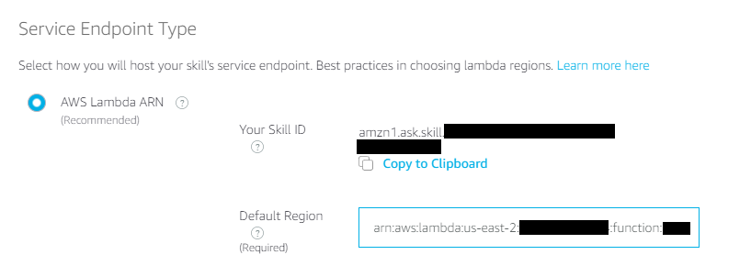
* Code files (***package.json*** is relevant to declare the dependencies):  
  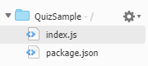  
  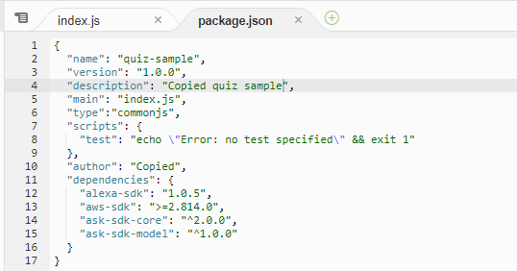
* Code deployed (code from [skill-sample-nodejs-quiz-game/.../lambda/custom/index.js](https://github.com/alexa-samples/skill-sample-nodejs-quiz-game/blob/3b1eaac22a325d46c7cfc72eafb2384aec752310/lambda/custom/index.js)).  
  
* To see the deployment logs there is a tab for monitoring, it is required to click the “View CloudWatch logs”.  
  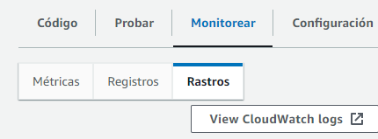
* The events are generated every time I ask Alexa to execute the skill (I had to activate the Skill in my phone).  
  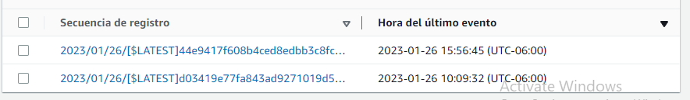
* **\* Error:** *“ReferenceError: require is not defined in ES module scope, you can use import instead”*  
  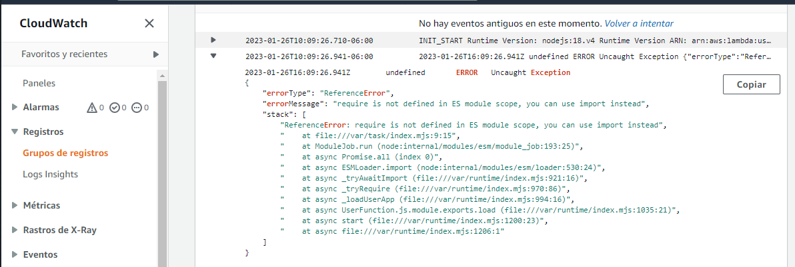
  + **\* Solution:**   
    The file I used for the code was *.mjs* and a *.js* file is required to execute *require* function instead of import (<https://stackoverflow.com/questions/31931614/require-is-not-defined-node-js>).  
    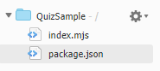
* **\* Error:** “*Error: Cannot find module 'ask-sdk-core'\nRequire stack:\n- /var/task/index.js\n- /var/runtime/index.mjs*”  
  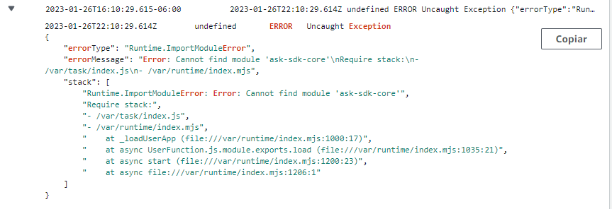  
  **\* Solution:**
  + It looks like I have to use *npm* locally to download the dependencies and then compress them into a ZIP file and load it into the AWS Lambda console.  
    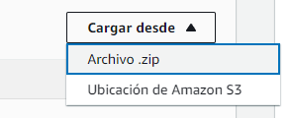  
    * [#cannot-find-module-ask-sdk-core.html](https://amazon.developer.forums.answerhub.com/questions/179991/cannot-find-module-ask-sdk-core.html), <https://developer.amazon.com/es-ES/docs/alexa/alexa-skills-kit-sdk-for-nodejs/set-up-the-sdk.html>, <https://stackoverflow.com/questions/34437900/how-to-load-npm-modules-in-aws-lambda>
  + $ npm install --save ask-sdk-core  
    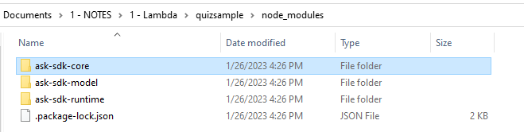  
    * It installed all the packages.
* **\* Error:** “*Cannot find module 'index'\nRequire stack:\n- /var/runtime/index.mjs*”  
  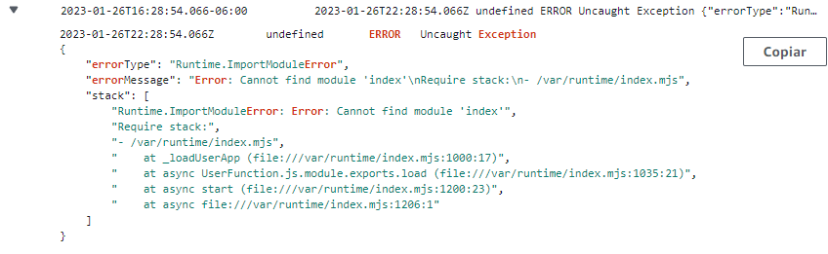  
  **\* Solution:**
  + I compressed the entire *quizsample* directory and it is required to have the *index.js* file in the root directory.  
    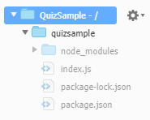  
    * <https://stackoverflow.com/questions/74146214/error-cannot-find-module-handler-nrequire-stack-n-var-runtime-index-mjs>
* **Success.** I was able to execute the Lambda function and play the Quiz sample with Alexa. 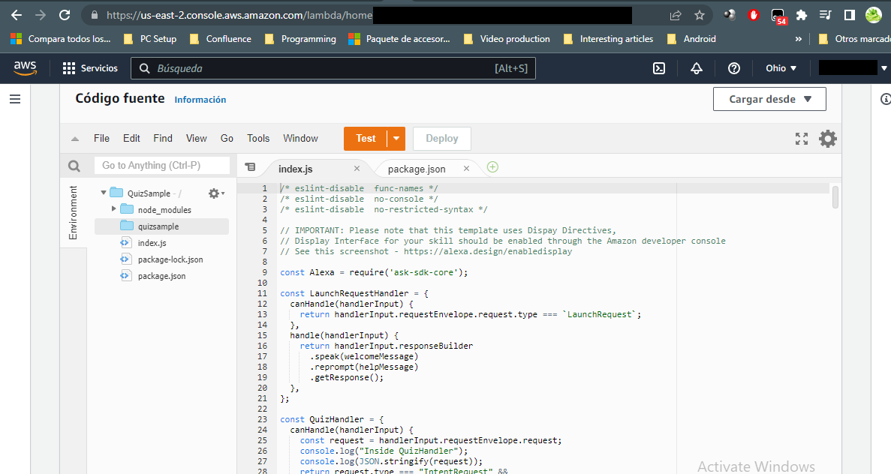

**For future reference:**

* Alexa resource usage limits -> <https://developer.amazon.com/en-US/docs/alexa/hosted-skills/usage-limits.html>.

**Questions:**

* **How are accessed the slots from code?**
  + Through *handlerInput.requestEnvelope.request.intent.slots*.  
    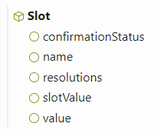  
    * <http://ask-sdk-node-typedoc.s3-website-us-east-1.amazonaws.com/interfaces/slot.html>
    - The *confirmationStatus* is an enumeration indicating whether the user has explicitly confirmed or denied the value of this slot.  
      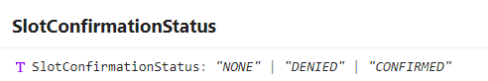
    - The *resolutions* contains a list of *Resolution* instances, each one with an status code.  
      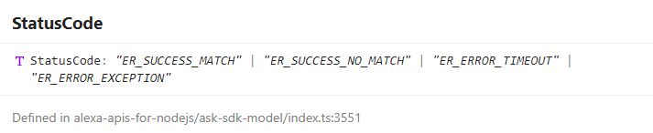
    - The *slots* variable contains a map of slots.  
      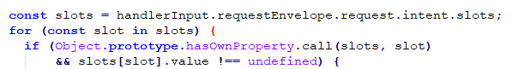  
      * <http://ask-sdk-node-typedoc.s3-website-us-east-1.amazonaws.com/interfaces/intent.html#slots>  
      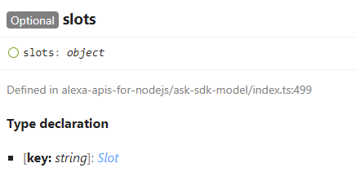
  + I printed the *Intent.Slots* variable content:  
    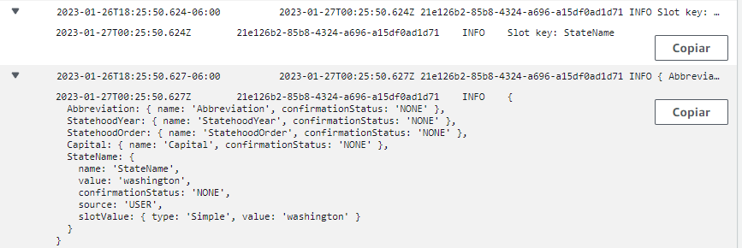
    - The key in the slots map is the Slot Type.  
        
      * <http://ask-sdk-node-typedoc.s3-website-us-east-1.amazonaws.com/interfaces/intent.html#slots>
  + With this code I accessed an specific slot value:  
    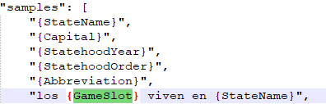  
    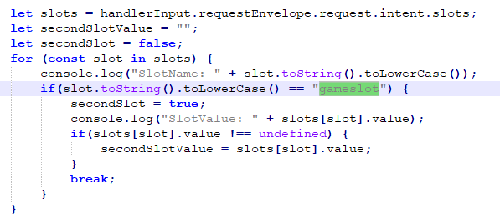
* **Is there a way to connect to a database?**  
  **R.** It seems DynamoDB is free (25GB). Probably I’ll require to set it up and use a nodejs library to access it from the skill.  
  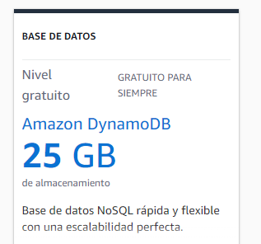  
  * <https://aws.amazon.com/es/free/>