**# # # Alexa Integration with OpenAI (+Costs)**

I have 18 dollars of free trial that expires on “*1 de mayo de 2023”* just for creating an Open AI account.  
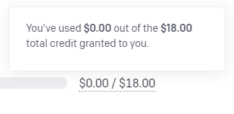  
* <https://beta.openai.com/account/usage>

**Making my first OpenAI request:**

* I’ll create a secret key to make HTTP requests.  
  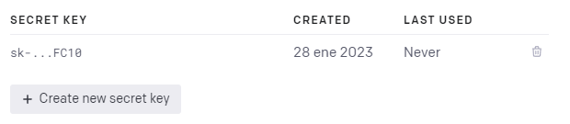  
  * <https://beta.openai.com/account/api-keys>
* One important setting is called **temperature**…
  + Temperature is a value between 0 and 1 that essentially lets you control how confident the model should be when making predictions.  
    *\* 0 will always retrieve the same answer, and* ***as closer to 1 the model will retrieve more diversity of answers****.*
* **My first request:**
  + curl https://api.openai.com/v1/completions -H "Content-Type: application/json" -H "Authorization: Bearer ***<SECRET-APY-KEY>***" -d '{"model": "text-davinci-003", "prompt": "*Dime para que sirve el asistente Alexa.*", "temperature": 0, "max_tokens": 50}'  
    **\* Response:**
    - {"id":"cmpl-5dg3CPpdrPdRyxbKNB5v462qr2F","object":"text_completion","created":1674914454,"model":"text-davinci-003","choices":[{"text":"\n*nAlexa es un asistente virtual de Amazon que te ayuda a realizar tareas cotidianas como reproducir música, responder preguntas, controlar dispositivos*","index":0,"logprobs":null,"finish_reason":"length"}],"usage":{"prompt_tokens":12,"completion_tokens":50,"total_tokens":62}}

**Notes about OpenAI NodeJS library:**

* <https://beta.openai.com/docs/api-reference/introduction>

* $ npm install openai  
  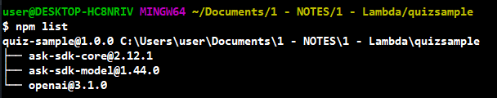  
  * <https://stackoverflow.com/questions/10972176/find-the-version-of-an-installed-npm-package>
* Library usage:  
  * <https://www.npmjs.com/package/openai>, <https://beta.openai.com/docs/libraries/node-js-library>  
  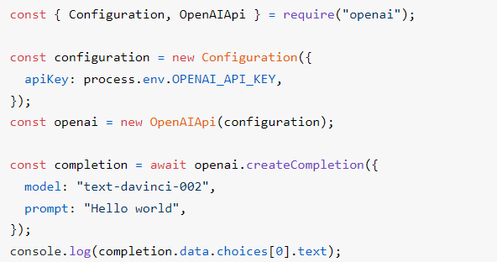
* I added the configuration to the imports section:  
  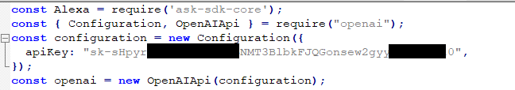
* Then I declared as *async* the handler method:  
  
* And then I made the request from inside the handler…  
  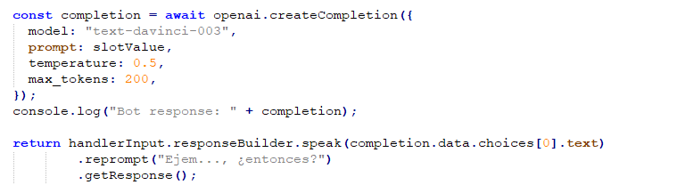
* **\* Error:** “*Task timed out after 3.01 seconds*”  
    
  **\* Solution:**
  + I changed the timeout for the AWS Lambda function in “*General Configuration*”.  
    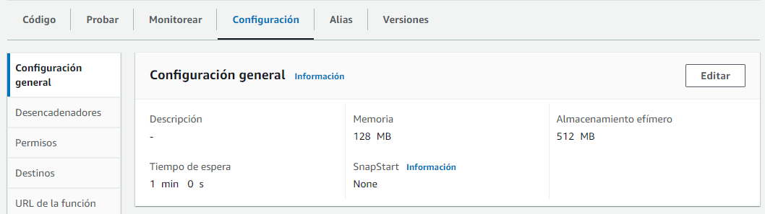  
    *\* Click on “Edit” and...*  
    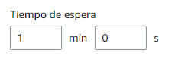* <https://docs.aws.amazon.com/lambda/latest/dg/configuration-function-common.html#configuration-timeout-console>
* To keep the context of the conversation it seems it is required to include the previous interactions in the prompt.  
  * <https://community.openai.com/t/how-do-you-maintain-historical-context-in-repeat-api-calls/34395/8>
* **\* Error:** with “para” (“stop”) slot value…  
  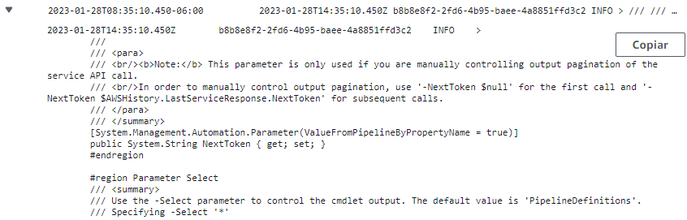  
  **\* Solution:** Try..catch block (<https://developer.mozilla.org/en-US/docs/Web/JavaScript/Reference/Statements/try...catch>).
* The maximum number of tokens that the model supports is 2048 tokens.  
  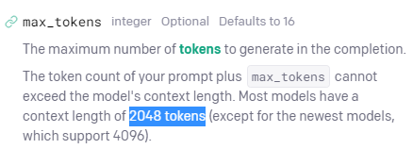  
  * <https://beta.openai.com/docs/api-reference/completions/create#completions/create-max_tokens>

**About costs:**

* It seems an regular person says max 300 words per minute.  
  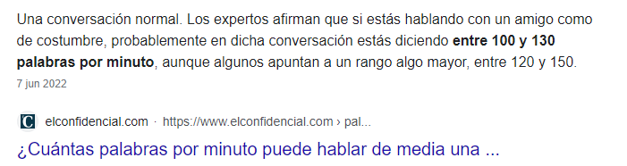
  + Every interaction will cost 400 tokens, or approx. $0.01 US dollars. Considering an interaction like 200-300 words, which isn’t likely.

**Integrating Open AI to Alexa:**

* I was able to integrate the Davinci AI (completion feature) inside my Alexa Skill.
* I added stop commands…  
  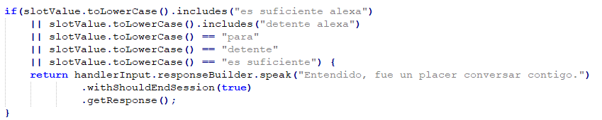
* Last user input and Alexa response is considered.  
  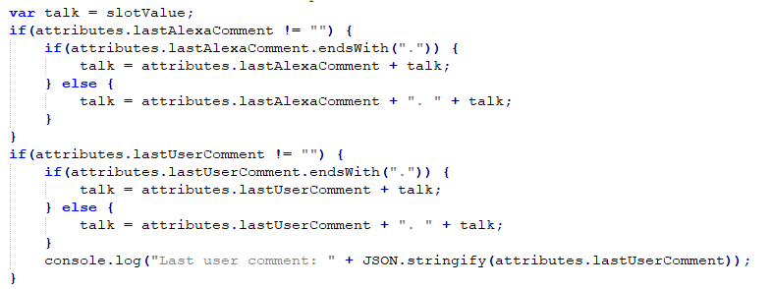
* The AI configuration:  
  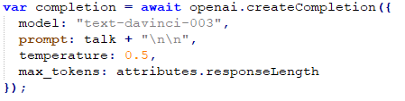

**Challenges:**

* How can I deal with **short/cut answers**? **R.** Saying “Continue”.  
  * <https://community.openai.com/t/completion-cut-off-and-unknown-characters/16708/2>, <https://www.reddit.com/r/OpenAI/comments/zgkulg/chatgpt_often_will_not_finish_its_code_or/>
* It usually finishes without completing a phrase:  
    
  **\* Solution:** I’ll remove the last sentence when this happens.  
  
* To **deal with lists**, if I detect one I ask again for the answer adding a modifier “*in one phrase*”, giving more tokens to retrieve the answer.  
  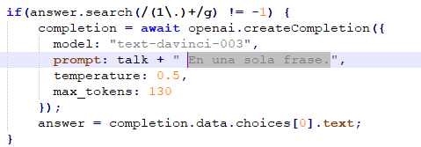
* **Alexa never adds question marks** to the slot value, but this seems to not be a problem for the AI to retrieve coherent answers.
* In order to make the AI recognize the text to complete as a conversation, I added “\n\n” at the end of each interaction (from user or from AI).  
  
* To make it feel more as a conversation, I did the AI stop when a question mark is reached.  
  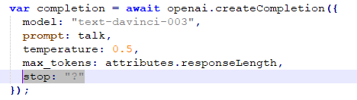  
  **\* This didn’t work** because the stop sequence isn’t included in the retrieved response from the AI, I decided to cut the response once it comes back using “*.search(/\?/g)”*.
* To make Alexa whisper:  
  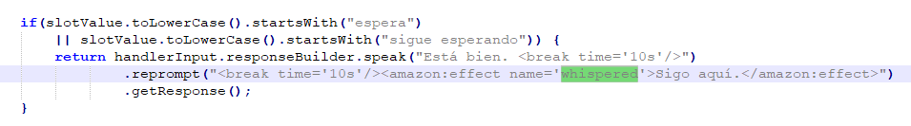  
  * <https://developer.amazon.com/en-US/docs/alexa/custom-skills/speech-synthesis-markup-language-ssml-reference.html#amazon-effect>
* **Multi-language problem…**, there’s no way to recognize if something has to be pronounced in English or Spanish.  
  * <https://us-east-2.console.aws.amazon.com/cloudwatch/home?region=us-east-2#logsV2:log-groups/log-group/$252Faws$252Flambda$252FQuizSample/log-events/2023$252F01$252F30$252F$255B$2524LATEST$255D1f30fbcdcb754640b084b9838c55bf57$3Fstart$3D1675118263439$26refEventId$3D37356385572588309253190015140528546342398399410461343753>
* It seems when the response takes more than 10 seconds Alexa interrupts the connection. I’m making two requests, the first request took 5 seconds with 80 tokens, and the second one 8 seconds with 150 tokens approx.  
  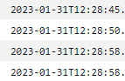  
    
  * <https://amazon.developer.forums.answerhub.com/questions/205700/waitcontinue-in-alexa-skill-response.html>
  + I can make the first request with 10 tokens just to know if the response is a list or not.