Hypothesis 1 – Bug 1

* Game does not pay out at correct level.
* When player wins on 1 match, balance does not increase.

The game must not be calculating the amount the player gives – i.e. the player bets 5 and he wins (so the game must be ‘returning the bet he placed and not adding the further winnings i.e. another 5).

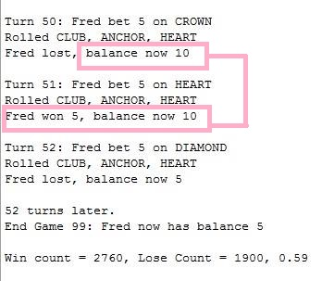Balance was not increase (Before)

Hypothesis 2 – Bug 2

* Player cannot reach betting limit:
* Limit set to 0, but game ends with player still with 5 (dollars) remaining.

There must be an error in the code at a particular spot not accounting for equal to limit.

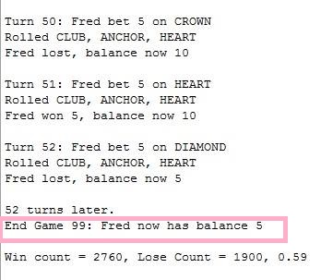limit was set to 0 and game ended at 5 (Before)

Hypothesis 3 – bug 3

* Odds in the game do not appear to be correct.
* Crown and Anchor games have an approximate 8% bias to the house.
* The win: (win + lose) ratio should approximately equal 0.42.

The game must be selecting at random the first draw of cards but for the next games played within the session it will be using the ones drawn from the first draw.

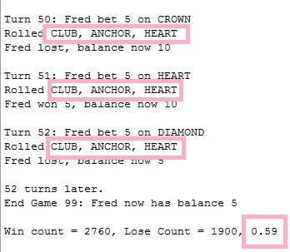continuously choosing the same card for each game(before)