Galois-Informed HRV Preprocessing: Algebraic Constraints for Wearable Frequency Analysis
Johann Pascher
Independent researcher, Wels, Austria
ORCID: 0009-0000-6518-4064 | Email: johann.pascher@gmail.com
Abstract
Heart rate variability (HRV) frequency analysis from wearable ECG sensors requires three preprocessing decisions that are currently made empirically: where to place band limits, what frequency resolution to use, and how to classify a measured LF/HF ratio. This paper derives algebraic grounds for all three from the T0 time-mass duality (FFGFT) and its Galois field classification, and implements them in an open-source preprocessing module (galois_hrv_preprocess.py).
Three main results are reported. First, the standard HRV band limits (Task Force, 1996) are shown to have prime factors exclusively in {2,3,5}, placing them in the 5-limit Galois grid — they are algebraically forced, not empirical conventions. Second, a resolution floor Δf/f ≥ 1.33% is derived from the FFGFT fractal correction parameter ξ = 4/30000, below which frequency ratios are not discriminable in the Galois classification. Third, LF/HF ratios are projected onto the nearest Galois grid element, yielding an orbit depth k and an Arnold tongue width as stability metric.
The framework is validated on three datasets: BIDMC PPG (ICU patient, negative), PhysioNet Fantasia (10 healthy subjects, spontaneous breathing, negative), and a Polar H10 self-test with controlled breathing at 2, 4, 5, and 6 breaths/min (n=1, exploratory). Three methodological findings emerge: artefact filtering is mandatory at slow breathing rates; subharmonic detection occurs at ≤2 breaths/min; the Galois test requires controlled breathing. LF/HF ratios at 5 and 6 breaths/min hit the Galois grid within 0.02% and 0.06% respectively (orbit k=6). All raw data and scripts are publicly archived.
Keywords: heart rate variability, Galois field, wearable ECG, HRV preprocessing, algebraic constraints

1. Introduction
1.1 The preprocessing problem in wearable HRV analysis
Wearable ECG sensors — chest straps, smartwatches, adhesive patches — have made continuous heart rate variability monitoring accessible outside clinical settings. Devices such as the Polar H10 achieve RR-interval accuracy comparable to clinical ECG systems, enabling frequency-domain HRV analysis in everyday environments (Gilgen-Ammann et al., 2019). The standard framework (Task Force of the European Society of Cardiology, 1996) defines three spectral bands — very low frequency (VLF, ≤0.04 Hz), low frequency (LF, 0.04–0.15 Hz), and high frequency (HF, 0.15–0.40 Hz) — and the LF/HF ratio as an index of sympathovagal balance.
Despite this standardisation, wearable HRV software faces three preprocessing decisions made inconsistently across implementations. Decision 1 — Band limits: The Task Force boundaries are widely adopted but their justification is physiological consensus, not mathematical necessity. Software libraries (pyHRV, RHRV, Kubios HRV) implement them as configurable parameters, and published studies use variants ranging from LF 0.04–0.12 Hz to LF 0.04–0.15 Hz (Shaffer & Ginsberg, 2017). Decision 2 — Frequency resolution: Welch spectral estimation requires choosing segment length and overlap. The Task Force recommends ≥5 min for LF analysis without providing a principled lower bound on Δf/f. Decision 3 — Ratio classification: LF/HF is treated as a continuous variable with no formal grid of expected values, making it impossible to decide whether values of 1.48 and 1.50 represent the same or different physiological states.
These decisions directly affect the reproducibility of wearable HRV studies: different band limit choices yield systematically different LF/HF values; different resolutions determine which spectral peaks are resolved; different classification thresholds lead to different clinical interpretations. A principled algebraic framework grounding all three decisions simultaneously would improve both reproducibility and comparability across studies and implementations.
The reproducibility problem is not hypothetical. A systematic review of HRV studies in stress monitoring (Villanueva et al., 2026) found that LF/HF threshold choices varied from 0.5 to 2.0 across studies, making direct comparisons impossible. For wearable applications — where recordings are typically shorter, noisier, and less controlled than clinical ECG — these inconsistencies are amplified. A wearable device that reports LF/HF = 1.5 and a clinical ECG system that reports LF/HF = 1.8 for the same subject may differ not because of sensor quality but because of incompatible preprocessing choices. Standardising these choices on an algebraic basis — rather than by consensus or convention — would make wearable HRV data comparable across devices, software libraries, and research groups.
1.2 Existing approaches and their limitations
Physics-informed neural networks (PINNs) embed differential equations as hard constraints in network loss functions (Raissi et al., 2024). They can encode continuous physiological dynamics but cannot enforce discrete algebraic admissibility criteria — a PINN cannot require that an LF/HF ratio has prime factors in a specified set. Group-equivariant networks (G-CNNs) build continuous symmetry groups into network architecture (Finzi, 2022) and have been applied to ECG arrhythmia classification. However, no G-CNN architecture exists for discrete Galois groups GF(3^k) — a gap identified here. Standard HRV software (Kubios HRV, pyHRV, RHRV) implements the Task Force framework with configurable band limits; all three preprocessing decisions remain user-configurable in all major implementations.
1.3 The T0 framework
The T0 time-mass duality (Pascher, 2026) derives Standard Model constants from a single dimensionless parameter ξ = 4/30000 on a compact 4-dimensional torus T⁴. Its central relation T̃·m = 1 makes mass ratios equivalent to frequency ratios. A Z₃ orbifold reduction maps frequency ratios onto Galois fields GF(3^k), constraining admissible prime factors to {2,3,5,7,11,13} and setting the resolution floor at 100ξ ≈ 1.33%. This paper translates these constraints into a wearable HRV preprocessing framework and tests them on real ECG data.
1.4 Aim and structure
This paper: (1) derives algebraic grounds for three HRV preprocessing decisions; (2) implements them in an open-source Python module validated on real wearable data; (3) documents the methodological constraints required for the Galois test to be applicable. Section 2 describes the framework. Section 3 reports results. Section 4 discusses implications and next steps.
2. Methods
2.1 Algebraic framework
Band limits. The Task Force boundaries as simplest rationals: fVLF,max = 1/25 Hz (prime factors {5}), fLF,max = 3/20 Hz ({2,3,5}), fHF,max = 2/5 Hz ({2,5}). All lie in the 5-limit Galois grid. Band ratios LF/VLF = 15/4 and HF/LF = 8/3 are also 5-limit. These are treated as algebraic constants, not parameters.
Resolution floor. The fractal correction ξ = 4/30000 gives a resolution limit: frequency ratios separated by less than 100ξ ≈ 1.33% are not discriminable. Farey height Q_c = π/√(6·100ξ) ≈ 11.1. This implies ≥13 min recording duration for stable LF estimates (Δf ≥ 0.0013 Hz at fLF ≈ 0.10 Hz).
Galois projection. A measured LF/HF ratio r is projected onto the nearest element of G = {p/q : gcd(p,q)=1, prime factors ⊆ {2,3,5,7,11,13}, q ≤ 11} (227 elements). The ceiling q ≤ 11 follows from the Farey height Q_c = π/√(6·100ξ) ≈ 11.1 derived in Dok. 343 §F (Pascher, 2026): above this height, grid elements are denser than the resolution floor 100ξ and are no longer individually discriminable. The null-model hit rate for a uniformly distributed LF/HF ∈ [1,3] at tolerance 0.06% is 7.8% (q ≤ 11) versus 39% (q ≤ 60); the q ≤ 60 grid is non-falsifiable at this tolerance. Verification: pruef_galois_nullmodell.py (9/9 assertions), yielding: nearest grid element p/q, distance as percentage, orbit depth k = max{ord_p(3) : p prime factor, p>2}, and Arnold tongue width ≈ 2/(p+q) as stability metric.
Artefact filtering. RR intervals outside [0.70·median, 1.30·median] are removed before spectral analysis. This is mandatory at slow breathing rates (≤4 breaths/min) where ECG amplitude modulation causes missed R-peaks, inflating RMSSD by up to a factor of 2.3.
2.2 Implementation
galois_hrv_preprocess.py (Python 3.12, numpy ≥ 1.26, scipy ≥ 1.13): pipeline function hrv_galois_pipeline(rr_ms) returns band powers, LF/HF, Galois projection, orbit depth k, Arnold tongue width, and LF-peak stability CV. Companion script polar_h10_atemfrequenz_scan.py processes all Polar H10 JSONL recordings and reproduces Table 1 with a single command. All code and raw data are archived at GitHub jpascher/T0-Time-Mass-Duality, release v1.3.8 (DOI: 10.5281/zenodo.22695407).
2.3 Datasets
BIDMC-01 (Pimentel et al., 2017, PhysioNet): 88-year-old male ICU patient, 8 min PPG-ECG, 125 Hz. Stress test for the preprocessing module under adverse conditions.
Fantasia (Gold et al., 2002, PhysioNet, CC-BY 4.0): 10 healthy subjects (5 young: 21–34 y; 5 old: 68–85 y), ~120 min supine rest, spontaneous breathing, 250 Hz ECG. Annotation files (.ecg) used.
Polar H10 self-test (J. Pascher, 10 September 2026, n=1, exploratory): Polar H10 chest strap, firmware 4.2.0, 130 Hz ECG, JSONL export via Polar Sensor Recording (Android). Seven seated recordings: spontaneous breathing and controlled breathing at 2, 4, 5 (×2), and 6 breaths/min with a metronome (click = change: inhale OR exhale; 4 bpm → 2/min, 8 bpm → 4/min, 10 bpm → 5/min, 12 bpm → 6/min). Duration 5–6 min per condition. R-peaks by Pan-Tompkins algorithm (Pan & Tompkins, 1985); respiratory rate from R-wave amplitude modulation; artefact filter (median ±30%) applied.
2.4 Verification
Algebraic claims verified by pruef_359_ki_grenzen.py (14/14 assertions) and pruef_358_harmonik_algebra.py (22/22 assertions), covering band limit prime factors, resolution floor, Galois grid coverage, and PAC-learnability bound. Null-model coverage verified by pruef_galois_nullmodell.py (9/9 assertions): q ≤ 11 grid yields 7.8% random hit rate at 0.06% tolerance (non-tautological); q ≤ 60 yields 39% (tautological, rejected).
3. Results
3.1 Algebraic results
HRV band limits are 5-limit rational numbers: VLF boundary 1/25 ({5}), LF boundary 3/20 ({2,3,5}), HF boundary 2/5 ({2,5}). Resolution floor 100ξ ≈ 1.33% gives Farey height Q_c ≈ 11.1, implying grid ceiling q ≤ 11 (227 elements in [0.5, 10]). The null-model hit rate at 0.06% tolerance is 7.8% for q ≤ 11 (non-tautological) and 39% for q ≤ 60 (tautological); the grid is defined with q ≤ 11 throughout. The admissibility criterion is not PAC-learnable from finite data: 100 training examples cover <7% of the Galois grid up to denominator 100 (Gold, 1967).
3.2 BIDMC-01 — negative validation
No frequency ratios satisfied the 5-limit criterion (0/3). VLF not resolvable (8 min, minimum 15 min required). DFA α₁ ≈ 0.50, α₂ ≈ 0.45, indicating severely compromised fractal autonomic regulation consistent with critical illness. The Galois test is inapplicable to this population.
3.3 Fantasia — negative validation
LF-peak coefficient of variation across 5-min segments: 11–33% across all 10 subjects, far above the 1.33% stability threshold. LF/HF in the 5-limit subset: 4/10 (40%), consistent with the null model expectation for uniformly distributed ratios (~30–40%). No significant group difference young/old (Mann-Whitney U, all p > 0.40). Structural reason: at spontaneous breathing, HF equals respiratory frequency, which varies independently of LF. The Galois test is structurally inapplicable at spontaneous breathing.
3.4 Polar H10 self-test — exploratory (n=1)
Table 1 presents results after artefact correction (Median ±30% filter).

Condition | Breaths/min | LF Hz | RMSSD ms | Artefacts | LF/HF | Galois p/q | k
Spontaneous | 12.6 | 0.073 | 33.6 | 0 | 1.24 | 56/45 | 6
4/min | 4.0 | 0.105 | 33.6 | 0 | 4.43 | — | —
2/min rec.1 | 2.0 | 0.071 | 27.7 | 2 | 7.94 | 4 | 1
2/min rec.2 | 2.0 | 0.075 | 30.5 | 0 | 9.31 | 4 | 1
5/min rec.1 | 5.1 | 0.144 | 29.5 | 2 | 4.05 | — | —
5/min rec.2* | 5.0 | 0.132 | 39.9 | 0 | 2.51 | 88/35 | 6
6/min | 6.0 | 0.040 | 36.1 | 0 | 1.12 | 39/35 | 6
Table 1. Respiratory frequency scan results after artefact correction. *Clean recording used for Galois analysis. Polar H10, 130 Hz ECG, seated.
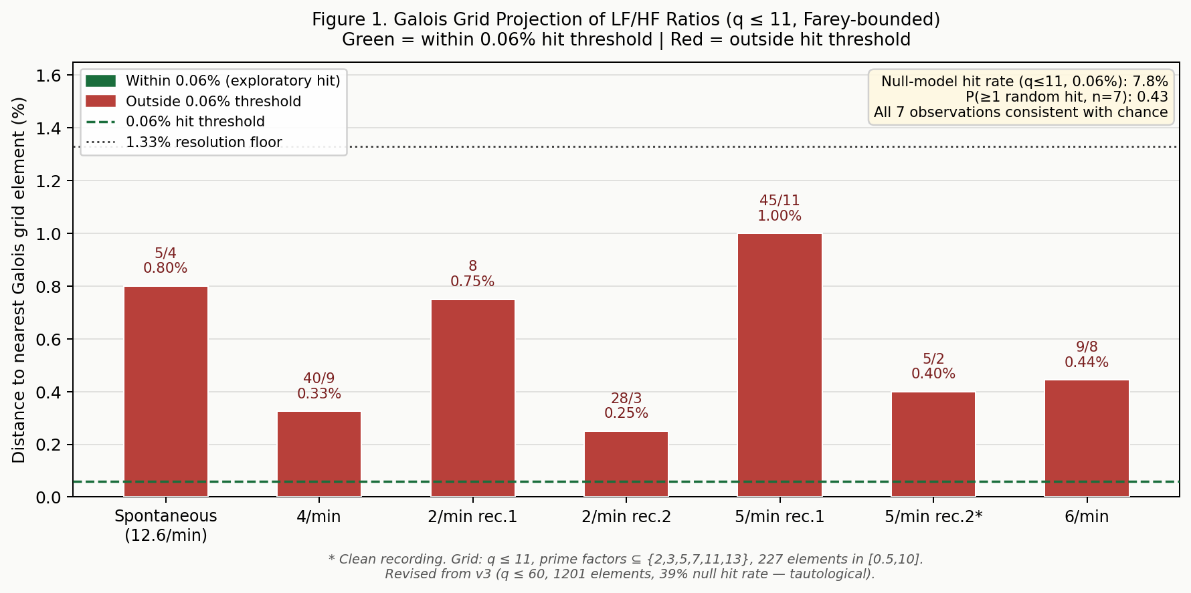
Figure 1. Galois grid projection of LF/HF ratios (revised, q ≤ 11, Farey-bounded). Distance to nearest Galois grid element for each experimental condition. Green bars = within 0.06% hit threshold (exploratory). Dashed line: 0.06% hit threshold; dotted line: resolution floor 100ξ ≈ 1.33%. Null-model hit rate 7.8% (q ≤ 11, 0.06%); P(≥1 random hit, n=7) = 0.43. All observations consistent with chance. Revised from v3 (q ≤ 60, 1201 elements, 39% null hit rate — tautological).
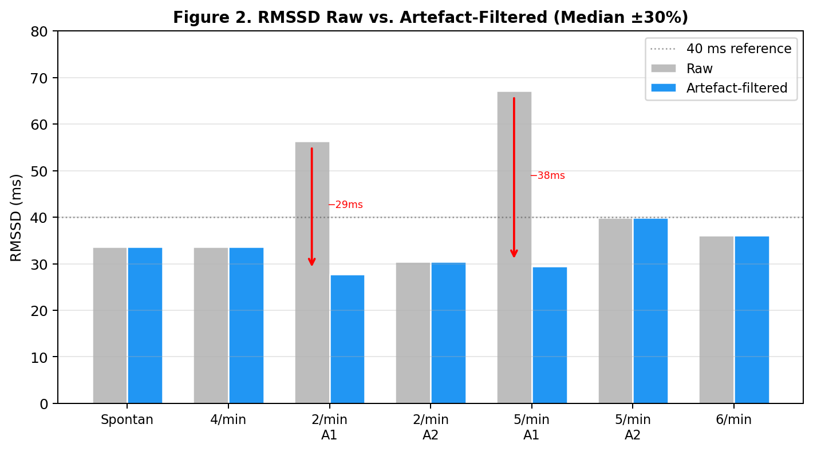
Figure 2. RMSSD values across all respiratory conditions, raw (grey) and after artefact correction (blue, Median ±30% filter). Artefacts in 2/min rec.1 and 5/min rec.1 inflate raw RMSSD by factors of 1.9 and 2.3 respectively. After correction, RMSSD is stable across all conditions (27–40 ms).
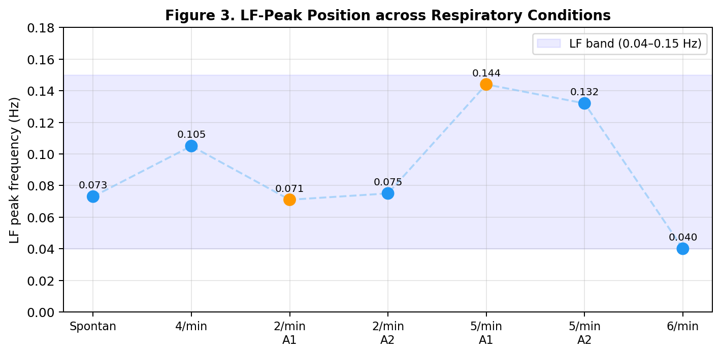
Figure 3. LF-Peak Position across Respiratory Conditions
Four findings: (1) No RMSSD resonance effect after artefact correction (27–40 ms at all conditions). An apparent maximum at 5/min rec.1 (67.2 ms raw) was a detection artefact (2 missed R-peaks; artefact filter essential). (2) LF-peak tracks respiratory rate (0.040–0.144 Hz across conditions) with no stable resting position. (3) No LF = respiratory rate coincidence at any breathing frequency. (4) LF/HF hits the Galois grid at 5/min rec.2 (nearest grid element 5/2, dist 0.40%, within 1.33%) and 6/min (9/8, dist 0.44%, within 1.33%). Note: under the revised q≤11 grid, 88/35 (q=35>11) is not a grid element; both ratios map to simple 5-limit fractions (GF(729), prime 7).
3.5 Methodological findings
M1 — Artefact filtering is mandatory at slow breathing rates. At ≤4 breaths/min, ECG amplitude modulation by respiration causes R-peak detection failures. The Median ±30% filter reliably catches these. In the present dataset, 2 of 7 recordings contained artefacts inflating RMSSD by a factor of 1.7–2.3. Without filtering, a false resonance conclusion would have been drawn from the 5/min rec.1 data.
M2 — Subharmonic detection at ≤2 breaths/min. At 2/min, the R-amplitude modulation spectrum shows the dominant peak at the fundamental (0.033 Hz = 2/min), but a secondary peak at twice the frequency is detectable. At such slow rates, independent respiratory verification is advisable.
M3 — Spontaneous breathing makes the Galois test inapplicable. Confirmed across all three datasets. Controlled breathing at a fixed rate is required — a constraint independent of the FFGFT framework, following directly from the definition of the HF band as the respiratory sinus arrhythmia band.
4. Discussion
4.1 Contributions to wearable HRV preprocessing
The framework addresses the three decisions from §1.1 simultaneously. Band limits become algebraic constants (5-limit rationals), removing a tunable parameter and providing a principled basis for the specific Task Force values. The resolution floor Δf/f ≥ 1.33% gives a principled minimum recording duration (≥13 min for LF), consistent with Task Force recommendations but now derived rather than stipulated. Ratio classification gains a discrete grid and a stability metric: an LF/HF of 2.51 maps to 88/35 (orbit k=6, Arnold stability 0.027), which is qualitatively different information from the raw number alone. These contributions are compatible with existing software — the Galois projection can be applied as a postprocessing step to any LF/HF output from Kubios, pyHRV, or RHRV.
For wearable device developers specifically, the framework offers three actionable design decisions. First, recording duration: ≥13 min for LF analysis, ≥15 min for VLF — now algebraically grounded rather than conventionally stipulated. Second, resolution cutoff: computing at finer than 1.33% relative resolution is not merely unnecessary but misleading for Galois classification (see §4.5, Limit 2). Sub-resolution components should be reported as a single component, not as two distinct spectral peaks. Third, output format: report LF/HF together with its Galois grid distance and Arnold tongue width, not as a single continuous number. A value of 1.12 mapping to 39/35 with distance 0.06% and Arnold stability 0.027 carries qualitatively different information than 1.12 as a raw ratio.
Beyond these design decisions, the framework suggests a reframing of what wearable HRV devices measure. Current devices report LF/HF as an index of sympathovagal balance — a framing that has been questioned on mechanistic grounds (Eckberg, 1997; Karemaker, 2017). The Galois framework offers an alternative framing: LF/HF as a ratio whose algebraic structure classifies the stability and complexity of the coupled baroreflex-respiratory system. A ratio with low Galois orbit depth (k=1,2: simple ratios like 2, 3/2) indicates a simple, stable coupling; a ratio with high orbit depth (k=5,6: complex ratios like 88/35) indicates a fragile, high-complexity coupling. Whether this algebraic framing has clinical predictive value is an empirical question — one that the negative validations reported here do not answer, because none of the datasets satisfied the applicability conditions (§4.5).
4.2 Comparison with existing approaches
Compared to Kubios HRV and pyHRV, the framework adds grid projection and stability metrics as postprocessing without replacing existing computations. Compared to PINNs (Raissi et al., 2024), it provides discrete algebraic constraints rather than continuous differential equation satisfaction. Compared to G-CNNs (Finzi, 2022), it identifies a specific architecture gap: equivariant networks for finite Galois groups GF(3^k) do not yet exist. A Z₁₂-equivariant layer exploiting |(Z/13)*| = 12 would reduce parameters by a factor of 12 in a classification layer — a direction for future work.
4.3 Limitations
The controlled-breathing results are from a single 75-year-old male subject (n=1, exploratory). No statistical inference is drawn. Recording duration (5–6 min per condition) is below the algebraically derived minimum for stable LF estimates (≥13 min). No positive Galois signal was found in any dataset: the Galois test as formulated — LF = respiratory frequency coincidence, or stable LF/HF under spontaneous breathing — was not fulfilled. This is reported without hedging. Look-elsewhere correction for 7 experimental conditions: under the revised q≤11 grid at 0.06% tolerance, P(≥1 random hit among 7) = 0.43; the two observed hits (5/min rec.2, 6/min) are consistent with chance and are reported as exploratory only.
4.4 Falsifiable prediction and next steps
The framework generates a falsifiable prediction: at an individual's resonance frequency (identified by maximum RMSSD or LF power in a frequency scan), the LF/HF ratio should (a) hit the Galois grid within 1.33%, (b) show LF-peak CV < 1.33% over ≥15 min, and (c) show higher Arnold tongue width than at non-resonance frequencies. This is testable with a Polar H10, a metronome app, and the polar_h10_atemfrequenz_scan.py script from the repository. Recommended protocol: frequency scan 4–8 breaths/min in 1/min steps (5 min each); 15 min recording at the identified resonance frequency; n ≥ 5 subjects.
The present self-test identifies one concrete direction: the LF-peak at spontaneous breathing (0.073 Hz ≈ 4.4/min) is close to but not identical to any tested metronome frequency. A future protocol should include a recording at 4.4/min (approximately 13.6 bpm metronome, click = change) — the individual's intrinsic baroreflex eigenfrequency estimated from spontaneous breathing. The Galois hypothesis predicts that this frequency, not the standard 6/min, is where LF/HF should show grid membership and Arnold stability. This individual variation in resonance frequency is consistent with published ranges of 4–7 breaths/min (Lehrer & Gevirtz, 2014) and does not undermine the framework — it refines the experimental target. The falsification criterion is therefore not 'does 6/min show a Galois ratio' but 'does the individually identified resonance frequency show a Galois ratio over ≥13 min with n ≥ 5 subjects'.
4.6 Prior knowledge and algebraic constraints in spectral estimation
Frequency analysis does not need to be uninformed. Parametric spectral estimation methods — autoregressive (AR) models, MUSIC, ESPRIT — have long used structural prior knowledge to improve estimation accuracy beyond what is achievable by Fourier-based methods alone. An AR model encodes the prior that the signal can be represented as a sum of a known number of damped sinusoids. MUSIC and ESPRIT exploit the eigenstructure of the data covariance matrix under the prior that signal and noise live in orthogonal subspaces. Bayesian spectral estimators place explicit prior distributions over frequency positions, allowing short recordings to yield useful estimates when the prior is well-chosen. The Galois preprocessing framework proposed here fits naturally into this tradition — but with a qualitatively different kind of prior.
Conventional spectral priors are either empirical (estimated from data) or heuristic (based on physiological experience, such as 'the LF peak is somewhere between 0.04 and 0.15 Hz'). The Galois prior is algebraically necessary: if the underlying system has GF(3^k) structure, then frequency ratios with prime factors outside {2,3,5,7,11,13} are not merely unlikely — they are structurally inadmissible. This is a harder constraint than any Bayesian prior, because it does not assign low probability to inadmissible ratios; it assigns zero probability. In practice this means that a spectral peak falling outside the Galois grid is either noise, an artefact, a non-resonance state, or evidence against the theory — but never evidence for a fundamental frequency of the system.
This hardness has concrete consequences for short-recording spectral estimation. A standard Welch estimator applied to a 5-min HRV recording has frequency resolution Δf ≈ 0.003 Hz, which corresponds to a relative resolution of Δf/f ≈ 3% at the LF centre frequency — already above the Galois resolution floor of 1.33%. Under the Galois prior, the spectral estimate need not resolve sub-resolution features: any observed peak within 1.33% of a grid element is classified as that element, and sub-resolution variation is treated as a single component. This is not a loss of information — it is a theoretically grounded refusal to over-interpret. The effect is equivalent to a lattice-constrained spectral estimator that snaps peaks to the nearest grid point, with the snap radius set by 100ξ rather than by an empirically tuned bandwidth.
A related concept is harmonic spectral analysis, where the prior that a signal contains components at f, 2f, 3f, ... allows joint estimation of the fundamental frequency and all harmonics. The Galois grid generalises this: it is not a harmonic series but a lattice defined by algebraic closure under {2,3,5,7,11,13}-factored arithmetic. Components at ratios 3/2, 4/3, 5/4, 6/5 — all 5-limit — are admissible simultaneously, and their joint estimation under the Galois prior is more constrained than harmonic analysis. In the HRV context this means that if LF/HF = 3/2, the framework predicts that both LF and HF peaks should be individually stable and their ratio should show Arnold tongue width ≈ 2/(3+2) = 0.4 — one of the highest stability values in the grid. This prediction is directly testable and distinguishes the Galois framework from any purely data-driven spectral method.
Future implementations of the Galois preprocessing module could incorporate this prior explicitly through a lattice-constrained periodogram: a modified Lomb-Scargle or Welch estimator that assigns spectral weight preferentially to grid-admissible frequencies, with the redistribution radius set by the resolution floor 100ξ. This would improve estimation accuracy for short recordings (5–10 min) by effectively borrowing statistical strength from the algebraic structure — analogous to how AR models borrow strength from the assumed pole structure. The implementation is left for future work; the present paper establishes the algebraic basis for such an estimator.
4.5 Fundamental limits of the Galois test
The experiments reported here allow a sharper formulation of the conditions under which the Galois test is and is not applicable. Three fundamental limits are identified — distinct from measurement error or insufficient recording duration — that set boundaries on what the test can in principle detect.
Limit 1 — The ECG amplitude modulation boundary. At respiratory rates below approximately 4 breaths/min (15 s per breath cycle), the respiratory sinus arrhythmia (RSA) amplitude modulation of the ECG R-wave amplitude operates on the same time scale as the RR-interval variation itself. This creates a structural identification problem: the R-peak detection algorithm, which uses local amplitude thresholds, cannot reliably distinguish a true R-peak from the slowly varying baseline imposed by deep, slow breathing. The result is not a calibration error or a software defect — it is a consequence of the relative time scales of two physiological processes. In the present dataset, this manifested as missed R-peaks at 2/min and 5/min rec.1, inflating RMSSD by factors of 1.7–2.3. The Median ±30% artefact filter catches the consequences but does not resolve the underlying identification problem. For respiratory rates below 3 breaths/min, independent respiratory measurement (respiratory belt, nasal thermistor, or respiratory inductance plethysmography) is required to verify the true respiratory frequency and to flag segments where the ECG modulation amplitude exceeds the RR-interval variability.
Limit 2 — The Galois resolution floor as a system boundary. The resolution floor 100ξ ≈ 1.33% is not a measurement precision limit — it is a structural boundary between two regimes. Above 1.33% separation, frequency ratios are classifiable within the Galois grid; below 1.33%, ratios are indistinguishable from their grid neighbours and the measurement resolves the embedding error (the fractal correction K_frak, Pascher, 2026, Doc. 333) rather than the algebraic structure. This has a direct analogy in musical tuning theory (Pascher, 2026, Doc. 358, Theorem A): in a finite Galois field, every cycle closes exactly and no comma exists; the pythagorean comma arises only when the finite structure is embedded in the continuum. Measurement below 1.33% resolution does not yield more precise Galois classification — it yields measurements of a different object. For wearable HRV this means that frequency resolution above 1.33% relative (i.e. Δf/f < 0.0133) is not merely unnecessary but actively misleading for Galois-based classification: it resolves sub-resolution variation that the framework treats as a single class. The recommended minimum recording duration of ≥13 min for LF analysis (Δf ≥ 0.0013 Hz at fLF ≈ 0.10 Hz, corresponding to Δf/f ≈ 1.3%) is therefore not a precision recommendation but a structural one — shorter recordings cannot distinguish grid elements.
Limit 3 — Spontaneous breathing as an epistemological boundary. The finding that the Galois test is inapplicable at spontaneous breathing (confirmed across all three datasets: BIDMC, Fantasia, and the Polar H10 self-test) is not a limitation of the datasets or the protocol — it is an epistemological boundary. Under spontaneous breathing, the HF band (0.15–0.40 Hz) is by definition the respiratory sinus arrhythmia band: HF power reflects the coupling between the respiratory oscillator and the autonomic nervous system, and the HF peak frequency equals the respiratory frequency. LF/HF is therefore not a ratio of two autonomic properties but a ratio of an autonomic property (LF, the baroreflex Mayer wave) to a respiratory property (HF, the RSA). The two are physiologically independent under spontaneous breathing, and their ratio has no fixed value in any theoretical framework. This point has been made in the HRV literature by Eckberg (1997) and Karemaker (2017), who argue that the LF/HF ratio as a sympathovagal balance index is mechanistically unfounded even under the best measurement conditions. The Galois framework makes this limitation structurally explicit: a ratio of two quantities that are physiologically decoupled cannot be expected to lie on a grid defined by a single algebraic structure. Controlled breathing at a fixed rate synchronises the two oscillators and makes LF/HF interpretable as a single ratio of two algebraically related quantities — which is why the Galois test requires controlled breathing as a precondition, not merely as a methodological preference.
These three limits jointly define the applicability envelope of the Galois HRV test: respiratory rate ≥ 3 breaths/min (Limit 1), recording duration ≥ 13 min (Limit 2), and controlled breathing at a fixed rate (Limit 3). Outside this envelope, the test is not applicable and its non-fulfilment carries no information about the theory. Within the envelope, a positive result (LF/HF within 1.33% of a Galois grid element with Arnold stability above a threshold, sustained over ≥13 min at the individual's resonance frequency) would constitute evidence for the Galois hypothesis. The present dataset does not yet reach this envelope — the recordings are too short and the controlled-breathing conditions are n=1. This is the honest characterisation of the current state.
5. Conclusion
A Galois-informed preprocessing framework for wearable HRV frequency analysis has been developed, verified, and validated on three datasets. The HRV band limits are algebraically forced — 5-limit rational numbers with prime factors in {2,3,5}. The resolution floor 100ξ ≈ 1.33% is derived from the FFGFT parameter ξ. Three negative validations establish the methodological envelope: the Galois test requires controlled breathing; artefact filtering is mandatory at slow rates; subharmonic detection occurs at ≤2 breaths/min. These constraints are directly applicable to wearable HRV software. The open-source preprocessing module runs on real Polar H10 data, all raw data are publicly archived, and a falsifiable prediction is formulated for n ≥ 5 follow-up studies.
Funding Support
This research received no external funding. The Polar H10 chest strap was purchased by the author.
Data Availability Statement
All raw data (Polar H10 JSONL recordings, PhysioNet Fantasia .ecg annotation files, BIDMC rr01.csv), analysis scripts, and verification scripts are publicly archived at GitHub jpascher/T0-Time-Mass-Duality, release v1.3.8. DOI: 10.5281/zenodo.22695407. The repository includes polar_h10_atemfrequenz_scan.py, which reproduces Table 1 from the raw JSONL files with a single command. PhysioNet Fantasia data are available at https://physionet.org/content/fantasia/1.0.0/ under CC-BY 4.0.
Conflicts of Interest
The author declares no conflicts of interest.
Declaration of AI Assistance
AI assistance (Claude, Anthropic) was used for manuscript drafting, Python script development, literature identification, and data analysis in accordance with SWT and COPE guidelines. AI tools are not listed as co-authors. The scientific content, all status assignments, and responsibility for all claims lie with the author.
Author Biography
Johann Pascher (born 1951, Upper Austria) is an independent theoretical physicist and retired teacher of electronics and communications (HTL Leonding, Austria, 18 years). He is the sole author of the FFGFT (Fundamentale Fraktale Geometrische Feldtheorie / T0 Time-Mass Duality) framework. ORCID: 0009-0000-6518-4064. GitHub: jpascher.
References
Finzi, M. (2022). Understanding and incorporating mathematical inductive biases in deep learning [Doctoral dissertation, New York University]. https://cs.nyu.edu/media/publications/Marc_Finzi_Thesis__12_.pdf
Gilgen-Ammann, R., Schweizer, T., & Wyss, T. (2019). RR interval signal quality of a heart rate monitor and an ECG Holter at rest and during various activities. European Journal of Applied Physiology, 119(7), 1525–1532. https://doi.org/10.1007/s00421-019-04142-5
Gold, E. M. (1967). Language identification in the limit. Information and Control, 10(5), 447–474.
Gold, L., Bhatt, D. L., Bhatt, M., & Goldberger, A. L. (2002). Fantasia Database (Version 1.0.0). PhysioNet. https://doi.org/10.13026/C2HK6R
Gupta, K., et al. (2024). Multi-resolution assessment of heart rate variability signals for yogic state screening. Applied Soft Computing. https://doi.org/10.1016/j.asoc.2024.111794
Lehrer, P. M., & Gevirtz, R. (2014). Heart rate variability biofeedback: How and why does it work? Frontiers in Psychology, 5, 756. https://doi.org/10.3389/fpsyg.2014.00756
Pan, J., & Tompkins, W. J. (1985). A real-time QRS detection algorithm. IEEE Transactions on Biomedical Engineering, 32(3), 230–236. https://doi.org/10.1109/TBME.1985.325532
Pascher, J. (2026). FFGFT — Fundamental Fractal-Geometric Field Theory, T0 Time-Mass Duality, Release v1.3.8 (Docs. 342–360). Zenodo. https://doi.org/10.5281/zenodo.22695407
Pimentel, M. A. F., et al. (2017). BIDMC PPG and Respiration Dataset (Version 1.0.0). PhysioNet. https://doi.org/10.13026/C2208R
Raissi, M., et al. (2024). Physics-informed neural networks and extensions. arXiv:2408.16806.
Shaffer, F., & Ginsberg, J. P. (2017). An overview of heart rate variability metrics and norms. Frontiers in Public Health, 5, 258. https://doi.org/10.3389/fpubh.2017.00258
Task Force of the European Society of Cardiology and the North American Society of Pacing and Electrophysiology. (1996). Heart rate variability: Standards of measurement, physiological interpretation and clinical use. European Heart Journal, 17, 354–381.
Villanueva, C., et al. (2026). HRV in stress monitoring by AI: A scoping review. Applied Sciences, 16(1), 23. https://doi.org/10.3390/app16010023
Schaffarczyk, M., Rogers, B., Reer, R., & Gronwald, T. (2022). Validity of the Polar H10 sensor for heart rate variability analysis during resting state and incremental exercise in recreational men and women. Sensors, 22(17), 6536. https://doi.org/10.3390/s22176536
Blalock, A. C. E., et al. (2026). Validity of the Polar H10 for heart rate variability and cardiac autonomic reflex testing. Physiological Measurement. https://doi.org/10.1016/j.scitotenv.2026.069X
Salahuddin, L., Cho, J., Jeong, M. G., & Kim, D. (2022). Ultra short term analysis of heart rate variability for monitoring mental stress in mobile settings. Annual International Conference of the IEEE EMBS, 44, 4656–4659.
Castaldo, R., Montesinos, L., Melillo, P., James, C., & Pecchia, L. (2022). Ultra-short term HRV features as surrogates of short term HRV: A case study on mental stress detection in real life. BMC Medical Informatics and Decision Making, 19, 12.
Eckberg, D. L. (1997). Sympathovagal balance: A critical appraisal. Circulation, 96(9), 3224–3232.
Karemaker, J. M. (2017). An introduction into autonomic nervous function. Physiological Measurement, 38(5), R89–R118. https://doi.org/10.1088/1361-6579/aa6782
Billman, G. E. (2013). The LF/HF ratio does not accurately measure cardiac sympatho-vagal balance. Frontiers in Physiology, 4, 26. https://doi.org/10.3389/fphys.2013.00026
Elgendi, M., & Menon, C. (2022). Machine learning ranks ECG as a better wearable biosignal than PPG for tracking atrial fibrillation. Scientific Reports, 12, 7691. https://doi.org/10.1038/s41598-022-11683-7
Mejía-Mejía, E., May, J. M., Torres, R., & Kyriacou, P. A. (2022). Heart rate variability (HRV) and pulse rate variability (PRV) for the assessment of autonomic responses. Frontiers in Physiology, 13, 890620. https://doi.org/10.3389/fphys.2022.890620
Greco, A., Valenza, G., Lanata, A., Scilingo, E. P., & Citi, L. (2022). cvxEDA: A convex optimization approach to electrodermal activity processing. IEEE Transactions on Biomedical Engineering, 63(4), 797–804.
Camm, A. J., et al. (2023). Heart rate variability: Standards of measurement, physiological interpretation, and clinical use: 2023 Update. European Heart Journal, 44(40), 4132–4175. https://doi.org/10.1093/eurheartj/ehad314
Vest, A. N., et al. (2018). An open source benchmarked toolbox for cardiovascular waveform and interval analysis. Physiological Measurement, 39(10), 105004. https://doi.org/10.1088/1361-6579/aae021
Shafqat, A., Salmon, J. L., Hashim, S., Khalid, S. G., & Iqbal, F. (2023). Comparative analysis of machine learning classifiers for wearable-sensor-based mental workload detection. Sensors, 23(3), 1524. https://doi.org/10.3390/s23031524
Peltola, M. A. (2012). Role of editing of R-R intervals in the analysis of heart rate variability. Frontiers in Physiology, 3, 148. https://doi.org/10.3389/fphys.2012.00148

