1. Jokob Poeltl

$19,137,008 (4)

2. Christian Wood

$17,736,279 (3)

3. Brook Lopez

$15,752,956 (1)

4. Mason Plumlee

$9,905,618 (1)

5. Dwight Powell

$8,685,402 (1)

1. Jerami Grant

$27,839,378 (4)

2. PJ Washington (RFA)

$20,136,346 (4)

3. Harrison Barnes

$18,833,232 (3)

4. Herb Jones (RFA)

$15,228,240 (3)

5. Grant Williams (RFA)

$14,930,670 (3)

1. Miles Bridges (RFA)

$27,446,151 (4)

2. Cam Johnson (RFA)

$23,626,560 (4)

3. Kyle Kuzma

$17,622,670 (2)

4. Khris Middleton

$16,330,247 (2)

5. Bruce Brown Jr.

$14,608,780 (3)

1. Kyrie Irving

$35,194,493 (4)

2. Fred VanVleet

$30,234,123 (4)

3. D'Angelo Russell

$20,755,152 (3)

4. Ayo Dosunmu (RFA)

$16,569,252 (4)

5. Tre Jones (RFA)

$11,884,228 (3)

1. Austin Reaves

$13,071,926 (3)

2. Caris LeVert

$11,751,800 (2)

3. Seth Curry

$9,252,154 (2)

4. Malik Beasley

$8,686,668 (2)

5. Lonnie Walker IV

$8,596,058 (2)

$ Annual Average Value (Years)

**Top FA by Position**

The 2023 Free Agency class has frequently (and mostly accurately) been considered pretty poor in terms of talent available compared to most off-seasons. However, it is still going to be a crucial time period for teams and has plenty of interesting storylines. I decided to create a model to predict the contract players from this free agent class will end up signing (Note: This is **not** the same as predicting the value a player will provide a team). Using [Spotrac](https://www.spotrac.com/nba/free-agents/) contract data and [Sports Reference](https://www.basketball-reference.com/leagues/NBA_2023_totals.html) player stats, I used machine learning to predict the length and average annual value of the contracts that will be handed out in the coming month. Now I’m going to combine this model with my CBA knowledge and some of my opinions to examine this free agency class.

**2023 NBA Free Agency Overview**

[Jeremy Patak](https://www.flowcode.com/page/jeremypatak)

**PG**

**SG**

**SF**

**C**

**PF**

I think my model made a bunch of great predictions, but there are a few that I look at and know that they won’t even be close to accurate. I have the advantage of being able to see context while my model is just looking at a big data set that I put together.

One example of a limitation that could lead to inaccurate predictions has to do with past observations not being predictive of the future. The data set I used is made up of all players who signed contracts as free agents in the 2013-2022 offseasons. In case you haven’t heard, a new CBA will be going into effect tomorrow (July 1st)! This new CBA introduces a second tax apron that is highly punitive to teams with high enough salaries, so free agents may sign for less now than they would have under the old CBA. However, teams now also have to be above the salary floor by the first game of the regular season (instead of by the end of the regular season) or suffer significant financial punishments. This could cause teams to overspend on some players to reach the floor. We can’t predict all of the ways the CBA will change front office decision-making yet, but a change in rules will likely be followed by a change in strategy, and that could impact model performance for the worse.

Before going any further, I want to point out a few contract predictions I don’t think will be accurate and attempt to explain why the model may predict something like that.

**Model Limitations/Pitfalls**

**Draymond Green**

**Predicted Contract: $11,928,327 AAV**

**2 Years**

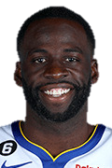

**Khris Middleton**

**Predicted Contract: $16,330,247 AAV**

**2 Years**

Green declined his $27.6M Player option last week, so I feel confident in saying that he will not be signing

for ~ $12M. So why did my model predict that he will sign nearly an identical contract as Dillon Brooks? Green is widely respected around the league for his basketball IQ and leadership, and he has earned the reputation of a winner. Even though those things don’t show up on a box score or in my data set, it will be (part of) the reason Green’s next contract will be much larger than Brooks’.

Middleton also declined a player option worth much more ($40M) than his predicted AAV. My data set uses the players combined stats from the last two seasons, and those seasons were tough for Middleton, specifically last year. He was injury-riddled and struggled when he was on the court, so the model doesn’t see him as the all-star that we see him as. While he’s likely still not in his prime, the Bucks (or somebody else!?) are going to value him more than a player in the MLE range, and his contract will reflect that.



**Kyrie Irving**

**Predicted Contract: $35,194,493 AAV**

**4 Years**

**Austin Reaves**

**Predicted Contract: $13,071,926 AAV**

**3 Years**

My model doesn’t include any Playoffs data, and that’s when Reaves took the next step, but this prediction still may not be too far off. The Lakers only have Early Bird rights on Reaves, so the max they can offer him is about 4yrs / $52M ($13M AAV), depending on the amount of the average player salary. His only way to get a bigger deal is to get an offer sheet from another team (that will almost certainly get matched by LA). If he does that, my model will be way off, but if he doesn’t, the Lakers are getting a huge steal.

Kyrie is still one of the best PGs in the league, but he’s only played 89 games in the past 2 seasons, and only one player (Kawhi, 2019) in my dataset has played that few games over their last 2 seasons and still received a contract that offseason for at least 30% of the cap. Luckily for Kyrie, the Mavs could not be more desperate to keep him after they let Jalen Brunson walk out the door for nothing a year ago. It would be a catastrophe for Dallas if Kyrie left, so look for him to surpass that 30% mark ($40.8M AAV) anyways.

**Matches I Want Made**

If I was the King of Free Agency, I would force players to go to teams that make basketball and team-building sense. However, I’m not, and players sometimes pick teams for other reasons. I’m going to ignore that for a minute and highlight a couple of my favorite FA-Team pairings, even if they’re pretty unlikely to happen.

**Jerami Grant -** Predicted Contract: $27,839,378 AAV / 4 Years



**Where?** Sacramento Kings!

**Why?** The Kings just had their best season in nearly 20 years. They have 4 starters already under contract to return, and could just run it back it back if they resign Harrison Barnes (Predicted Contract: $18.8M/3 Years). Even though this team was the 2-seed in the West last season, they still weren’t respected as real threats from much of the media and fans. Grant’s skillset provides a clear upgrade for them at the Forward spot, and he’s still just 29 years old, so he can fit in with this Kings core. If they could get him at or around $28M AAV, he also provides a reasonable contract for trade-matching purposes if the Kings look to upgrade that way in the future.

**How?** The Kings already did most of the work to make this possible by trading Richaun Holmes to the Mavs on draft night. If they renounce their cap hold of Harrison Barnes, they would have up to approximately $33.5M in cap space to sign Grant with. Even though the framework is in place to pull this off, it’s pretty unlikely it actually happens. Current intel is that Portland is still trying to make it work with Dame, and letting the team’s second-best player leave probably wouldn’t thrill him. The Blazers can offer more money and one extra year than the Kings, so the Kings will probably have to look elsewhere once Grant resigns.



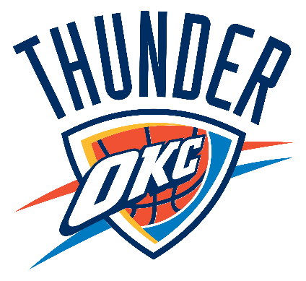

**Herb Jones** (RFA) **-** Predicted Contract: $15,228,240 AAV / 3 Years

**Where?** Oklahoma City Thunder

**Why?** Do I really need to sell you on adding Jones’ defensive talent alongside this young

up-and-coming core of Shai, Giddey, Williams, and Holmgren? Not only is his skillset an outstanding compliment to this group, but he’s the perfect age that won’t force OKC to speed up their rebuild if acquired.

**How?** Jones being a restricted free agent obviously complicates things. He could sign an offer sheet with the Thunder using their cap space, but New Orleans is going to be very hesitant to let him walk. If OKC wants to goes this route and actually get him they’re going to have to up their offer. However, due to the *Arenas Provision*, OKC would have to fit the average value of the entire contract into their cap space this season, even though they could only offer up to the NTMLE in season 1 of the deal. This would come out to about a

4yr / $66.4M deal being the most they could offer in an offer sheet. NOLA can only offer about 4yrs / $52M to Jones if he doesn’t get an offer sheet elsewhere. The Thunder doing this would make them end up paying more, but they’re likely going to match regardless.

The Thunder do have another option though: attempt to acquire Jones in a sign-and-trade. The Pelicans wouldn’t be able to receive a player like Lu Dort in the trade, who may not be in the Thunder’s long-term plan after they drafted Cason Wallace, due to base year compensation rules. NOLA could try to take back a lower salary, shot-in-the-dark type player like Mann, Wiggins, or Robinson-Earl, but it may not be worth it for them to hard-cap themselves at the first apron to do so (since they are already pre. The Thunder have plenty of draft assets still, so if they want to get this done, that may be what it takes.

The Mid-Level Exception is a tool that teams can use to sign players in free agency, even when they have no cap space. There are 3 different versions of it, and each team has access to one, depending where their salaries are in relation to the luxury tax. The largest of the 3 is the Non-Taxpayer MLE (**$12.405M** in 2023-24), followed by the Room MLE (**$7.723M**) and the Taxpayer MLE (**$5.0M**). New to this season due to the changes in the CBA, teams over the second-apron do not have access to any version of the MLE.

**Mid-Level Exception Market**

Teams are hard capped at different levels if they use the NTMLE or TPMLE, so even if they have it, they may prefer not to use it.

**Which MLE Can Each Team Use?** (Projections; subject to change)

**Non-Taxpayer MLE**

**Taxpayer MLE**

**Room MLE**

**No MLE Available**





Download Orlando Magic Free Download HQ PNG Image | FreePNGImg

Los Angeles Lakers - WikipediaOklahoma City Thunder Logo - PNG and Vector - Logo Download



**Up to $12,405,000**

**Up to $5,000,000**

**Up to $7,723,000**

**MY FAVORITE TARGETS**

McDaniels fell out of the playoff rotation for the Sixers, but has shown promise of being a versatile and impactful wing. The **Nuggets** will likely be losing key contributor Bruce Brown, and only have a $5M TPMLE to try and replace him. That’s basically an impossible task, but they could do a lot worse than taking a shot on McDaniels.

**Jalen McDaniels**

Predicted Contract: $6,656,003 AAV / 2 Years

Carter’s pesky defense and spot up shooting would be awesome in Boston now that Marcus Smart is out of town, but the path to make that happen seems too complicated to come true. There is another team that is in need of some PG help though: the **Bulls** don’t seem to expect Lonzo Ball back this year, and could potentially lose any of Dosunmu, White, or Beverly to free agency. Carter can provide cost efficient minutes for them while they continue to figure out their guard rotation.

**Jevon Carter**

Predicted Contract: $6,450,545 AAV / 2 Years

**Max Strus**

Predicted Contract: $12,887,776 AAV / 3 Years

Strus is also projected slightly over the NTMLE by my model, but I think there’s a shot he could end up signing right at it (even though there’s also a shot he signs for $15M+). As one of the better shooters in this FA class, I’d like to see him go fill a need for the **Magic** as they continue to build their foundation.

Brooks has been a newsworthy player recently, and not in too many good ways. However, I think that this may really overshadow the value that he can bring to a franchise. Memphis has already indicated they will not be bringing him back, so it will be interesting to see what he’s searching for in his free agency. I think he could fill in nicely as a defensive minded wing on the **Knicks** next to Barrett, Brunson, and Randle. However, all current rumors make it sound like the Rockets are going to throw a lot of money at him that will make it tough to turn down.

**Dillon Brooks**

Predicted Contract: $11,418,195 AAV / 4 Years

Technically, Williams probably isn’t going to be in the MLE Market. My model predicts his to get more than the full NTMLE and I agree, but I wanted to include him somewhere in my Free Agency Overview. Williams may be one of the most impactful free agents. He’s a high-level role player who’s proven that he can make positive impacts with his shooting and defense deep into the playoffs, and that’s not something that all players at this price tag can do. While he’s a RFA, I don’t see the C’s bringing him back. The **Mavs** need as many winning players around Luka as they can find, and I think Williams would be a great addition.

**Grant Williams** (RFA)

Predicted Contract: $14,930,670 AAV / 3 Years

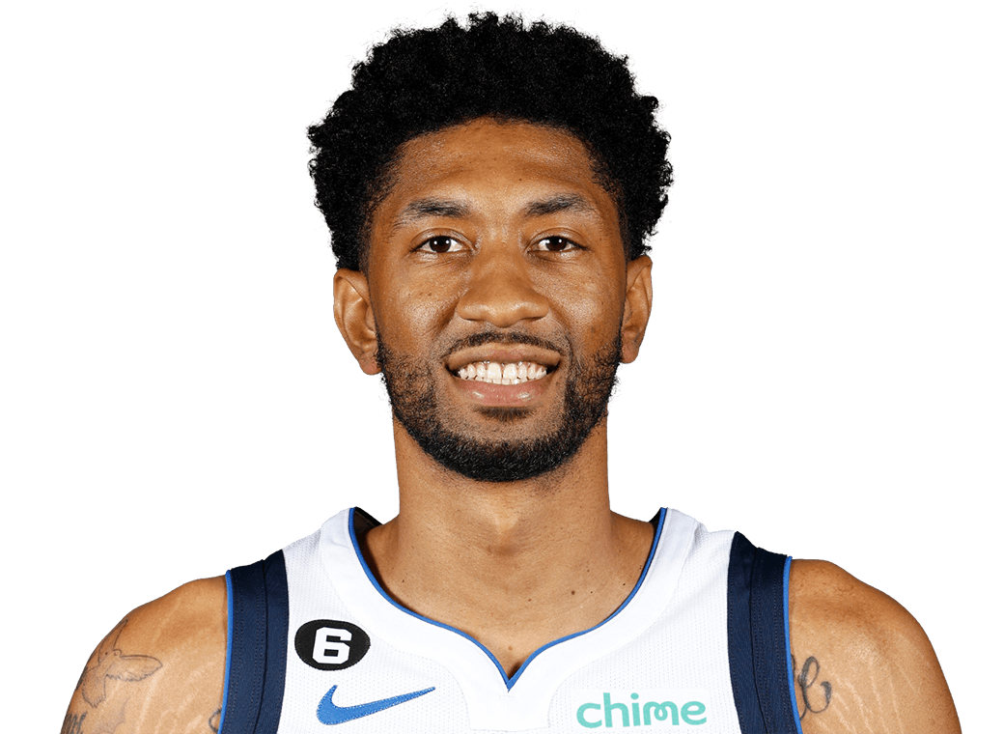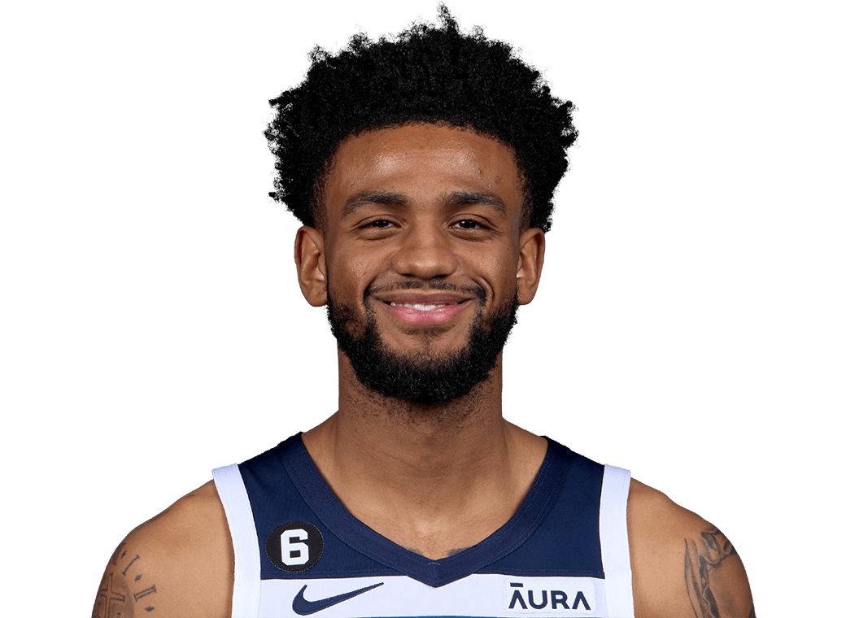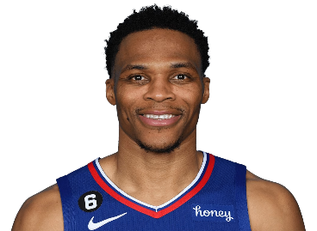

Wood is projected to get a $17.7M / 3

Year contract by my model, which would

be the exact opposite of a bargain. Dallas brought him in because of a lack of Center production, and by the end of the year he wasn’t even seeing the floor some games. The price is going to get driven down a lot, and I wouldn’t be shocked if we don’t see Wood sign a contract in July at all. Since many of his problems aren’t with his talent, a team will eventually bite, and depending how low that price gets, it could end up being a pretty big bargain, since he’s going to have to make

some changes or continue to suffer a lower pay-day.

The Phoenix Suns need to fill out the

rest of their roster (6 players) with only

minimum contract players. Their season ended last year in part due to depth issues, and it seems like they’re going to face this problem again this season. I think it would be huge for their outlook to be able to sign a non-minimum level player to a minimum contract, and I think Ingles would be a good candidate to try and convince. He’s projected to sign a $5M / 1 Year by my model, but could definitely provide needed contributions to the Suns if he decides this is the route to go.

Another player to look at here: **Eric Gordon**

I would love to see Alexander-Walker

sign with the Celtics and help fill the hole

left by Marcus Smart and Malcom Brogdon’s (apparently serious) injury. However, the Celtics could only sign him to a minimum, and not the $3.5M / 2 Year deal my model predicts. They could attempt a sign and trade sending Pritchard to MIN, or they could use some of their TPMLE to make the signing, but either direction they choose will hard-cap them at the first or second apron, respectively, which will probably make the deal more trouble than it’s worth. *(Look for BOS to take a chance on a player like* ***Dalano Banton*** *at the minimum instead).* However, whoever does get NAW, whether he stays in Minnesota or goes elsewhere, is getting a

solid backup PG on a reasonable salary.

**Joe**

**Ingles**

**Christian**

**Wood**

**Russell**

**Westbrook**

**Nickeil**

**Alexander-Walker**

As bad as things were for Westbrook

with the Lakers, he was really able to fit

in nicely on the Clippers, and things were mutually beneficial. My model projects him getting an $8M / 1 Year contract, but the problem with that is that it is really hard to find a situation for him and the team that makes sense outside of LA. Unfortunately for him, the Clippers are already over the second apron, so the absolute most they could offer him is just under $4M per year (by using his non-bird rights to pay him 120% of the minimum salary). He will deliver more than enough

value to make it worth it for the Clippers.

**Bargain Bin**