Jasmine Patel

CPE 315 Lab 2: Towers of Hanoi

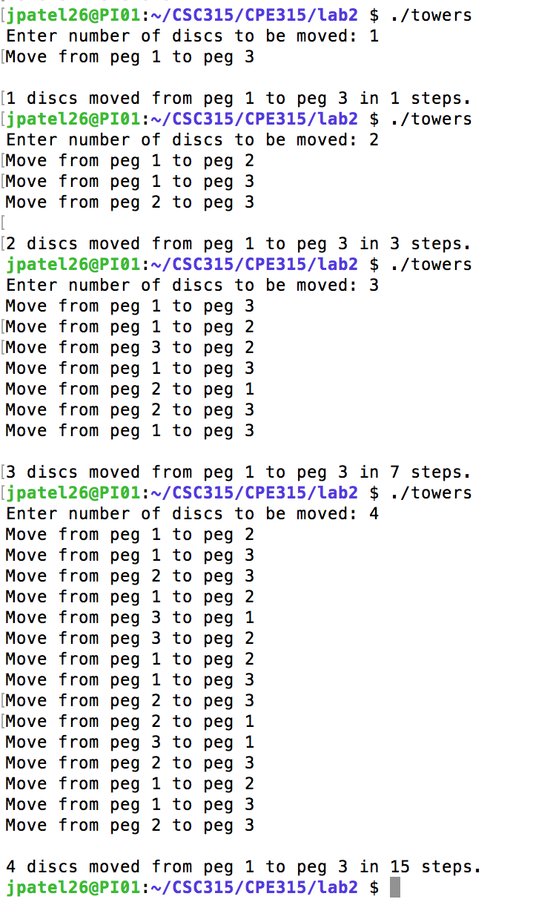

Additional Output

Discs: Moves:

5 31

6 63

7 127

8 255