Name: Jemil Patel

Instructor: Gary Thai

CMSC 206 (CRN: 46518)

Project 4 Write-Up

***Project Design***

* Create a function named strip_punctuations that accepts a list of words and returns an updated list after removing punctuations from before and after each word
  + Use two for loops to loop through each word and consecutively find the first and last occurrence of any letter in the word
  + Append the original word sliced from start to stop to the new list
  + Return the new list of words
* Create a function named average_word_length that accepts a list of words and returns the average length of a word
* Create a function named word_frequency that accepts a list of words and returns a dictionary with (word, frequency) pair sorted in descending order by frequency
  + Using a for loop check if a word is not ‘a’, ‘an’, ‘the’, ‘and’
    - If the word is not already present in the dictionary, then assign that word as a key to the dictionary with a value of 1
    - Else increment the value of that word by 1
  + Create and return a new dictionary by sorting the original one via descending order of frequency
* Create a function named word_length that accepts a list of words and returns a dictionary with (word, length) pair sorted in descending order by length
  + Using a for loop check if the word is not already present in the dictionary
    - If not, then assign that word as a key to the dictionary with a value equal to its length
  + Create and return a new dictionary by sorting the original one via descending order of length
* Create a function named number_of_sentences that accepts a text or a list of words and returns the number of sentences present
  + Using a for loop check if any word has ‘.’, ‘?’, ‘!’
    - If so, then increment the number of sentences by 1
  + Return the number of sentences
* Ask the user to input a valid filename and display an error message if file not found, repeat this until you get a valid filename
* Extract words from the text file
* Declare and initialize necessary variables to store different values using the above created functions
* Display your calculations
* Create a new variable named results to store the output from getmeasures method of readability package after passing the text of the speech as an argument
* Display the readability results
* Create a word cloud using the generate_from_frequencies method of the WordCloud class by passing the dictionary of word frequencies as an argument
* Display the word cloud and save it as a png file

***Test Cases***

Test Case 1

Test Case 2

Test Case 3

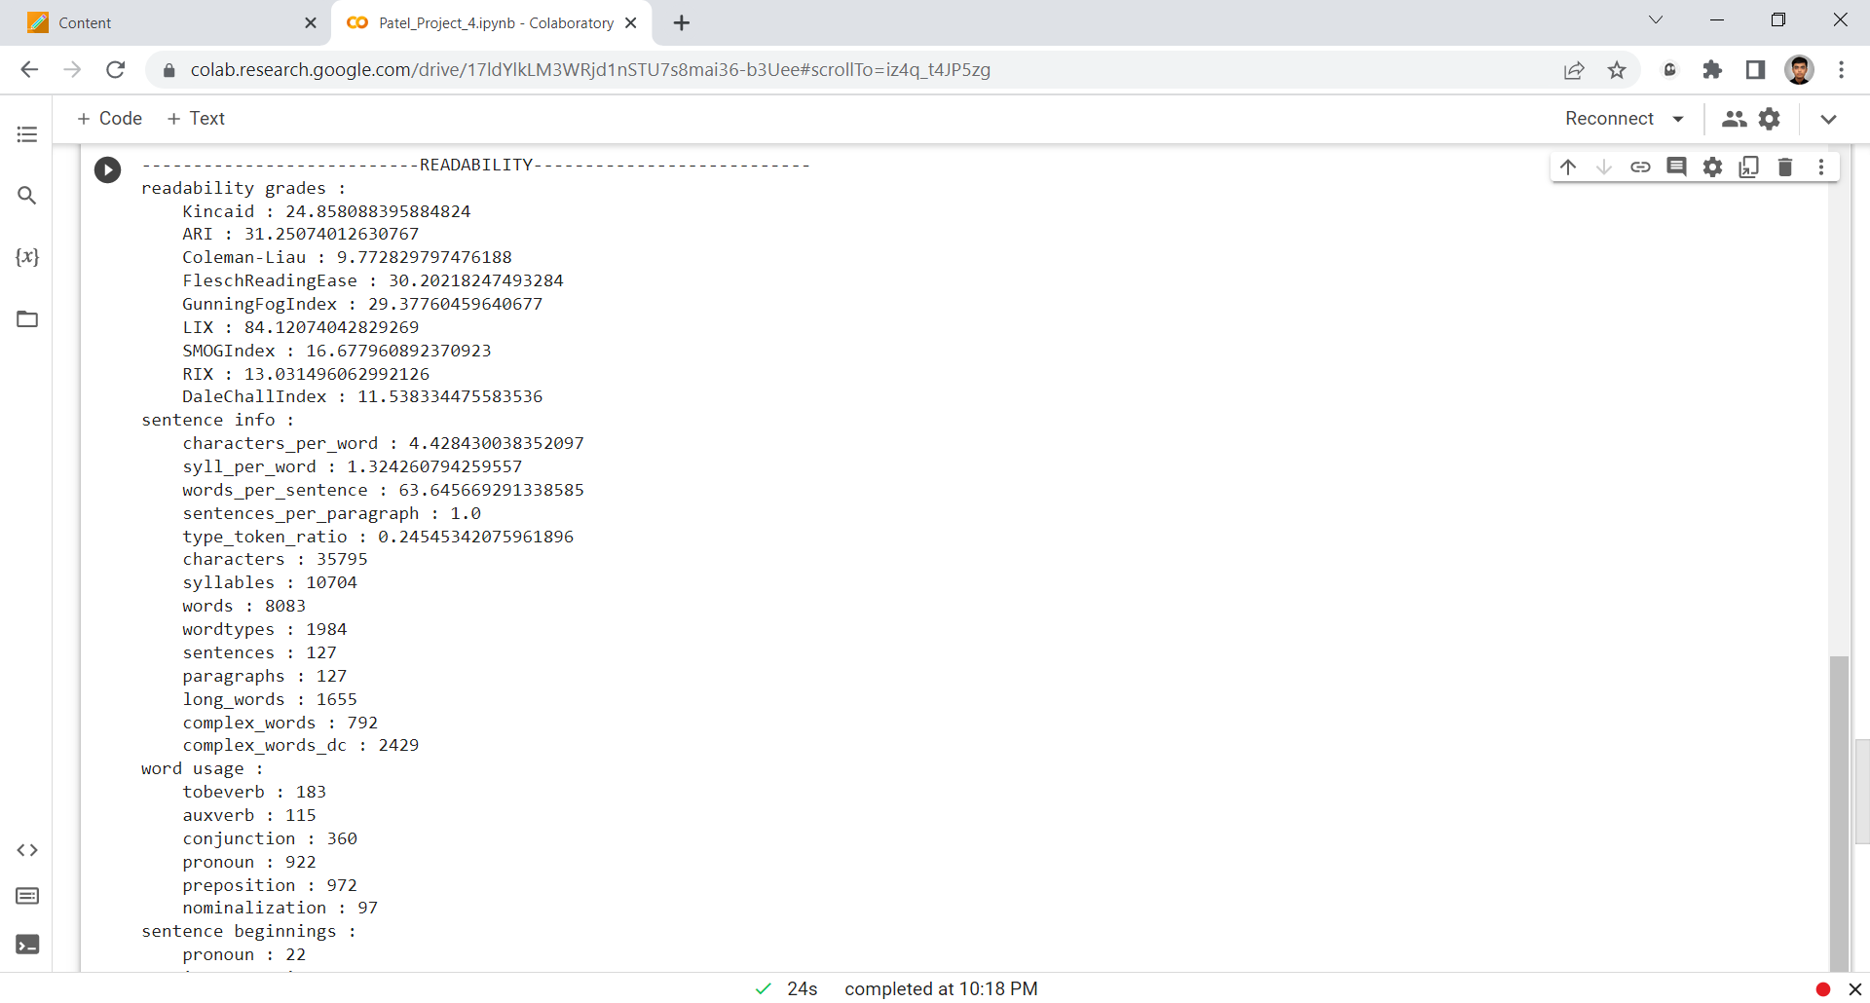

Test Case 4

***Learning Experience***

Project 4 has been a great learning experience for me. Through it I learned a lot of new things such as readability package, wordcloud, etc. In order to start with it I first decided to break a speech into words separated by spaces and then strip away the punctuations before and after each word. Next, I created functions for each task wherein I basically just played and manipulated with a list of words to get a certain thing. This was it for the calculation part but for the readability score I had to read through the documentation of readability package to figure out how it works. I then implemented it in my program so that it provides a variety of details regarding a speech. Finally, I completed the wordcloud tutorial given to me which helped me create a wordcloud based on the frequency of words appearing in a given speech.

I struggled at many places, but it was due to my lack of logic, trial and error, and missing out something tiny that screws the whole program. I figured out on my own how to create each function, what data type will it utilize, and how will it work. I used the sorted function to sort a dictionary by descending order of its values. Unpacking the result from readability score was tedious but I managed to present the information in a neat and organized manner. Thus, I would say that this project was not impossible to complete but yes it certainly required some knowledge and effective thinking.

I will follow the same approach for my future projects that I used for this and my previous projects which is to read all the instructions carefully, form a rough base program, test it with many cases, and finally add the other requirements one by one. If I were the instructor, I would not change a thing because my program fulfils all the given requirements.

***Assumptions***

* The program is case-insensitive for any speech.
* Compound words will not be counted in the list of longest words.
* One cannot proceed without entering a valid filename.
* It was not possible for me to come with a specific expected output each time, so I just included the test run screenshots and did not create a table.