COEN 160 OO Analysis, Design and Programming Fall 2016

Project (Groups of two) Due: 9th Nov (10pm)
One submission per group (Deliverable1_teammateFirstInitialLastNames)

Deliverable 1 of HummingBee Home Garden Sprinkler System(60 pts)
- Draw an Usecase Diagram (see below for an example of an Usecase diagram) identifying the Usecases you will implement for your project. (10 pts)
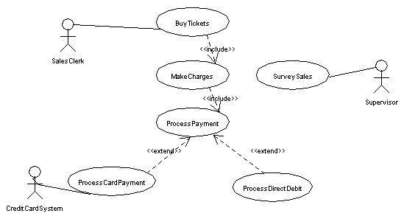
- Use-Cases to illustrate the functionality of the system (25 pts).
Select the primary use cases for the system and describe each of them with a textual description using the template given on the class slides on OOAnalysis under Week 3 (included below for a quick reference).
Use-Case: (Goal): Name of Use-Case, usually a verb indicating it is a process
Actors: External agents (people using and interacting with the system in specific roles including the initiators) and other systems.
Purpose and Description: A summary of the intention and a high-level summary of the actions.
Type: Primary, Secondary and Essential or Real
Cross-references:Related Use-cases and ystem functions
Scenario Details (Typical course of events):
Actor Action System Response
1. Numbered descriptions of 2. Numbered descriptions of
the actions of actors. the system responses

Alternative Courses: Alternatives course of actions that may arise at main course of events at specific line numbers.

- CRC cards to show a list of the most important classes and a brief description of their responsibilities. (25 pts)
Select five of the most important problem specific classes and describe their responsibilities using the CRC card template (refer to class slides on OOAnalysis under Week 3).

