EVENTRAVELER

Members:

Julia, Alpha, Gabriela, Valerie, Loy

Description:

We’re creating website that helps user find hotels based on criteria such as location, dates, prices and match them with events at their destination

Sketch :

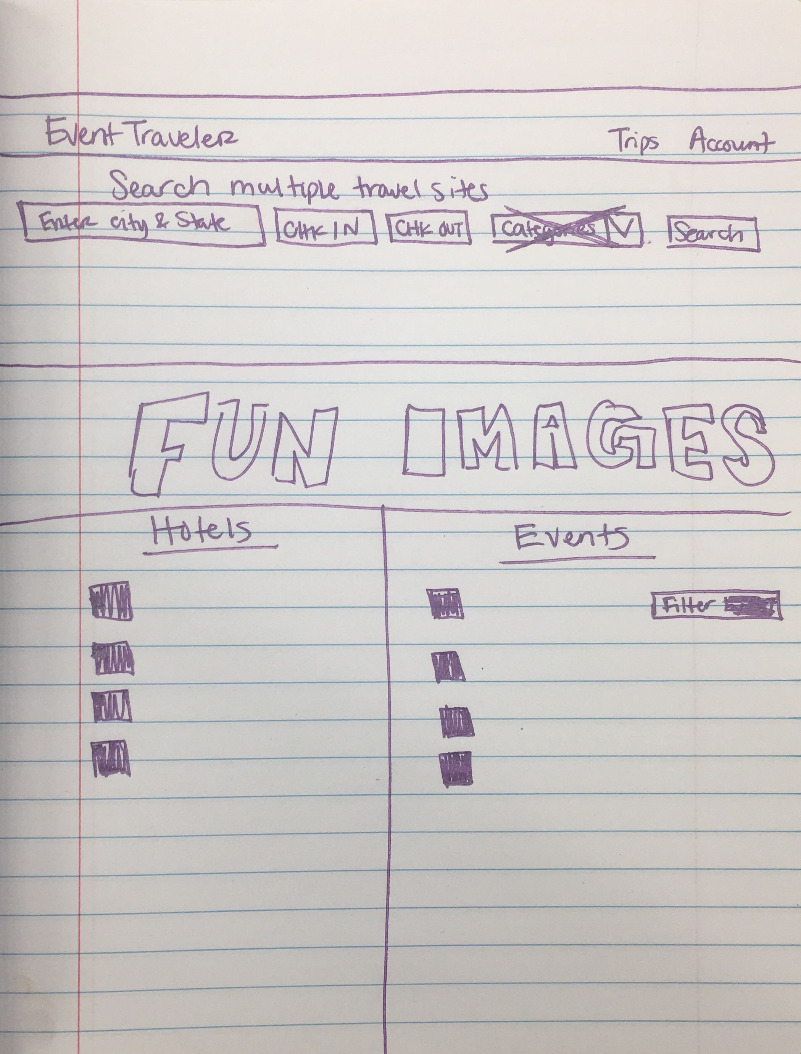

APIs to be used:

1st API: Unofficial Kayak

2nd API: Eventful

Breakdown of tasks:

Front-end design:

* HTML: Loy
* CSS (materialize): Valerie

Backend:

* Kayak API: Julia
* Eventful API: Gabriela
* Firebase: Alpha