**Snake_And_Ladder_Game**

In partial fulfillment of the requirements of

**PG Diploma** Submitted **in Advanced Computing**

By

**Sumit Vyasv (PL)200940581031 Vaibhav Baraskar (PL)200940381127**

**Tejas Rane- 200940381122 Arijit Saha- 200940381021**

**Vikas Kandgul- 200940381128 Pooja Derle- 200940381073**

**Ajikya Patwardhan- 200940581001 Pavan Jadhav- 200940381061**

**Abhay Tiwari- 200940381002 Sneha More- 200940581028**

**Komal Valivadekar- 200940381039 Sahil Bhagwat- 200940381087**

Dr. **Sasikumar Sir**

**Name of the Project Guide**

Senior Director at CDAC

**Mr. Sohan More**

**Name of the Faculty Project Guide**

Project Coordinator



**Centre for Development of Advanced Computing**

**Kharghar/Juhu**

**CERTIFICATE**

This is to certify that the project entitled **“Snake_And_Ladder_Game”** is a bonafide work of Sumit Vyasv (PL) 200940581031, Vaibhav Baraskar (PL) 200940381127,

Tejas Rane-200940381122, Arijit Saha-200940381021, Vikas Kandgul-200940381128 PoojaDerle-200940381073,AjikyaPatwardhan-200940581001, PavanJadhav-200940381061,AbhayTiwari200940381002,SnehaMore200940581028,KomalValivadekar- 200940381039 ,Sahil Bhagwat- 200940381087**etc.** submitted to C-DAC Mumbai in partial fulfillment of the requirement for the award of the Post Graduate Diploma in Advanced Computing.

**(Name) (Name)**

**Supervisor/Guide Faculty Supervisor/Guide**

**Declaration**

I declare that this written submission represents our ideas in our own words and where others' ideas or words have been included, we have adequately cited and referenced the original sources. We also declare that we have adhered to all principles of academic honesty and integrity and have not misrepresented or fabricated or falsified any idea/data/fact/source in my submission. We understand that any violation of the above will be cause for disciplinary action by the Institute and can also evoke penal action from the sources which have thus not been properly cited or from whom proper permission has not been taken when needed.

-----------------------------------------

(Name of student1 and Student ID)

-----------------------------------------

(Name of student2 and Student ID)

Date:

**Abstract**

This project aims to bring the fun and simplicity of snake game with some new features. This project explores a new dimension in the traditional snake game to make it more interesting and challenging. The simplicity of this game makes it an ideal and major project for candidate to work up on. Along with the traditional game of snake and ladder and carrying our prime motive “**Sowing seeds of knowledge while playing**” we have involved a set of questionaries’ on each block of game. The main highlight is if you answer wrong at snake mouth it will drag you down or else it won’t harm you that is we have changed the functionality of the traditional game.

Based on the data obtained can be interpreted that media reviewers mention that from the aspect of the game the snake-ladder as a learning medium belong to the category of very good by 94.09%. From the aspect of student interest in learning by media of the snake-ladder game that is 85.27% belong to category of good. While the third aspect regarding the quality and appearance of the media, the snake-ladder game is declared excellent by 84.93%

**Contents**

|  |  |  |
| --- | --- | --- |
| **Chapter** | **Contents** | **Page No.** |
| **1** | **INTRODUCTION:** Give at least two to three sentences about your project. |  |
|  | **1.1 Description *(Brief description of project)*** The main functionality of the project should be explained in brief |  |
|  | **1.2 Problem Formulation *(Explain the problem)*** |  |
|  | **1.3 Motivation *(need of the project)***: List the various approaches along with its drawbacks for solving the problem and briefly explain the approach used for your project. |  |
|  | **1.3 Proposed Solution:** Explain the method/technique used for solving the problem and how it overcomes the drawbacks mentioned under heading 1.3. Also explain how the project is going to help end users. |  |
|  | **1.4 Scope of the project *(scale/range of your project)*:** Extent of how far your project can be completed. This can be in terms of domain or application related constraints/limitations. |  |
| **2** | **REVIEW OF LITERATURE *(include at least 3IEEE or similar reputed technical papers as reference or give reference sites and details of algorithms used*)** Should be atleast 2 pages which gives the ideas referenced by the reference papers. Mark the references wherever appropriate. (Note: - Please don’t write the paper titles and the abstract of papers.) |  |
| **3** | **SYSTEM ANALYSIS** |  |
|  | **3.1 Functional Requirements *( write requirements of the project)*** Should follow the IEEE SRS format |  |
|  | **3.2 Non Functional Requirements** Should follow the IEEE SRS format |  |
|  | **3.3 Specific Requirements *(Hardware and software requirements)*** |  |
| **4** | **ANALYSIS MODELING** |  |
|  | **4.1 Use-Case Diagrams and description**  **4.2 Activity Diagrams**  **4.3 Class Diagram**  **4.4 Sequence Diagram** |  |
|  | **4.5 Timeline Chart *(For the project duration) [Gantt]*** |  |
| **5** | **DESIGN** |  |
|  | **5.1 Data Modeling *(E-R Model, Relational tables with its associated Data dictionary****)*  ER Diagram normalized till the third normal form accompanied by the respective data dictionary table should be included |  |
|  | **5.2 Architectural Design (*Project Flow /architecture* *with description)*** |  |
|  | **5.2 User Interface Design** GUI for your project |  |
| **6** | **IMPLEMENTATION** |  |
|  | **6.1 Algorithms / Methods Used**  Mention your algorithms if any or any methodology used. |  |
|  | **6.2 Working of the project *(code for mentioned algorithms) [do not copy paste entire code. Only main snippets]*** |  |
| **7** | **TESTING *(white box /black-box / any testing algorithm used)*** |  |
|  | **7.1 Test cases *(conditions on which testing is done)*** |  |
|  | **7.2 Type of Testing used *(explanation and reason of testing method used)*** |  |
| **8** | **RESULTS AND DISCUSSIONS *(final results or outputs)*** |  |
| **9** | **CONCLUSIONS & FUTURE SCOPE** |  |

Appendix

Literature Cited

Publications by your group (if any)

Acknowledgments

**List of Figures**

|  |  |  |
| --- | --- | --- |
| **Fig. No.** | **Figure Caption** | **Page No.** |
| 1. | Use Case Diagram |  |
| 2. | Activity Diagram |  |
| 3 | Class Diagram |  |
| 4 | Sequence Diagram |  |
| 5. | E-R Diagram |  |
| 6 | Web Architecture Design |  |
|  |  |  |

**List of Abbreviations**

|  |  |  |
| --- | --- | --- |
| **Sr. No.** | **Abbreviation** | **Expanded form** |
| i | DSS | Decision Support System |
|  |  |  |
|  |  |  |
|  |  |  |
|  |  |  |
|  |  |  |
|  |  |  |

**Chapter 1**

**Introduction**

This project is completely focused upon raising of IT-sector and providing a learning platform along with playing. SNAKE AND LADDER is a game which provides an interface through which the new learners can gain some knowledge or the person familiar with basic knowledge can improvise himself/herself by solving the questionaries’ input in it. We have come up with a platform where one can play spend time but in such a manner where she/he relaxes as well as gain some useful content in that time period too. This made us achieve our prime motive “Sowing seeds of knowledge while playing”.

* 1. **Description**

Snake-ladder media includes visual media because it involves the sense of sight in using such media and is called graphical media because the snake-ladder media is presented in the form of images. Snake-ladder game is one type of game that is often played by everyone. This medium is adapted to the characteristics of the students as well as working professionals to absorb information with the help of images on each question and rely on their visual ability to obtain information.

Learning is a tool that can channel the message, can stimulate the thoughts, feelings, and willingness of learners so as to encourage the learning process in the learners themselves. In the development of this media the focus is the development with the material of spatial structures. Planar structures are structures that are entirely located on one plane.

According to the use of snake-ladder games has advantages such as:

* Snake-ladder games can be used in teaching and learning activities because these activities are fun for students so that students are interested to learn while playing.
* Students can participate in the learning process directly.
* The snake-ladder game can be used to help all aspects of student development, one of which develops the intelligence of mathematical logic.
* Snake-ladder games can stimulate students to learn to solve problems.
  1. **Problem Formulation**

Create a snake and ladder application. The application should take input from Keyboard and mouse

Number of snakes (s) followed by s lines each containing 2 numbers denoting the head and tail positions of the snake.

Number of ladders (l) followed by l lines each containing 2 numbers denoting the start and end positions of the ladder.

After taking these inputs, you should print all the moves in the form of the current player name followed by a random number between 1 to 6 denoting the dice roll and the initial and final position based on the move.  
Format: <player > rolled a <dice value> and moved from <initial position> to <final position>

**1.3 Motivation**

The motivation for doing this project was primarily an interest in undertaking a challenging project in an interesting area of research. The opportunity to learn about a new area of computing not covered in lectures was appealing. What uplifted us to have our hands on this project was, what we saw is, more and more people showing their rate of interest in massive world of coding and having their will to learn something more in it.

**1.4 Scope**

Users preferring the classical games can switch to the game. Beginners in computer programming can take hints via the mini project to boost up their programming techniques. Can be brought in practice in training centers that offers basic programming courses. Can be the best choice as stress relieving game in the busy life pattern of the people in present life. Simplicity and efficient is main fact that we get using the java language, so user can execute snakes and ladders in each and every computer almost. Can be milestone for the programmers trying to learn to build projects in java.

Multiplayer format to be involved in upcoming development of the game. More sectors of learning to be targeted. Hint option to be added as more difficult questions comes across. Badges to be given after a particular crossing particular count of questions. Attempts to be given to change answer if found wrong in first attempt.

**Chapter 2**

**Review of Literature**

Snake and Ladder is no more now traditional concept of only gaming with dice 100 blocks or player just visiting each block beating up snake and reaching a position just for winning purpose.

We are here with a motive in mind to somehow raise and support IT-sector and its involvement in every sector whether it may be civil, mechanical etc. from our side. Not only IT-sector, but General knowledge plays a key role in selection of any government examination. So here we can firmly say we have targeted two sectors with help of this game and its components where snake and ladder are in graphical manner.

This is totally new concept, where it isn’t just a game anymore, now the player will indulge into playing as well learning some concepts of JAVA programming as well as some FAQ are to be considered as most important general knowledge questions asked in exams too.

We found no such previous references, so we had our seniors, guides, senior authorities with us in building this game.

* Dr. **Sasikumar** **M** Senior Director of CDAC Mumbai.
* Mr. **Mr. Chandra Shekhar** Joint Director of CDAC who guided us with object-oriented methodology.
* Mrs. **Kiran Waghmare** our senior faculty.
* Mr. **Abhishek Singh** Project Engineer who helped us with JavaScript.
* Mr. **Santosh Mondal** senior faculty who helped us with dice functionality and game board.

Other references:

* <https://www.w3schools.com/>
* <https://www.javatpoint.com/>
* <https://www.geeksforgeeks.org/>
* <https://www.programiz.com/>

**Chapter 3**

**System Analysis**

## **3.1 Functional Requirements**

**System Analysis**

**3.1 Functional Requirements**

3.1.1 Select Category:

The players will get option to select category they want to play like student or programmer. They will get the questions accordingly. The game will keep the players performance log.

3.1.2 Actual Game Play:

At first position players will get a question to solve. Then the player will get score on that score he/she will be moved to next position. On the next position player will be redirected to another problem page and game will be continued like that.

3.1.3 Play/Pause:

Players will be able to pause the game and resume it afterwards with the same position and score.

3.1.4 Check Performance:

Every Player will be able to see personal performance log.

**3.2 Non-functional Requirements**

3.2.1 Performance Requirement

* The system should be available at all times, which means the user can access it using boards of different size from 8*8 to 12* 12 boxes.
* The system should store every user’s data into the database.
* For user convenience application is user friendly and easy accessible.
* The system is made in such way that it is reliable in its operations and secure in details
* The system is easy for the user to understand.

.2.2 Safety Requirements

* All login ids and passwords of user should be protected for or the application.
* In case the database is corrupted or hacked by some hackers or intruders then all data must be deleted and backup system should be retrieved.
* All users must possess a unique username & password.
* Password must contain a combination of Alpha-Numeric characters with special symbols in it.
* It should contain min 8 to max 16 characters length in it.

3.2.3 Security Requirements

* This system provides, security, user friendly interface and quickly response.
* The system must automatically logout of all users after certain pried of in activity. The database should be protected from attacks and unauthorized access.
* The interface should be protected from attacks. All passwords should be stored as a secure hash of the administrator password.
* System must use SSL encryption (Secure Socket Layer) password in all transactions that store in databases and it is a one-way function.

3.2.4 Software Quality Attributes

3.2.4.1 Stability:

The system output won’t change from time to time .The same output will be given always for a given input.

3.2.4.2 Maintainability:

Only maintainers are allowed to connect into internal servers. The system shall keep a log of all the errors.

3.2.4.3 Durability:

The software will be tested for working with multiple users.

3.2.4.4 Robustness:

In case device crashes, a backup of history must be stored.

3.2.4.5 Performance:

Performance depends on Memory, CPU, Network bandwidth, Disk space, and Feedback time and Application must be lightweight

3.2.4.6 Effectiveness:

The software will be made to handle operations effectively.

**Chapter 4**

**Analysis Modeling**

## 4.1 Use Case Diagram: -

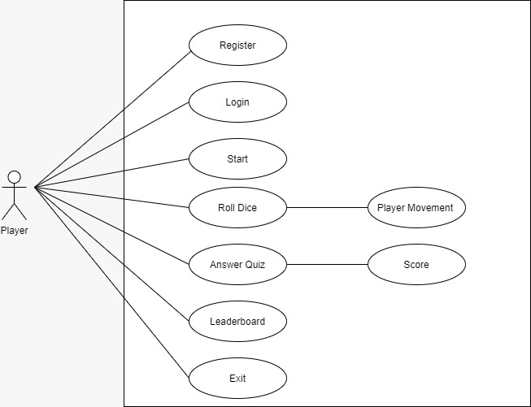

4.2 Class Diagram:-

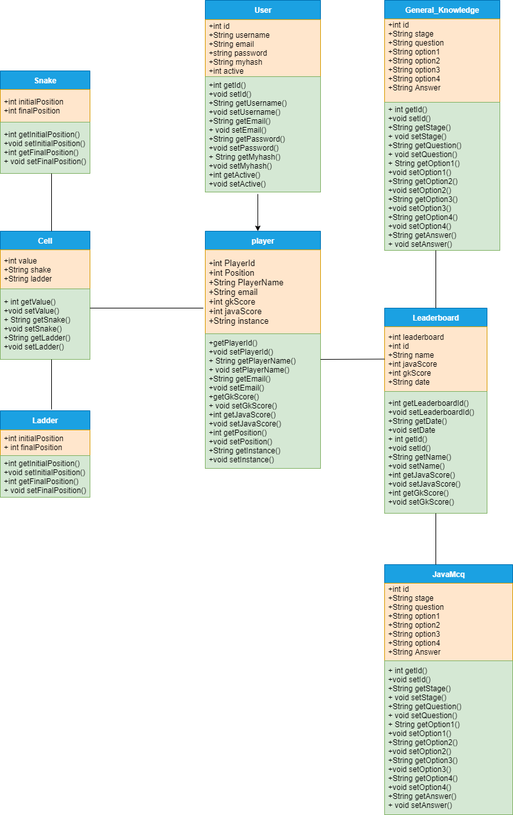

4.3 Activity Diagram:-

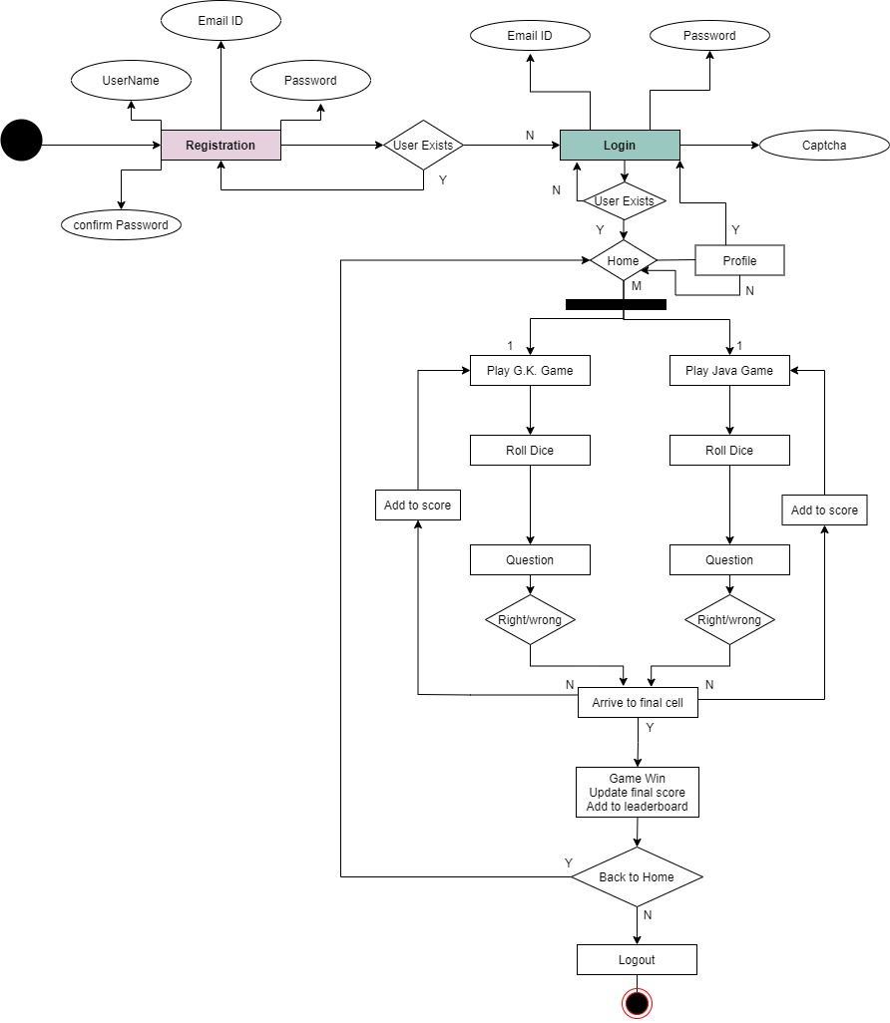

4.4 Sequence Diagram:-

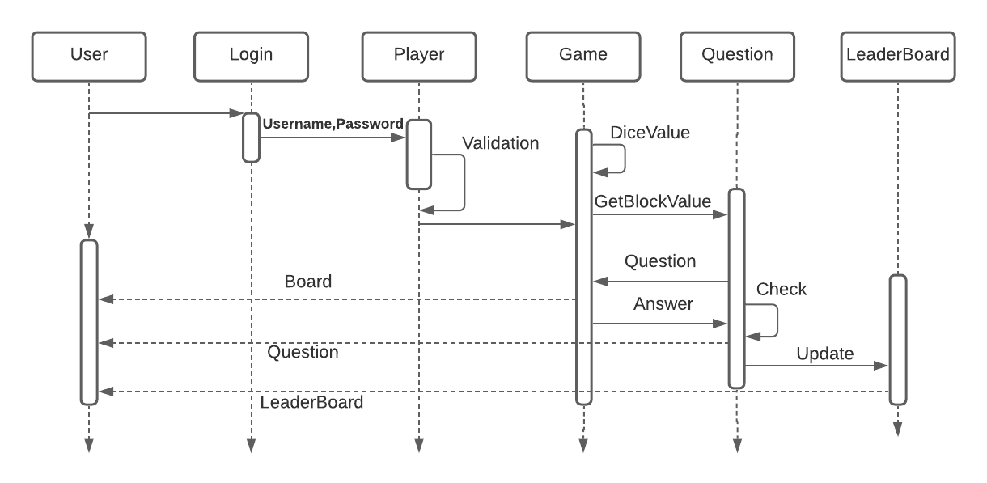

**Chapter 5**

**DESIGN**

**5.1 Data Modeling *(E-R Model, Relational tables with its associated Data dictionary****)* ER Diagram normalized till the third normal form accompanied by the respective data dictionary table should be included

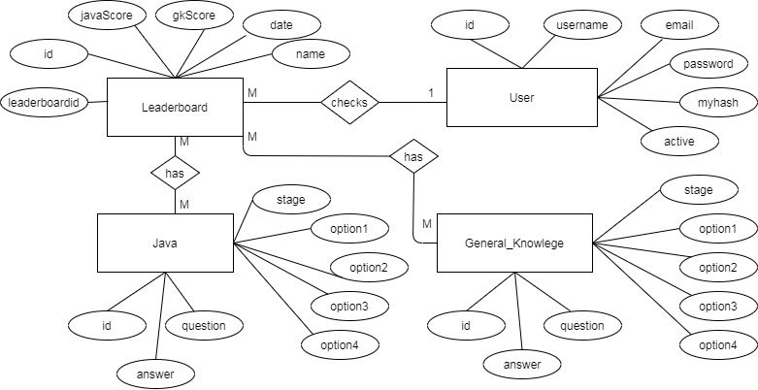

**5.2 Architectural Design (*Project Flow /architecture* *with description)***

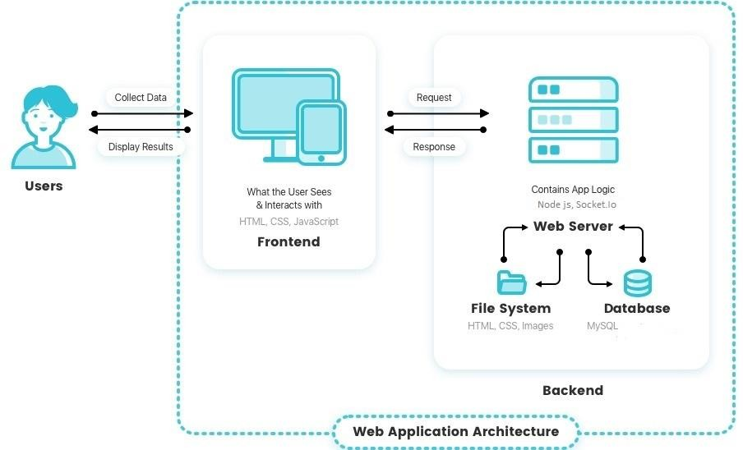

* 1. **User Interface Design** GUI for your project

5.2.1 Signup Page:

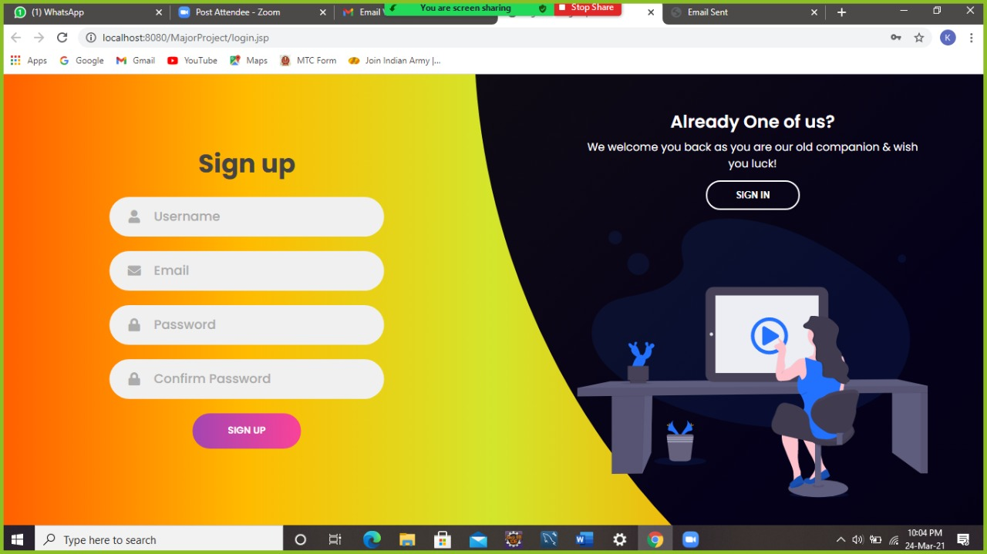

5.2.2 Sign-In Page:

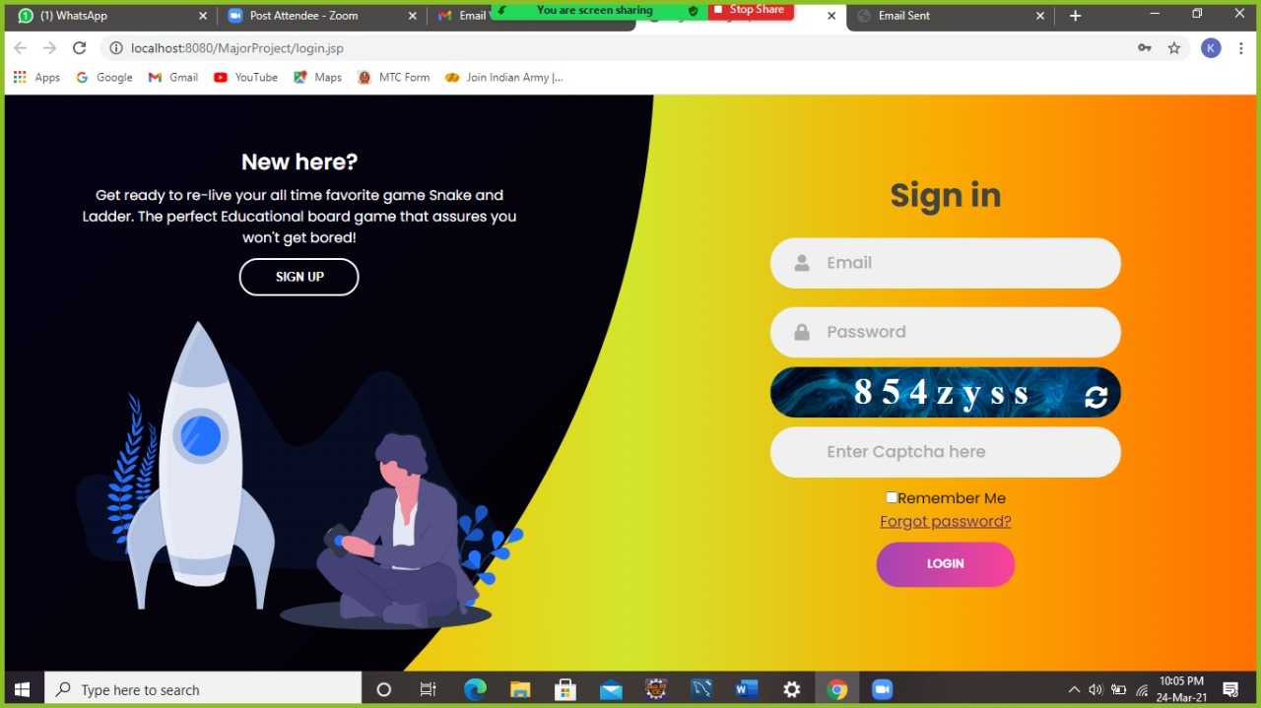

**5.2.3 Home page:**

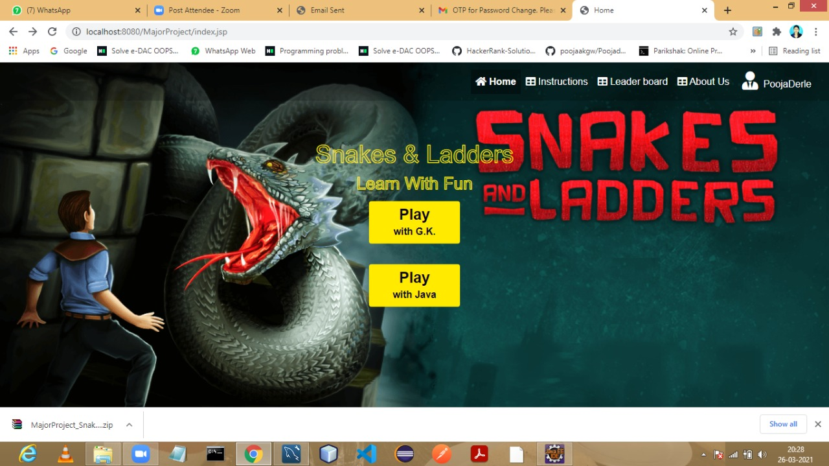

**5.2.4 Play with GK and Play with Java:**

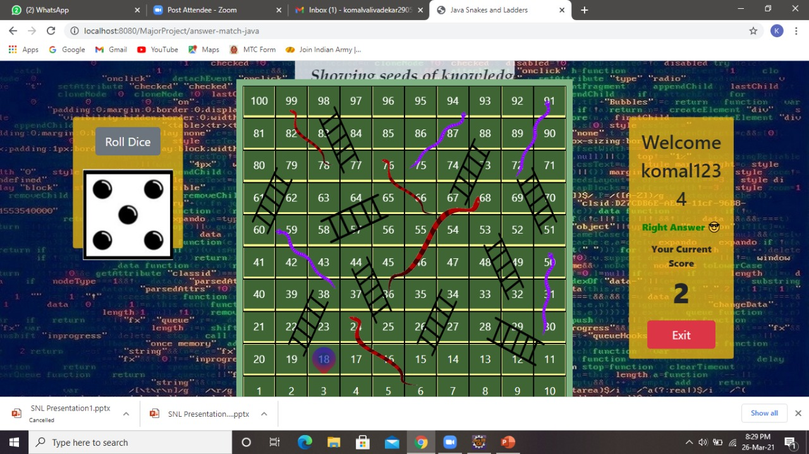

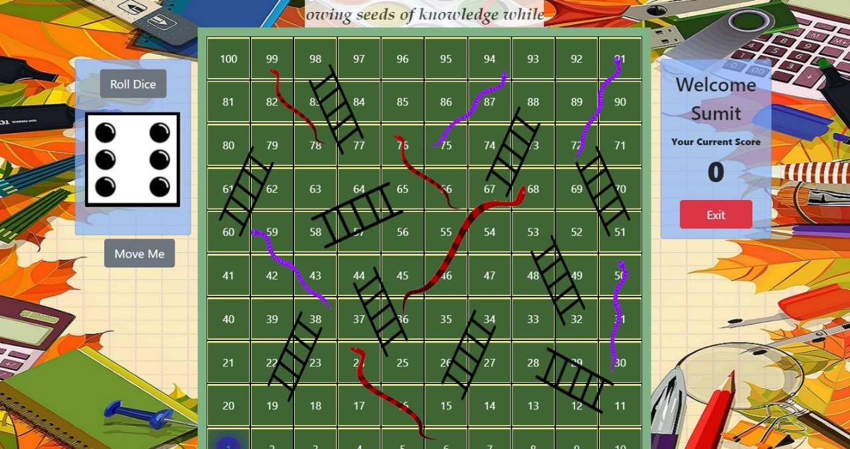

5.2.5 Quize:

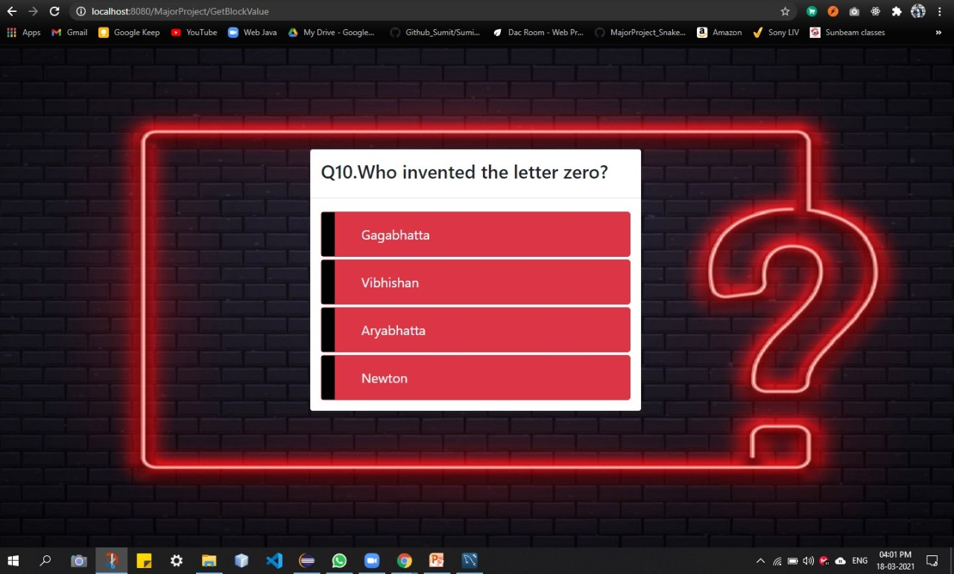

5.2.6 Forgot Password And Email Verification:-

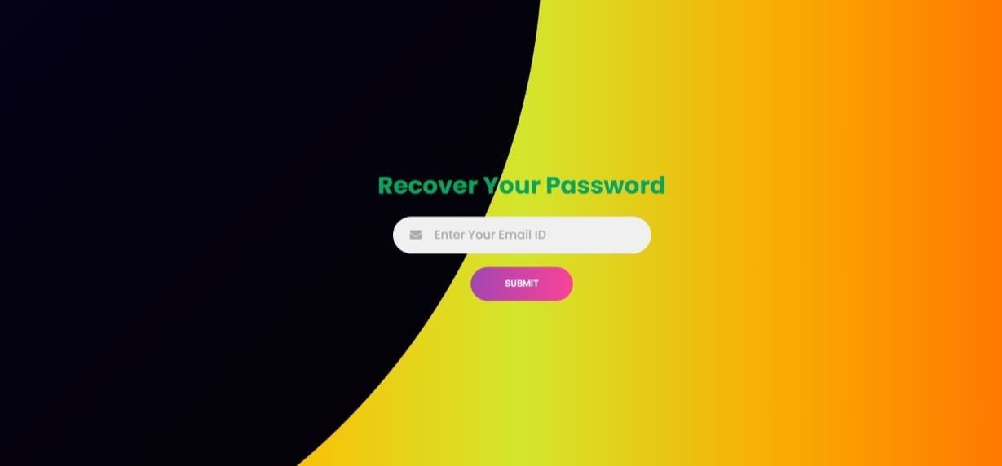

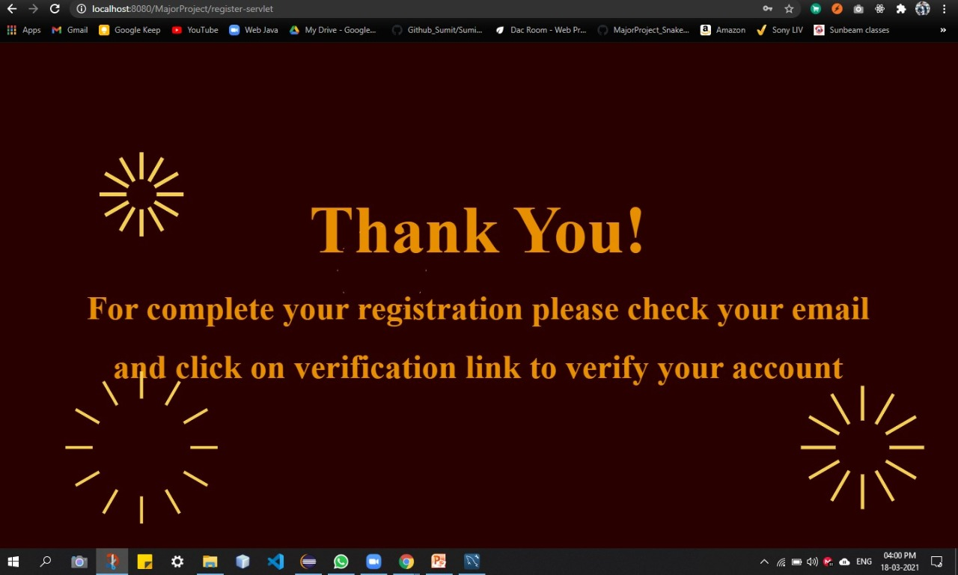

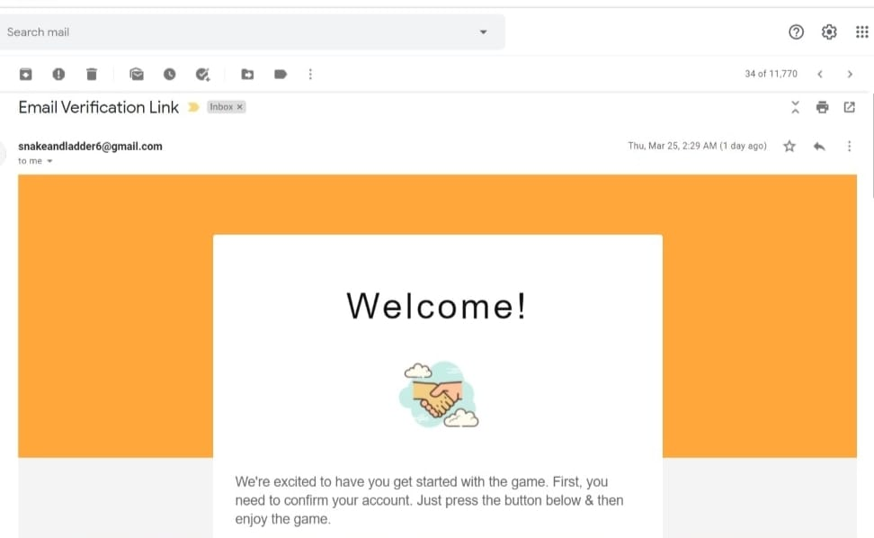

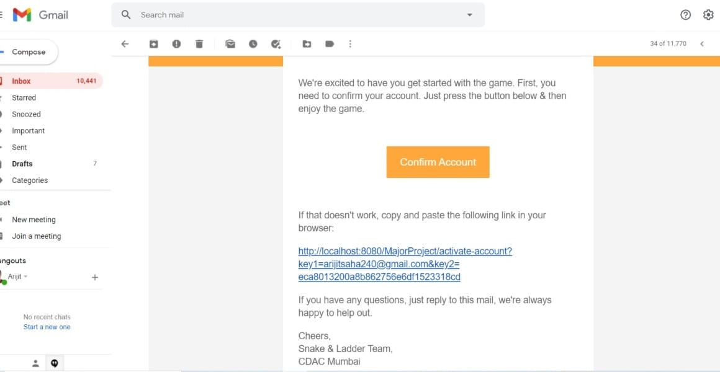

5.2.7 Profile Page:-

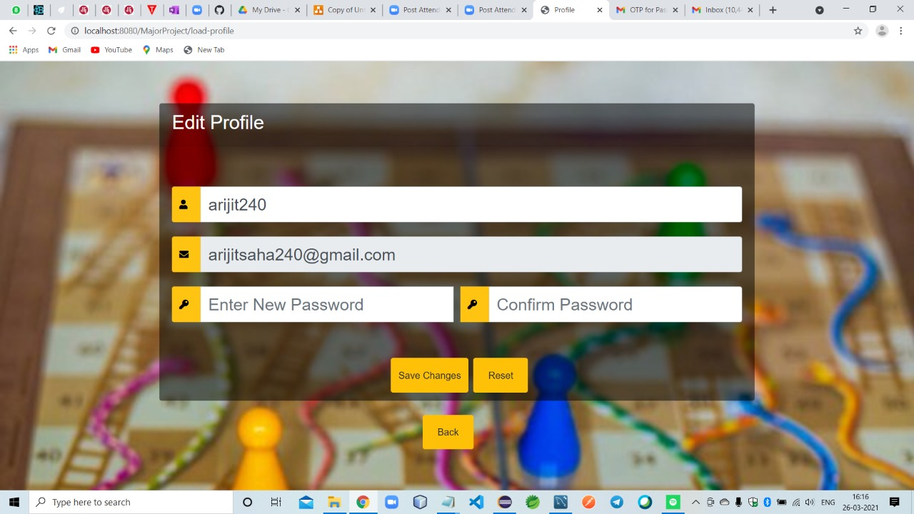

5.2.8 Leader-Board:-

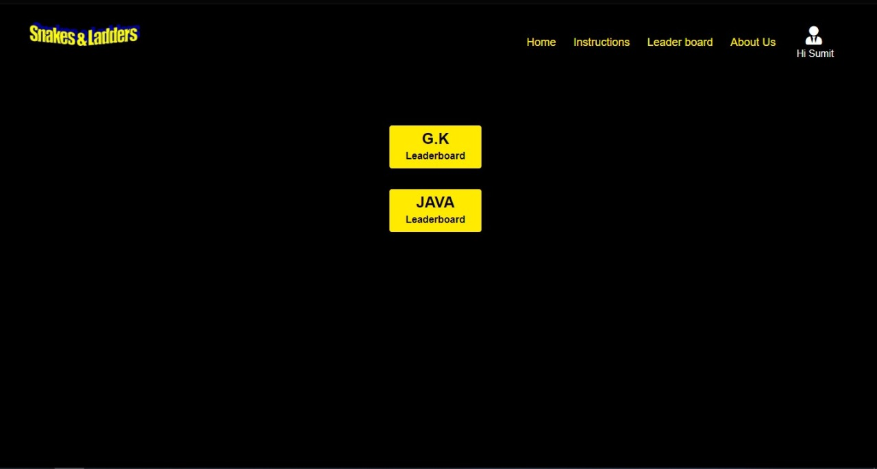

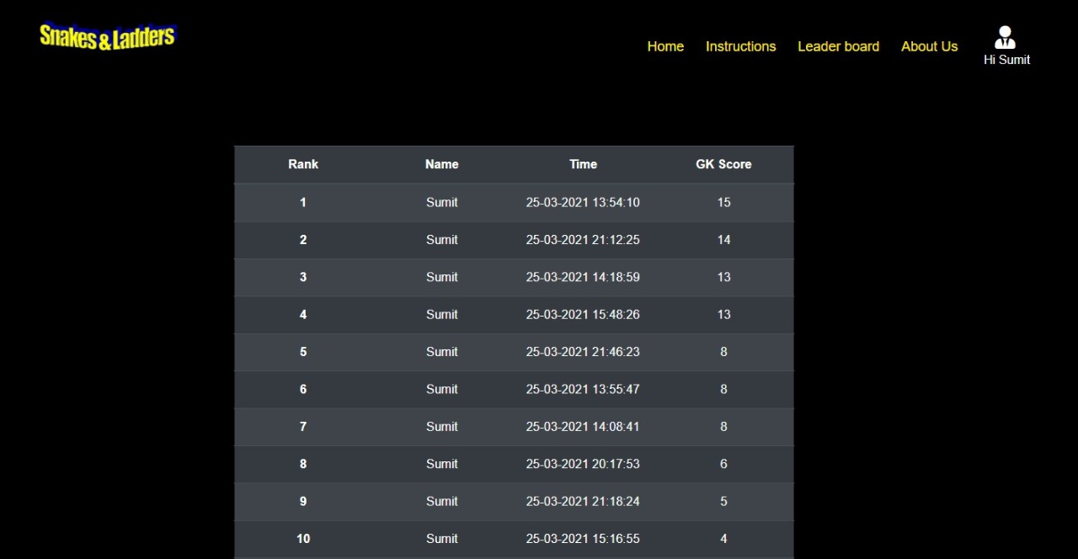

5.2.9 Instruction page:-

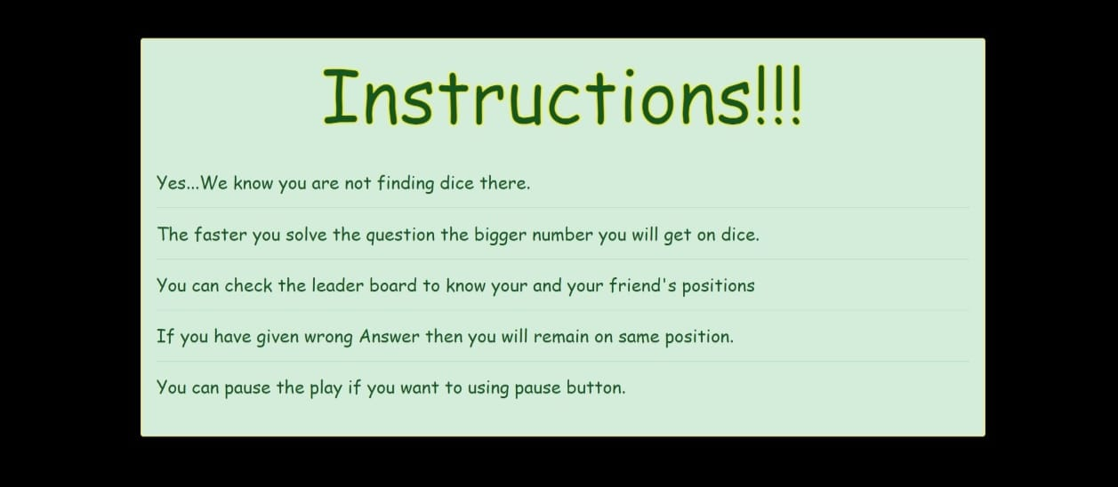

5.2.10 About Page:-

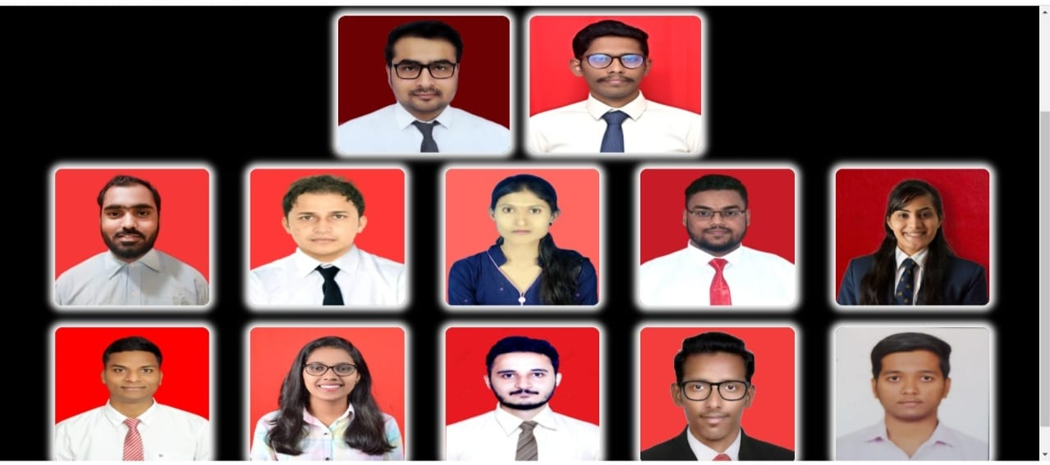

**Chapter 6**

**IMPLEMENTATION**

**6.1 Algorithms / Methods Used**

**We have use following algorithms:**

1. Message Digest Algorithm 5 (MD5)

* Algorithm is a widely used hash function producing a 128-bit hash value.
* Message Digest Algorithm 5 (MD5) is a cryptographic hash algorithm that can be used to create a 128-bit string value from an arbitrary length string.
* It is widely used. MD5 is most commonly used to verify the integrity of files.
* It provides for only one way authentication – there is no mutual authentication of wireless client and the network. And very importantly it does not provide a means to derive dynamic, per-session wired equivalent privacy (WEP) keys.

1. Random Number Generation :

* Applications have the feature to generate numbers randomly, such as to verify the user many applications use the OTP.
* The best example of random numbers is dice. Because when we throw it, we get a random number between 1 to 6.
* Another way to generate a random number is to use the Java Random class of the java.util package
* Random numbers are the numbers that use a large set of numbers and selects a number using the mathematical algorithm. It satisfies the following two conditions:

1) The generated values uniformly distributed over a definite interval.

2) It is impossible to guess the future value based on current and past values.

**6.2 Working of the project *(code for mentioned algorithms)***

**Chapter 7**

**TESTING**

**7.1 Test cases *(conditions on which testing is done)***

**7.1 Test Cases**

|  |  |  |  |  |  |  |
| --- | --- | --- | --- | --- | --- | --- |
| **Test Id** | **Item to be Tested** | **Steps** | **Input** | **Actual Output** | **Expected Output** | **Pass/Fail** |
| **1** | **User Id** | **User enters user Id** | **User Id** | **Display Success** | **Display Message successful** | **Pass** |
| **2** | **System check for proper username and password entered by users** | **System compares the data entered by user and the entered data in database** |  |  |  |  |
|  |  | **If username and password is valid** |  | **Make Connection** | **Make connection** | **Pass** |
| **If username and password is invalid** |  | **Report invalid user id** | **Report error** | **Pass** |
| **3** | **System checks whether details of user are entered as per the format** | **System checks the data entered by user is in valid form or not.** |  |  |  |  |
|  |  | **If valid** | **User entered data** | **Entered in database** | **Entered in database** | **Pass** |
|  |  | **If invalid** | **User entered data** | **“Invalid Data” message will be printed** | **“Invalid Data” message will be printed** | **Pass** |

**7.2 Type of Testing used**

**Functional Testing:**

To be truly robust application require more than simple functional testing before release into production.

* + - Permits only secure and authentication access.
    - Thus requires the user to be registered with the system before use.
    - Does all validation time to time as per the need.
    - Does all the convention of the data internally while requires.
    - Appropriate alerts are generated as per the conditions for user convenience.
    - Database is updated time to time as the transaction process proceeds.

At least one and preferably all of the following type of testing before realising application to customers should be performed. Manual Testing.

### **Features to be tested:**

Here we all testing all features provided by the proposal system to ensure all the features that distinguish the system are implemented property. The following are the features will be testing here.

* 1. Registration for User:

Here we check whether the process is working as per Expectations and when incorrect input is given the system responds with proper error message.

* 1. Maintain Log for each User Session:

Here we check that all users log is maintained properly and all tables in the database are updated properly.

* 1. Blocking of unauthorized users to access: Here with the help of databases table record of the user are maintained. So that the unauthorized users are unable to access the account and in order to do this proper update must be done.
  2. User and System interaction be proper

**Chapter 8**

**Results and Discussions**

Gamification is a term that is not only limited to using in-game elements to be applied in non-game contexts. However, the term gamification is a combined concept in presenting information through the Implementation of games and encouraging users such as behavior to solve problems Motivation, direct feedback and cognitive development through the inserted content. Gamification will illustrate an idea that is not entirely new by adopting from games to be developed to attract interest in several fields, such as education and economics.

Gamification can be implemented in life, because literally playing games is something that has existed in humans since the dawn of civilization and, in particular, recent research has shown that gaming can contribute to faster reactions and also to increase brain activity enabling it .The concept of gamification is different from educational games or serious learning. In recent years Gamification has experienced rapid adoption in the sectors of business, education and health. This is driven by its potential to shape user behavior in the desired direction

**Chapter 9**

**Conclusions**

This Application intended to give a complete overview of Snakes & Ladders game. These requirements relate to the functionality, constraints, performance, attributes and the system interface. The Snakes & Ladders is a program used to play game and answer quiz. First goal is to allow users or players to play the game and solve quiz interactively from their computer. And the second goal will be the program provides security, user friendly interface and quickly response.

\

**Appendix**

### Appendix - A List of Useful Websites

<https://www.codewithc.com/snakes-and-ladders-game-project-c/>

<https://www.researchgate.net/publication/347952776_Gamification_Strategy_Through_Snake_Ladder_Game_Systematic_Literature_Review>

**Literature Cited**

[2] Arsyad, Azhar. 2011. Media Pembelajaran.Jakarta: Rajawali Grafindo Persada

[3] Badrujaman,A. 2009. Teori dan Praktek Evaluasi Program Bimbingan dan Konseling.Jakarta:

PT.Indeks.

[4] Borgen, D. 2009. Play as The Learning Medium for Future Scientists Mathemathician and Eingneers.

American Journal,1-16

[5] Cecep Kustandi dan Bambang Sutjipto. 2011. Media Pembelajaran Manual danDigital. Bogor: Ghalia

Indonesia.

[6] Daryanto. 2010. Media Pembelajaran.Jakarta: Rajawali Grafindo Persada.

[7] Fajar Wahyudi. 2014. Buku Paten Matematika SD Kelas 4,5,6. Jakarta: Laksana

[8] Hartati, Sasmita Christina Yuli, dkk. 2012. Permainan Kecil (Cara Efektif Mengembangkan Fisik,

Motorik, Keterampilan Sosial dan Emosional). Malang: Wineka Media

[9] Hartati, Sofia. 2005. Perkembangan Belajar pada Anak Usia Dini. Jakarta:Depdiknas.

[10] Ika Wulandari. 2013. Memahami Kesebangunan Bangun Datar. Klaten:PT Citre Aji Parama.

**Acknowledgements**

We have taken efforts in this project. However, it would not have been possible without the kind support project guide and project coordinator. I would like to extend my sincere thanks to all of them.

I am highly indebted to **Dr.Sasikumar Sir** (Project Guide) for their guidance and constant supervision as well as for providing necessary information regarding the project & also for their support in completing the project.

I would like to express my gratitude towards **Mr. Sohan More** (Project Coordinator) for their kind co-operation and encouragement which help me in completion of this project.

My thanks and appreciations also go to my colleague in developing the project and people who have willingly helped me out with their abilities.