**SOFTWARE REQUIREMENTS**

**SPECIFICATION**

**For**

**SNAKES AND LADDER**

Version 1.0

CDAC, Mumbai

06th February, 2021

Designed by: Team- 4 & Team- 6

**Table of Contents**

**1. Introduction** ........................................................................................................................**3**

1.1 Purpose...............................................................................................................................**3**

1.2 Document Conventions .....................................................................................................**3**

1.3 Intended Audience and Reading Suggestions ….................................................................**3**

1.4 Product Scope ....................................................................................................................**3**

1.5 References ..........................................................................................................................**3**

**2. Overall Description** ............................................................................................................**4**

2.1 Product Perspective ...........................................................................................................**4**

2.2 Product Functions...............................................................................................................**4**

2.3 User Classes and Characteristics ........................................................................................**4**

2.4 Operating Environment .....................................................................................................**4**

2.5 Design and Implementation Constraints ..............................................................................**5**

2.6 User Documentation ..........................................................................................................**5**

2.7 Assumptions and Dependencies .........................................................................................**5**

**3. External Interface Requirements** ........................................................................................**5**

3.1 User Interfaces....................................................................................................................**5**

3.2 Hardware Interfaces............................................................................................................**5**

3.3 Software Interfaces ............................................................................................................**5**

3.4 Communications Interfaces .................................................................................................**5**

**4. System Features** .................................................................................................................**6**

4.1 System Feature....................................................................................................................**6**

4.2 System Feature 2 (and so on) ..............................................................................................**6**

**5. Other Non-functional Requirements** .................................................................................**6**

5.1 Performance Requirements.................................................................................................**6**

5.2 Safety Requirements...........................................................................................................**6**

5.3 Security Requirements .......................................................................................................**6**

5.4 Software Quality Attributes ...............................................................................................**7**

5.5 Business Rules....................................................................................................................**7**

1. **Other Requirements** ...........................................................................................................**7**
   1. Appendix A: Glossary....................................................................................................................**7**
   2. Appendix B: Analysis Models....................................................................................................................**7**
2. **Introduction**
   1. **Purpose**

This Software Requirements Specification (SRS) document is intended to give a complete overview of Snakes & Ladders game software. These requirements relate to the functionality, constraints, performance, attributes and the system interface.

The Snakes & Ladders is a program used to play game and answer quiz. First goal is to allow users or players to play the game and solve quiz interactively from their mobile as well as computer. And the second goal will be the program provides security, user friendly interface and quickly response.

* 1. **Document Convention**

**Headings: -**

Text: -Bold

Font-Size: - 14

Highlighting: - Times New Roman

**Sub Headings: -**

Text: -Bold

Font-Size: - 12

Highlighting: - Times New Roman

**Header: -**

Text: - Simple

Font-Size: -10

Highlighting: - Times New Roman

**Footer: -**

Text: - Simple

Font-Size: -10

Highlighting: - Times New Roman

**1.3 Intended Audience and Reading Suggestions**

The SRS document also gives project managers a way to ensure the game’s adherence to our original vision. Although the document needs to be read from start to end for complete understanding. The following document is written in modules and hence can be read as such. For an overview of the document one needs to check the overall description. For a detailed description of the game play element and their interaction with the character refer system features.

**1.4 Product Scope**

This Software Requirements Specification (SRS) describes the functional and non-functional requirement for the project. As far as the document is concerned the main purpose of this research is to provide a virtual concept for the combination of both structured and unstructured information.

* 1. **References**
* https://stackoverflow.com
* https://w3school.com
* https://discuss.codingblocks.com
* https://www.geeksforgeeks.org

**2. Overall Description**

**2.1 Product Perspective**

The usage of various suitable learning mediums in teaching and learning enhances cognitive development of the students with learning difficulties. So, Learning for new learners should be taught in a fun way, using a familiar context. Incorporating games into the classroom is a way to engage students in the Content and hence improve their learning outcomes. The aim is to examine the using of snake and ladder game as a learning medium for those students. This study is using qualitative methods. Data was collected by observation of the game that has been conducted. Observation and outcome of data have been analyzed in order to make the researcher more convenient in gaining the information.

**2.2 Production Functions**

* Every player must begin the game at the compartment number 1 and ended in

the compartment number 100.

* There are certain amount of snakes and ladders located on particular parcels

on the board.

* Each player will be represented by a piece of dice and a few objects.
* Snakes and ladders of various sizes are being used whereby the snake will

cause the players to take a few steps of backward compartment and the

advanced players will make some forward compartment.

* Each player must throw the dice in order to determine the highest value

during the first round of the game.

* The player gets a turn to throw the dice again when getting number six and

move forward to the appropriate compartments according to the figures

shown.

* There can be more than one object that represents the players in a parcel.
* If the player is in the box with the snake, the player must go down to the box

indicated by the head of the serpent.

* If the player is in the box with the ladder, the player must move to the boxes

indicated by the peak of the ladder.

* The player who made it to the box of 100 will be the winner of this game.

**2.3 User Classes and Characteristics**

* Admin: Admin are the ones who verify all the info of player and Admin can also update and change the questions.
* End users/Customers: The end user will be the one who play the game.

**2.4 Operating Environment**

* Hardware platform:
* Processor – Above Pentium 4, with clock speed of 2.0GHz
* RAM – 1 GB or above
* Hard Disk – Free disk space of above 1GB
* Software platform:
* Front-end: HTML5, CSS, Bootstrap, JSP.
* Back-end: MySQL 8, Java 8
* Supported tools:
* Eclipse IDE 2020-03, MySQL Workbench 8.0

**2.5 Design and Implementation Constraints:**

* User interface is only in English. No other language option is available.
* End user can log-in only with his assigned user-name and password.

2.6 User Documentation:

The User Documentation contains Help menu of the application which is used as a reference for any help needed. It gives all the minute details about the project and all the necessary information about the product, if any user has any problem or query about any module or functionality regarding the project, one can refer it to solve the problem and see how to operate the application. This report is the complete documentation of our project. It gives complete details about the project, its functionality, users, software used, hardware requirement, environment and so on.

2.7 Assumptions and Dependencies

* Assumptions
* There is an active internet connection with the system.
* The system has internet browser installed
* Users know the English language, as the user interface will be provided in English
* Dependencies
* There is a need of constant updating of project work on daily basis.
* Conflict can occur while merging of code.

3. External Interface Requirements

**3.1 User Interfaces :**

The main element is web-pages using HTML, JSP. Multiple interfaces are there like log-in pages, registration page, game board. Based on the play we can generate final results.

**3.2 Hardware Interfaces :**

In the hardware interface, the system interacts with hardware given the processor of any desktop PC or any laptop. In future enhancements, it can be made responsive to be able to work with mobile devices as well.

**3.3 Software Interfaces :**

In software interfaces,”” is the back-end technology used along with MySQL Database. The front-end technologies include HTML, CSS, Bootstrap, React, JSP. Data will be communicated between these interfaces accordingly.

**3.4 Communication Interface:**

The main communication interface for interacting with the Game will be the web Browser.

**4. System Features**

**4.1 Description :**

This game will help players to check their knowledge in the respective field . This game also aims at carrying out an analysis of the player’s performance which will in return help them to improve the performance . Player will be given a question to solve on every block. Questions will be chosen according to player’s performance.

**4.2 Functional Requirements**

**4.2.1 Select Category :**

The players will get option to select category they want to play like student or programmer. They will get the questions accordingly. The game will keep the players performance log.

**4.2.2 Actual Game Play :**

At first position players will get a question to solve. Then the player will get score on that score he/she will be moved to next position. On the next position player will be redirected to another problem page and game will be continued like that.

**4.2.3 Play/Pause :**

Players will be able to pause the game and resume it afterwards with the same position and score.

**4.2.4 Check Performance :**

Every Player will be able to see personal performance log.

**5. Other Non-functional Requirements**

**5.1 Performance Requirements :**

* The system should be available at all times, which means the user can access it using boards of different size from 8*8 to 12* 12 boxes.
* The system should store every user’s data into the database.
* For user convenience application is user friendly and easy accessible.
* The system is made in such way that it is reliable in its operations and secure in details
* The system is easy for the user to understand.

## 5.2 Safety Requirements :

* All login ids and passwords of user should be protected for or the application.
* In case the database is corrupted or hacked by some hackers or intruders then all data must be deleted and backup system is should be retrieved
* All users must possess a unique username & password.
* Password must contain a combination of Alpha-Numeric characters with special symbols in it.
* It should contain min 8 to max 16 characters length in it.

**5.3 Security Requirements**

* This system provides, security, user friendly interface and quickly response.
* The system must automatically logout of all users after certain pried of in activity. The database should be protected from attacks and unauthorized access.
* The interface should be protected from attacks. All passwords should be stored as a secure hash of the administrator password.
* The system must use SSL encryption (Secure Socket Layer) password in all transactions that store in databases and it is a one-way function.

## 5.4 Software Quality Attributes

**5.4.1 Stability:**

The system output won’t change from time to time .The same output will

Be given always for a given input.

**5.4.2 Maintainability:**

Only maintainers are allowed to connect into internal servers.

The system shall keep a log of all the errors.

**5.4.3 Durability:**

The software will be tested for working with multiple users.

**5.4.4 Robustness:**

In case device crashes, a backup of history must be stored.

**5.4.5 Performance:**

Performance depends on Memory, CPU, Network bandwidth,

Disk space, and Feedback time and Application must be lightweight

**5.4.6 Effectiveness:**

The software will be made to handle operations effectively.

**6.** **Other Requirements**

* **Appendix A:Glossary**
* SRS: Software Requirement Specification
* GUI: Graphical User Interface
* SQL :Structured Query Language
* HTML :Hyper Text Markup Language
* CSS: Cascading Style Sheet

* **Appendix B: Analysis Models**

1. **Use Case Diagram:**

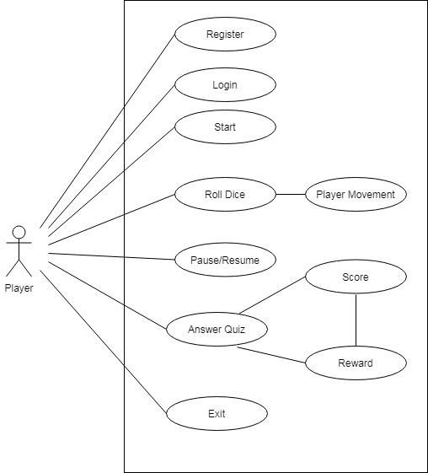

1. **Class Diagram:**

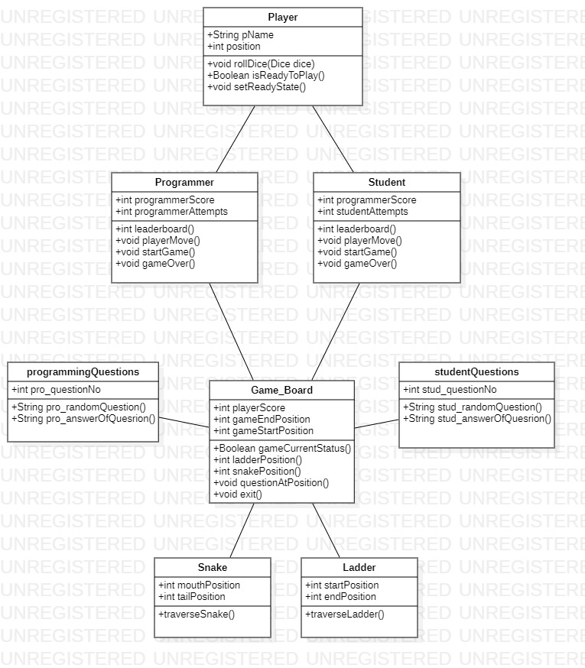

1. **Activity Diagram:**

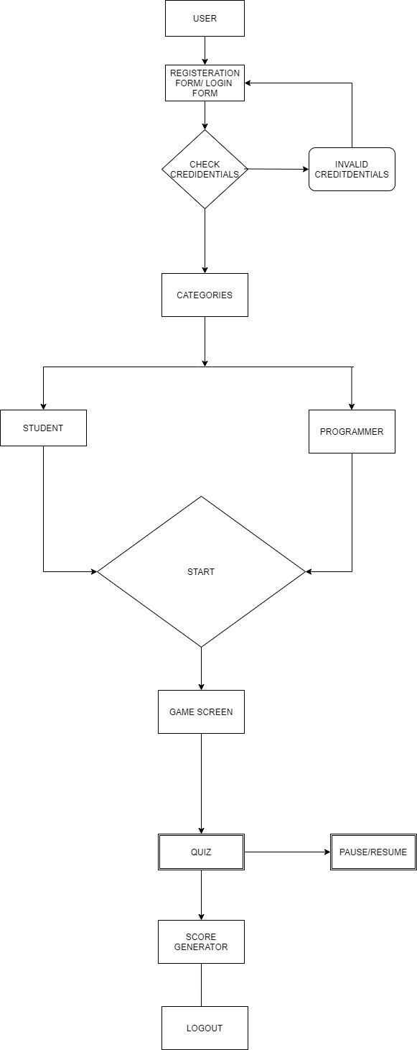

1. **Sequence Diagram:**

