TEST AWS-LAMBDA-DYNAMODB

This project was developed with serverless, nodeJs express, aws lambda and DynamoDB.

Deployment process

Clone repository:
https://github.com/jpaz932/aws-lambda-dynamo.git

Instal dependencies:
npm i

configure credential for AWS profile:
aws configure
-The credentials will be shared in the mail

Deploy with serverless:
serverless deploy

This will create the following services in aws:

-s3 Bucket

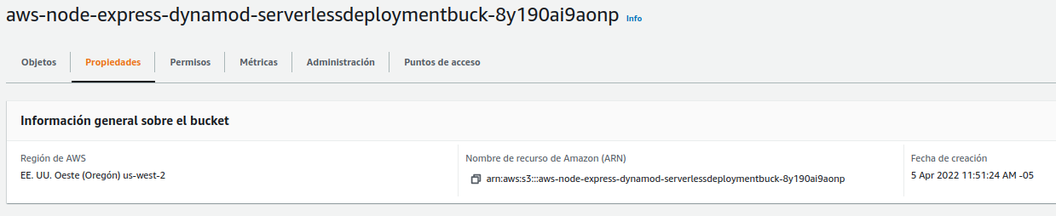

-Cloudwatch Log group

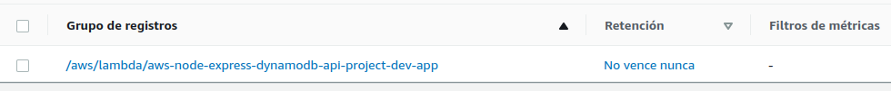

-API GateWay

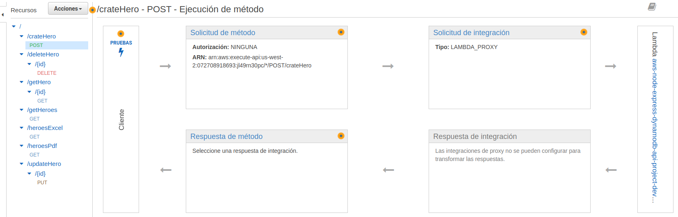
-Lambda

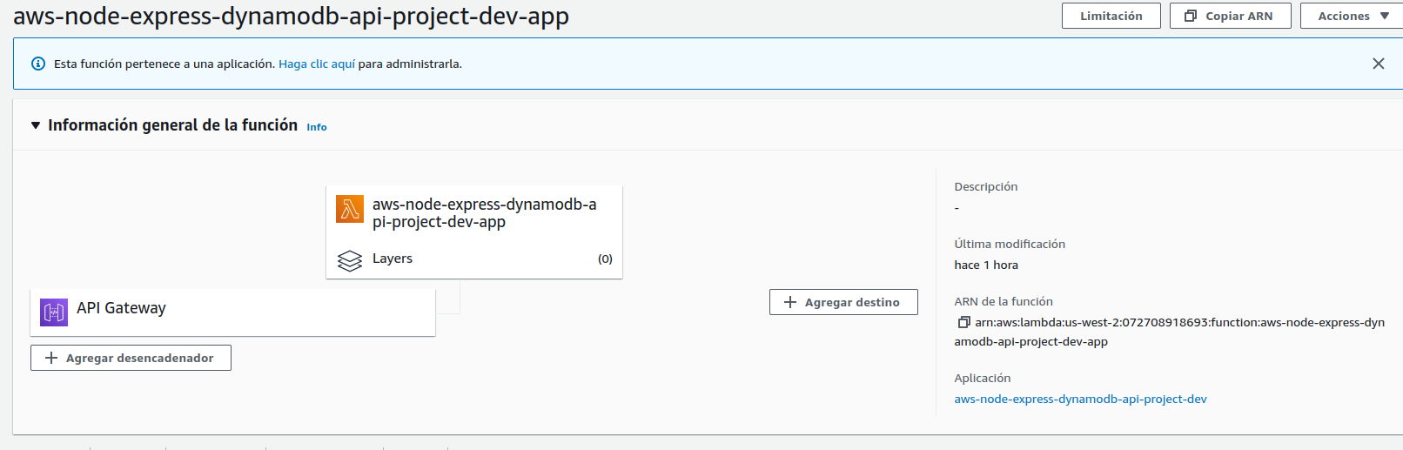

Once the deployment is complete you will see something similar to the following:

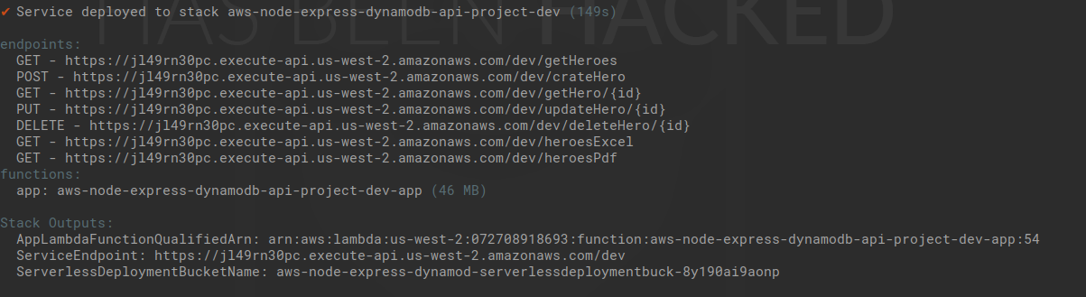

run unit tests:
npm run test
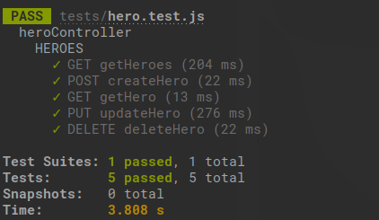

Import the postman collection located in documentation folder
heroes.postman_collection.json

Link postman documentation:
https://documenter.getpostman.com/view/6751435/UVyuTFZm

Endpoints:

