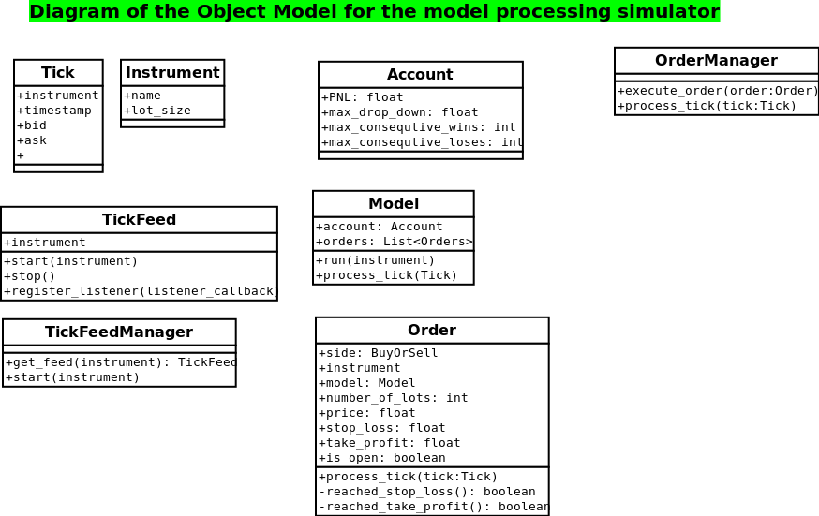
Order Simulator

Tick
Represents a tick
created by a csv file containing historical data

Instrument
Represents an instrument (currency pair)
Contains related information like lot size

TickFeed
Opens a tick file creating a stream of ticks
Allows listeners to register by providing a callback

TickFeedmanager
Contains and manages a pool of feeds. A client can
request a specific feed based in the instrument so
it can register with it.

Account
Contains the data of an account and is aggregated by a model

Model
Implements the trading algorithm and is will be used for
optimization. Exposes a call-back function that will be
called by the tick feed for each new tick.

Based in the outcome of the algorithm it can create an Order
and execute it using the Order Manager

Order
Encapsulates all the details of an order. Is created by the model
and closed by the OrderManager.

OrderManager
Registers with the tick feed to receive a notification for each
new tick. Is responsible for the closing of all the orders

