**Capstone Project Design Document**

**TABLE OF CONTENTS**

**1. INTRODUCTION**

1.1 Purpose

1.2 Scope

1.3 Overview

1.4 Reference Material

**2. REQUIREMENTS DESCRIPTION**

**3. SYSTEM OVERVIEW \***

4**. SYSTEM ARCHITECTURE**

4.1 Architectural Design

4.2 Decomposition Description

4.3 Design Rationale

**5. DATA DESIGN**

5.1Data Description

5.2 Data Dictionary

**6. COMPONENT DESIGN**

**7. HUMAN INTERFACE DESIGN**

7.1 Overview of User Interface

7.2 Screen Images

7.3 Screen Objects and Actions

**8. APPENDICES**

**1. INTRODUCTION**

**1.1 Purpose**

The purpose of this document is to outline the technical design of the Unami Sushi and Grills website and to provide an overview for the implementation of the project.

Detail the functionality of the individual components and overall system.

Provide a basis for the Unami website design and development

This document will be updated and refined based on changing requirements.

**1.2 Scope**

**Description & Scope**

The Unami Sushi and Asian Grill website is a little kickstart for their small business. It will be simple, clean, user friendly, and helpful. The site will closely represent the people, quality of product, and make customers feel as if they were in the restaurant. It is important that the website does not have too many features or feel cluttered. Unami itself is small and keeping the website feel personable will be best for Unami.

**Goal**

The goal of the website is to provide Unami Sushi and Asian Grills with a place to show their food items, spread the word of their restaurant, and give their customers a better idea of what Unami is about. Currently Unami only has a facebook page with minimal photos and information. This site will allow them to boost their credibility

and reputation by providing more information about each menu item. With more information about their food and history will give customers comfort in actually coming in and trying various menu items.

**Benefits**

* popularity
* customer volume
* credibility and reputation
* keep customers informed
* content and information

**1.3 Overview**

This document is for future development and reference. It can be modified as Unami grows or changes.

This document will help keep Unami website on the right track without it turning into something completely different from its goals.

* *Website UI* - Shall remain simple and clean. The UI will not be modified in design unless it is absolutely necessary. Both customers/visitors and admins should have logical and user friendly interfaces
* *Updates -* Owners/employees will not update the site unless they pay someone. If updated should be made by owners/employees then it should be integrated through the site itself without having them touch the code

*Content* - This will be limited to the site. Unami itself will contain more menu items than the site. The site will be a quick look of Unami.

* **1.4 Reference Material**

# [**The Sushi-Burrito That Will Change the Way You Eat Sushi Forever**](http://uoregon.spoonuniversity.com/2015/02/09/sushi-burrito-will-change-way-eat-sushi-forever/) **-** Used this article to learn more about Unami Sushi and Asian Grills

**2. REQUIREMENTS DESCRIPTION**

**User Requirements**

* Log in or out
* View menu items
* Search menu items
* View locations
* Get contact information
* Description and price of menu item to be available
* Write a review about a certain item or experience of service
* View hours
* Learn about Unami Sushi and Asian Grills
* Look through food gallery
* Photos of the owner and his employees
* See upcoming events where Unami will be participating in
* Learn what a Sushi Burrito is
* View specials

**System Requirements**

* Working user account system, with authorised employee accounts and capabilities.

(Updated: Owners do not want user accounts or comments for customer comments or reviews.)

* Working menu item database with all necessary information and browse and search capabilities.
* Location provided utilizing embedded google maps system and contact information
* Easily editable menu and special selections allowing administrators to easily change menu items and details.

**3. SYSTEM OVERVIEW**

The primary goal of this project for our clients is to provide them a website through which they can attract new customers and give their customers more information about their business and the food they sell there. The primary focus of the site itself will be base around a menu database containing the names, descriptions, and pictures of many of the dishes that they serve at Unami Sushi. Our clients want the website to be simple and concise, and make it easy for viewers to find the information they need whatever that may be.

The owners also requested that we make the system easy to manage so that they, or someone they hire, can easily make changes to the site whenever they are need. For this we will be implementing some way to log into the system and gain privileges to changes aspects of the site. For this functionality we will be implementing the ability to create, edit, and delete menu items in the systems database. We will also add the ability for an administrator to add and remove menu items from certain menus, in a way that they can display certain items in a shifting slideshow gallery on the main page of their site, or add items to a specials menu.

In addition to these primary features, we will also be adding minor functionality that seems customary in a website of this sort, such as location mapping and easy to use contact information. We had also planned on implementing a system through which customers could post reviews of their favorite dishes server at Unami Sushi. However, we recently learned that the owners did not want us to implement such a system, and only wanted a simple menu and gallery and the means to manage the site efficiently. As a result the actual database and system our client wants seem to be rather small compared the larger features we had originally intended. Another goal for this project will be to use good visual design sense to make sure the site is appealing to the owners and customer base.

Hopefully as we grow more skilled and learn more about our abilities and more that we could do for the site, we can convince our clients to let us add more useful capabilities to our system, but for now we will simply be trying to make a great site for a local business and to help them

**4. SYSTEM ARCHITECTURE**

4.1 Architectural Design

A large part of the system we're developing for Unami Sushi is a specialized menu database where we can store data about every individual item on the menu in the restaurant. With our system, we will be able to store basic information about each dish such as a name, description, and image. Additionally there can be data stored along with each dish that will be hidden to customers and available as an asset to the business, such as information about all the ingredients, cost of ingredients, and other useful information. How much data will be stored within the menu database is ultimately up to the business owners and how much information they want to provide. It is completely understandable that they may not want to place the ingredients to some of their dishes online if they consider their secrecy important to the business.

Additionally, we may be implementing a comment and review system that allows users of the site to submit comments and ratings for their food. We previously considered embedding functionality from a third party review system such as Yelp, but decided not to utilize them due to a disagreement we have with their business practices. Instead we will allow users to submit a short comment and rating to their food either under anonymity or after entering a name if they wish.

To implement the system we have envisioned for our clients, we’ll utilize a simple multi table database. The table containing menu items will form the backbone of our project and will connect to the tables of both images and reviews/comments. Additionally, we will implement minor user functionality to allow approved users to access the controls of the system and allow our clients to do important tasks such as adding additional menu items and make important changes to details of these items.

The table of individual menu items will be connected to the comment and review table in a way that each menu item will be connected any relevant comment/review objects. These will be displayed in a list on the detailed view page of an individual menu item, if it has any comments or reviews. However, the system will also account for reviews or comments not necessarily left on specific menu items, but also for the restaurant as a whole. These however will be displayed elsewhere, possibly on the front page.

To leave a review or comment, a customer can register a user account. The comment objects themselves will be attached to a comment list object that can contain a list of comments and can be attached to both menu items and more obtuse concepts like the front page or the restaurant itself. The comment will also be linked to the use account that created it, and in similar fashion, the user account will be linked to all comments/reviews that the user creates.

(Updated: The clients now do not want customer comments or reviews, so part of this information is obsolete.)

In a similar method to the user objects, there will be special accounts for the employees and owners of the restaurant to use to sign in. These special accounts will be authorised to make changes to the site, such as adding and editing menu items, managing special menu items, and other various administrative actions.

**4.2 Decomposition Description**

Small diagram showing the layout of the menu item system and how items fit into display categories

4.3 Design Rationale

**5. DATA DESIGN**

**5.1 Data Description**

The only major data stored in our database at the current point will be the menu items, and potentially the administrative users account data. In addition to a typical menu item identification primary key, the menu items will contain a name, description, and picture or link to a picture. They may also have information meant for the business and not the customers, but given the recent news from our client that they intend for this site to be a quick look for people new to the restaurant. In which case, it will be pointless for menu items to contain data that won’t be used.

User accounts will also be very simple and easy to manage. They’ll contain a UserID primary key, a username, if necessary as a different item from the userid, potentially contact information, and a stored password. However, this user data and accounts will probably be managed by the identity capabilities we will enable for our site which will handle the small details of the user account system.

**5.2 Data Dictionary**

Menu Description: An appetizing description of a particular dish and information about it.

Menu Item: The primary objects of our database, and focus of our system. Each will contain a name, description, and picture of the menu item.

Menu Name: The name of a particular menu item dish.

Menu Pictures: A stored picture or link to a stored picture of the particular menu item.

**6. COMPONENT DESIGN**

6.1 Navigation Structure

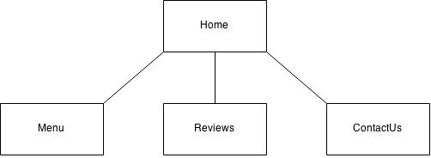

6.2 Logo

Unami already has a logo, which we will need to find a higher quality version of it to use throughout the website.



6.3 Blog-feature

We will be implementing a blog feature. This will be featured on the front page to allow customers to view specials or to notify them of any upcoming closures. We would only want to display the last several blog posts. The owner/employee of the website would update this whenever they see fit.

**6.4 Database Design**

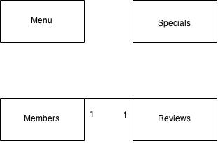

**6.5 Menu System**

We will have a way of updating the menu and prices from a web browser that only the owner or an employee would be able to access and update. This will decide what menu items the customers will see when they visit the menu page. It will contain options to add new items, delete items, edit items, or hide them from the customers.

**7. HUMAN INTERFACE DESIGN**

7.1 Overview of User Interface

The system will be able to display information about Unami. Visitors(not logged in) to the website will be able to view the menu and view the comments and ratings. If they have have a log in they will be able to add a review that contains their username, comment and a rating. On the right side of the screen on the comments page is where the prompt to sign up or sign in. The overall design we are trying to achieve will be simple and clean.

**7.2 Screen Images**

**Homepage Interface**

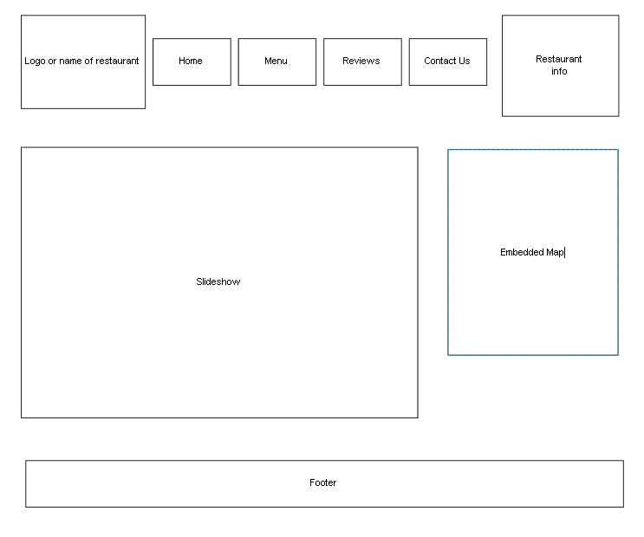

**Menupage Interface**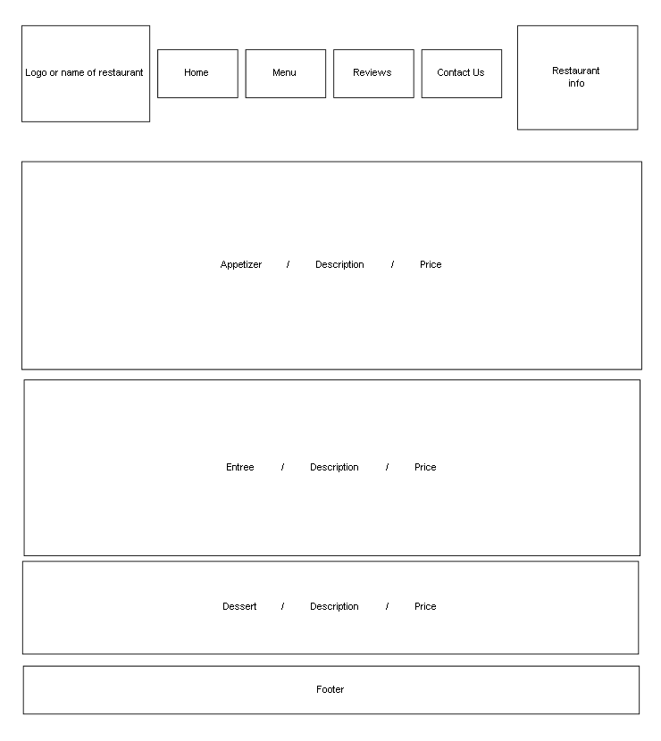

**Reviewpage Interface**

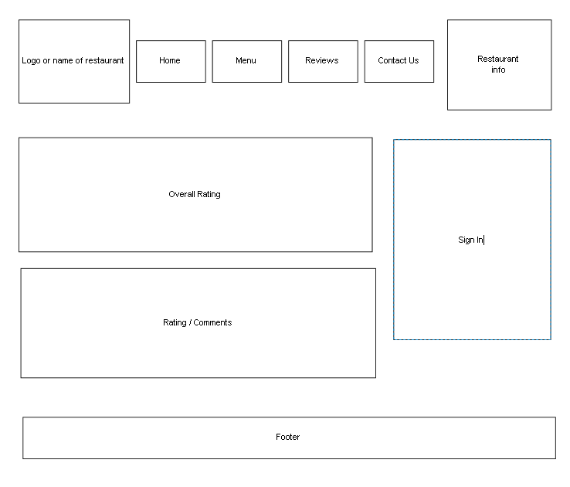

7.3 Screen Objects and Actions

* Homepage will have a slideshow of images of the restaurant and food- click to full screen the image
* Embedded map generated from Google - click to take you to google maps
* Footer on the page will contain links as well as an address
* The header on the page will contain the links to the web pages
* **Use Case Diagram**

