#### Codebasics SQL Challenge

By João Pedro – [Github](https://github.com/jpbetanza/AtliQHardwares-adhoc-SQL-Requests)

Requests:

1. Provide the list of markets in which customer "Atliq Exclusive" operates its business in the APAC region.

Answer:

SELECT DISTINCT market

FROM fact_sales_monthly INNER JOIN dim_customer

ON fact_sales_monthly.customer_code = dim_customer.customer_code

WHERE customer = "Atliq Exclusive" AND region = "APAC"

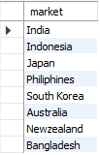

1. What is the percentage of unique product increase in 2021 vs. 2020? The final output contains these fields: unique_products_2020, unique_products_2021, percentage_chg

Answer:

WITH

result1 (unique_products_2020) AS (

SELECT COUNT(DISTINCT product_code) AS unique_products_2020

FROM fact_sales_monthly

WHERE fiscal_year = "2020"

),

result2 (unique_products_2021) AS (

SELECT COUNT(DISTINCT product_code) AS unique_products_2020

FROM fact_sales_monthly

WHERE fiscal_year = "2021"

),

result3 (percentage_chg) AS (

SELECT ROUND((((unique_products_2021/unique_products_2020)-1)*100),2)

FROM result1 JOIN result2

)

SELECT * FROM result1 JOIN result2 JOIN result3



1. Provide a report with all the unique product counts for each segment and sort them in descending order of product counts. The final output contains 2 fields: segment, product_count

Answer:

WITH

count_column (segment, product_count) AS (

SELECT segment, COUNT(distinct product_code)

FROM dim_product

GROUP BY segment

)

SELECT * FROM count_column ORDER BY product_count DESC

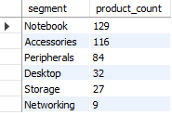

1. Follow-up: Which segment had the most increase in unique products in 2021 vs 2020? The final output contains these fields: segment product_count_2020 product_count_2021 difference

Answer:

WITH

segment20_sel (segment, product_count_2020) AS (

SELECT segment, count(DISTINCT fact_gross_price.product_code)

FROM fact_gross_price JOIN dim_product

ON fact_gross_price.product_code=dim_product.product_code

WHERE fact_gross_price.fiscal_year="2020"

GROUP BY segment

),

segment21_sel (segment, product_count_2021) AS (

SELECT segment, count(DISTINCT fact_gross_price.product_code)

FROM fact_gross_price JOIN dim_product

ON fact_gross_price.product_code=dim_product.product_code

WHERE fact_gross_price.fiscal_year="2021"

GROUP BY segment

)

SELECT segment20_sel.segment, product_count_2020, product_count_2021,

product_count_2021-product_count_2020 as difference,

ROUND(100*((product_count_2021/product_count_2020)-1)) as percentage

FROM segment20_sel INNER JOIN segment21_sel

ON segment20_sel.segment = segment21_sel.segment

ORDER BY difference DESC

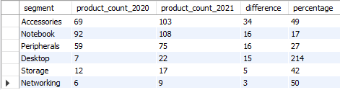

1. Get the products that have the highest and lowest manufacturing costs. The final output should contain these fields, product_code product manufacturing_cost

Answer:

WITH big_table(product_code, product, manufacturing_cost) AS (

SELECT fact_manufacturing_cost.product_code, product, manufacturing_cost

FROM fact_manufacturing_cost INNER JOIN dim_product

ON fact_manufacturing_cost.product_code = dim_product.product_code

)

SELECT product_code, product, ROUND(manufacturing_cost,2) as manufacturing_cost

FROM big_table

WHERE manufacturing_cost = (SELECT max(manufacturing_cost) FROM big_table)

UNION ALL

SELECT product_code, product, ROUND(manufacturing_cost,2) as manufacturing_cost

FROM big_table

WHERE manufacturing_cost = (SELECT min(manufacturing_cost) FROM big_table)



1. Generate a report which contains the top 5 customers who received an average high pre_invoice_discount_pct for the fiscal year 2021 and in the Indian market. The final output contains these fields, customer_code customer average_discount_percentage

Answer:

SELECT dim_customer.customer_code, customer, ROUND(pre_invoice_discount_pct*100,2) AS average_discount_percentage

FROM fact_pre_invoice_deductions INNER JOIN dim_customer

ON fact_pre_invoice_deductions.customer_code = dim_customer.customer_code

WHERE fiscal_year="2021"

AND pre_invoice_discount_pct>=(SELECT AVG(pre_invoice_discount_pct) FROM fact_pre_invoice_deductions where fiscal_year="2021")

AND market = "India"

ORDER BY pre_invoice_discount_pct DESC

LIMIT 5

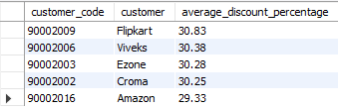

1. Get the complete report of the Gross sales amount for the customer “Atliq Exclusive” for each month. This analysis helps to get an idea of low and high-performing months and take strategic decisions. The final report contains these columns: Month; Year; Gross_sales_Amount

Answer:

SELECT month(date) as month,year(date) as year, round(sum(sold_quantity*gross_price)) as Gross_sales_Amount

FROM fact_sales_monthly INNER JOIN fact_gross_price

ON fact_gross_price.product_code=fact_sales_monthly.product_code

AND fact_gross_price.fiscal_year=fact_sales_monthly.fiscal_year

INNER JOIN dim_customer

ON dim_customer.customer_code=fact_sales_monthly.customer_code

WHERE dim_customer.customer="Atliq Exclusive"

GROUP BY date ORDER BY year and month ASC

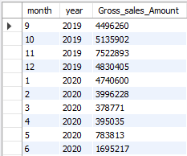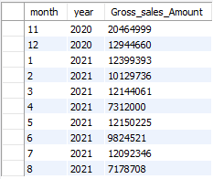

1. In which quarter of 2020, got the maximum total_sold_quantity? The final output contains these fields sorted by the total_sold_quantity, Quarter total_sold_quantity

Answer:

SELECT quarter(DATE_ADD(date, INTERVAL 4 MONTH)) AS quarter, sum(sold_quantity) AS

total_sold_quantity

FROM fact_sales_monthly

WHERE fiscal_year="2020"

GROUP BY quarter ORDER BY total_sold_quantity DESC;

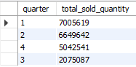

1. Which channel helped to bring more gross sales in the fiscal year 2021 and the percentage of contribution? The final output contains these fields, channel; gross_sales_mln; percentage

Answer:

WITH tabela (channel, gross_sales_mln) AS (

SELECT channel, round(sum(sold_quantity*gross_price)) AS gross_sales_mln

FROM fact_sales_monthly

INNER JOIN fact_gross_price

ON fact_sales_monthly.product_code=fact_gross_price.product_code

AND fact_sales_monthly.fiscal_year=fact_gross_price.fiscal_year

INNER JOIN dim_customer

ON fact_sales_monthly.customer_code=dim_customer.customer_code

WHERE year(date)="2021"

GROUP BY channel

)

SELECT channel, gross_sales_mln, ROUND(gross_sales_mln/(SELECT sum(gross_sales_mln) FROM tabela)*100) AS percentage

FROM tabela

ORDER BY percentage DESC

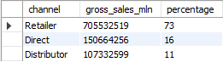

10. Get the Top 3 products in each division that have a high

total_sold_quantity in the fiscal_year 2021? The final output contains these

Fields: division; product_code; product; total_sold_quantity; rank_order

Answer:

WITH tabela (division, product_code, product, total_sold_quantity) AS (

SELECT division, fact_sales_monthly.product_code, product, sum(sold_quantity) AS total_sold_quantity

FROM fact_sales_monthly INNER JOIN dim_product

ON fact_sales_monthly.product_code=dim_product.product_code

WHERE fiscal_year="2021"

GROUP BY fact_sales_monthly.product_code, division, product

ORDER BY division DESC, total_sold_quantity DESC

)

SELECT * FROM ( SELECT *, ROW_NUMBER() OVER (PARTITION BY division ORDER BY total_sold_quantity DESC) AS rank_order FROM tabela)

RANKED

WHERE rank_order<= 3;

