Figure 1. Cross-sections of crowding conditions used in 3D off-lattice Monte-Carlo simulations
Radius of crowding molecules

1 2 3 4

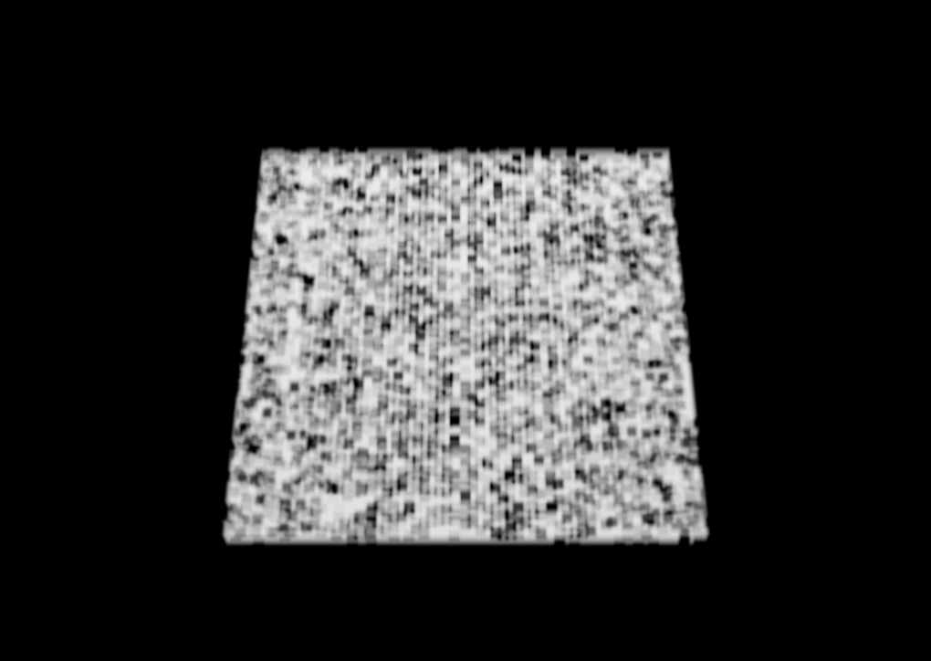

25

50

75
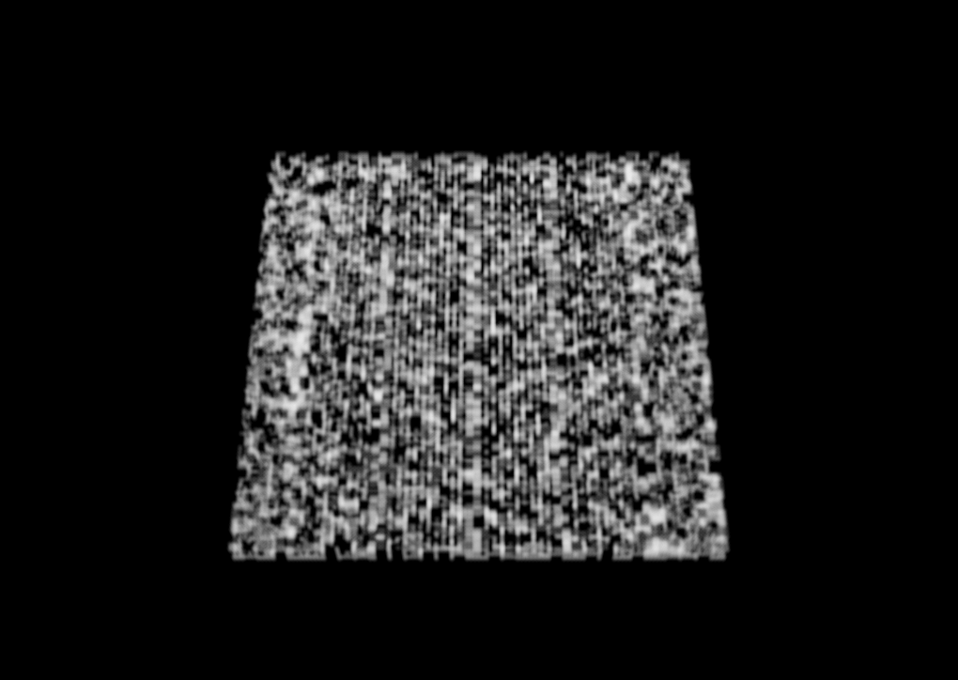
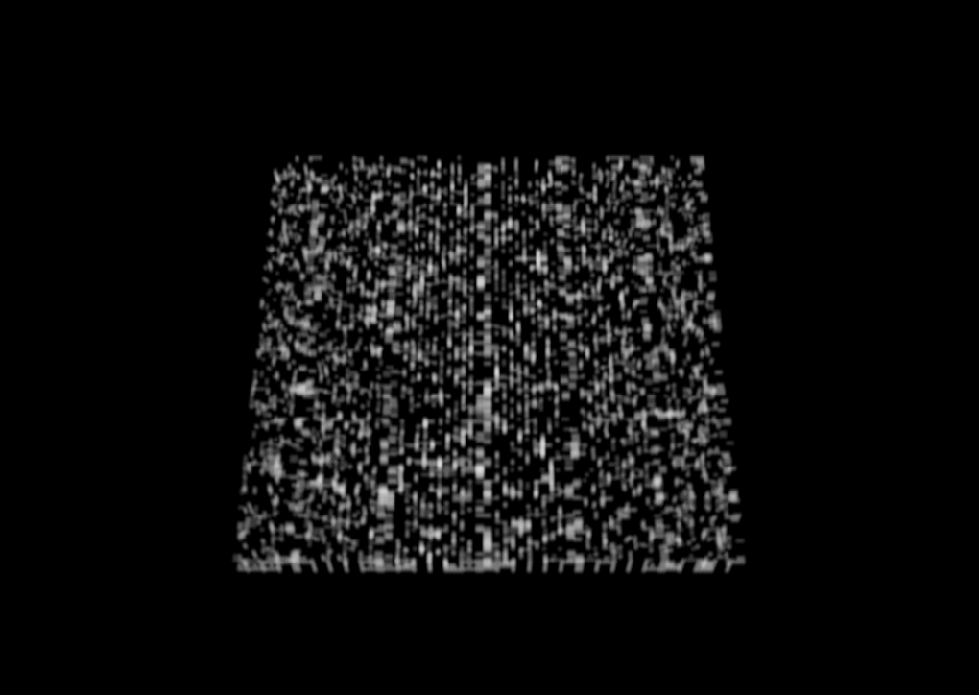
Crowding molecules(black) were randomly placed on a lattice that defined the maximal sphere packing for each radius of molecules used. After the crowding molecules were placed, the reactants were randomly distributed in the remaining free space. Simulations were performed at various levels of crowding. Illustrated are the accessible volumes(white) with 25, 50, and 75 percent of all lattice points occupied by crowding molecules.

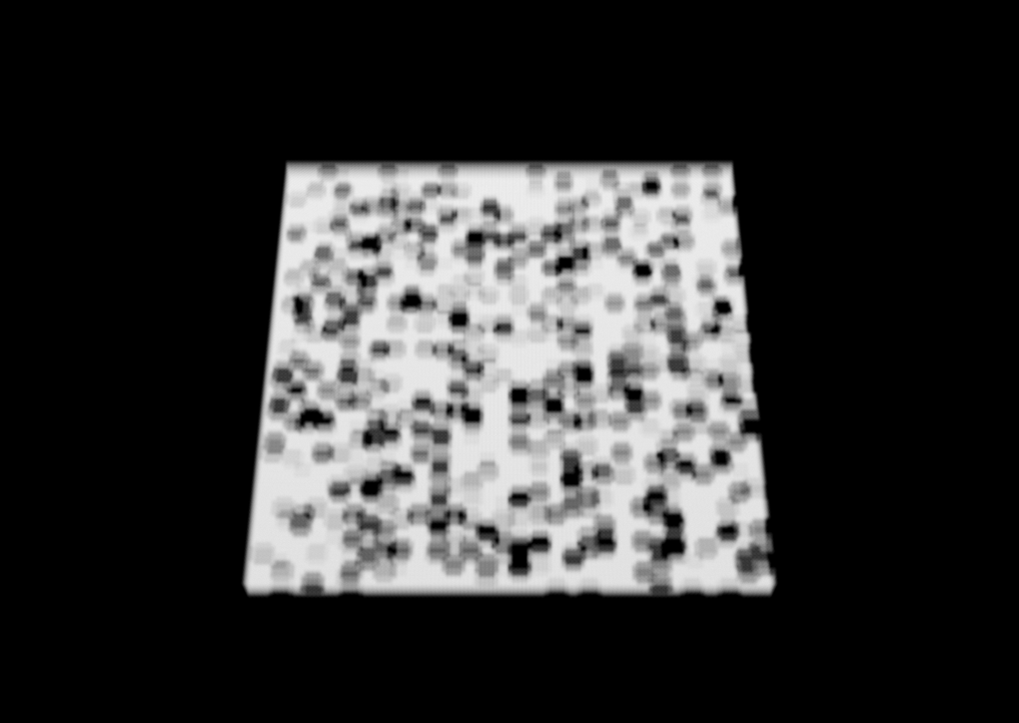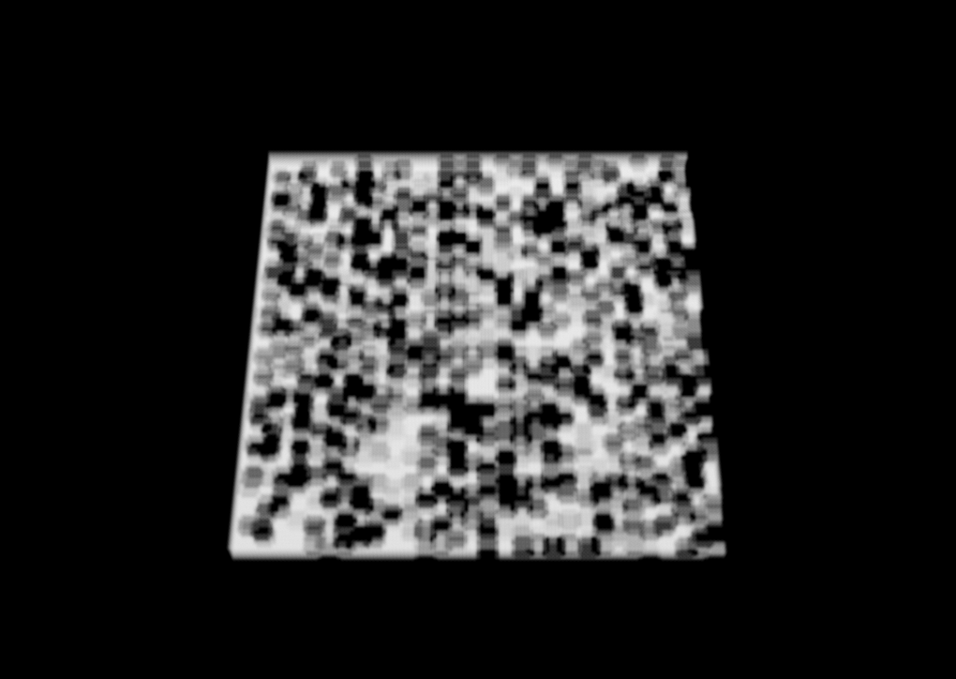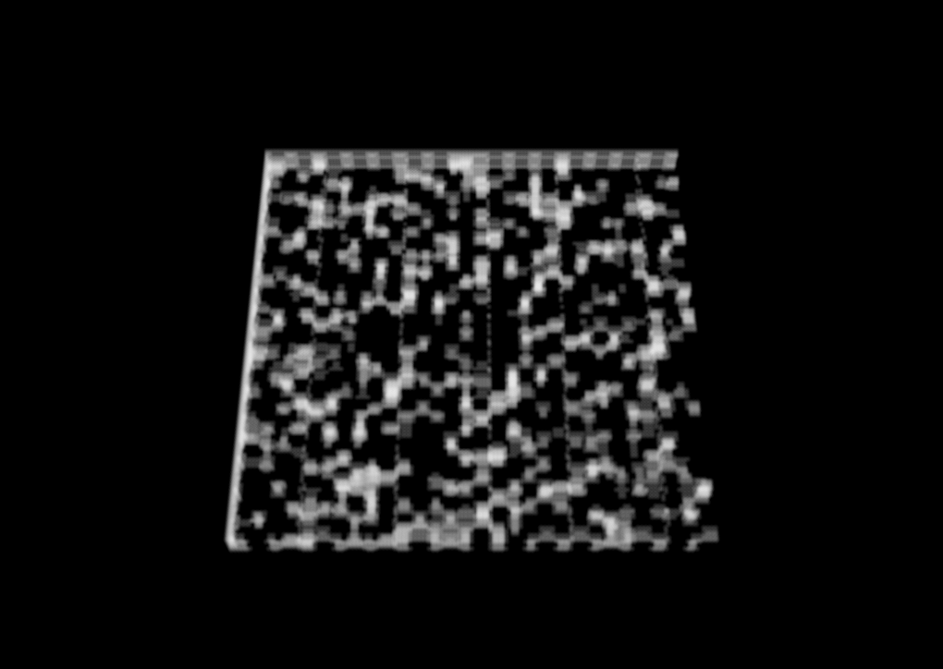

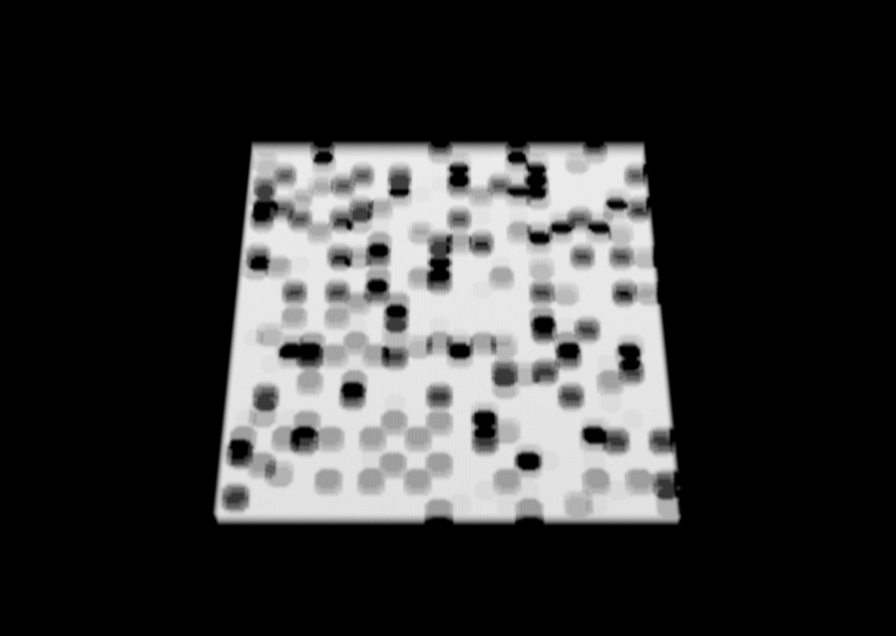
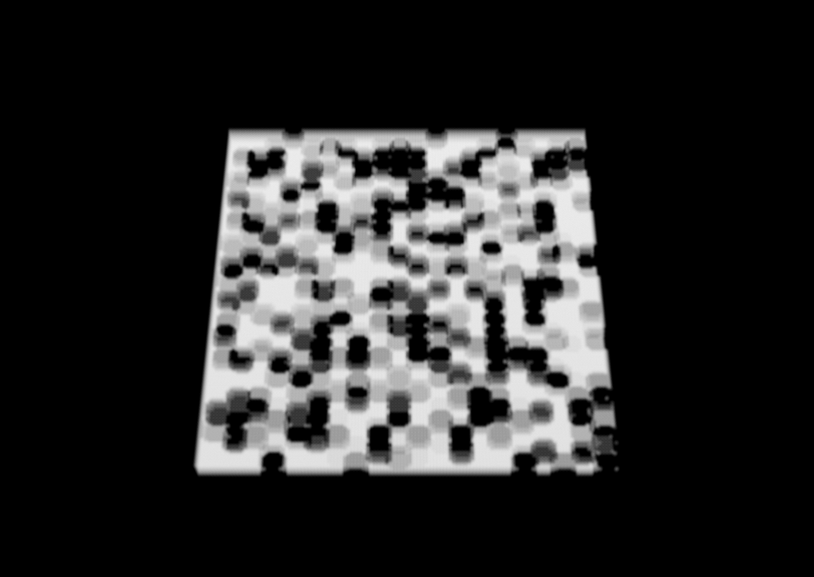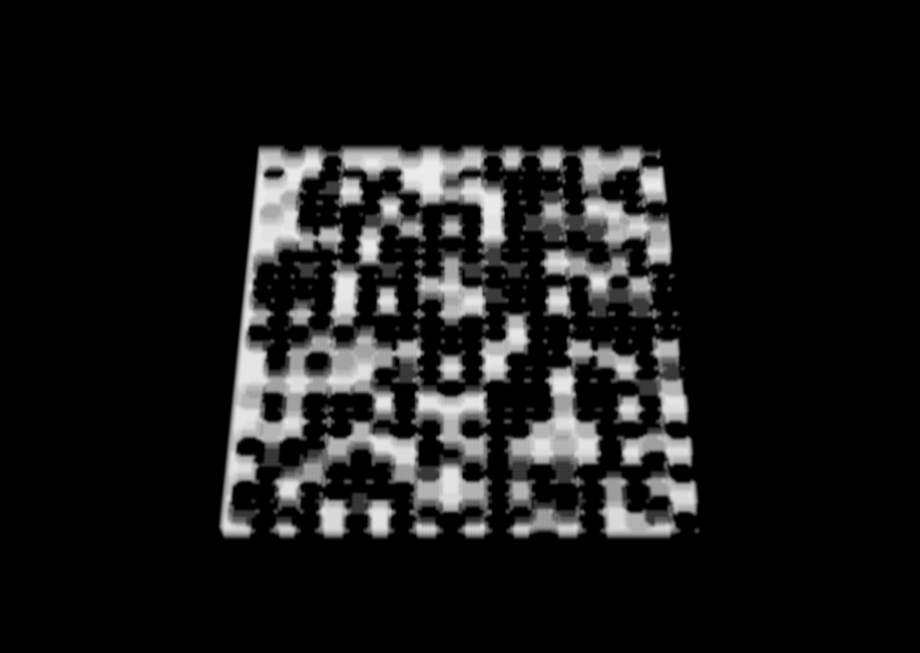

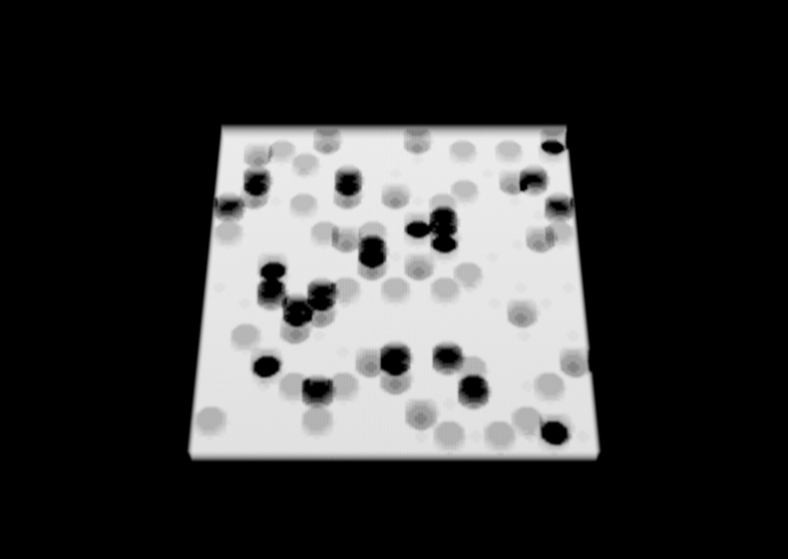
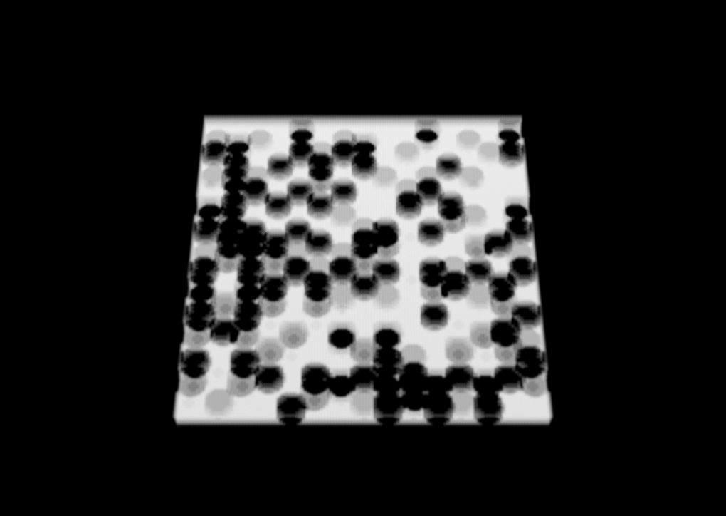
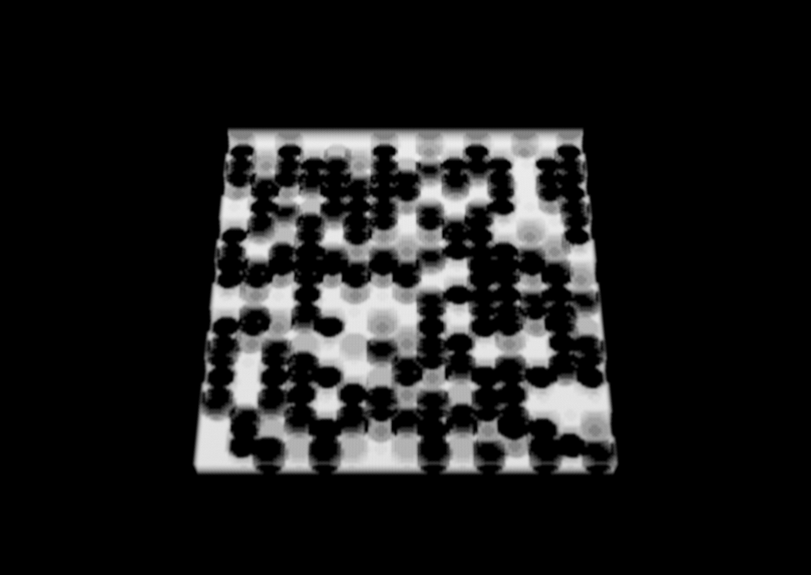
Figure 2. Cross-sections of crowding conditions used in 2D off-lattice Monte-Carlo simulations
Percent Crowding

25 50 75

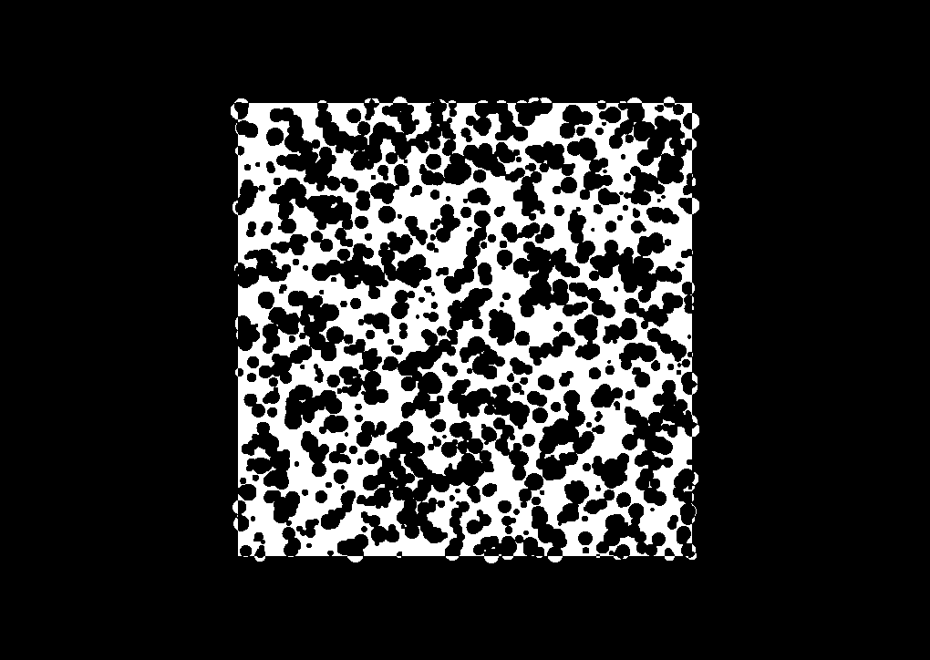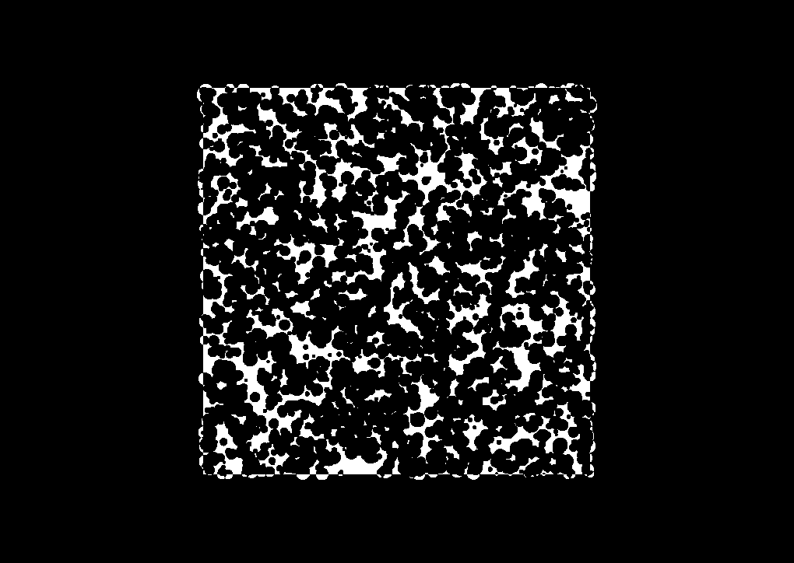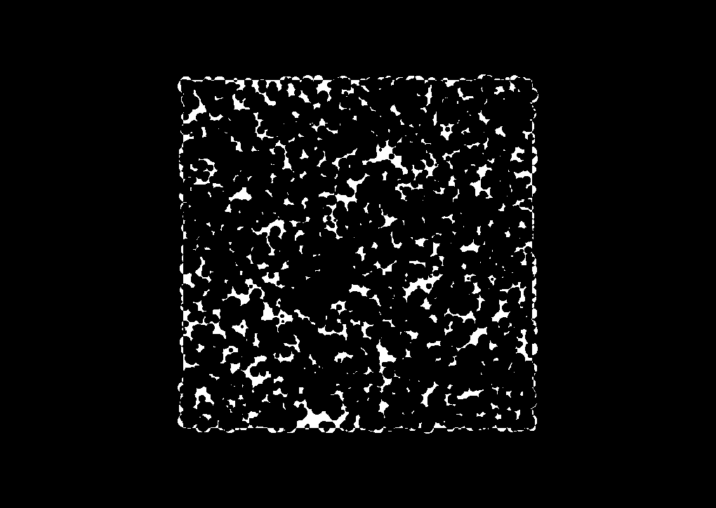

Random
(5-20)

Uniform
(1)
Radius Type
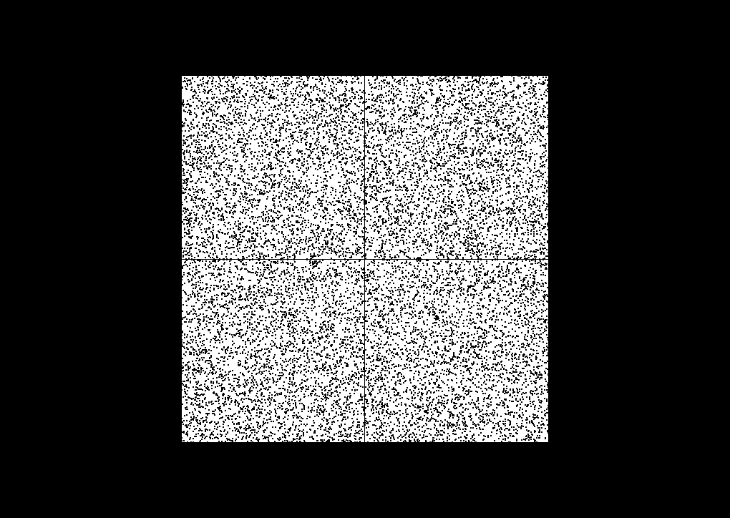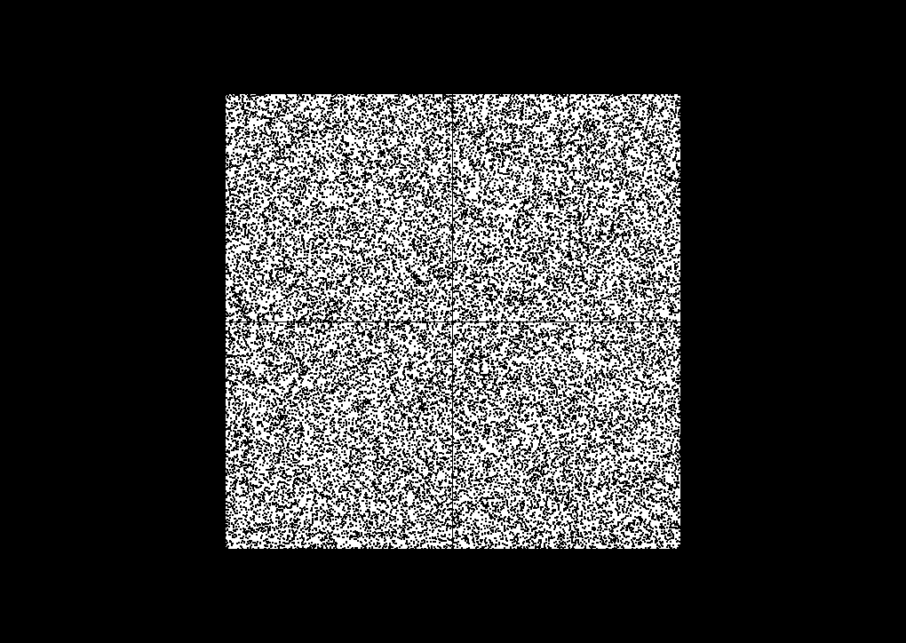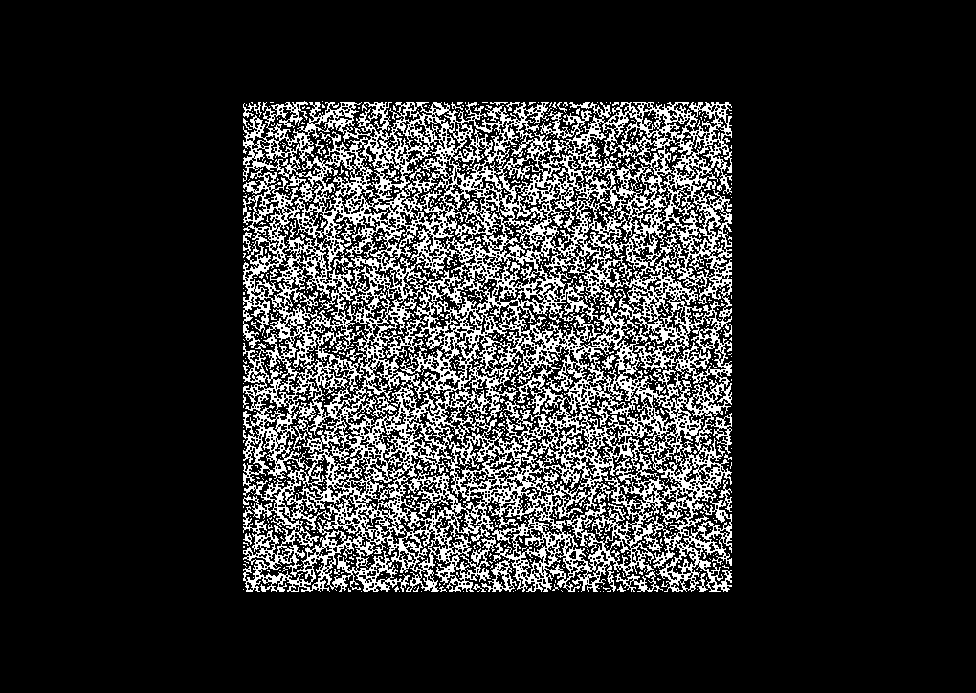
Crowding molecules(black) were randomly distributed over a two dimensional space with overlap. After the crowding molecules were placed, the reactants were randomly distributed in the remaining free space. Simulations were performed at various levels of crowding. Illustrated are the accessible volumes(white) with circular crowding molecules of radius one in a 500x500 space or random radii between five and twenty in a 1000x1000 space.

Figure 3. Behavior of molecules in 2D lattice and 2D/3D off-lattice simulators

A
B
C
A
B
Movement of A and B
Movement of C
Disassociation of C
Movement of A and B
Movement of C
Disassociation of C

2D/3D
off-lattice simulations

2D lattice simulations

Microscopic kinetics were simulated with lattice and off-lattice based Monte-Carlo methods. Molecules were considered spheres/circles of a given radius or as points on a lattice. Complexes of two molecules were considered as two spheres/circles moving together around their center of mass or as a single point a lattice.

METHODS
Molecular Geometries
The bimolecular reaction A+B⬄C was simulated and 20 simulations were averaged to generate the final progress curves. A and B were considered spheres/circles of radius 1 and C was considered 2 spheres/circles of radius 1. The total time simulated was choosen to include equilibrium conditions.
Simulator Parameters
TIME – Number of simulated time points
R_PROB – Probability that C disassociates into A and B
F_PROB – Probability that A and B form C after colliding
Simulator Alogorithm
For time=1:TIME
For all molecules
Pick random molecule
If molecule == A/B
Translate center of mass, random direction
If collision with B/A
If random < F_PROB
Bind A and B/B and A into C
else
stop at point of collision
end
else
stop close to collision
end
If molecule == C
If random < R_PROB
Move A and B in random 0.5 unit direction apart
end
else
Translate center of mass one unit, random direction
Rotate A and B around center of mass, random angle
End
If collision
Stop at point of collision
end
end

end

Validation of 2D/3D Off-lattice Simulators
Simulations in a 1000x1000x1000 space were performed to validate the off-lattice simulator. The probability of C disassociating into A and B, r_prob, was set to 0.0001 and the probability of binding after colliding, f_prob, was set to 1. These two parameters are related to k1 and k2 in the mass action model as shown in the equation below.
(4/3*pi*r^3)/V*Cn’(t)=f_prob*2*(4/3pi*r^3)*An(t)Bn(t)/V^2 – r_prob*(4/3*pi*r^3)*Cn(t)/V
Cn’(t) = f_prob*(4/3*pi)/V * An(t)*Bn(t) – r_prob*Cn(t)
K1= f_prob*(4/3*pi*r^3)/V = 0.0008
K2 = r_prob = 0.00001

Figure 4. Validation of 2D/3D simulators without crowding

The average of ten 3D simulations is compared to the mass action model with the expected rate constants. We see the mass action model and the simulated data have the same equilibrium values, but different initial rates. This difference is most likely due to the excluded volume of the reactants. The 2D simulations are even more influenced by the excluded volume of the reactants and differ at both the transient and steady states of the reaction.
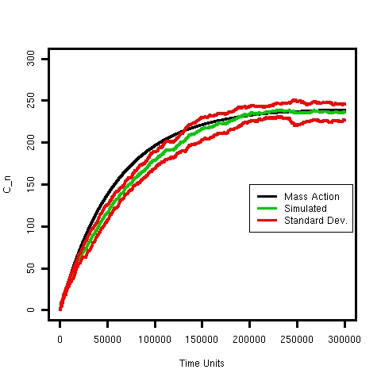

Table 1. Metrics of molecular crowding

2D Simulations | Radius | N | % Accessible Volume | % Crowding | Fractal Dimension
 | (5-20) | 1500 | 0.49 | 0.52 | 1.73
 | (5-20) | 3000 | 0.23 | 0.27 | 1.52
 | (5-20) | 4500 | 0.11 | 0.14 | 1.34
 | 1 | 16000 | 0.82 | 0.99 | 1.97
 | 1 | 32000 | 0.64 | 0.93 | 1.93
 | 1 | 48000 | 0.50 | 0.87 | 1.88
3D Simulations
 | 1 | 43028 | 0.54 | 0.82 | 2.95
 | 2 | 5145 | 0.63 | 0.83 | 2.95
 | 3 | 1480 | 0.71 | 0.83 | 2.94
 | 4 | 609 | 0.74 | 0.84 | 2.93
 | 1 | 86055 | 0.27 | 0.64 | 2.90
 | 2 | 10290 | 0.37 | 0.66 | 2.88
 | 3 | 2960 | 0.47 | 0.67 | 2.86
 | 4 | 1218 | 0.52 | 0.67 | 2.85
 | 1 | 129083 | 0.10 | 0.46 | 2.82
 | 2 | 15435 | 0.18 | 0.48 | 2.81
 | 3 | 4440 | 0.26 | 0.50 | 2.78
 | 4 | 1827 | 0.31 | 0.51 | 2.76
Accessible Volume
The accessible volume was determined for each crowding space
Fractal Dimension
The fractal dimension of the 2D and 3D accessible volumes were calculated using a box counting algorithm. The minimum resolution used was equal to the radius of the reactants. Figure X shows an example of the linear fit to the resolutions chosen.
Percent Crowding
Percent crowding was defined as the percent of the space that was not occupied by the crowding molecules.

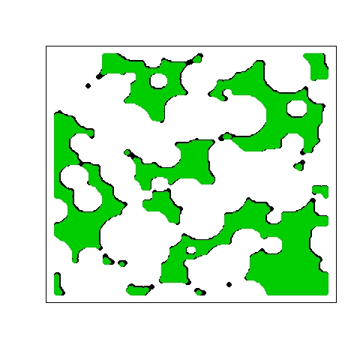
Figure 5. Illustration of accessible volume

Accessible volume is shown in green, the crowding molecules are shown in white, and the empty non-accessible volume is shown in black.

crowding molecules
accessible
volume
Non-accessible volume

Fractal Dimension Plots
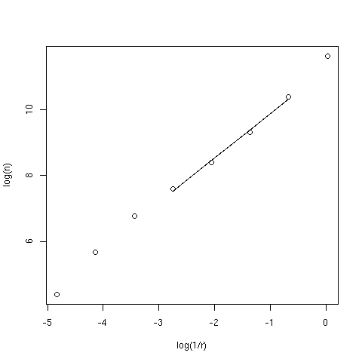

Fitting
The mean and variance of 20 simulations were fit with constrained non-linear weighted least squares optimization using the simplex induction hybrid (SIH) method. Models were refit with a different set of constraints if the returned parameters were near the initial limits or the chi-square was above 10. The models were compared after normalizing the chi-square value for the number of parameters.

Conclusions
- The ability of the models to fit the simulated data depends on the type of crowding.
- Fractal dimension and accessible volume can be used to characterize the density and complexity of the simulated volume.
- The S model fits high fractal dimension better than low fractal dimensions, but is generally outperformed by the ST or MST models.
- We find that under certain crowding conditions each model predicts unrealistically low k1 and k2 values.

