- Basically takes the form of a 5 page (max) 2 column IEEE formated paper due at the last lecture of term.

Abstract
introduction, goal, evaluation (dataset and metrics), results

Keywords:
genetic programming, modular behavior, diversity, multi-objective

1. Introduction
[brief introduction to GP]
This project expands the previous work on the class sandboxes to test and understand additional features for GP. The goal is to find which new features are capable of improving the performance of the system on a balanced and an unbalanced dataset. The modified system will be benchmarked against the results of the current system for the datasets Gisette \cite{ref1} and Shuttle \cite{ref2}. This works assumes that all classes are equally important, so the benchmark is based on the class-wise detection rate (DR) metric. The features tested in this work are non-linear instructions, diversity maintenance, and multi-objective approaches. Introns removal are also tested in order to try to improve the overall runtime of the system.
The next paper sections are organized as follows: [SECTION ORGANIZATION]

2. Current System and Benchmark
The system currently implemented is a GP algorithm for multi-class classification using linear representation. The system is able to evolve modular behaviors using teams of programs. Each program has an action, where an action means the class that the program will output a membership value. In a team, the program with the highest output value defines what class the team will classify the input. At each generation, a percentage of worst teams are replaced. If a program no longer participates in any team because of them were removed, then it is also removed. The system replaces the removed programs by cloning the same number of programs from the resulting population using uniform probability. There are three types of mutations for programs. The first mutation randomly selects an instruction and make a small change, e.g. using another registers as the target or using another arithmetic operation. The second and third mutations randomly add and remove an instruction. After creating the new programs, new teams are produced by cloning the remaining teams using proportional selection based on their fitness. Two mutations may affect a clone, adding or removing a program. If a program is added, it must be one of the newly created programs.
Other relevant features of the current system are: both the team size and the instruction size of the programs are variable, so the solutions structure are dynamic; a balanced sampling heuristic with oversampling is used to obtain the training data each generation, in order to ensure the solutions learn the patterns for all classes; the stop criterion is simply the end of the last generation; and the fitness function is the accuracy metric. The parameters used to run the system for the Thyroid and Shuttle datasets are shown in Figure \ref{fig:new1}. The parameters were chosen so that they would give a good performance in a suitable time. Due to different amount of classes to be learned, each dataset uses a different maximum of programs per team. For this configuration, the best solution across 30 runs is 0.94 for the Thyroid dataset and 0.425 for the Shuttle dataset.

Program Population Size | 400
Team Population Size | 200
Generations Total | 20
Max. Mutations per Program | 5
Mutation Chance (single instruction) | 0.9
Mutation Chance (instruction set) | 0.9
Mutation Chance (team) | 0.9
Replacement Rate | 0.2
Min. Instructions per Program | 1
Initial Instructions per Program | 10
Max. Instructions per Program | 20
Min. Team Size | 2
Initial Team Size | 3
Max. Team Size | 6
Extra Registers | 1

Figure 1. Parameters runs on the Gisette and Shuttle datasets.

3. Initial features: Non-linear Instructions and Introns Removal

The first feature added to the system is non-linear instructions: ln, exp, cos, if <, and if >=. To work around the problem of overflow, if an overflow occurs the returned result is the variable value before the execution of the operation. The hypothesis is that non-linear instructions will result in a higher accuracy, that leads to a higher DR. A better accuracy is expected since now problems will be able to increase their complexity to match complex data patterns.
A set of 30 runs is performed for the Gisette dataset and 20 runs for the Shuttle dataset using the new instructions. The Mann-Whitney U-Test was applied to compare the best solutions of each of the runs with a significance level p ≤ 0.05, in terms of accuracy and DR. For both datasets, the results were deemed not statistically relevant neither for accuracy nor DR. This probably happened because non-linearity is not particularly useful for the Gisette and Shuttle dataset. Another problem may have occurred with the new instruction that are propense to overflow, so that overflow occurred too frequently, and few modifications were made to registers content. Since the accuracy wasn't improved, neither was the detection rate.
Besides the performance measure, another comparison was performed between the average runtime for each run. As shown in \ref{fig:new2}, the average runtime for the Gisette and Shuttle datasets without non-linear instructions is 27.042 and 48.896, respectively. With the new instructions, the results are 31.964 and 64.59. So it is very clear that the new instruction set added a heavy extra runtime penalty.
The next experiment was to add introns removal to the GP algorithm with and without complex instructions, so instructions with no effect on the final output are ignored while processing the instruction set. As expected adding intron removals didn't affect the algorithm performance. The second expectation was that all algorithms with the intron removal would perform significantly better than without this removal. This was only true for the GP with complex instructions, where the average runtime decreased from 31.964 to 29.457 for Gisette and from 64.59 to 61.992 for Shuttle. But the comparison between the algorithm without complex instructions had a slightly increase in runtime, so the additional processing time for the introns removal didn't balanced the gain in instructions processing time. This seems reasonable since the simpler instructions set doesn't have any time consuming instructions, while the ln, exp, and cos instructions are slower to process. Also, the introns removal is more effective for the complex instruction set because instructions inside if's are not executed, avoiding waste of computational resources.

 | Gisette Runtime |  | Shuttle Runtime
 | Avg. | Std. Dev. | Avg. | Std. Dev.
Simple instructions without introns removal | 27.042 | 0.794 | 48.896 | 2.735
Simple instructions with introns removal | 30.671 | 0.846 | 52.791 | 2.559
Complex instructions without introns removal | 31.964 | 1.396 | 64.59 | 5.269
Complex instructions with introns removal | 29.457 | 1.266 | 61.992 | 7.587

Figure 2. Runtime performance for various combinations of instructions sets and introns removal.

4. Diversity Maintenance

In this section we are going to analyze how genotypic and behavioural diversity maintenance affects the system performance. The genotypic distance will be calculated using the method described by \cite{ref3}, where the distance between teams is the the ratio of active programs common to both teams. An active program is one that was selected at least once by the team to produce the output of the team. The diversity is calculated as the average of the pairwise distance between the K-Nearest Neighbors (KNN) across the genotype distance search space, with k = 8. The objective of using KNN in this context is to give a higher fitness to individuals that occupy a sparse local region in genotypic space. The fitness is calculated by the formula (1-p)*(raw fitness) + p*diversity, where p can be tuned to modify the weight of the parameters. The p value used is 0.1, selected empirically.
The behavioral diversity will be calculated using fitness sharing as defined in \cite{ref4}, where individuals share their fitness when they correctly classify a sample. Therefore individuals are rewarded by performing well against specific samples that other individuals are not able to classify. A second behavioral diversity maintenance method will be modified version of fitness sharing, named class-wise fitness sharing. The formula is modified so the fitness sharing is calculated separately for each class, and then averaged by the total number of classes. The goal of this modified version is to ensure that fitness sharing it prioritizing classes with more samples.
The initial results, using the Mann-Whitney U-Test at p≤ 0.05, showed that the Gisette dataset didn't benefited much from niching, which is understandable since it is balanced and has just two classes. The problem is that for the Shuttle dataset, where niching should have a bigger effect, the various diversity maintenance methods didn't affected its performance results positively. The genotype diversity maintenance had a performance too similar and was considered irrelevant. And the two types of types sharing ended up worsening the algorithm performance. Another hypothesis could be that diversity maintenance methods may need a longer time to indeed affect the system. So another set of runs was performed, now comparing the results of the four methods in three case studies with different number of maximum generations. The population size was decreased for higher number of generations, so the system would still run a suitable time.
Figure \ref{fig:new3} shows the average of the system performance during each generation for 30 runs, for the three case studies. The main point to notice is that a higher number of generations only benefited the system with no diversity maintenance and the genotype method, and that these methods performance curve were smoother and higher that the fitness sharing methods. Regarding the genotype-based diversity maintenance, I consider that the good result was due to the raw fitness, and that more tests would be necessary to ensure that the genotype diversity was relevant for the system performance. I wasn't able to understand exactly what happened with the fitness sharing methods, but these methods results were very unstable and improved just slightly over time. It would be expected that with diversity being encouraged, the results for the DR for each class per generations would be more balanced, but as shown on Figure \ref{fig:new4}, the DR per class still maintained the behavior of abrupt changes in classes DRs for the fitness sharing method.

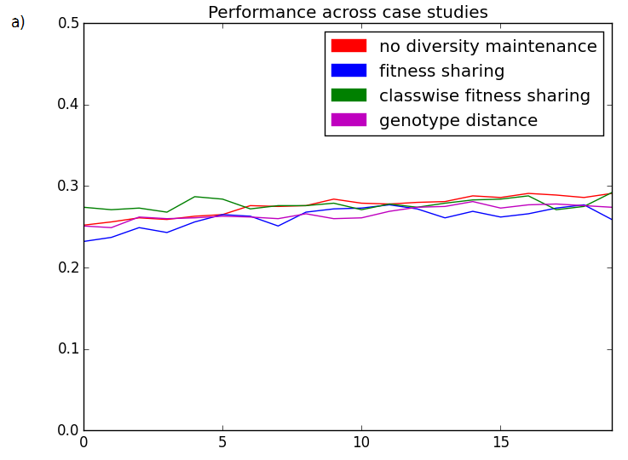
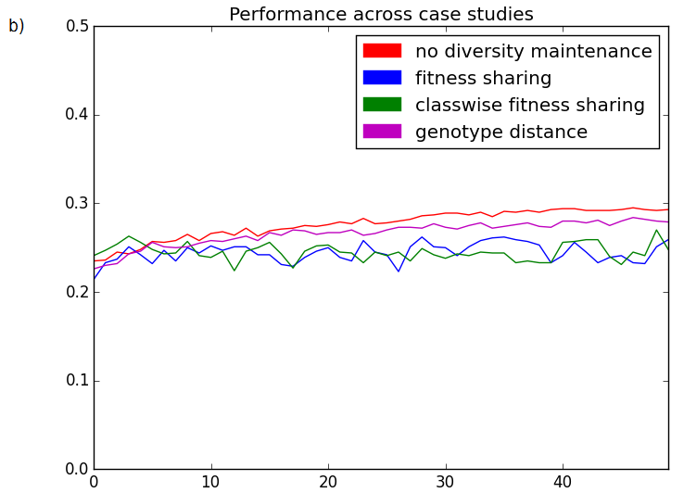
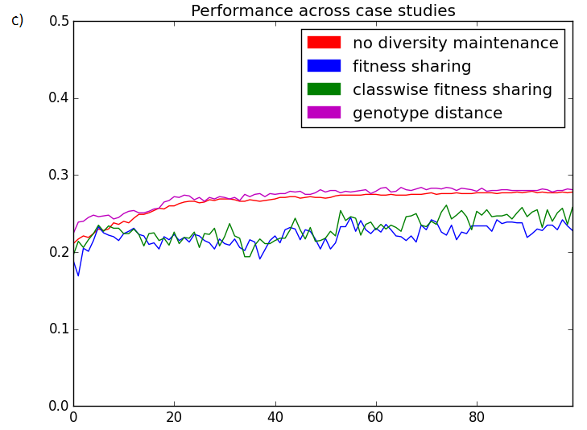

Figure 3. System performance using various diversity maintenance methods across three sets of parameters: a) 400/200 population, 20 generations, b) 200/100 population, 50 generations, and c) 100/50 population, 100 generations

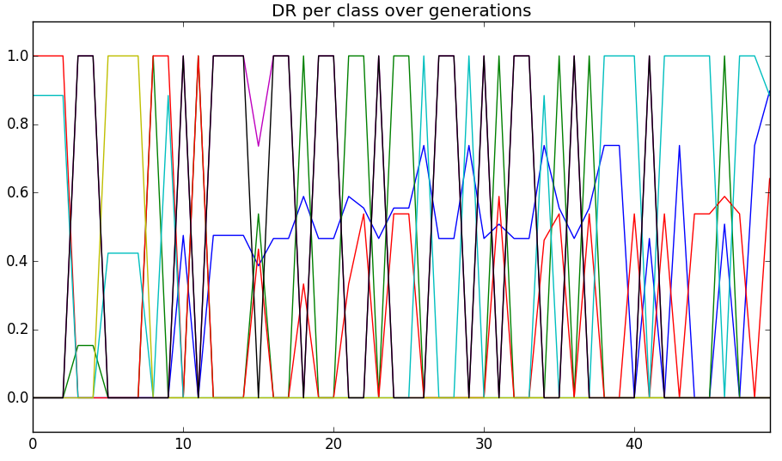
Figure 4. DR per class changing over generations for the Fitness Sharing method.

References:
[1] Gisette
[2] Shuttle
[3] Genotypic versus Behavioural Diversity for Teams of Programs Under the 4-v-3 Keepaway Soccer Task
[4] Fitness Sharing in Genetic Programming

